Lesson plan
Teaching objectives: After the class, the students are expected to
- Read and write the passage by adopting the SCR model
- View life and adapt to new surroundings positively
- Apply the linguistic features to the continued part.

Teaching Procedures:
Step 1 Introduction of SCR model
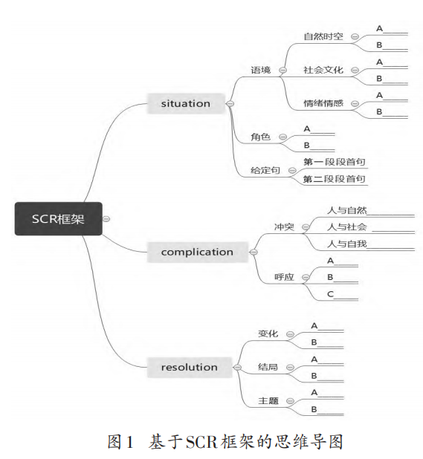

Step 2 Application of SCR model in reading the original text
- Raise questions
- Classify those questions
- Analyze and conclude the original text
- Predict what can be written in the continued part based on the above understanding
- Predict what can be written respectively in two paragraphs according to the given clues
- Dig deep into the theme, problem, solution, and change of feelings based on the model
time: PE class & first week in high school
venue: long track & huge school building
headaches
fearful; unsettled
Eva (主角) Coach Pitt/ classmates/ her grandfather
-long track vs. There was nothing she feared more than having to run a whole mile.
-huge school building vs. Having a poor sense of direction
- It was a six-story building. On each floor, hallways stretched in four directions, leading to classrooms, laboratories, and teachers’ offices. Somewhere in the building, there was also a library, a cafeteria, and a gym.
- Eva figured she would be left in the dust… she thought. “I’ll come in last for sure.”
- she focused on reaching the shadow east on the track by an oak tree up ahead. Then she concentrated on jogging to the spot where the track curved.
Theme: wisdom & personal growth

Step 3 Appreciation of good works
--focus on changes & cohesion and coherence

