**选择性必修四Unit 1 Reading and thinking教学设计**

**文本分析**

本单元的主题是“科幻小说”，在reading and thinking环节是一篇记叙文，改编自阿西莫夫的科幻短篇小说《包你满意》，讲述的是机器人制造公司员工Larry的妻子Claire和测试版家庭机器人Tony之间发生的故事。语篇主要分为明暗两条线。明线是妻子Claire对Tony从排斥、警觉，到接受、信任，再到被深深吸引的情感变化过程；暗线是机器人试验的成功与否。该语篇也曾是人教版选修七第二单元的阅读文本，但是新教材又进行的二次改编，除了语言上的细微改动外，故事以Tony突然对Claire做出亲昵举动，并倾述了一段不合常规的表白作为结束，特意在高潮处戛然而止，留下悬念，而结局在读后听力活动中呈现。

**教学思路**

该阅读文本主要围绕机器人制造公司员工Larry的妻子Claire对测试版家庭机器人Tony之间的情感变化过程和机器人试验这明暗两条线展开。学生首先通过整体阅读在宏观上把握好语篇结构，再通过精读细节在微观上梳理Claire对Tony的情感变化这一明线，并充分利用好语篇结尾处留下的悬念，通过设问，一步步引导学生积极思考故事情节的发展和结局，并在课后续编结尾。同时，本单元的reading and thinking环节不同于其它各单元，阅读文本结尾处留下的悬念，在读后听力环节呈现。因此，该阅读课可分为两课时，第一课时完成阅读文本内容的处理和读后续编，第二课时欣赏学生的续编的不同故事结局，完成读后听力活动，了解小说原有的结局，并针对机器人试验这条暗线辩证思考人与机器之间的关系。

**教学过程**

**Step 1 Pre-reading**

Activity 1 Explore the relationship between humans and robots.

Q1. How do humans and robots get on with each other?

Activity 2 Talk about the genre of this text.

What’s the genre（体裁）of this text?

1. Narration C. Exposition D. Argumentation

Activity 3 Talk about the title.

Q1. How do you understand the word “adapted”?

Q2. How do you understand the title “Satisfaction Guaranteed”?

**Step 2 Reading for the main idea and the structure**

Activity 1 Read for the main idea.

Main idea: It is mainly about how a household *Robot* was *tested* *out* in a family.

Activity 2 Read for the structure.

Part1 Tony’s arrival at Claire’s home.

Part2 (Para.2-8) The process of Tony helping Claire.

Part3 The result of Tony living with Claire.

**Step 3 Reading for the characters**

Activity Clarify the main characters and their relationships to each other.

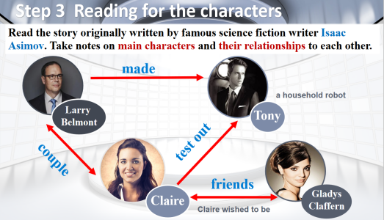**Step 4 Reading for the details**

Activity1 Read the story carefully and pay attention to the changes of Claire’s feelings towards Tony as the story developed.

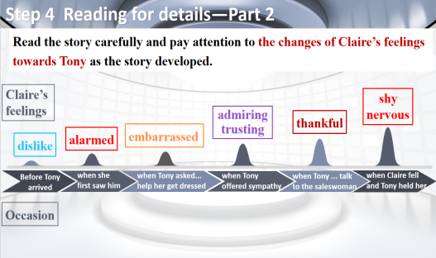Activity 2 Read for the result of Clair living with the robot.

Q: What happened before the party began?

**Step 5 Discussing and writing**

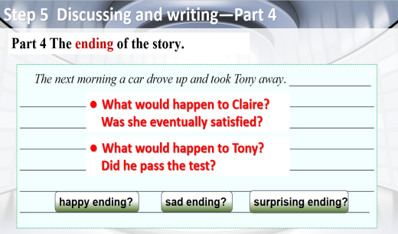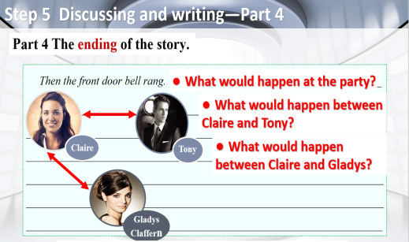Activity Work in groups and come up with a reasonable ending.

**Step 6 Listening and discussing**

Activity1 Listen to the rest of the story and discuss with your deskmate about how different is it from your ending.

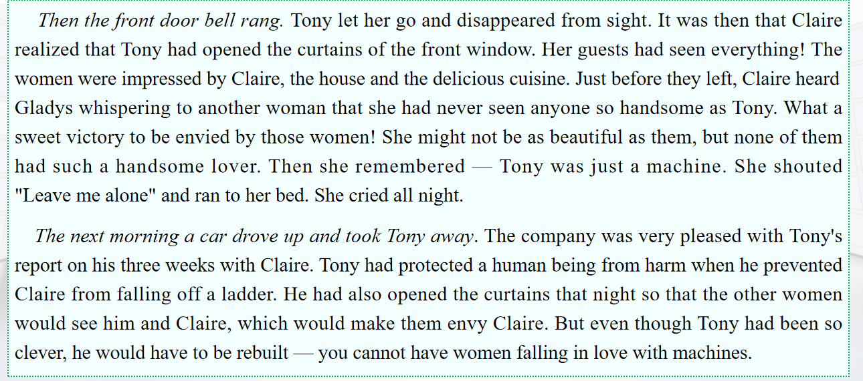Activity 2 Continue to complete the changes of Claire’s feelings towards Tony.

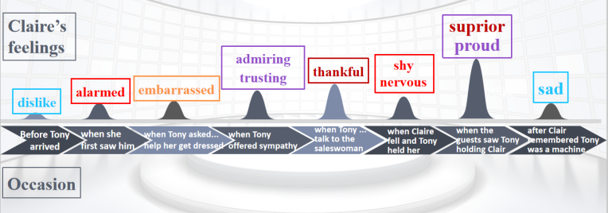**Step 7 Thinking**

Activity 1 Think about the similarities and differences between Tony and human being.

Activity 2 Discuss the two questions in groups.

Q1.What relationship do you think will develop between humans and robots in the future?

Q2. *Nowadays the application of the robots has already become an irresistible trend.*

Is it a challenge or an opportunity for the future development of mankind?Why?