2023年6月全国新课标I/II卷应用文---小组合作建议
杭州二中树兰高级中学 郭合英
真题展示：
假定你是李华，外教Ryan准备将学生随机分为两人一组，让大家课后练习口语，你认为这样分组存在问题。请你给外教写一封邮件，内容包括；
1. 说明问题；
2. 提出建议。
注意:
1. 写作词数应为80个左右：
2. 请按如下格式在答题卡的相应位置作答。
Dear Ryan,
I’m Li Hua from Class 3. _____________________________________________________________________________________________________________________________________________________________________________________________________________________________________________
Yours sincerely,
Li Hua

Teaching goals：
- Cultivate the students’ ability to comprehend the question carefully.
- Learn the mixed structure of practical writing (议论性质的应用文).
- Accumulate some appropriate expressions.
- Make comments on some students’ compositions.
Teaching focus：
- Cultivate the students’ ability to comprehend the question carefully.
- Show the grading criteria for the fifth grade composition of the college entrance examination.
- Accumulate some appropriate expressions.
Teaching difficulties：
- Cultivate the students’ ability to comprehend the question carefully.
- Accumulate some appropriate expressions.
Teaching process：
Step 1 Lead in
Show the grading criteria for the fifth grade composition of the college entrance examination.
Step 2 The outline of the practial writing
Para.1: Beginning: self-introduction + writing purpose
Para.2: Body: put forward questions + solve problems.
Para.3: Ending：Hope the suggestion is adopted and get a reply from the other party.
Step3：Build up vocabulary
To accumulate some vocabulary relevant to the practical writing.
一、话题词汇
1. 准备做某事
2. 随机
3. 两人一组
4. 口语
5. 说明问题
6. 提出建议
二 同义词拓展
- should
- I think
- want to
- good
- be different from
- pay attention to
- play a role in
关于Beginning的积累: 自我介绍+写作目的
- 我真的欣赏您的教学风格，但是，我个人认为随机分配两人一组练习口语并不是一个能
提高我们学习的好方法。
I really your teaching style, but , pairing the students off to practise spoken English isn’t a way to .
- 非常抱歉地打扰你，但是, 关于你的随机两人一组练习口语的建议，我迫不及待地想和你
分享我的一些想法。
sorry to excuse you, but I share my ideas ____________
your proposal that you allow the students to practise verbal English in pairs.
3. 在上节课中，你做了一个决定：每两个学生随机被分成一组练习口语，我想表达一下我个人的一点看法，所以我给你写这封信。 .
The last class your decision every two students were randomly divided into groups, to my mind differs from my thoughts.
, I’m determined to drop you the line.
4.我向你道歉因占用了你的宝贝时间去读我的信。我想让你知道我的一些想法。如果我是
你，我不会随机分配两人一组去练习口语。
I’m supposed to you for occupyingyour to read my proposal to you. I’ll keep you my thoughts. , I wouldn’t allow my students to to practise spoken language in a random way.
关于Body的积累: 问题说明+具体建议+ 细节拓展
- 随机两人一组没有根据学生的兴趣和爱好分组。倘若两个不同爱好的人被分在一起，他
们因没有共同的爱好而让口语练习陷入无话可说的境地。

- 我不赞成的地方就是随机。老师应该根据学生的水平分组，为他们搭建一个平台，以强
带弱，快速提高学生的口语水平, 也能起到加强友谊的作用。

- 由于每个学生的性格不同，毫无疑问随机分组并不是一个好的方法让学生去练习口语。
为什么不根据学生的爱好和他们的成绩去分组呢？

- 个人认为非常有必要把这些因素考虑在内，这不仅有助于口语的提高；而且还有助于增
强他们之间的友谊。倘若你能给我们布置一些口语练习的作业那再好不过了，比如有关小视频的练习，这能给我们的学习带来

- 我想提出我个人的看法：让学生自己挑选他们的合作伙伴是个不错的主意。这可以让他
们在快乐中学习，更能提高学习的效率。

- 我个人认为四到五人一个小组会更好，口语练习的氛围会更热烈，避免两人无话可说的
尴尬

- 我的个人建议是五人一组比较好，如果他们中有人是口语大咖，他就可以帮助其他学生
快速进步。

关于Ending的积累
1. 虽然说熟能生巧，但是高的效率需要好的方法。希望我的建议能引起你的共鸣。

2. 希望我的建议能让口语练习达到到事半功倍的效果。期待你的回复。

3. 希望我的提议有意义，能让彼此共赢。期待着你的早日回复。

4. 如果你能考虑我的建议我将不胜感激。

5.如果我的建议被采用了，我将会非常感激的。我坚信如果采用自愿结合的方式，我们的
口语一定能提高的。期待着你的早日回复。

Step 4: Make comments on some students’ compositions
学生作品1
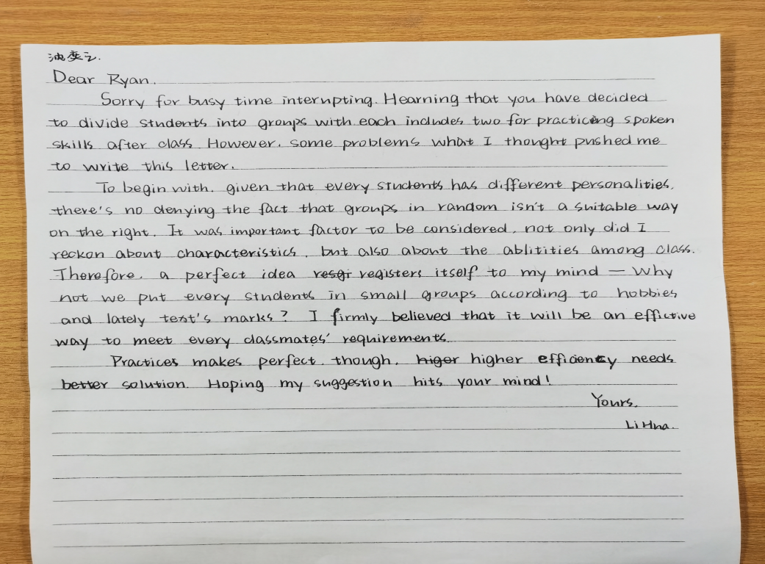 | 习作点评：
学生作品2
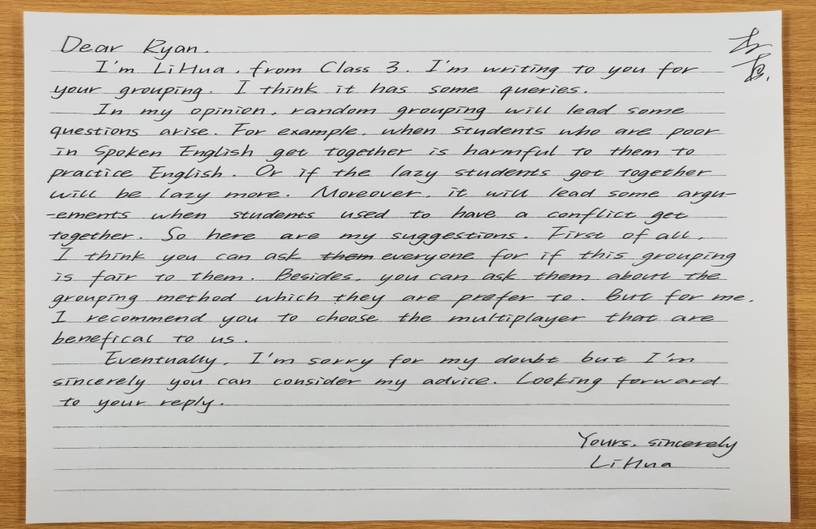 | 习作点评：
学生作品3
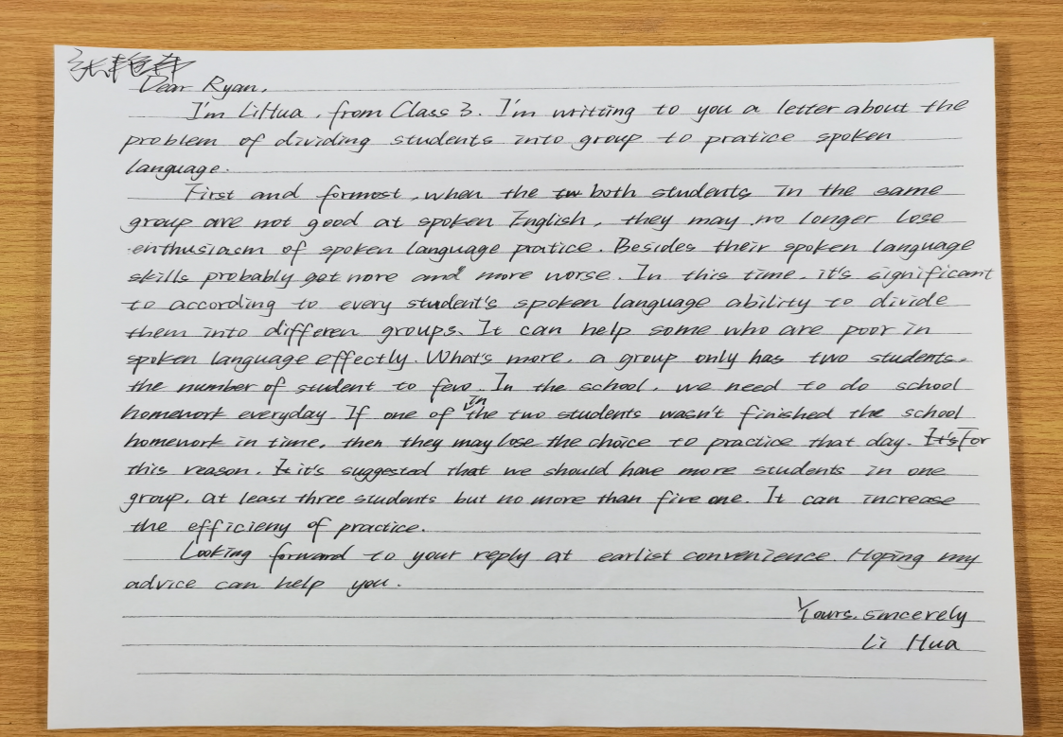 | 习作点评：
Step 5: Excellent sample essay
Dear Ryan
I am LiHua from class3. Aimed at sharing my suggestions relate to the grouping method in a random way with the purpose of getting our oral English enhanced, I’ll drop you the line.
What comes first is that pairing off arbitrarily may not necessarily serve to promote
its original effect due to lack for scientific method. Providing two students with poor spoken language were put together, they would be stuck in improving their spoken level.
Additionally, Students' interests and hobbies are not taken into account. If two people with different interests are divided together, they have no common interest, leaving the oral practice into a state of silence. Therefore, I can’t wait to offer my personal opinion: it is a fablous idea to enable students to choose their own partners freely. It allows them to learn in a happy moment, which not only can it improve the students’ spoken ability, but also it can play a role in strengthening their friendship.
Hope my suggestion will exert a enormous function on spoken drill and get twice the result with half the effort. Your prompt reply will be highly appreciated.
Yours,
Li Hua

