**The World**（**0401-0415**）材料分析和教学目标：

本次选用的材料：①*The Washing Post*的*Stuck in space for nine months, astronauts would go back ‘in a heartbeat’*（被困太空九个月的宇航员表示仍会‘毫不犹豫’重返太空）、②*The Times*的Wonders of China（中国奇观）、③New Scientist的Wood made see-through using rice and egg whites（利用大米与蛋清制备可降解透明木材）、④ *The Week*的*The author who started the teen vampire craze*（引发青少年吸血鬼热潮的作家）和⑤BBC的新闻报道。通过语法填空、阅读理解、分析长难句、翻译句子、听力填空和词汇拓展等方式，让学生从多角度提升学习兴趣，提高分析句子、运用词块和听力能力。外媒英语新闻可以让学生体验真实语境下的语言运用，拓展学生的国际视野，了解时事，逐步提升跨文化沟通能力，形成正确的世界观、人生观和价值观。

**教学思路：**

**Part 1: News Report 1 *The Washing Post* (April 2 2025 A12)**

**Stuck in space for nine months, astronauts would go back ‘in a heartbeat’**

**被困太空九个月的宇航员表示仍会‘毫不犹豫’重返太空**

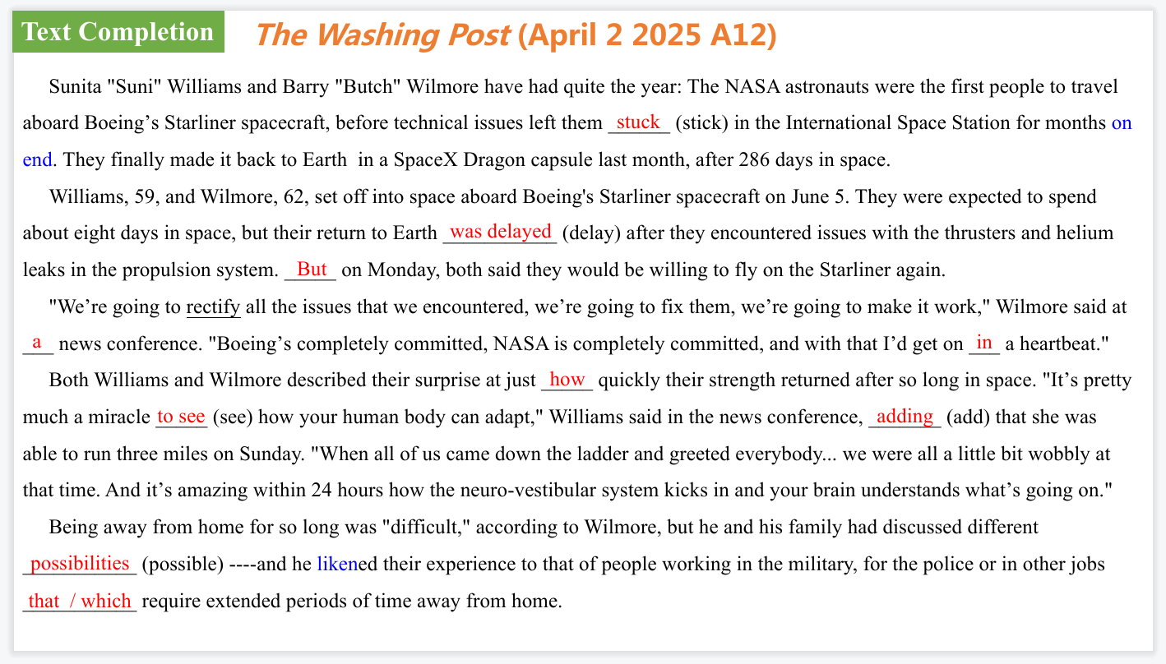

【设计意图】通过语篇填空的形式帮助学生理解新闻的主要内容，同时训练语言语法的运用能力：在语篇的视角下如何正确使用所给词汇，根据语法规则确定词汇的正确形式，使得文章通顺，激活学生的思维和语言。该新闻主题语境是关于“人与社会”中“社会热点问题”这一子主题，通过学习让学生了解被困太空九个月的美国宇航员表示仍会‘毫不犹豫’重返太空的新闻。

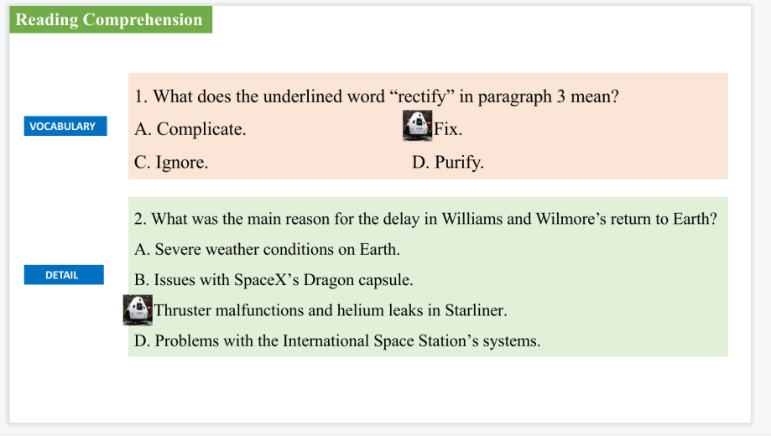

【设计意图】通过阅读理解的形式帮助学生理解新闻的主要内容。

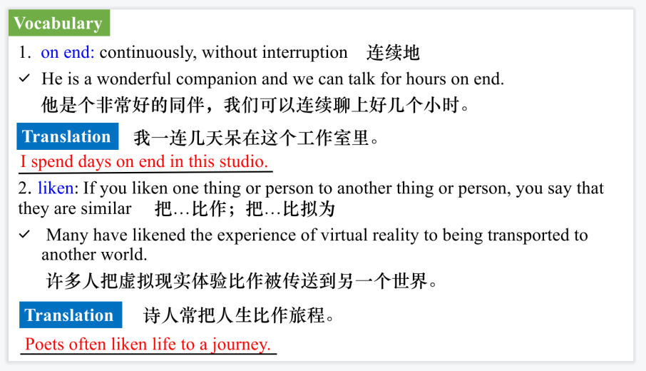

【设计意图】对文本中的词汇进行解读，并通过翻译句子对其进行巩固。

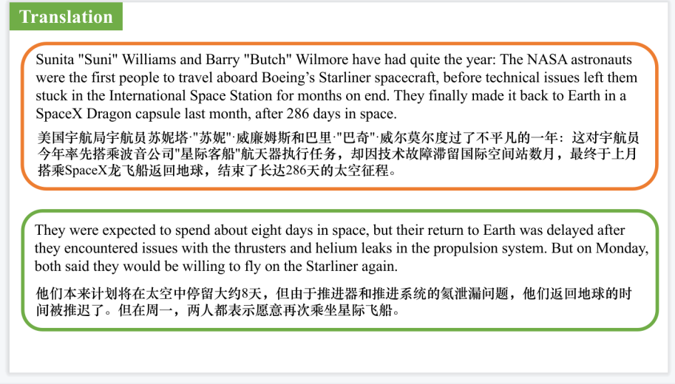

【设计意图】对文中的两个句子进行翻译练习，对其中单词、词组、句法进行巩固并关注句子结构。

**Part 2: News Report 4 *The Times*（April 15, 2025 P11)**

**Wonders of China中国奇观**

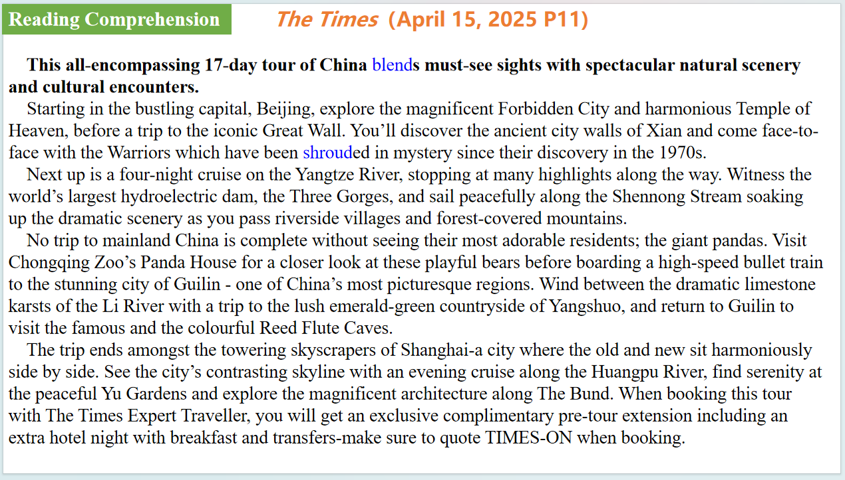

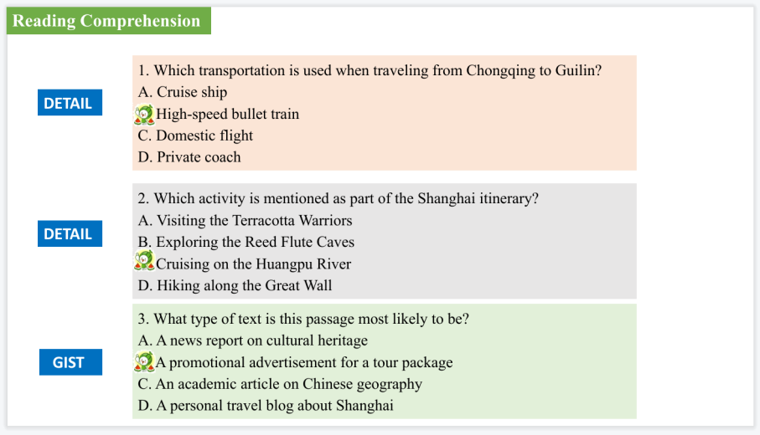

【设计意图】通过阅读理解的形式帮助学生理解新闻的内容的细节，提升学生的根据上下文的猜词能力。

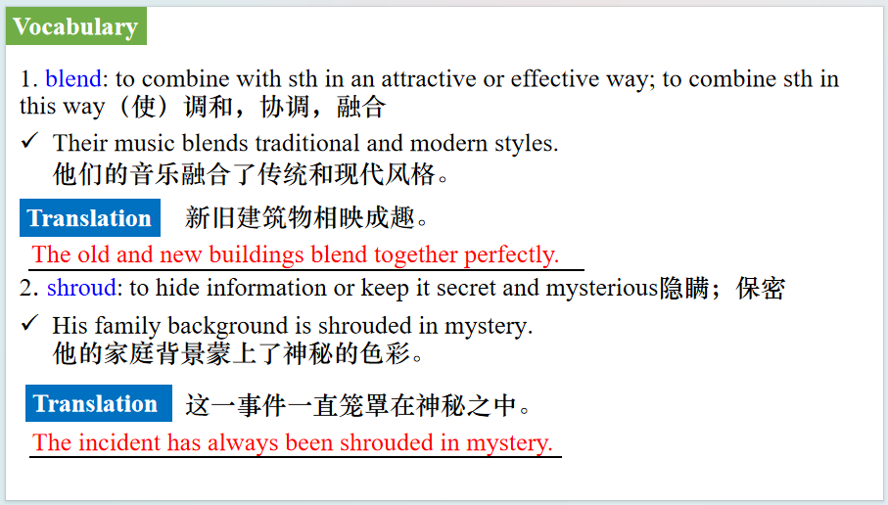

【设计意图】对文本中的词汇进行解读，并通过翻译句子对其进行巩固。

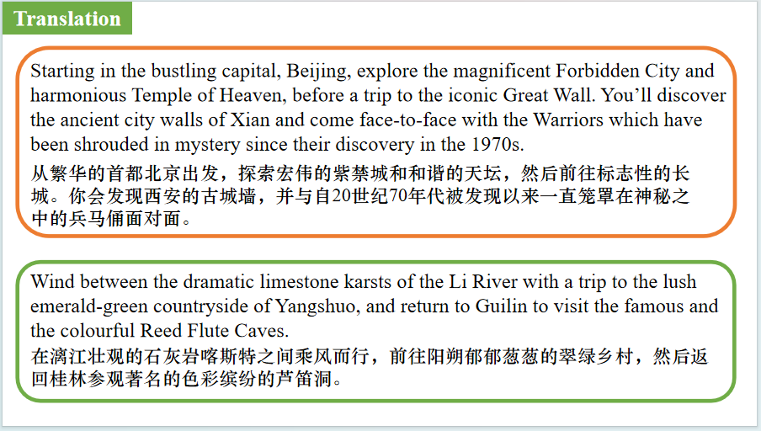

【设计意图】对文中的两个句子进行翻译练习，对其中单词、词组、句法进行巩固并关注句子结构。

**Part 3: News Report 2 *New Scientist*（April 5 , 2025 P17)**

**Wood made see-through using rice and egg whites**

**利用大米与蛋清制备可降解透明木材**

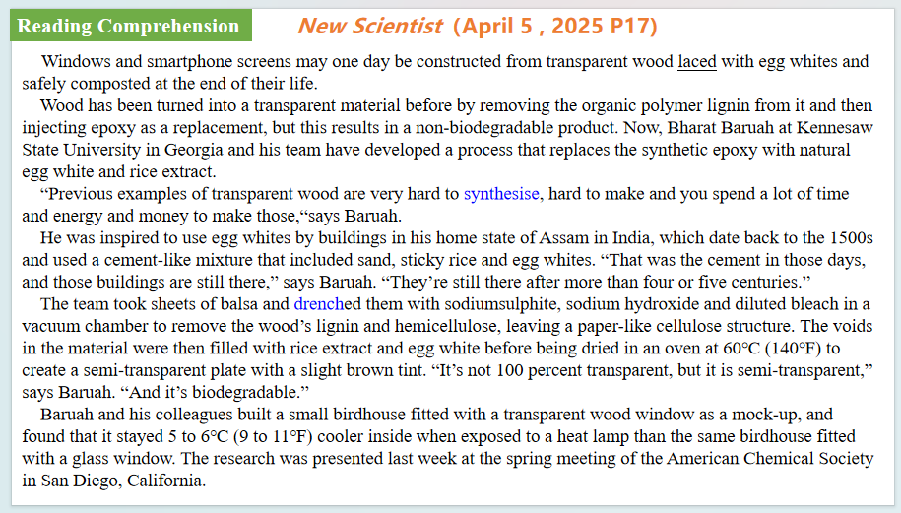

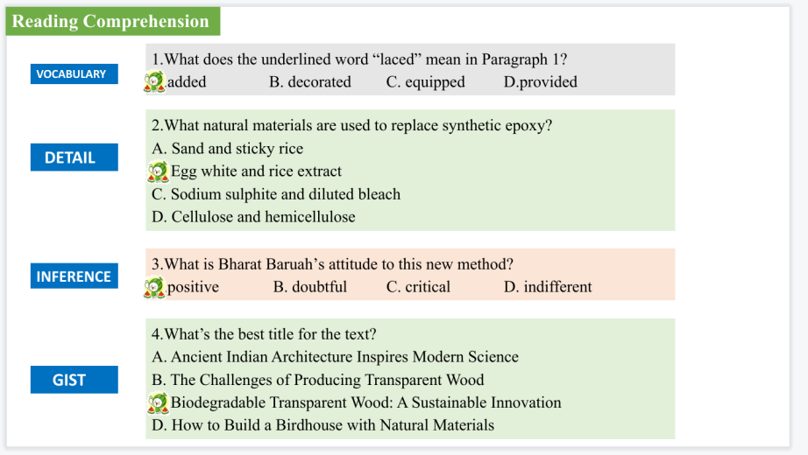

【设计意图】通过阅读理解的形式帮助学生理解新闻的内容的细节，提升学生的根据上下文的猜词能力。

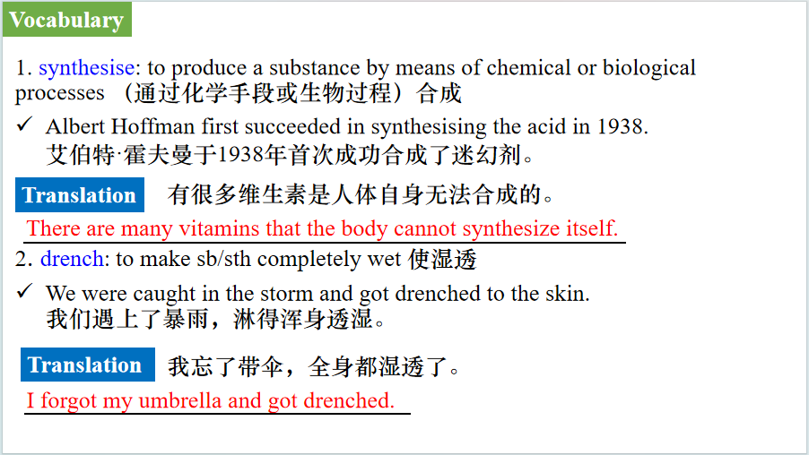

【设计意图】对文本中的词汇进行解读，并通过翻译句子对其进行巩固。

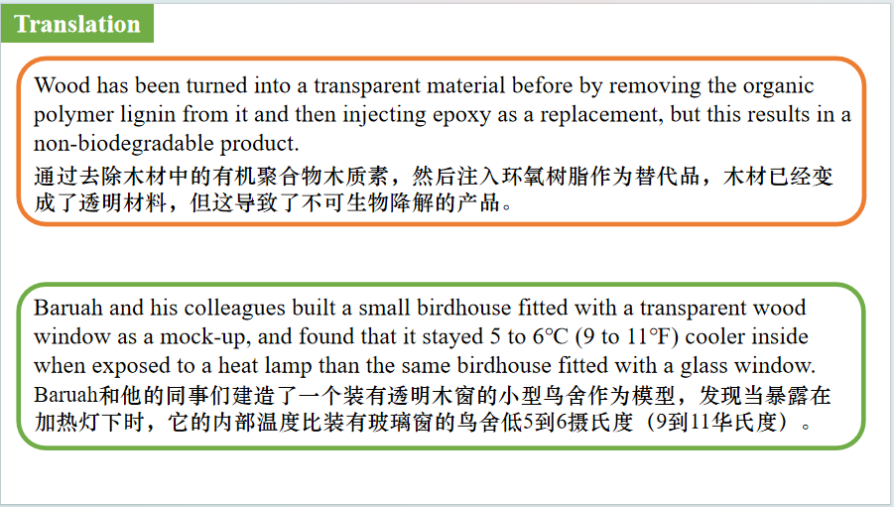

【设计意图】对文中的两个句子进行翻译练习，对其中单词、词组、句法进行巩固并关注句子结构。

**Part 4: News Report 4 *The Week* (April 11 2025 P35)**

**The author who started the teen vampire craze引发青少年吸血鬼热潮的作家**

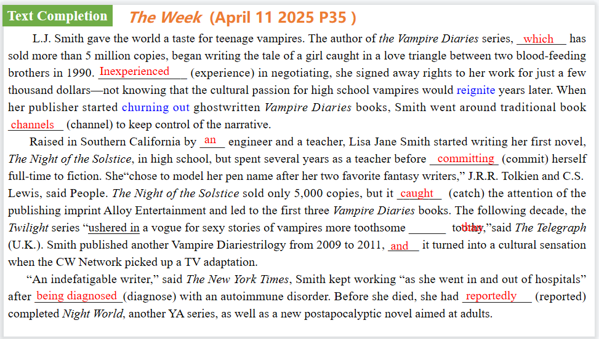

【设计意图】通过语篇填空的形式帮助学生理解新闻的主要内容，同时训练语言语法的运用能力：在语篇的视角下如何正确使用所给词汇，根据语法规则确定词汇的正确形式，使得文章通顺，激活学生的思维和语言。该新闻主题语境是关于“人与社会”中“绘画、建筑等领域的代表作品和人物”这一子主题，通过学习让学生了解尽管早期的挫折和健康问题，L.J.史密斯作为一个作家取得了持久的成功，尤其是《吸血鬼日记》系列。

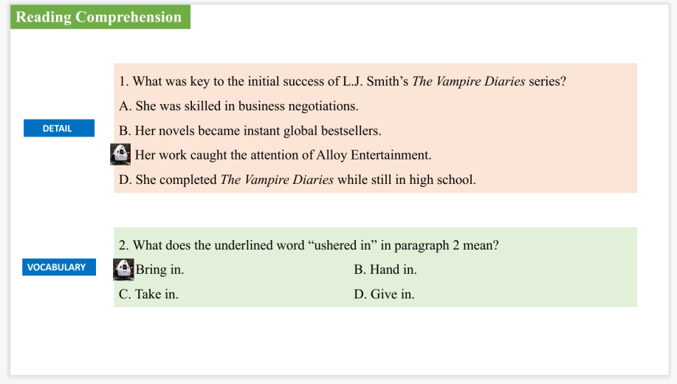

【设计意图】通过阅读理解的形式帮助学生理解新闻的内容的细节，提升学生的根据上下文的猜词能力。

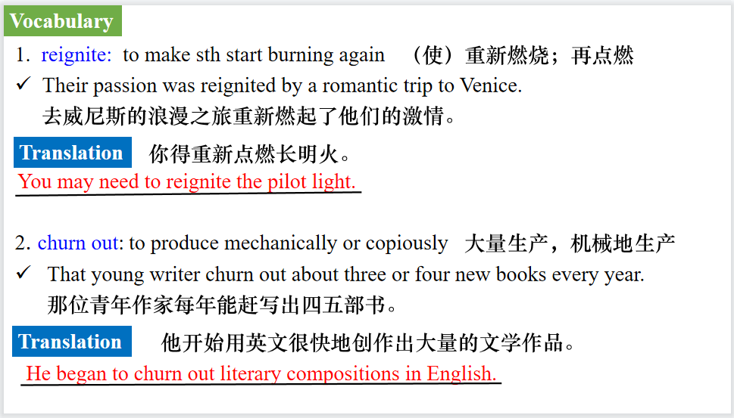

【设计意图】对文本中的词汇进行解读，并通过翻译句子对其进行巩固。

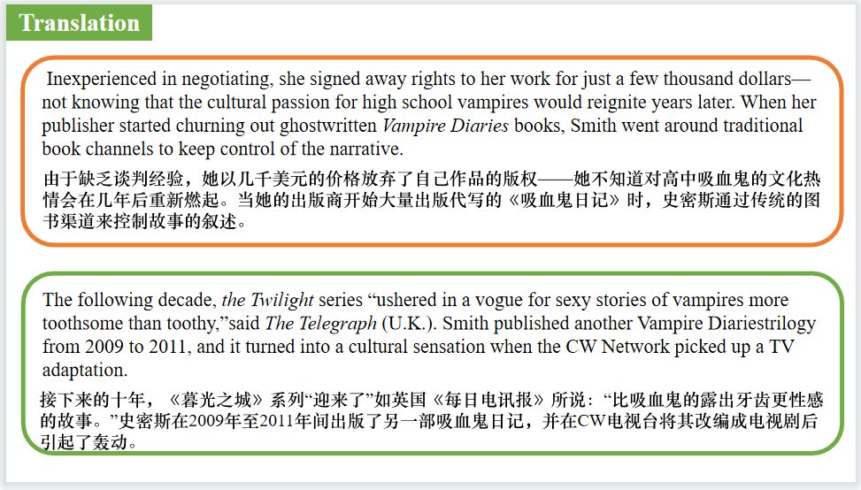

【设计意图】对文中的两个句子进行翻译练习，对其中单词、词组、句法进行巩固并关注句子结构。

**Part 5: BBC News 04/08/2025**

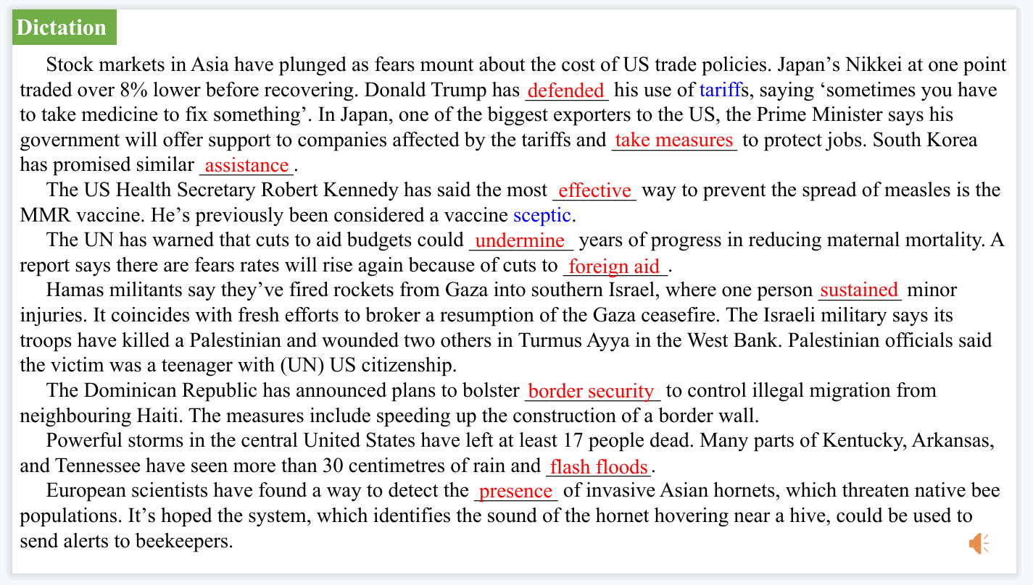

【设计意图】听一则材料，通过听力填空的方式理解文本，考察听力辨识词汇的能力。

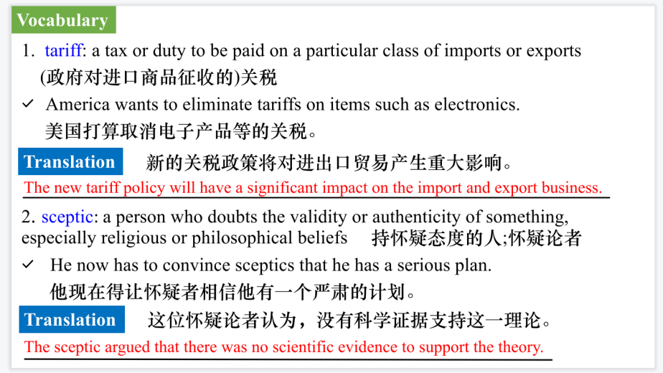

【设计意图】对文本中的词汇进行解读，并通过翻译句子对其进行巩固。

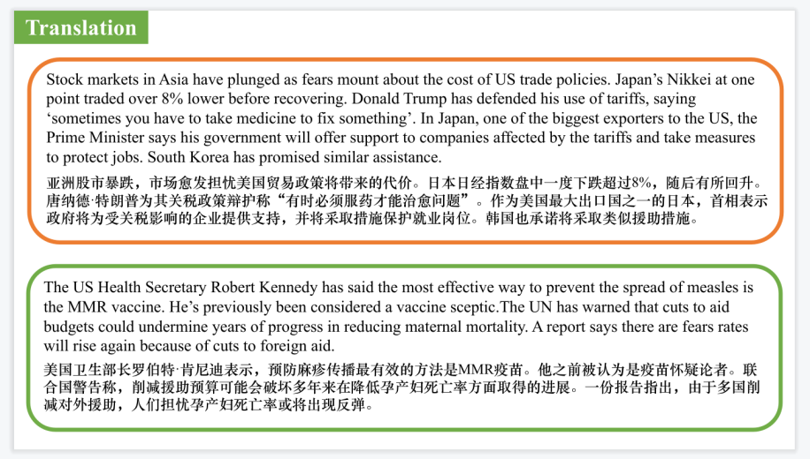

【设计意图】对文中的两个句子进行翻译练习，对其中单词、词组、句法进行巩固并关注句子结构。

附：外刊原文

**Part 1: News Report 1 *The Washing Post* (April 2 2025 A12)**

**Stuck in space for nine months, astronauts would go back ‘in a heartbeat’**

**被困太空九个月的宇航员表示仍会‘毫不犹豫’重返太空**

Sunita "Suni" Williams and Barry "Butch" Wilmore have had quite the year: The NASA astronauts were the first people to travel aboard Boeing's Starliner spacecraft, before technical issues left them stuck in the International Space Station for months on end.

But when they finally made it back to Earth last month, after 286 days in space, their immediate concerns were much more mundane.

"I wanted to hug my husband and hug my dogs," Williams said at a news conference Monday, the pair's first since they returned home two weeks ago in a SpaceX Dragon capsule. And she craved a taste of home: "my father was a vegetarian, so I had a good grilled cheese sandwich when I got home, so that reminded me of him."

Williams, 59, and Wilmore, 62, set off into space aboard Boeing's Starliner spacecraft on June 5. They were expected to spend about eight days in space, but their return to Earth was delayed after they encountered issues with the thrusters and helium leaks in the propulsion system.

But on monday, both said they would be willing to fly on the Starliner again.

"We're going to rectify all the issues that we encountered, we're going to fix them, we're going to make it work," Wilmore said at the news conference. "Boeing's completely committed, NASA is completely committed, and with that I'd get on in a heartbeat."

Wilmore argued that the issues with the Boeing spacecraft were a shared responsibility.

"There were questions that I, as a commander of the spacecraft, that I should have asked, and I did not," he said. "At the time, I didn't know I needed to. And maybe you could call that hindsight. But I'll start and point the finger, and I'll blame me."

He continued: "Blame... I don't like that term, but certainly there's responsibility throughout all the programs, and certainly you can start with me. Responsibility with Boeing, yes. responsibility with NASA, yes, all the way up and down the chain. We all are responsible. We all own this."

The pair did not directly comment on increased politicization of their final weeks in space, after Elon musk, SpaceX CEO and adviser to President Donald Trump, claimed that the company offered to return the astronauts last year but that the Biden administration rejected the offer for political reasons. Trump made similar claims, but Williams and Wilmore, as well as NASA's leadership, have said they were not aware of any such offer from SpaceX.

"When we're up there operating in space you don't feel the politics, you don't feel any of that, it's focused strictly on mission," Nick Hague, the Crew-9 commander who helped bring the two astronauts back to Earth and also appeared at the news conference, said in response to a question about the mission's politicization.

In a separate interview with Fox News before the news conference, both Williams and Wilmore said they were grateful national leaders are taking notice and getting involved in the space program. Asked if he had any words for Trump and Musk, Wilmore replied: "I respect you, I trust you. You've given me no reason not to trust you, either one of them."

Wilmore also rejected some of the narratives that emerged around their experience: "So in certain respects we were stuck, in certain respects, maybe we were stranded, but based on how they were couching this, that we were left and forgotten in orbit, we were nowhere near any of that at all."

Both Williams and Wilmore described their surprise at just how quickly their strength returned after so long in space.

"It's pretty much a miracle to see how your human body can adapt," Williams said in the news conference, adding that she was able to run three miles on Sunday. "When all of us came down the ladder and greeted everybody... we were all a little bit wobbly at that time. And it's amazing within 24 hours how the neuro-vestibular system kicks in and your brain understands what's going on."

Both astronauts noted the work of specialists throughout their mission and after their return----including nutritionists and strength, conditioning and rehabilitation specialists.

Being away from home for so long was "difficult," according to Wilmore, but he and his family had discussed different possibilities----and he likened their experience to that of people working in the military, for the police or in other jobs that require extended periods of time away from home.

And, Wilmore added, he didn't feel as though they missed any holidays while in space. "I think we celebrated every single one," he said. "We actually had a reindeer that we built and rode like a bull. I don't know if you saw those pictures, but we celebrated in style, trust me."

"But this holiday special season will be special, for sure," he said.

Williams said she has starting making other plans----including a trip to New England with her husband and travels farther afield.

"When you come back from space, it's really hard to sit where you are because there were so many amazing places that you saw," she explained, saying that "there's a bigger bucket list than I had when I left.”

**Part 2: News Report 4 *The Times*（April 15, 2025 P11)**

**Wonders of China中国奇观**

**This all-encompassing 17-day tour of China blends must-see sights with spectacular natural scenery and cultural encounters.**

Starting in the bustling capital, Beijing, explore the magnificent Forbidden City and harmonious Temple of Heaven, before a trip to the iconic Great Wall. You’ll discover the ancient city walls of Xian and come face-to-face with the Warriors which have been shrouded in

mystery since their discovery in the 1970s.

Next up is a four-night cruise on the Yangtze River, stopping at many highlights along the way. Witness the world’s largest hydroelectric dam, the Three Gorges, and sail peacefully along

the Shennong Stream soaking up the dramatic scenery as you pass riverside villages and forest-covered mountains.

No trip to mainland China is complete without seeing their most adorable residents; the giant pandas. Visit Chongqing Zoo’s Panda House for a closer look at these playful bears before

boarding a high-speed bullet train to the stunning city of Guilin - one of China’s most picturesque regions. Wind between the dramatic limestone karsts of the Li River with a trip to the lush emerald-green countryside of Yangshuo, and return to Guilin to visit the famous and the colourful Reed Flute Caves.

The trip ends amongst the towering skyscrapers of Shanghai-a city where the old and new sit harmoniously side by side. See the city’s contrasting skyline with an evening cruise along the Huangpu River, find serenity at the peaceful Yu Gardens and explore the magnificent architecture along The Bund. When booking this tour with The Times Expert Traveller, you will get an exclusive complimentary pre-tour extension including an extra hotel night with breakfast and transfers-make sure to quote TIMES-ON when booking.

**Part 3: News Report 2 *New Scientist*（April 5 , 2025 P17)**

**Wood made see-through using rice and egg whites**

**利用大米与蛋清制备可降解透明木材**

Windows and smartphone screens may one day be constructed from transparent wood laced with egg whites and safely composted at the end of their life.

Wood has been turned into a transparent material before by removing the organic polymer lignin from it and then injecting epoxy as a replacement, but this results in a non-biodegradable product. Now, Bharat Baruah at Kennesaw State University in Georgia and his team have developed a process that replaces the synthetic epoxy with natural egg white and rice extract.

“[Previous examples of transparent wood are] very hard to synthesise, hard to make and you spend a lot of time and energy and money to make those,”says Baruah.

He was inspired to use egg whites by buildings in his home state of Assam in India, which date back to the 1500s and used a cement-like mixture that included sand, sticky rice and egg whites. “That was the cement in those days, and those buildings are still there,” says Baruah. “They're still there after more than four or five centuries.”

The team took sheets of balsa and drenched them with sodiumsulphite, sodium hydroxide and diluted bleach in a vacuum chamber to remove the wood’s lignin and hemicellulose, leaving a paper-like cellulose structure. The voids in the material were then filled with rice extract and egg white before being dried in an oven at 60℃ (140℉) to create a semi-transparent plate with a slight brown tint. “It’s not 100 percent transparent, but it is semi-transparent,” says Baruah. “And it’s biodegradable.”

Baruah and his colleagues built a small birdhouse fitted with a transparent wood window as a mock-up, and found that it stayed 5 to 6℃ (9 to 11℉) cooler inside when exposed to a heat lamp than the same birdhouse fitted with a glass window.The research was presented last week at the spring meeting of the American Chemical Society in San Diego, California.

**Part 4: News Report 4 *The Week* (April 11 2025 P35)**

**The author who started the teen vampire craze引发青少年吸血鬼热潮的作家**

L.J. Smith gave the world a taste for teenage vampires. The author of *the Vampire Diaries* series, which has sold more than 5 million copies, began writing the tale of a girl caught in a love triangle between two blood-feeding brothers in 1990. Inexperienced in negotiating, she signed away rights to her work for just a few thousand dollars—not knowing that the cultural passion for high school vampires would reignite years later. When her publisher started churning out ghostwritten V*ampire Diaries* books, Smith went around traditional book channels to keep control of the narrative. “I wanted to finish the story,” she said in 2014. “So many people still wrote to me constantly, saying, ‘Can you just tell me how it ends?’”

Raised in Southern California by an engineer and a teacher, Lisa Jane Smith started writing her first novel, *The Night of the Solstice*, in high school, but spent several years as a teacher before committing herself full-time to fiction. She “chose to model her pen name after her two favorite fantasy writers,” J.R.R. Tolkien and C.S. Lewis, said People. *The Night of the Solstice* sold only 5,000 copies, but it caught the attention of the publishing imprint Alloy Entertainment and led to the first three *Vampire Diaries* books. The following decade, *the Twilight* series “ ushered in a vogue for sexy stories of vampires more toothsome than toothy,” said *The Telegraph (U.K.). Smith published another Vampire Diariestrilogy from 2009 to 2011,* and it turned into a cultural sensation when the CW Network picked up a TV adaptation. But Alloy dropped Smith when she refused to “ recycle storylines from the TV show”—and it kept publishing *Vampire Diaries* novels. Incensed, she took to Amazon’s now- defunct Kindle Worlds to publish her own novel and novella in the series. “Readers warred with each other online as to which should be regarded as canonical,” and Smith won out.

“An indefatigable writer,” said *The New York Times*, Smith kept working “as she went in and out of hospitals” after being diagnosed with an autoimmune disorder. Before she died, she had reportedly completed *Night World,* another YA series, as well as a new postapocalyptic novel aimed at adults. Many of her teenage fans from the 1990s, she noted, had helped hook a new generation on *Vampire Diaries*. “It’s nice to hear people say, ‘Now I can share it with my daughter.’”