**广东省名校2022届高三年级下学期联合测试**

**英 语**

**注意事项:**

1.答卷前,考生务必将自己的姓名、考生号、考场号和座位号填写在答题卡上。

2.回答选择题时,选出每小题答案后,用铅笔把答题卡上对应题目的答案标号涂黑。如需改动,用橡

皮擦干净后,再选涂其他答案标号。回答非选择题时,将答案写在答题卡上。写在本试卷上无效。

3.考试结束后,将本试卷和答题卡一并交回。

**第一部分： 阅读理解（共二节，满分50分）**

**第一节 (共 15 小题；每小题 2.5 分，满分 37.5 分)**

阅读下列短文,从每题所给的 A、B、C 和 D 四个选项中,选出最佳选项。

**A**

**Proper Care and Use of a Microscope**

A microscope is a useful instrument for observing small objects. By producing a magnified

image, the microscope reveals details that are undetectable to the naked eye.

Before using the microscope, please read the instructions below.

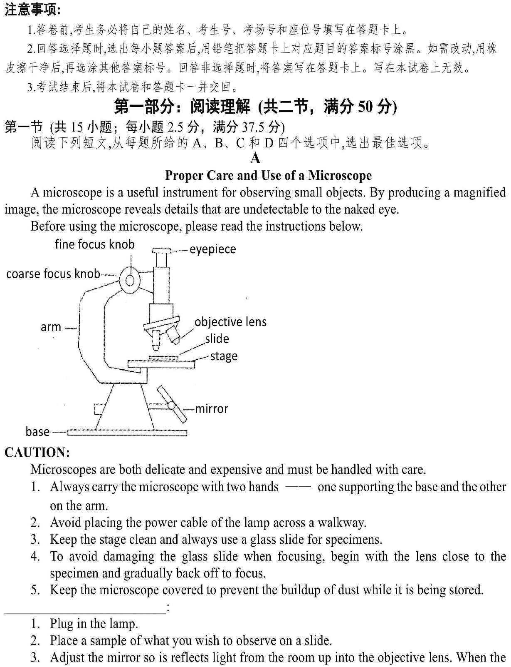

**CAUTION:**

Microscopes are both delicate and expensive and must be handled with care.

1. Always carry the microscope with two hands —— one supporting the base and the other on the arm.

2. Avoid placing the power cable of the lamp across a walkway.

3. Keep the stage clean and always use a glass slide for specimens.

4. To avoid damaging the glass slide when focusing, begin with the lens close to the specimen and gradually back off to focus.

5. Keep the microscope covered to prevent the buildup of dust while it is being stored.

_________________________:

1. Plug in the lamp.

2. Place a sample of what you wish to observe on a slide.

3. Adjust the mirror so is reflects light from the room up into the objective lens. When the mirror is

correctly adjusted, a complete circle of light will turn up when you look through the eyepiece.

4. Place your slide with the specimen directly over the center of the glass circle on the stage. If it is a wet slide, be sure the bottom of the slide is dry.

5. With the LOW POWER objective lens placed over the slide, use the coarse focus knob to lower the lens to the lowest point.

6. Look through the eyepiece with one eye while closing the other eye. Slowly raise the lens until the focus is relatively clear.

7. Use the fine focus knob to fine-tune the focus.

8. Without changing the focus knobs, switch to the HIGH POWER objective lens. Once you have switched to HIGH POWER, use only the fine focus knob to make the image sharper.

**21. Which of the following pictures of carrying a microscope is right?**

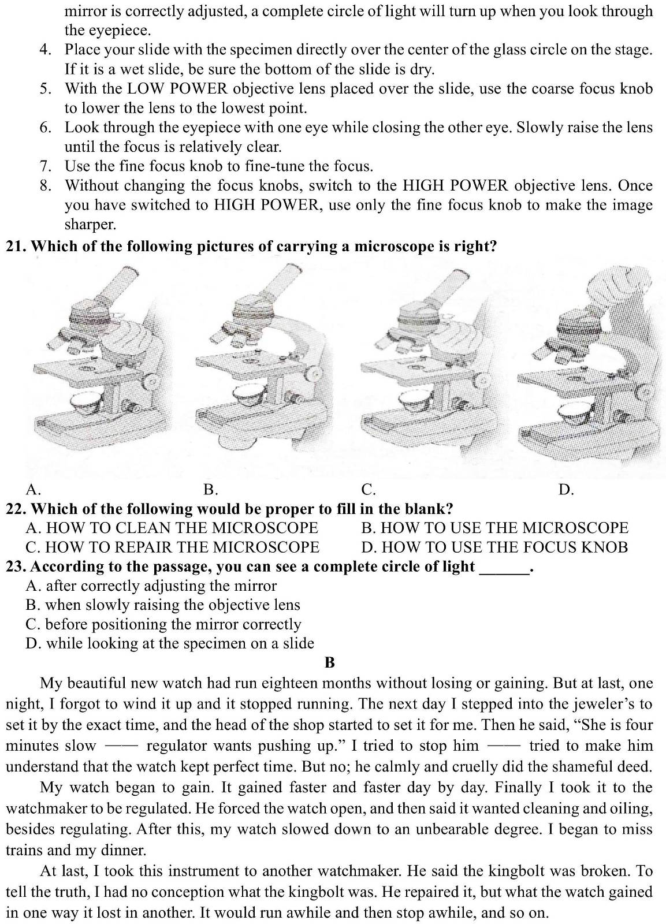

A. B. C. D.

**22. Which of the following would be proper to fill in the blank?**

A. HOW TO CLEAN THE MICROSCOPE B. HOW TO USE THE MICROSCOPE

C. HOW TO REPAIR THE MICROSCOPE D. HOW TO USE THE FOCUS KNOB

**23. According to the passage, you can see a complete circle of light ______.**

A. after correctly adjusting the mirror

B. when slowly raising the objective lens

C. before positioning the mirror correctly

D. while looking at the specimen on a slide

**B**

My beautiful new watch had run eighteen months without losing or gaining. But at last, one night, I forgot to wind it up and it stopped running. The next day I stepped into the jeweler’s to set it by the exact time, and the head of the shop started to set it for me. Then he said, “She is four minutes slow —— regulator wants pushing up.” I tried to stop him —— tried to make him understand that the watch kept perfect time. But no; he calmly and cruelly did the shameful deed.

My watch began to gain. It gained faster and faster day by day. Finally I took it to the watchmaker to be regulated. He forced the watch open, and then said it wanted cleaning and oiling, besides regulating. After this, my watch slowed down to an unbearable degree. I began to miss trains and my dinner.

At last, I took this instrument to another watchmaker. He said the kingbolt was broken. To tell the truth, I had no conception what the kingbolt was. He repaired it, but what the watch gained in one way it lost in another. It would run awhile and then stop awhile, and so on.

So I went with a heavy heart to one more watchmaker. While I waited and looked around I presently recognized in this watchmaker an old acquaintance —— a steamboat engineer of older days, and not a good engineer, either.

“She makes too much steam and …” he said.

I gave him a heavy blow on the head and ran away.

My uncle William used to say that a good watch was a good watch until the repairers got a chance to look at it. And he used to wonder what became of all the unsuccessful repairmen, and shoemakers, and engineers, and blacksmiths, and governors, and school-principals; but nobody could ever tell him.

**24. What did the author say about the jeweler?**

A. He made a mistake. B. He had a quick mind.

C. He had a hearing problem. D. He was a quiet repairman.

**25. After being cleaned, oiled and regulated, how was the author’s watch?**

A. It kept perfect time. B. It gained faster and faster.

C. It was not a little slow. D. It ran awhile and stopped awhile.

**26. Why did the author hit the watchmaker on the head?**

A. He was a liar. B. He was talking nonsense.

C. He treated the watch cruelly. D. He was an old enemy of the author.

**27. What did the author learn from his experience?**

A. Never get a watch repaired.

B. He should listen to his uncle.

C. Repair work was a complicated job.

D. Unsuccessful people exist in all walks of life.

**C**

The elusive profound mystery of happiness could be as simple as remembering the good times and forgetting the regrets, a new university study reported yesterday. For people who look at the past through rose-tinted glasses are happier than those who focus on negative past experience and regrets, according to a new study published in the journal *Personality and Individual Differences*.

The study is conducive to the explanation of why personality has such a strong influence on a person’s happiness. The findings suggest that people with certain personality traits are happier than others because of the way they think about their past, present and future. The study examined how people’s ratings on the “Big Five” personality traits relate to their approach to time and life satisfaction.

The “Big Five” model assesses how extroverted, open, responsible, agreeable, and neurotic a person is, and rates individuals as high or low on each personality trait rather than assigning them a personality type. “We found that the first four kind of people are happier with their lives because they tend to hold a bright view of the past and are less likely to have negative thoughts and regrets. People high on the neurotic scale essentially have the exact opposite view of the past and are less happier as a result,” said Ryan Howell, assistant professor of psychology at San Francisco State University, who authored the study with SF State College senior Jiawei Zhang. “This is good news because though it may be difficult to change your personality, you may be able to change your view of time and boost your happiness,” Howell said.

The authors suggest that enjoying happy memories or reframing painful past experience in a positive light could be effective ways for individuals to increase their life satisfaction.

“Personality traits influence how people look at the past, present and future and it is these different perspectives on time that drive a person’s happiness,” Howell added.

**28. The underlined phrase “through rose-tinted glasses” in Para. 1 probably means “______”.**

A. in a neurotic way B. in a pessimistic way

C. in an optimistic way D. in a disappointing way

**29. According to the passage, ______ may well improve your happiness.**

A. forgetting memories B. changing your personality

C. remembering painful past experience D. viewing painful past memories positively

**30. What kind of people are likely to be unhappier?**

A. Highly extraverted. B. Very agreeable.

C. Rather neurotic. D. Quite open.

**31. What is the best title for the passage?**

A. Personality Traits B. Secret of Happiness

C. Past Experience Leads to Unhappiness D. Never Let Regrets Affect Your Happiness

**D**

Integrity is the quality of being honest and strong about what you believe to be right. The concept of integrity has played a key role in moral philosophy throughout history and is promoted in all societies because of its importance to social relations. Individual integrity is vital to society, one that enables people to make use of their capacity for critical reflection, does not force people to take up particular roles and does not encourage individuals to betray each other. Besides, societies can be favorable to the development of individual integrity.

Individual integrity can lift up the spirits of the entire society. It can shape the lives of people living in a particular society, the lives of all fellow people and, in its broadest sense, even the destiny of a nation. By contrast, if those living in the society are corrupt, it could have bad effects, jeopardizing the healthy morality of the society.

On the other hand, a society can be favorable to the development of individual integrity. Society expects and requires integrity. A society consisting of people of integrity, and people who never compromise on their principles, could have a positive mark on the personal development on its members. Being a part of such a morally lively community could serve as a basis for absorbing traits of good character. This could be of a distinct advantage to any individuals in the society.

Nonetheless, some social structures are of the wrong sort for some individuals to pursue integrity. If that is the case, we have to ask questions about the moral nature of society first before raising questions about individual integrity. Questions about integrity may turn out to be about what kind of society it is, rather than about the relationship between individual interests and characteristics of a society. The pursuit of adequate individual integrity often depends, not so much on understanding who one is and what one believes and is committed to, but rather understanding what one’s society is and imagining what it could be.

Under no circumstances can we underestimate the importance of human integrity in a society. People, who are honest, trustworthy, compassionate and caring, are the factors decisive in the growth of individuals as well as the development of a society.

**32. Individual integrity has been valued in society because ______.**

A. it helps develop philosophy B. it is crucial to social relations

C. it is the basis of critical thinking D. it ensures people’s particular roles

**33. The underlined word “jeopardizing” in Paragraph 2 probably means “______”.**

A. strengthening B. assessing C. influencing D. destroying

**34. What does the author believe according to the passage?**

A. Individual integrity relies on what one has faith in.

B. The pursuit of individual integrity changes with time.

C. The nature of society is decided by economic development.

D. Social structures guide the formation of individual integrity.

**35. Which of the following shows the development of ideas in the passage?**

CP: Central Point P: Point Sp: Sub-point C: Conclusion

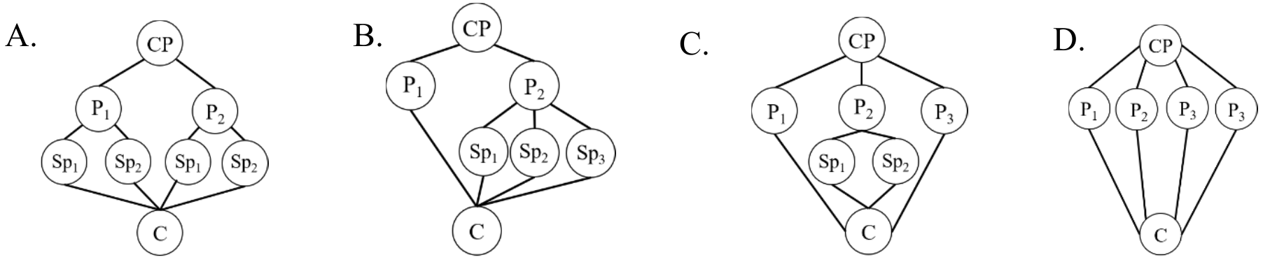

**第二节 (共 5 小题；每小题 2 分，满分 12.5 分)**

根据短文内容，从短文后的选项中选出能填入空白处的最佳选项。选项中有两项为多余选项。

**Four Body Language Tips for Success**

Have you ever been drawn to someone who looks confident and successful at work? There’s something about them —— that “it” factor you can’t quite pinpoint. 36 Here are five specific techniques to set up for ongoing success, especially in the workplace.

✓ 37

You’ve heard how dogs pick up on sounds that the human ear can’t hear. Well, it turns out we pick up on certain tones too, human to human. Simply put, lower, richer tones are more pleasing to us than higher, thin ones.

**✓ Take on a Powerful Pose.**

Research by social psychologist Amy Cuddy shows that standing or sitting a certain way triggers immediate changes in your body chemistry. 38 Besides, it can influence how others respond to you.

**✓ Make Eye Contact, But Not Too Much.**

There is such a thing as too much eye contact. You don’t want to be rude, but you also want to look like you care. Always make sure to use more eye contact when you are listening than I when you are speaking.

**✓ Use Your Hands to Improve Speech.**

If you want to get your point across more effectively, try incorporating some hand gestures while you speak. 39 Speech-associated gestures have been approved to help listeners stay focused and attentive.

Now you can be the person appearing more successful in and out of the boardroom. Remember —— it’s not always what you say verbally that activates your listeners. 40 .

A. Lower Tones Matter.

B. Mind Your Vocal Tone.

C. This can make you appear more confident.

D. It is time for your body to do some of the talking.

E. Using hand gestures is always a great way to appeal to your listeners.

F. Body language is a primary factor in making a strong first impression.

G. Not only will they make yourself understood, they also keep the listeners engaged.

**第二部分：英语知识运用 (共两节, 满分45分)**

**第一节 完形填空 (共 15 小题；每小题 1 分，满分 15 分)**

阅读下面短文，从各题所给的四个选项(A、B、C 和 D)中，选出可以填入空白处的最佳选项。

Do you listen? Do you really listen? Is there more to listening than just hearing?

Listening is, by far, one of the most important aspects of communication. So often, you pay attention to your way of speaking, your 41 , your dialect, but neglect your ability to listen.

It is my 42 that people scream out or change the intended purposes of much of what they hear. Too often, we consider listening the 43 part of conversation, although it requires our focus, purpose, and active participation.

Listening means to give ear to, to pay attention to, to 44 , to witness, to hear with thoughtful 45 , or to understand.

The most basic of all human needs is the need to understand and to be understood. The only way to understand is to 46 .

Learn to be an active listener. Give off positive body language. 47 a willingness to socialize. Ask the right questions. Boost your 48 so that you can understand more and achieve effective listening.

Listening means we should respond, that we should be touched, that what we hear has a(n) 49 on us. I believe that history 50 itself only because no one listens the first time.

You were given two ears, but only one mouth, which is a gentle hint that we should listen more, because God knew that listening was twice as 51 as talking. Listening is the key building block in effective communications. Good listening skills are crucial, as listening is the fundamental 52 of all information.

Isn’t now the time to give the gift of listening to those about you? Given them your 53 attention. Use your God given 54 to become a better listener. For me, I’m going to put into 55 what I believe in my heart and become a better listener.

41. A. sounds B. words C. gestures D. movements

42. A. conception B. plan C. purpose D. requirement

43. A. active B. passive C. basic D. useless

44. A. argue B. quarrel C. discuss D. obey

45. A. advice B. attention C. love D. help

46. A. ask B. learn C. try D. listen

47. A. Send B. Present C. Predict D. Design

48. A. courage B. confidence C. energy D. knowledge

49. A. impact B. connection C. emotion D. difference

50. A. makes B. fails C. repeats D. destroys

51. A. interesting B. hard C. much D. long

52. A. resource B. material C. source D. element

53. A. considerate B. wide C. extra D. entire

54. A. information B. talents C. messages D. ideas

55. A. effect B. position C. practice D. service

**第二节 语法填空 (共 10 小题；每小题 1.5 分，满分 15 分)**

阅读下面短文，在空白处填入 1 个适当的单词或括号内单词的正确形式。

In the 1950s, a family that owned a farm near Beulah, Michigan kept a bull chained to an elm (榆树). The bull paced **[56]** ______________ the tree, dragging the heavy iron chain, **[57]**______________ led to a groove (槽) in the bark (树皮). The groove **[58]** ______________ (deep)over the years. However, for whatever reason, it just did not kill the tree.

After some years, the family took their bull away. They cut the chain, leaving the loop around the tree and one link **[59]** ______________ (hang) down.

Then one year, one of the most historically serious agricultural **[60]** ______________(catastrophe) struck Michigan in the form of Dutch elm disease. All of the elms lining the road leading to the farm became withered and died due to the **[61]** ______________ (infect) disease, which made people panic as well. Everyone thought that the old elm would be the next. The farm owner considered going the safe thing: pulling it out and chopping it up into firewood before it died.

**[62]** ______________ (amaze), the tree did not die. Nobody could understand why **[63]**______________ was the only elm still standing in the county. It is said that **[64]** ______________

doesn’t kill you will make you **[65]** ______________ (strong). Or, as a plant pathologists (病理学家) put it, “Life breaks us all, but afterwards, many of us are strongest at the broken places.”

**第三部分 写作 ( 共两节, 满分 40 分)**

**第一节 应用文写作 (满分 15 分)**

假定你是李华，春节前夕，你校举行了 2022 年北京冬季奥运会倒计时十天庆祝活动。请你为校英文报写一篇报道，内容包括：

1、时间、地点、参加人员；

2、活动内容；

3、活动意义。

✵ ★**注意:** 1. 词数 80 左右；

2. 可以适当增加细节，以使行文连贯；

3. 标题已经为你写好，不计入总词数。

★参考词汇: 水上运动中心 aquatic sports center

*The Ten-day Countdown Ceremony of the Beijing 2022 Olympic Winter Games*

______________________________________________________________________________________________________________________________________________________________________________________________________________________________________________________________________________________________________________________________________________________________________________________________________________________________________________

**第二节 读后续写 (满分 25 分)**

阅读下面材料，根据其内容和所给段落开头语续写两段，使之构成一篇完整的短文。

On a bright, warm July afternoon, Mac Hollan, a primary school teacher, was cycling from his home to Alaska with his friends. One of his friends had stopped to make a bicycle repair, but they had encouraged Mac to carry on, and they would catch up with him soon. As Mac pedaled (骑行) along alone, he thought fondly of his wife and two young daughters at home. He hoped to show them this beautiful place someday.

Then Mac heard quick and loud breathing behind him. “Man, that’s a big dog!” he thought. But when he looked to the side, he saw instantly that it wasn’t a dog at all, but a wolf, quickly catching up with him.

Mac’s heart jumped. He found out his can of hear spray. With one hand on the bars, he fired the spray at the wolf. A bright red cloud enveloped the animal, and to Mac’s relief, it fell back, shaking its head. But a minute later, it was by his side again. Then it attacked the back of Mac’s bike, tearing open his tent hag. He fired at the wolf a second time, and again, it fell back only to quickly restart the chase (追赶).

Mac was pedaling hard now. He waved and yelled at passing cars but was careful not to show down. He was a steep uphill climb before him. He knew that once he hit the hill, he’d be easily caught up and the wolf’s teeth would be tearing into his flesh.

At this moment, Paul and Beeky were driving their car on their way to Alaska. They didn’t think much of it when they saw two cyclists repairing their bike on the side of the road. A bit later, they spotted what they, too, assumed was a dog running alongside a man on a bike. As they got closer, they realized that the dog was a wolf. Mac heard a large vehicle behind him. He pulled in front of it as the wolf was catching up fast, just a dozen yards away now.

★注意: 1. 续写词数应为 150 左右；

2. 开头已给出。

Paragraph.1

*The car abruptly stopped in front of him*. ________________________________________________

______________________________________________________________________________________

______________________________________________________________________________________

______________________________________________________________________________________

Paragraph.2

*A few minutes later, the other two cyclists arrived*.

______________________________________________________________________________________

______________________________________________________________________________________

______________________________________________________________________________________

**英语参考答案**

**阅读理解 (每小题2.5 分，满分50分)**

21～35 CBA ACBA CDCB BDDA 36~40 FBCGD

**完形填空 (共15小题；每小题1分，满分15分)**

41～45 BABDB 46～50 DBDAC 51～55 BCDBC

**语法填空 (共10小题；每小题1.5 分，满分15分)**

56. around 57. which 58. was deepened 59. hanging 60. catastrophes

61. infectious 62. Amazingly 63. it 64. what 65. stronger

**书面表达 (共两节，满分40分) *Possible Version*:**

**第一节 应用文写作 ( 满分15分)**

*The Ten-day Countdown Ceremony of the Beijing 2022 Olympic Winter Games*

The ten-day countdown ceremony of the Beijing 2022 Olympic Winter Games was held in our

school aquatic sports center before this Spring Festival.

The ceremony started with series of energetic shows presented by the students from different school

clubs. Still, what impressed everyone most was the performances of martial arts and Tai Chi boxing on

the ice, which amazingly symbolized such a traditional sports conception in Chinese culture that they

caused a sensation among the foreign friends on the spot.

After its conclusion, this ceremony was well received since it not only celebrates our country’s

hosting the Olympic Winter Games but also helps promote the ice-sports games among the students,

fostering our friendship with other friends from different nations.

**第二节 读后续写 ( 满分 25 分)**

***The car abruptly stopped in front of him***. Mac jumped off his bicycle and dashed for the back door of the car. It was locked. He then ran around to the passenger door, but it was locked, as well, so he began to climb through the open window. When spotting this, Paul quickly unlocked the door, and the frightened man dived in, slamming the door behind him. Paul looked out the back window and saw the wolf standing over Mac’s bike as if it were a kill. Shortly after, the animal ran off.

***A few minutes later, the other two cyclists arrived.*** Mac emerged from the car and hugged his friends. “I thought I was going to die,” Mac cried to them. Mac retrieved (取回) his bicycle, and the three men resumed (继续) their road trip, agreeing to keep in one another’s sight line. A few miles down the road, Mac pulled over and burst into tears. “The rest of the trip was amazing, but I had to let the former emotion out.”