A Teaching Plan for Workbook
Reading and Writing: Xu Xiake’s Guilin
by Chen Simin from Yuhang High School

Lesson Type: Reading & Thinking
- Teaching objectives:
After this class, the students will be able to
- learn about author’s unique travel experience in Guilin and the striking sceneries of mountain and water and how does the author write about his/her experience.
- use learned expressions to recommend Guilin to friends
- understand the meaning of the title after learning the passage
- Teaching Focus and Difficulties
- use learned expressions to recommend Guilin to friends
- understand the meaning of the title after learning the passage
- Teaching Procedures
Procedures | Students’ Activities | Aims
Leading-in | - Before reading  - Watch and answer  — What impresses you the most in the video?  - Share your ideas  - There is a famous Chinese saying about Guilin. What is it? How to say it in English?  - Look and predict  — What do you want to learn from the text?  Who is Xu Xiake?  What are the sceneries of Guilin?  Why did Xu Xiake visit Guilin? | To introduce the topic and activate students’ knowledge about studying abroad.  To practice students’ ability to view the title and pictures and make a prediction
Listening | - While reading  - Task 1: read for information in para. 1  — Find the answers to those questions you are curious about.  — What other information can you get from para.1?  - Task 2: read for reason  — Why does the author follow the footstep of Xu to visit Guilin? Please read the rest of the passage to find out the reason.  - Task 3: read for expressions  — 1. What new things does the author discover?  — 2. What does the author do to explore?  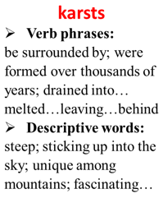  How does the author write about it?  - Task 4: independent reading  - Read para.3-7 and find the answers to the two questions above. Finish the mind map.  - Share mind map with the rest of the class  - Make a summary  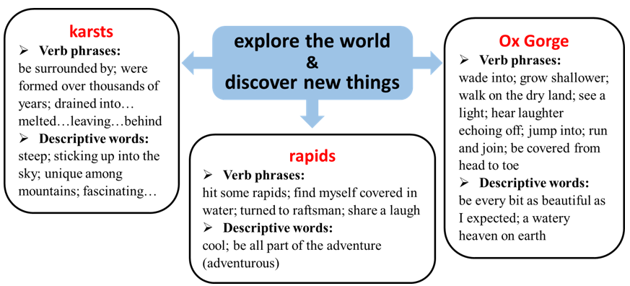 | To practice scanning for required information and answer some questions from prediction.  To practice figuring out key information from the text.  To practice scanning for relevant information to the topic  To identify the expressions indicating exploring the world and discovering new things.  To identify the expressions indicating exploring the world and discovering new things by students their own.
Talking | - After reading  Group work: Critical thinking  1. Focus on the ending. Do you also think Xu Xiake jumped in the pool and examine the mud?  2. Why does the author use the title? | To understand the rest of the passage and dig into the topic.
Homework | - Write a letter of recommendation to a friend  - Recommend Guilin to a friend using the expressions learned today  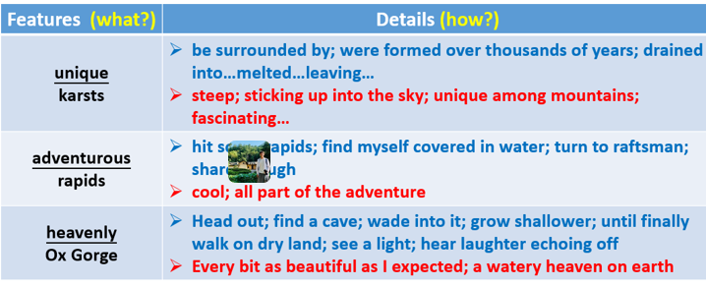 | To apply the expressions learned today to writing a letter of recommendation.

