文本特征：
本文分为背景介绍和日记两部分。
全文以Anne’s Best Friend为标题，在背景知识中介绍了Who is Anne, What is Anne’s friend?/How do they become friends?/Why is it her best friend?
在日记部分中，文本展现了Anne在躲进阁楼2年后，以日记为挚友，倾诉她对大自然的渴望。日记部分以第一段中的I’ve grown so crazy about everything to do with nature.为主旨句，分别用两个例子来证明Anne对大自然的狂热。文章的结构和写作手法（give examples和make contrasts）也由此呼之欲出。

教学步骤：
Step 1 Warming up
Free-talk: 1. Who/What is your friend?
- How do you become friends?
- Why do we need friends?
设计意图：通过who/what,how和why这三个问题设置主题语境，激活学生的思维和语言，让他们分享自己的交友经历，从而引入话题。

Step 2 Pre-reading
Prediction: What do you want to know after reading the title?
- Who is Anne?
- What is her friend?
- How did they become friends?
- Why is it her best friend?
设计意图：在热身讨论的基础上，通过解读标题对文本内容进行预测，促使学生围绕主题进行思考，以期在阅读过程中，不断开展与文本以及与文本作者本身的沟通，将预测信息和读后信息做对比和修正，增强阅读活动的自主性和目的性。

Step 3 Reading
- Background Information
- Read Paragraph 1 and find out: What is Anne's friend?
How did they become friends?
- Read Paragraph 2 and find out: Who is Anne?
Why is it(Kitty) her best friend?
设计意图：根据预测的问题进行有目的的阅读，锻炼学生快速捕捉、提取取信息的能力。在这一环节中，教师适当加入一些背景知识的讲解，如二战时期犹太人所遭受的悲惨境遇和Anne一家所避难时所住的环境，以帮助学生更好地理解Anne的心境以及她选择一本日记做挚友的原因。

- Anne’s story
- Find the sentence showing the main idea of the text.
I wonder if it’s because I haven’t been able to be outdoors for so long that I’ve grown so crazy about everything to do with nature.
设计意图：通过主旨句的检索，帮助学生抓住文本的主要内容和核心思想。

- How would Anne explain her craziness about nature?
- By giving examples B. By listing numbers
- By contrasting D. By analyzing the cause and effect
设计意图：先预测作者的写作手法，了解观点类文章的组织结构。

- How many examples are there in the passage?
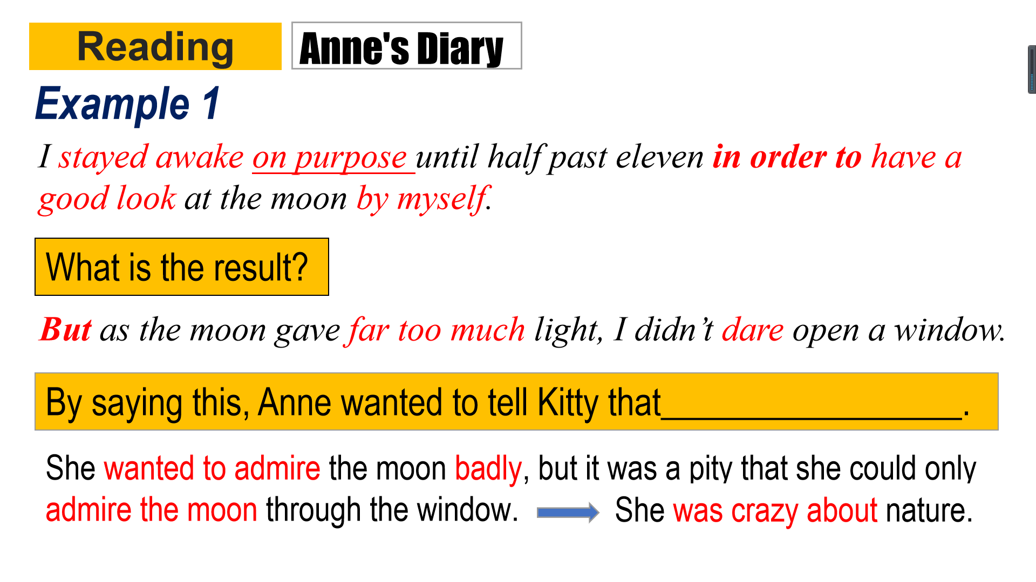
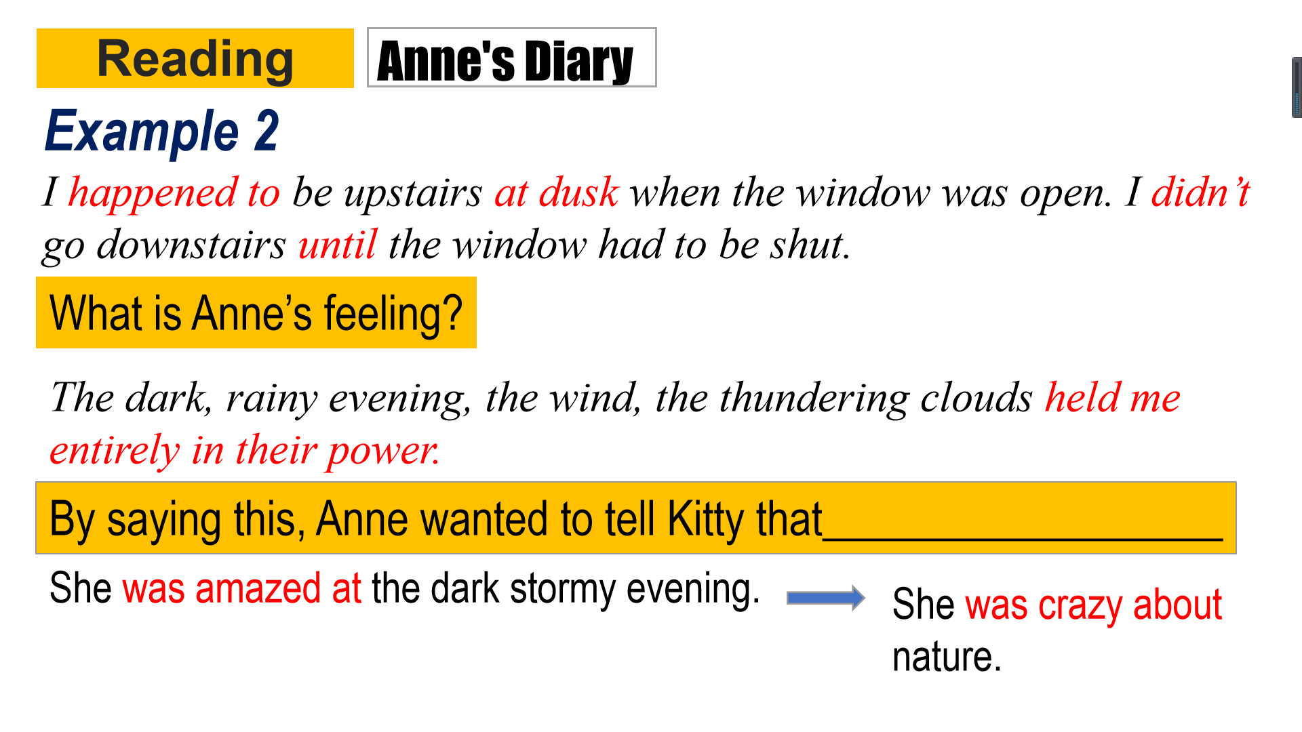
设计意图：通过阅读找出支撑主旨句（核心观点）的两个事例，一方面提升了学生的信息检索能力，另一方面也是对前一环节中猜测的验证，有助于学生自然习得观点类文章的写作手法。

- Checking: How did Anne explain her craziness about nature?
A. By giving examples B. By listing numbers C. By contrasting
D. By analyzing the cause and effect
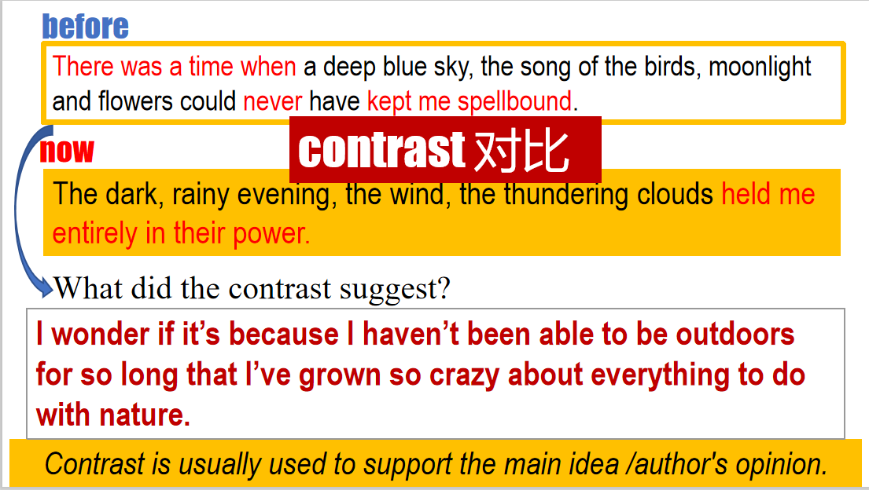
设计意图：
- 再次探讨除了举例子，作者的其他写作手法，从而激发学生的阅读兴趣，使得“再次阅读”成为一种自发性、目的性的活动。
- 通过阅读找出作者的写作手法，并归纳这种手法的作用，有助于学生再次自然习得观点类文章的写作手法。

- Thinking: Why did Anne became so crazy about everything to do with nature?
direct reason?
indirect reason?
Does the last paragraph also talk about her craziness about nature?
I am only able to look at nature through dirty curtains hanging before dusty windows. It’s no pleasure looking through these any longer because nature is one thing that really must be experienced. She was looking forward to seeing nature and experiencing it. She was not only crazy about everything to do with nature.
What she really wanted badly was freedom and peace.
设计意图：探讨和挖掘作者的写作意图，即Anne心中真正想要表达的诉求是什么？表面上是她对大自然的向往和热爱，实质上是她对自由与和平的渴望与追求。由表及里，将文本的理解推向深入。

Step 4 Thinking
Can you draw a mind map of the letter?
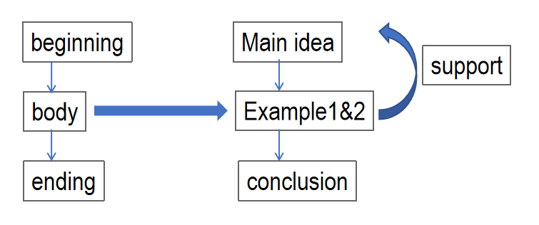
设计意图：归纳总结日记的结构和内容，再次回顾观点类文章的写作手法。

Step 5 Sharing
Walking with a friend in the dark is better than walking alone in the light. --Helen Keller
- Do you agree with Helen Keller?
- Can you give an example to support Helen's words?
eg: In the dark, lonely and depressive hiding days, Kitty was the only one Anne could confided to. By recording her thoughts, desires and expectations, Kitty helped divided Anne's grief and doubled her joy.
设计意图：通过探讨Helen Keller关于友谊的名言，一方面可以帮助学生深化理解Anne和日记本Kitty之间的友谊，另一方面也可以回归和深化对主题语境的理解，从而彰显阅读对思维品质提升的积极效应。

