基于主题意义的应用文写作

---.温二模应用文分析

梁李敏

2021.11温二模应用文写作

假定你是李华, 你已经完成国外某大学的网络课程学习。请你给该课程负责人写一封关于课程学习反馈的邮件, 内容包括：1、你的评价;2、你的建议。注意∶

1. 词数 80 左右; 2、可适当增加细节，以使行文连贯。

一． **审题---本文主题关于___________**

应用文审题

1.审

2.审

3.审

4.审

5.审

6.审

二． **框架**

para 1：

para 2：

para 3：

三．段落分析

**para 1：**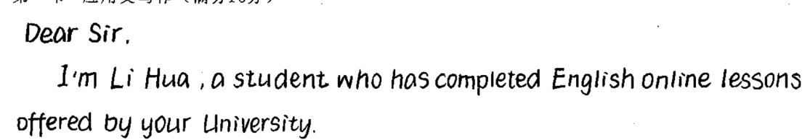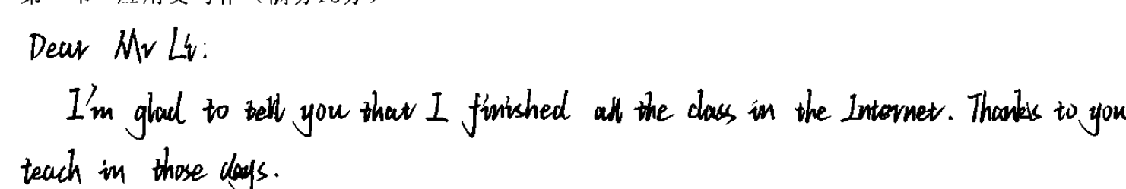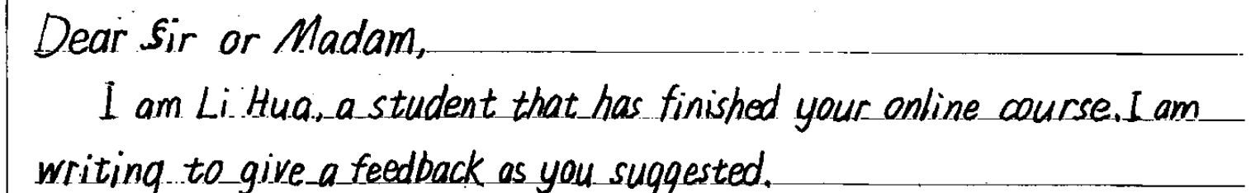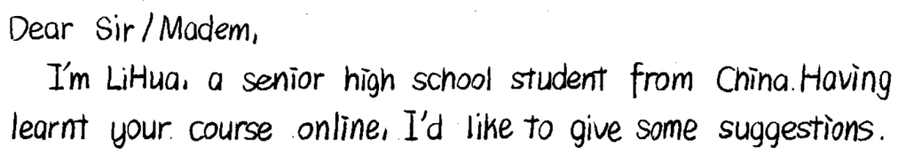

◆ **Tip l:**

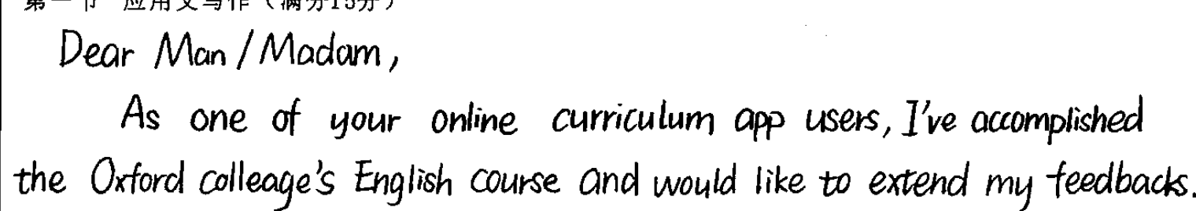

练习：(2018.11 浙江)假定你是李华，乘坐FL753航班抵达伦教后发现钱包遗失。请给航空公司写一封邮件说明情况并寻求帮助。内容包括：1.行程信息；2.钱包特征;3.如果找到请联系。注意：1.词数 80 左右；2.可适当增加细节, 以使行文连贯。

Dear Sir / Madam,

I’m writing to seek your generous help in finding my wallet which was lost when I arrived in London.

**para 2：**

**details**

◆ **Tip2:**

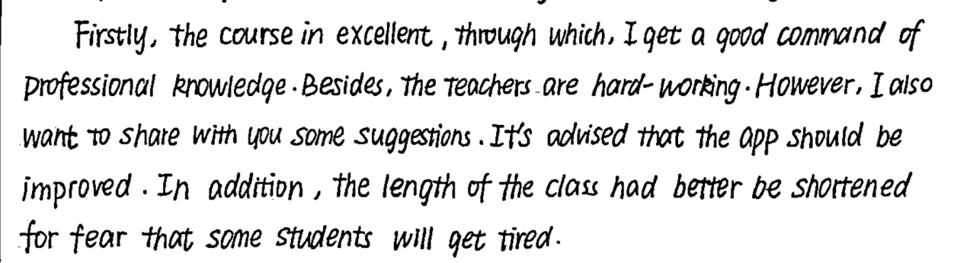

|  |  |  |  |
| --- | --- | --- | --- |
| 写作目标 | 1 | 2 | 3 |
| 结构合理（comment+advice） |  |  |  |
| 内容要点的展开是否与主题紧密相连 |  |  |  |
| 语言得体，注重交际性 |  |  |  |
| 恰当的衔接词 |  |  |  |
| 高级词汇(if any, underline them) |  |  |  |
| 丰富句式(if any, underline them) |  |  |  |

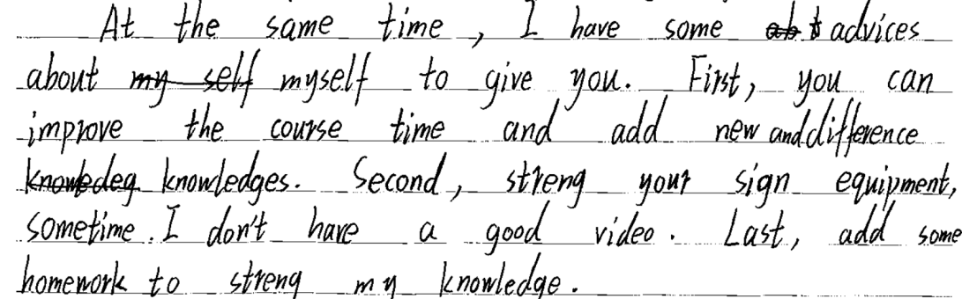

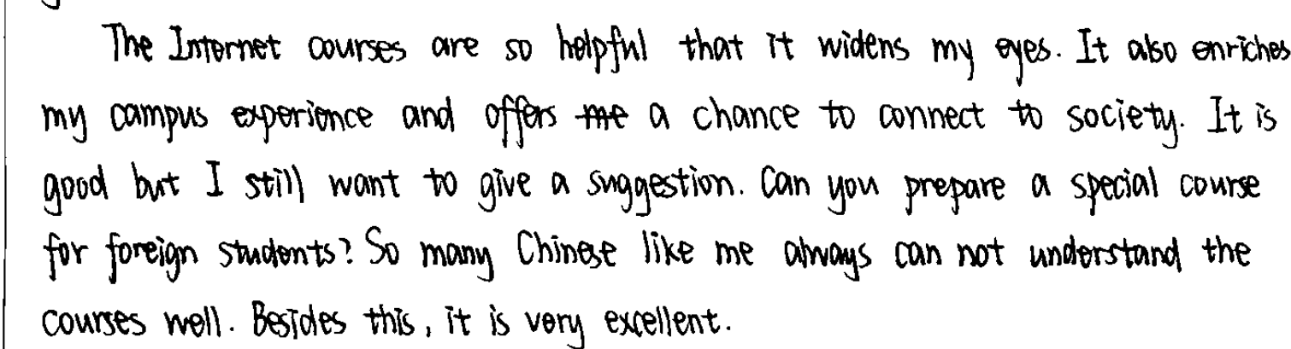

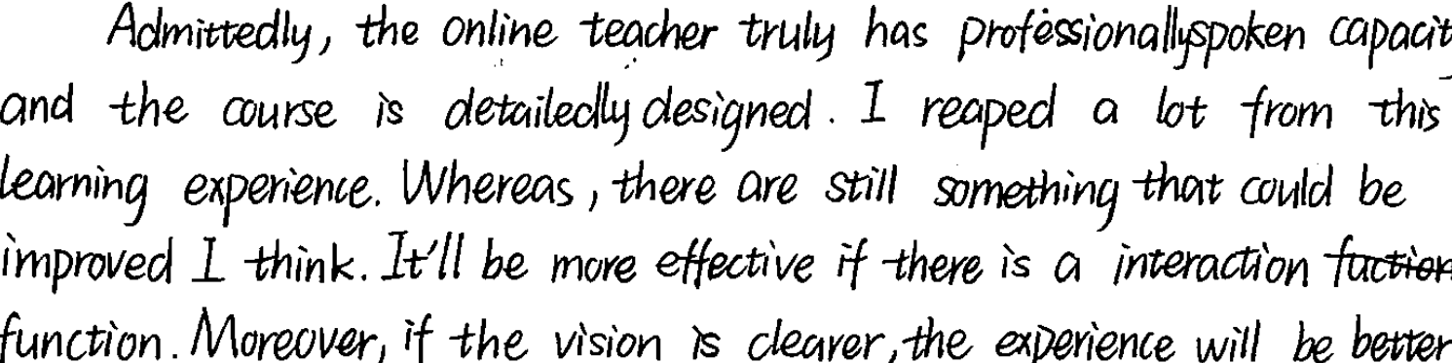

**para 3：**

**Which one do you think is the best ending? Why?**

1.Looking forward to your prompt reply.

2. Should you take my recommendations into account and I will be more than delighted to hear that.

3. Hoping that your online courses will be more excellent and practical sooner.

4. Hoping your course will be better and better in assisting more students.

5. Thank you for these awesome courses. Looking forward to a better set of curriculums next year!

6. I would appreciate it if you could listen to me.

◆ **Tip3:**

练习：(2020年12月嘉兴测试卷）假定你是李华，你的英国朋友Allen邀请你去参观一个画展，你有事不能前往。请给他写一封邮件，内容包括：

1、感谢邀请； 2、表达歉意； 3、说明理由

Dear Allen,

Thanks for your invitation to the Art Show this Sunday. I'd love to go with you, but much to my regret, I'm not able to make it.

Occupied with masses of homework, I have to devote myself exclusively to it. More importantly, I am supposed to get myself well furnished for the English speech contest to be held next Monday, because of which I can't spare any time.

________________________________________________________ Yours,

Li Hua

**四．Appreciation**

Dear Sir/Madam,

I'd like to express my deep thanks and appreciation for all the efforts that you've exerted in preparing and presenting English Public Speaking Course online.

The course is extremely informative and useful as a source of learning for me. The instructor is humorous, making his lessons clear and easy to follow, which not only boosted my English-speaking skills but also built my confidence. If you could arrange flexible learning schedule, like providing more weekend classes or playback channels, I'd definitely benefit more.

Looking forward to attending your next course.

Yours,

Li Hua

**五．Homework: Rewriting**

____________________________________________________________________________________________________________________________________________________________________________________________________________________________________________________________________________________________________________________________________________________

____________________________________________________________________________________________________________________________________________________________________________________________________________________________________________________________________________________________________________________________________________________

**不忘初心，牢记主题！！！**