缅怀翻译泰斗许渊冲：“诗译英法唯一人”

**Topic**：Introduction to Persons：Xu Yuanchong.

**Teaching objectives:**

1. Xu’s life introduction

2. The translation theories

3. The major works and appreciation

4. The comments from others

5. The effect on us

**Teaching focus:**

1. Xu’s life introduction

2. The translation theories

3. The major works and appreciation

**Teaching dicitulties:**

The translation theories

**Teaching process:**

**Step 1. Warming up**

1. **Lead in---** Play a game: Who is he?

This class, I’ll introduce a special person to you. According to the three clues, can you guess who he is ?

Clue 1: He has been proclaimed as the only expert in the world who can translate Chinese poetry into English and French rhyme.

Clue 2: He is not an academician but better than academicians.

Clue 3: The mad translation genius is confident or conceited?

1. **While-teaching**
2. Xu’s life introduction

1921年, born in Jiangxi province of China.

1938年，admitted to the National Southwest Associated University, Department of Foreign

Languages.

1943年，graduated from the National Southwest Associated University, Department of Foreign Languages.

1944年，got into the Institute of Tsinghua University, and after that he studied in Europe.

1948年，studied in France.

1983年，entered Peking University and served as a professor in Foreign Studies University, Institute of International Relations, School of Journalism.

1991年，entered Peking University and served as a professor in Foreign Studies University, Institute of International Relations, School of Journalism.

**His honours**

1. In 1999, he was nominated for the Nobel Prize in literature.
2. In 2010, he was awarded "translation culture life achievement award".
3. In 2014，"Aurora Borealis" outstanding literary translation Award.

Can you design a personal file for Xu’s life introduction?

Personal file

Photo：

Name：

Birthdate：

Nationality：

Characteristic：

Favorite thing to do：

Person admired in his life：

Motto：

2． The translation theories

许渊冲的“三论”

三美论: Beauty in sense “意美” Beauty in sound “音美” Beauty in form “形美”

三化论: Aufhellung“浅化” Equaliation“等化” Deepening“深化”

三之论: “知之” “好之” “乐之”

优化论: 优化论认为文学译文应该用最好的译语表达方式。

三势论: 两种文字对等叫均势，如果不等，那么一种就有优势，另一种就有劣势。翻译时尽可能做到发挥译语优势，改变劣势，争取均势。

三似论: “形似” “意似” “神似”

详解“三美论”

Beauty in sense “意美” 是作者的思想感情与实际景物相融合的产物，是诗之灵魂，翻译时要保留原诗的韵味及传递其诗歌背后的意义。

旨在“感心”：保留诗魂，再现意象。

【原诗】床前明月光，疑是地上霜。

【译文】Before my bed a pool of light,

Can it be frost on the ground?

【注解】这里把月光比作“a pool”，说明月光的明亮，意境美妙。

Beauty in sound “音美” 要留原诗的神韵，使译文押韵、有节奏且好听。

旨在“感耳”：韵式灵活，琅琅上口。

【原诗】床前明月光，疑是地上霜。

【译文】Before my bed a pool of light,

Can it be frost on the ground?

【注解】这里把月光比作“a pool”，说明月光的明亮，意境美妙。

Beauty in form “形美” 即翻译的诗歌在句子长短和对仗工整等方面要尽可能与原诗歌形式保持一致或相似，而且行数相同，分节相当。

旨在“感目”：长短相当，对仗工整。

【原诗】大漠沙如雪，燕山月似钩。

【译文】The desert sand looks white as snow;

The crescent moon hangs like a bow.

【注解】“钩”用“bow”来翻译才能和“snow”押韵。

许渊冲翻译“三民主义”

1941年，美国飞虎队来昆明帮助中国抗日，许渊冲为其担任翻译。招待宴会上，美方

想理解孙中山提出的 “三民主义”到底是什么意思。可在场官员的翻译实在是让他们摸不着头脑。这时许渊冲站了出来，他引用了林肯的话，让美方感受到中国语言是“简洁中带着深刻”。

of the people, by the people, for the people.

民有，民治，民享

相比直白机械的翻译，许渊冲可以将中国文化的美感和内涵，用外文表达得淋漓尽

致。甚至某种程度上，打破了中文世界和欧美国家的精神隔阂。

许渊冲和妻子

许渊冲的妻子照君，是一名俄罗斯语教师。两人在同学舞会上相遇，随后便开启了相遇

相知、相濡以沫的人生旅程。

Love once begun，will never end.

情不知所起，一往而深。

诠释了许渊冲对妻子的爱，爱一人，择一事，终一生。这个和时间赛跑的老人，虽然在

生命的最后时刻开始与孤独为伴。但他依旧相信妻子在自己身旁，恰如“情不知所起，一往

而深”的后两句。

The lovers may die for love，

In China The dead in love may revive.

生者可以死，死者可以生。

3. The major works and appreciation

从事文学翻译六十余年，许渊冲先后出版了180多本中英法文翻译著作。他将西方名著《包法利夫人》《红与黑》《李尔王》《罗密欧与朱丽叶》等译成中文，将唐诗宋词以及《诗经》《楚辞》《论语》《桃花扇》《牡丹亭》《西厢记》等翻译成英文、法文。

Why was Xu’s first translated poem “Don’t throw away”? Let’s enjoy the video.

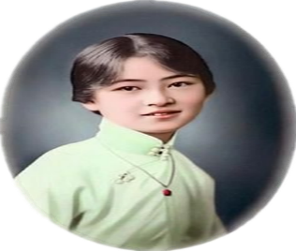

林徽因

Xu’s first poem: Don’t Cast Away

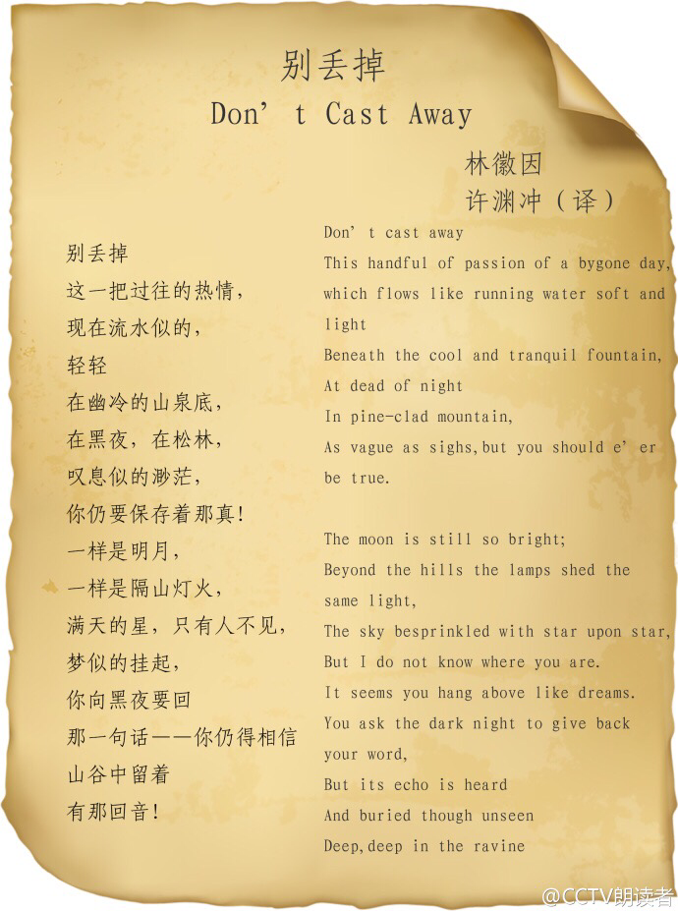

Major works：

1. The Art of Translation 《翻译的艺术》
2. Literary Translation Theories 《文学翻译谈》
3. Vanished Springs 《续忆逝水年华》

Translation Works

《中国古诗词六百首》 《汉魏六朝诗一百五十首》 《元明清诗一百五十首》

《宋词三百首》 《唐诗三百首》 《新编千家诗》

《诗经》 《西厢记》 《楚辞》

**Appreciation（1）**

《天净沙·秋思》

马致远

枯藤老树昏鸦，

小桥流水人家。

古道西风瘦马，

夕阳西下，

断肠人在天涯。

Over old trees wreathed with rotten vines fly evening crows;

Under a small bridge near a cottage a stream flows;

One ancient road in the west wind a lean horse goes.

Westward declines the sun;

Far, far from home is the heartbroken one.

**Appreciation（2）**

关雎 Cooing And Wooing

关关雎鸠, By riverside are cooing

在河之洲. A pair of turtledoves;

窈窕淑女, A good young man is wooing

君子好逑. A fair maiden he loves.

参差荇菜, Water flows left and right

左右流之. Of cress long here, short there;

窈窕淑女, The youth yearns day and night

寤寐求之. For the good maiden fair.

求之不得, His yearning grows so strong,

寤寐思服. He can not fall asleep,

悠哉悠哉， But tosses all night long,

辗转反侧. So deep in love, so deep!

参差荇菜, Now gather left and right

左右采之. Cress long or short and tender!

窈窕淑女, O lute, play music bright

琴瑟友之 .For the bride sweet and slender!

参差荇菜, Feast friends at left and right

左右芼之. On cress cooked till tender!

窈窕淑女, O bells and drums, delight

钟鼓乐之. The bride so sweet and slender!

**Appreciation of famous sentences**

1. 春风又绿江南岸。 Again the vernal wind has greened the Southern shore.
2. 两情若是久长时， If love between both sides can last for aye,

又岂在朝朝暮暮？ Why need they stay together night and day?

3．海内存知己， If you‘ve a friend who knows your heart,

天涯若比邻。 Distance cannot keep you two apart.

1. The comments from others
2. He has been proclaimed as the only expert in the world who can translate Chinese poetry into English and French rhyme. 他被评价为诗译英法唯一人。
3. He is not an academician but better than academicians. 他不是院士胜院士。
4. I have just finished reading it and marvel at the supple ease with which you dance in the clogs and fetters of rhyme and meter. 你带着音韵和节奏的镣铐跳舞，灵活自如，令人惊奇。

----- 钱钟书对许老的《毛泽东诗词》译本的褒奖

Two poems concerning Xu Yuanchong

Poem (1)

Xu, respected Translator gifted by Lord of Sky,

You walk poetic oceans, sing in sprit high.

Zeal for poems court, your melodies skyward fly,

Songs of China’s huge arenas for poets to vie.

许是天公赐译才，

渊深海阔踏歌来。

冲霄信步诗歌原，

赞我中华大擂台。

poem (2)

Xu, believing promise much easier than practice,

You take translation as meals, the daily business.

Zesting poets’ salons, your life composes a master,

Song to a studious and ever tireless translator.

许诺何难实干难，

渊源远愿译为餐。

冲茶款客诗词宴，

赞美人生不赋闲。

5. The effect on us

许老曾说：生命不是你活了多少日子，而是你记住了多少日子。你要使你过的每一天都值得记忆。为了有更多的译品，他经常向夜里偷时间来弥补白天的损失。这种精神难道不值得我们学习吗？

今天我以许老的译作王之涣的《登鹳雀楼》结束今天的课堂，希望许渊冲老先生的精神永远激励我们:生命不息，奋斗不止！

**《登鹳雀楼》**

**王之涣**

白日依山尽，

The sun beyond the mountain glows;

黄河入海流。

The Yellow River seawards flows.

欲穷千里目，

You can enjoy a great sight;

更上一层楼。

By climbing to a greater height.