**REQUIRED BOOK 1**

**UNIT 4 NATURAL DISASTERS**

**DISCOVERING USEFUL STRUCTURES**

**DESCRIBE PICTURES OF DISASTERS**

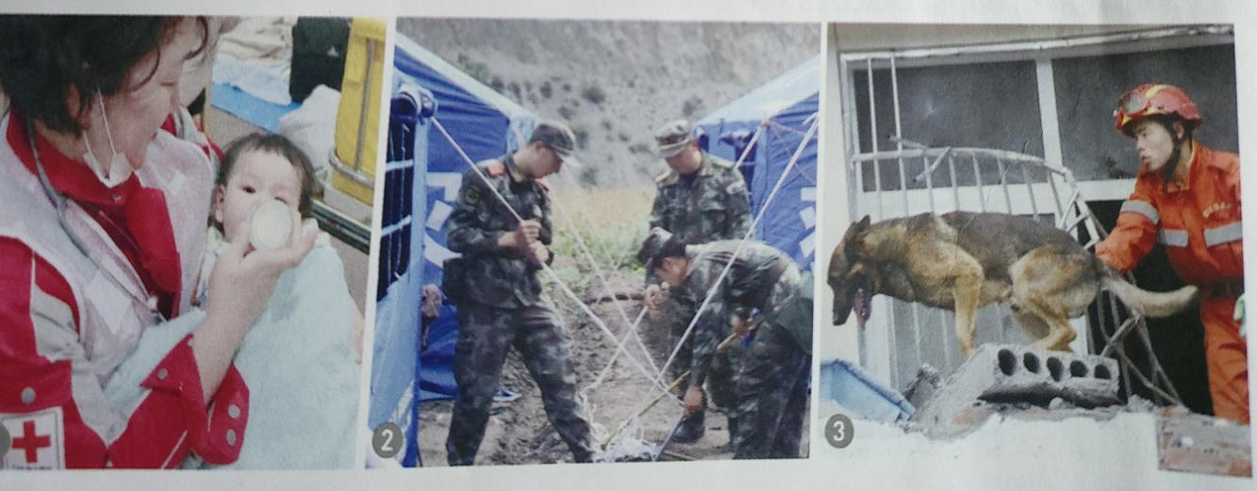

**西安市东城第一中学**

**张秀茹**

REQUIRED BOOK 1

**UNIT 4 NATURAL DISASTERS**

**DISCOVERING USEFUL STRUCTURES**

**DESCRIBE PICTURES OF DISASTERS**

**Topic context: Man and nature**

**Topic group: Disaster prevention**

**Sub-topic: Natural disasters and prevention, safety common sense and self-protection**

**Type: Grammar**

**Duration: 1 class(40mins)**

**Design philosophy**

As new senior English curriculum standard and “core competences”point out “in the process of developing the students’ language-using ability, teachers should focus on helping students improving their cultural awareness, thinking capacity and learning ability. This lesson is aimed at improving students’ language competence and cultural awareness.

**Learning content analysis**

This lesson is *Discovering Useful Structures* of required book 1, Unit 4. How to describe pictures of disasters is the teaching content. This grammar class is combined with the topic of this unit, Natural Disasters. Put grammar into topic and fulfill the requirement of English Curriculum (2017).

This lesson is *Discovering Useful Structures* of required book 1, Unit 4. It requires students to master attributive clauses and use these attributive clauses in the description of specific things, so as to improve their language expression and application ability.

**Students analysis**

The type of this class is *Discovering Useful Structures,* describe pictures of disasters. Students of senior one have learned attributive clauses in junior middle school. Learning something new based on what they have learned makes learning easier. Situational teaching approach(methodology) makes it easier and more interesting for students to learn grammar. The key point of this class is to use restrictive attritive clauses guided by relative pronouns to describe characteristics of people, things, supplement information and describe natural disasters and other everyday things.

**Teaching objectives**

In this class, students will

1. recognize the restrictive relative clauses and understand the use of relative pronouns;
2. summarize the form and functions of restrictive relative clauses;
3. use restrictive relative clauses to describe pictures of disasters.

**Important points**

1. How to lead students to recognize the restrictive relative clauses and understand the use of relative pronouns;
2. Help students summarize the form and functions of restrictive relative clauses

**Difficult points**

How to lead the students to use restrictive relative clauses to describe pictures related to disasters, supplement information and enrich language expression

**Teaching approaches and learning strategies**

Activity-based teaching approach

Situational teaching approach

Cooperative learning

Autonomous learning

**Preparation for teaching**

Teacher preparation: select some pictures of natural disasters

Student preparation: preview the content of this lesson

**Teaching procedures**

|  |  |  |  |
| --- | --- | --- | --- |
| **Steps** | **Teaching activities** | **Design purposes** | **Core competencies covered** |
| **Warming up (热身) 5mins** | | | |
| **Step 1 Perceive**  Lead in  **8mins** | Teacher invites students to enjoy a short clip about dogs rescue survivors in the earthquake. | Introduce the topic and get students to engaged in the class | Language ability: the perception of restrictive relative clauses  Cultural awareness: show students’ views on love |
| **Grammatical exploration（语法探究）30mins** | | | |
| **Step 2**  Discover the rules  **5mins** | 1.Find and underline the restrictive relative clause in the sentence.   * Underline the restrictive clauses in the sentences below.   2.Why do we use the restrictive relative clauses?   * What if these relative clauses are not used in these sentences?   3. *Find more sentences with restrictive clauses from the text on page 50.*  Observe the sentences and summarize the usage of the relative pronouns. | Get students to recognize the restrictive relative clauses master the function of restrictive relative clauses  Give ss the opportunity to actively experience, think and learn.  Make students understand and summarize the use of relative pronouns as well as strengthen the grammatical function of relative pronouns | Language ability: recognize restrictive relative clauses  Language ability: understand restrictive relative clauses  Ability to learn：summarize the usage of relative pronouns |
| **Step 3**  Practise the grammar  **7 mins** | Complete each sentence with relative pronouns. Then translate the sentences into Chinese. | Help ss understand the meaning and features of English sentences with their native language. | Cultural awareness: the differences in grammar and sentence patterns between English and Chinese |
| **Step 4**  **Application**  Describe pictures of disasters  **10mins** | *Write* *one or two sentences with restrictive clauses to describe these pictures.* | Get students to describe pictures of natural disasters and strengthen the grammatical function of restrictive relative clauses. | Cultural awareness: understand some major natural disasters at home and abroad from the perspective of historical events, and establish a sense of disaster prevention and self-protection.  Quality of thinking: cultivate students’ innovative thinking in the process of descripting pictures. |
| **Step 5 deep thinking**  Discover love and circulate love  **8 mins** | Love is a sniffing dog that helps find survivors.  Love is a bottle of milk that can feed the baby.  Love is also a tent that soldiers put up for victims | Stimulate students’ affection for sufferers  Have the awareness and attitude to actively respond to natura disasters and think positively from multiple angles as well as reduce psychological sufferings caused by disasters | Quality of thinking：Disasters are merciless but we Chinese have love    Quality of thinking：positive, helpful, supportive, self-healing |
| **Assignment (Homework) 2mins** | | | |
| **Compulsory assignment:**  **Write a short passage of 6 sentences to describe the rescue work after the natural disaster. At least 4 restrictive relative clauses must be used.** | | | |

**Blackboard design**

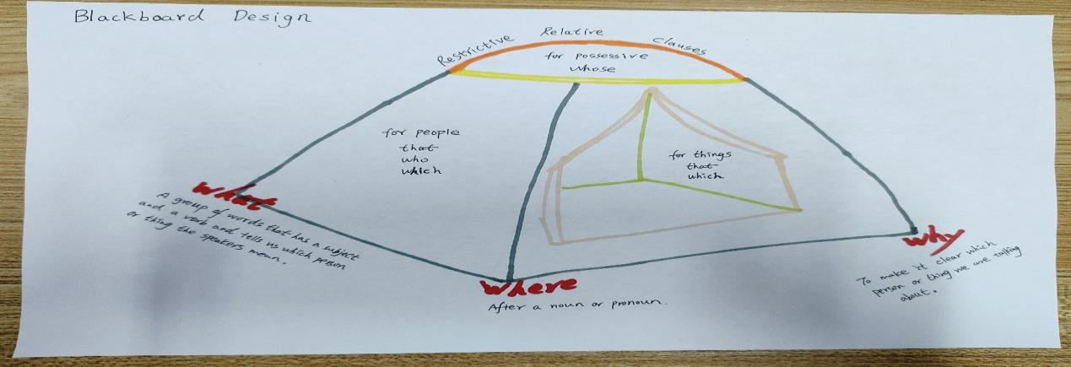

**Teaching reflection**

Highlights:

1. In this period, I begin with an English song love and end with a Chinese song love, which a perfect circle. And also I implement the principle of using one situation.
2. Execute the ideology and politics education in my class. Fully immerse students in love and guide them be a spreader of love.
3. I use the activity chains to guide the students to grasp the grammar step by step.
4. When the students finish my homework, I think they will be very happy to shoot the moving scenes about their family and upload it to Tiktok because they really act as the spreaders of love.

Improvements

Time permitting, I will let every student share their understanding about love because everyone wants to be heard.