**2024届2月浙江省名校协作体G12高三联考**

**应用文 讲评学案**

**PART 1 审题  
情境分析的“变与不变”**

【题目呈现】

假定你是校英文报的主编李华，最近准备出一期关于“倡导低碳生活”的专刊。请为专刊写一篇寄语，内容包括:

1.专刊的意义；

2.专刊的内容；

3.寄予的希望。

注意:

1. 写作词数应为80个左右;

2.请按如下格式在答题纸的相应位置作答。

**Dear Readers,**

**______________________________________________________________________________________________________________________________________________________________**

**Warm regards,**

**Li Hua**

**Editor-in-chief**

【基本信息把握】

|  |  |  |  |  |
| --- | --- | --- | --- | --- |
| 文体体裁 |  | | | |
| 写作人 |  | | | |
| 写作对象 |  | | | |
| 写作背景 |  | | | |
| 写作目的 |  | | | |
| 人称时态 |  |  |  |  |

【对比篇章分析情境】

6月13-19日是全国节能宣传周，主题为“绿色低碳，节能先行”。请你代表英文校报Youth写一封倡议书，倡导全体同学积极践行低碳节能的生活方式。内容包括：

1.低碳节能的做法;

2.低碳节能的益处;

3.呼吁大家共同参与。

|  |  |  |
| --- | --- | --- |
|  | **左边题目** | **右边题目** |
| 情境载体 |  | 倡议书——践行低碳节能 |
| 作者立场 |  | 代表英文报（本质类似学生投稿） |
| 写作要点 |  | 益处+做法+呼吁 |
| 语气态度 |  | 呼吁式（一起践行） |

【不变之处】

______________________________________________________________________________________________________________________________________________________________

**PART 2 建构  
分要点写作语料整合**

①首段自介+意义

本文属于创新类话题文章，分析题干后发现，第一段要写明自己的身份——校英文报刊的主编。随后，自然导入提倡低碳生活的意义。

②次段陈述主体

第二段是整篇应用文写作的核心部分，也就是所说的“主体”（body），即围绕专刊内容的设计，这部分需要学生自主考虑内容的分布和类型。

③尾段寄托希望

表达笔者代表报刊对读者们的希望，希望大家通过这个专刊走近低碳生活。展望的语气态度需要注意。

**【首段】**

Q1:对于创新类写作，首段如何开篇切入？

___________________________________________________________________________

**Example1：**

As the chief editor of our school's English newspaper,I'm pleased to introduce our latest issue focused on advocating a low-carbon lifestyle.

__________________________

**Example2:**

As the editor-in-chief of our school's English newspaper, I am excited to share with you our upcoming special edition focusing on "Advocating Low-Carbon Living."

________________________

**【次段】**

Q:专刊设立意义可以用什么句型？是否需要写很多？

______________________________________________________________________________

This edition's significance lies in its aim to inspire a commitment to environmental conservation among us.

This special issue holds great significance as it addresses a critical aspect of our present and future – the need for a sustainable and environmentally conscious lifestyle. We aim to raise awareness about the impact of our daily choices on the environment and promote actions that contribute to a lower carbon footprint.

Q:专刊的内容可以选取什么角度？

______________________________________________________________________________

【角度1：碳减排相关文章和成功案例（分总）】

Featuring articles on the benefits of reducing carbon emissions, tips on sustainable living, and success stories of individuals and communities making a real difference,we provide a comprehensive guide to eco-friendly practices.

In this edition, you can expect insightful articles on various facets of low-carbon living. From practical tips on energy conservation and waste reduction to inspiring stories of individuals and communities making a positive impact, our content aims to inform, inspire, and encourage a collective effort towards a greener and more sustainable future.

【角度2：生态保护+环境可持续发展、内在联系】

In this edition, you will find a diverse range of content aimed at inspiring and empowering individuals to make eco-conscious choices in their daily lives.

From practical tips on reducing carbon emissions and conserving energy to thought-provoking articles on the interconnectedness of environmental sustainability and social justice, our goal is to provide readers with valuable insights and resources to embark on their journey towards a greener future.

**【尾段】**

Q:表达希望应该用什么语气？可以如何升华内涵？

______________________________________________________________________________

We aspire for this issue to serve as a catalyst for positive change,encouraging everyone to take actionable steps towards a greener future.

My hope is that this special issue will spark meaningful conversations and actions within our school community and beyond. Let us come together to embrace the principles of sustainability, not just for ourselves but for the well-being of our planet and all its inhabitants.

**PART 3 例文与范作评价**

**【例文】**

Dear Readers,

As the chief editor of our school's English newspaper,I'm pleased to introduce our latest issue focused on advocating a low-carbon lifestyle.This edition's significance lies in its aim to inspire a commitment to environmental conservation among us.

Featuring articles on the benefits of reducing carbon emissions,tips on sustainable living,and success stories of individuals and communities making a real difference,we provide a comprehensive guide to eco-friendly practices.

We aspire for this issue to serve as a catalyst for positive change,encouraging everyone to take actionable steps towards a greener future.

Warm regards

Li Hua，

Editor-in-chief

你觉得本文的得分是_________

理由与可取之处：______________________________________________________________________________________________________________________________________________________________

【下水作文】

Dear Readers,

As the editor-in-chief of our school's English newspaper, I am pleased to share with you our upcoming special edition focusing on "Advocating Low-Carbon Living."

This special issue holds great significance as it addresses a critical aspect of our present and future——environmental conservation. We aim to raise awareness about the impact of our daily choices on the environment and promote actions that contribute to a lower carbon footprint.

In this edition, you can expect insightful articles ranging from practical tips on energy conservation and waste reduction to inspiring stories of individuals and communities making a positive impact, our content aims to inform, inspire, and encourage a collective effort towards a greener and more sustainable future.

I hope, through the thoughtful exploration of low-carbon living in these pages, each reader will find practical ways to integrate eco-friendly practices into their daily lives. Together, we can create a community that values and actively participates in the preservation of our environment, thus striving forwards a more sustainable and harmonious coexistence with our planet.

Wishing you an enlightening and transformative reading experience.

**Directions:**

**After reading these excellent compositions, please note down the materials that will be useful to your writing. Then revise and polish your own articles according to the following 5 aspects of reference.**

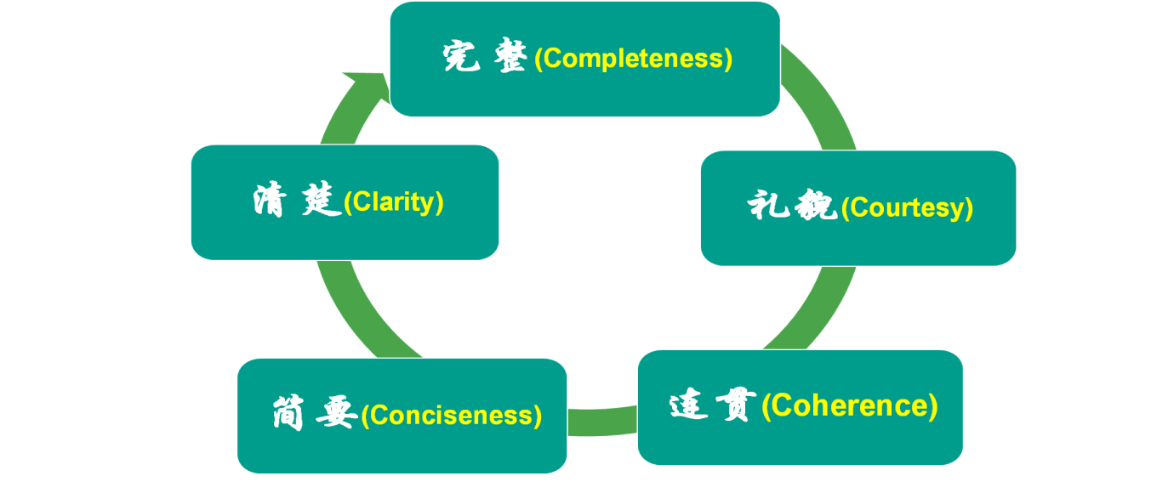

**PART 4 迁移与相似任务**

**【体裁迁移】**

6月13—19日是全国节能宣传周，主题为“绿色低碳，节能先行”。请你代表英文校报Youth写一封倡议书，倡导全体同学积极践行低碳节能的生活方式。内容包括：

1.低碳节能的做法；

2.低碳节能的益处；

3.呼吁大家共同参与。

注意：1.词数80左右；

2.可以适当增加细节，以使行文连贯；

参考词汇：低碳 low carbon  节能energy conservation

_______________________________________________________________________________

_______________________________________________________________________________

_______________________________________________________________________________

_______________________________________________________________________________

_______________________________________________________________________________

_______________________________________________________________________________

_______________________________________________________________________________

_______________________________________________________________________________

_______________________________________________________________________________

_______________________________________________________________________________

_______________________________________________________________________________

**【参考范文】**

Dear fellow students,

Do you know the earth is becoming warmer and warmer? It is human activity that has caused this global warming. A low-carbon lifestyle is the key to __________(处理) this big problem facing the earth.

To _________(实现) it, we should do our part in our daily life. First, turn off the taps, the lights and so on when we are not using them. It is a good idea to recycle everything ___________(可循环的) in our daily life. What’s more, motor vehicles use a lot of energy — so walk or ride a bike if we can. It also makes sense to _________(坚持) the habit of setting the temperature of our air conditioners at above 26℃ in summer.

Let’s all take action now! If we can make small changes in our way of life, we can make a big difference to the earth.

**The Students’ Union**

**关于“低碳、环保”话题语料素材整理**

low-carbon lifestyle 低碳生活方式

reduce carbon footprint减少碳排

sustainable energy usage可持续能源使用

renewable energy sources可再生能源

eco-friendly practices 环保实践

green transportation options 绿色交通选择

energy-efficient appliances 节能家电

waste reduction and recycling 减少浪费循环利用

environmental conservation efforts 环保努力

We should all strive to adopt a low-carbon lifestyle to reduce our impact on the environment. 我们都应该努力采用低碳生活方式，减少对环境的影响。

Riding bicycles or using public transportation are eco-friendly alternatives to driving cars. 骑自行车或使用公共交通是开车的环保替代方案。

Planting trees and participating in beach clean-up activities are important environmental conservation efforts. 种植树木和参加海滩清理活动是重要的环境保护努力。