选择性必修二Unit Unit 2 Studying Abroad: Is it a good or a bad idea?

文本简述
该板块的活动主题为“表达你对出国留学的看法”。随着经济社会的发展，出国留学的人数不断增长，出国热这种社会现象社会各界众说纷纭，褒贬不一，因此讨论这个问题具有强烈的现实意义。关于出国留学，学生和家长都应该综合考虑各方面因素，制定符合自身条件的成长目标和未来规划。该板块设定的语境是报纸上的专栏讨论，选取了两位家长关于此问题的投稿信，这两篇文章兼具书信和议论文的体裁特点，他们的论证有理有据，逻辑清晰，有利于引导学生客观分析出国留学的利和弊，培养批判性思维的能力。

教学目标
By the end of the class, students will
- be able to express opinion about studying abroad
- read and learn the structure of an argumentative letter
- learn to use connectors to make argumentative letter in a logical order

- 教学设计
Step 1: Lead-in
Background introduction: Nowadays, many vloggers who study abroad choose to share their daily life and academic study on social media platform, which shows a fresh and different life.
Have you ever considered studying abroad like them?

Step 2: Pre-reading
Is it necessary to study abroad? Why or why not?
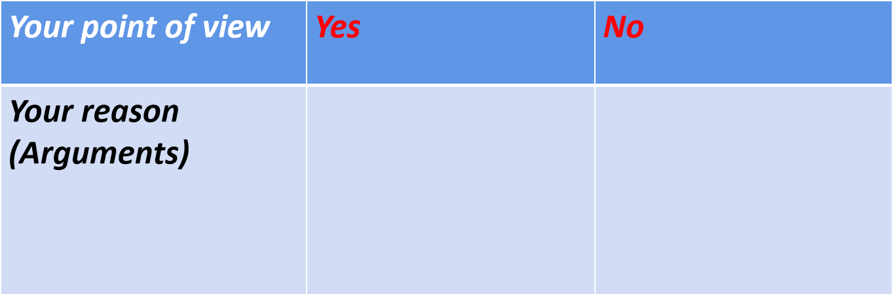
Step 3: While-reading
Activity 1 Read for text type
Skim the title and the passage quickly.
What is the text type of this passage?

A. Narration
B. Expository writing
C. Argumentative letters

Activity 2 Read for structure
Skim the passage quickly and work out the structure.

Activity 3 Read for details
Read the passage carefully and answer the following questions.
1. What is Wang Li’s point?

2. How does Wang Li develop her point?

- Summary How to write an argumentative essay
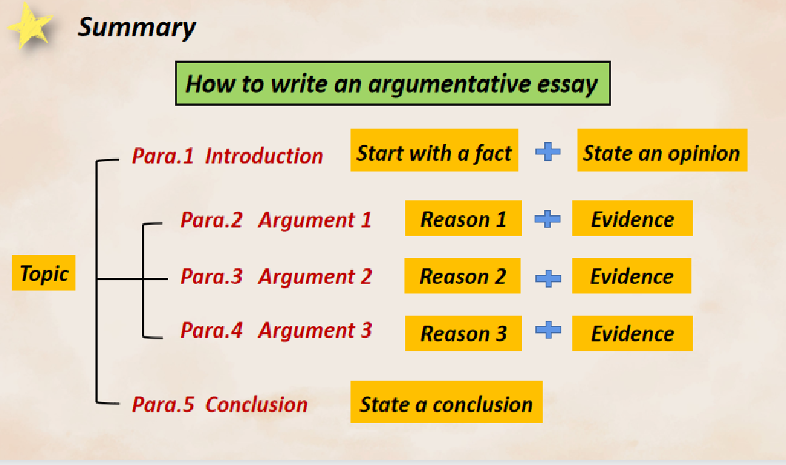

3. According to the summary, read Letter 2 again, then finish the table.
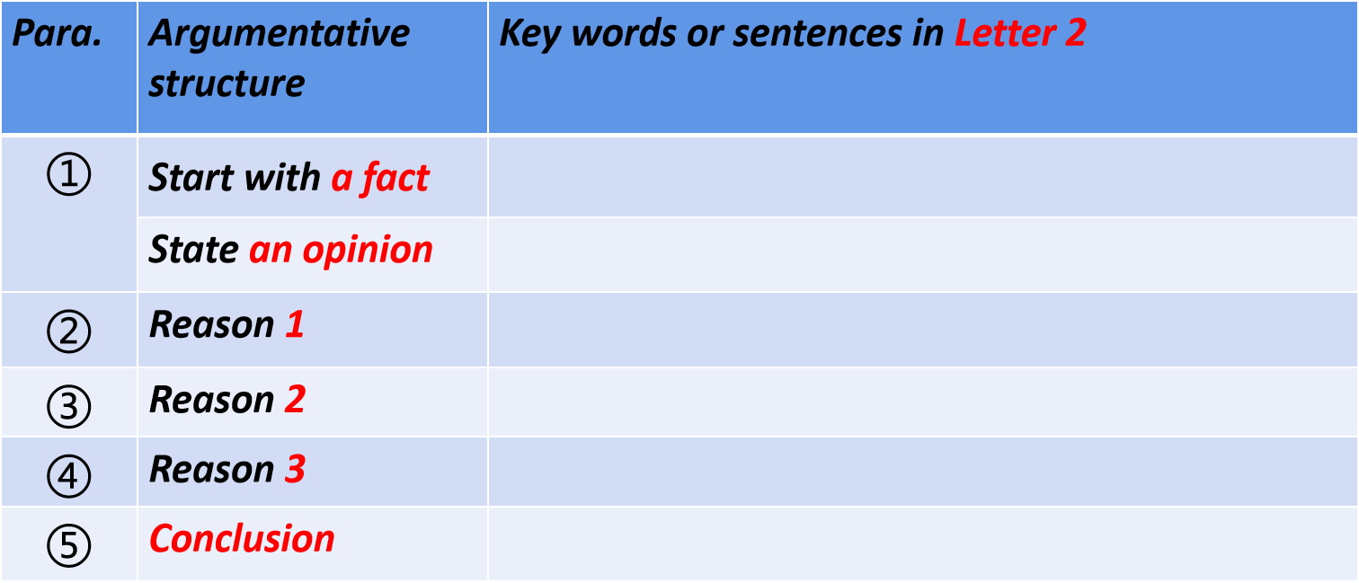

Activity 4 Read for language feature
- Summarize the connectors used to show the different parts of the argument in the letters.
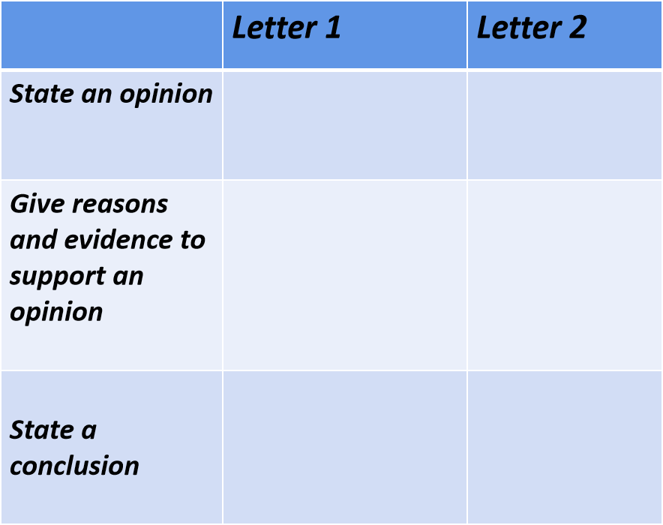
- Read the letters again, then use the connectors to rewrite the sentences below.
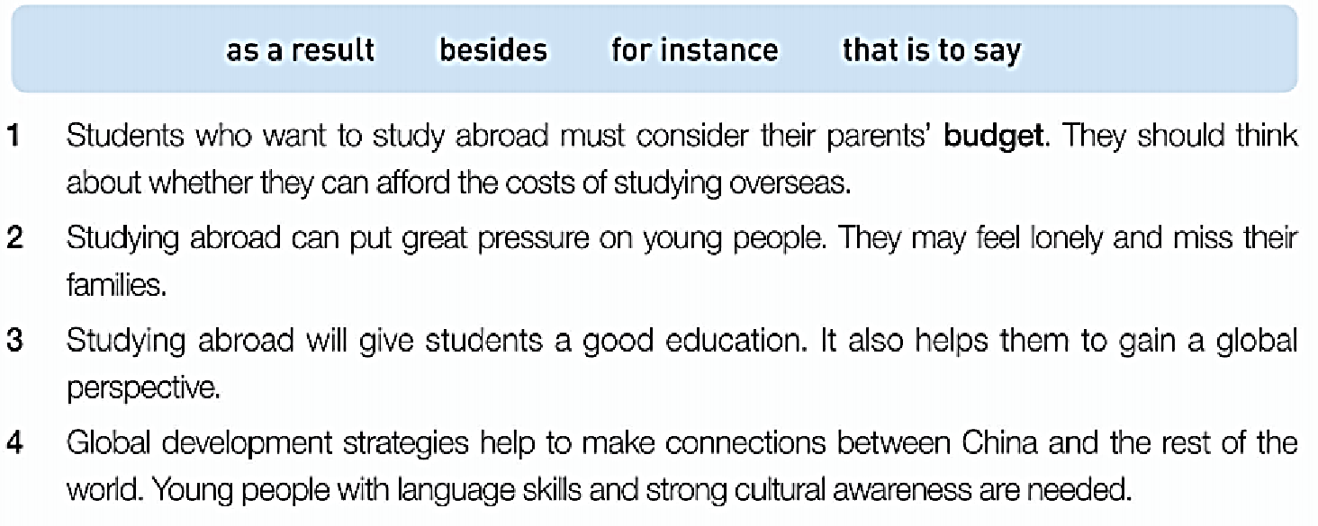

Activity 5: Group Discussion: Is it necessary to study abroad?

Use the checklist to help you review your letter.
- Is your main idea clear?
- Is the body of your letter logical and convincing?
- Is your conclusion clear?
- Have you used the connectors?
- Are there any grammatical errors?

