选择性必修二Unit 3 Reading and thinking Food and Culture

文本简述
该板块围绕“理解食物与文化的关系”展开，从外国人的视角看中国各地典型菜肴，并阐述其中反映的文化内涵、历史传统、地域特色等，引导学生理解和思考食物与地域、文化传统、当地人性格等的关系。
教学目标
By the end of the class, students will
- 阅读有关饮食与文化的事理说明文，抓住文本的时间、地域线索，理解和把握食物与地域文化、历史传统、当地人性格特点等之间的关系；
- 能够感知、理解文本中的因果关系及其丰富内涵；
- 了解博大精深的中国饮食文化，坚定文化自信；
- 学会用英语介绍中国饮食文化，如主要菜系及其特点。

- 教学设计
Step 1: Lead-in
New York-based photographer Henry Hargreaves and food stylist Caitlin Levin created snapshots of countries using 'iconic' delicacies from each region. Commenting on their latest project, they write “These maps show how food has traveled the globe. This project speaks to the universality of how food unites people.”
Let’s enjoy the feast for the senses !

Step 2: Pre-reading
- How many kinds of Chinese cuisines in China?
- How can these cuisine be described?
- Why are there so many cuisines?

Step 3: While-reading
Activity 1 Read to check
Q1: What do you think the text is about?
The text mainly talks about ___________________________.

Q2: How do you understand “You are what you eat”?

Activity 2 Read for structure
Match the main idea with each paragraph.
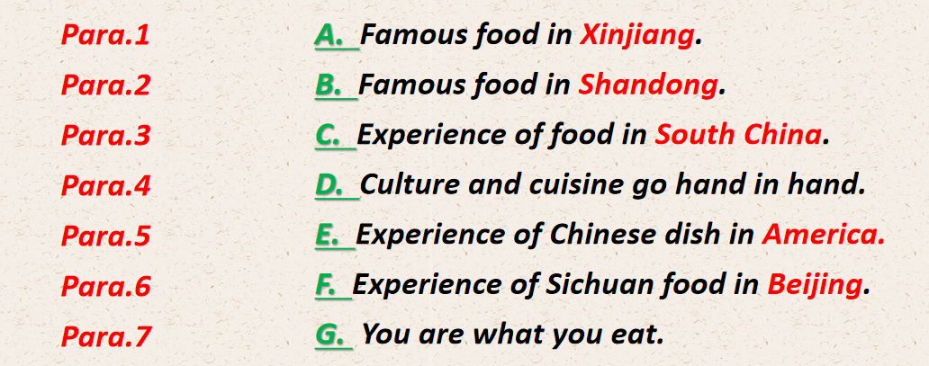
Question to think: How is the passage developed?

Activity 3 Read for information
- Read Para.2 carefully and answer the following questions.
Q1: What is America’s most popular Chinese dish?
Q2: And what can the dish tell us about Americans?

- Read Para.3-6 carefully and complete the table.
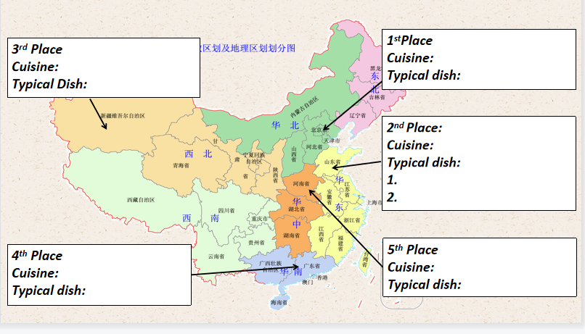

- Consolidation
Work in pairs. Ask and answer the questions.
S1: Where did the write experience....?
S2: ....
S1: Which dish impresses the writer most in...?
S2: ....
S1: What do we know about people in ... according to their food?
S2: ....
S1: What is the personality of people in ...?
S2: ....
S1: Why is ... the typical dish in ...?
S2: ....

- Read Para.2 carefully and answer the following questions.
Q1: What can the food local people consume tell us?
Q2: What is the main idea of Para.7? How do you understand it?

Activity 4 Critical thinking
Discuss the following questions with your partner.
Q1. Do you think “culture and cuisine go hand in hand”? Give your reasons.
Q2. Imagine that it is true that people's personalities are closely linked to the foods they eat. What does eating the following foods tell you about a person?

spicy food vegetarian food junk food seafood sweets chocolate rice noodles onion garlic bacon ham sausage cabbage mushroom bean curd

Activity 5: Read for language
- Where can we find the topic paragraph?
Which is the topic sentence?
- Understand cause and effect.
Do people in different places share the same food or different kinds of food?
Do people in different places share the same culture or different cultures?
What is the relationship between the two sentences?
- Match the causes to the effects.
Cause
1.The flavor preferences of Americans often differ from those of the Chinese
2.We had no idea how to order food.
3.These groups traditionally wandered the open range on horses.
Effect
A: The chef just began filling our table with the best food we had ever eaten.
B: Their traditional foods are what you can cook over an open fire.
C: Chinese food in America is changed to suit American tastes.
- Try to find more cause and effect sentences in the pqssage.

Activity 6: Summary
Most people relate “You are what you eat” to healthy eating. It 1
(actual) refers to personality, character, and culture. Chinese cuisine is a case in point. When introduced to America, it 2 (change) to suit American tastes, which tells us Americans like trying new foods.
Later, I visited China and 3 (experience) authentic Chinese food. In Beijing, we ate in a restaurant where the chef treated us to dinner 4
(consist) of Sichuan peppercorns. It was wonderful but what was even more important was the friendship. In Shandong Province, we had 5
(boil) dumplings with vinegar. I found making dumplings is always an affair with the whole family. In South China and central China, I experienced local dishes from Guangdong’s elegant dim sum to the 6 (exception) stewed noodles in Henan. Through food, Chinese people everywhere show friendship and kindness. At 7 minimum, the kinds of food 8
(consume) by local people tell us what they grow in their region, what kinds of lives they lead, and 9 they like and do not like.
All in all, culture and cuisine go hand 10 hand, and if you do not experience one, you can never really know the other.

