**202302杭州八县市高二期末应用文讲评**

浙江省龙游中学 颜运珍

**原题：**

假定你是李华，从互联网（the Internet）上得知一个国际中学生组织将在新加坡（Singapore）举办冬令营，欢迎各国学生参加。请写一封电子邮件申请参加。

内容包括：

1．自我介绍（包括英语能力）;

2．参加意图。

**教学设计：**

**一、Read and understand the requirements**

1. Identify what kind of practical writing it is. ( it’s an application.)
2. What kind of person should be adopted while writing? (first person )
3. What kinds of tenses should be adopted? (The simple present tense;

and simple future tense .)

**二、The structure of an application letter**

1. Usually, when will people write an application letter ?

When some one wants to apply for a job, land or secure a position, or wants to be a member of a club or group . Sometimes people will write an application if he or she wants to be be admitted to a school or university.

1. Who are the intended readers? How do we usually address them?

The readers can be the potential employer or to whom the application may concern. “ Dear Sir or Madam,” would be the appropriate address.

1. If you want to gain the recognition of the receiver, what should be included in your letter?

The most important parts should be the qualifications that you have and the reasons why you want to join it.

So we can get the structure of an application letter.

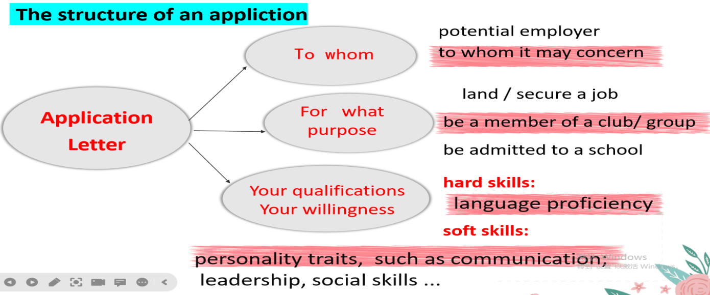

Part 1: 开篇表意，提出申请 (自我介绍+写信目的）

Part 2: 申请理由，阐述优势（具备资格、性格优势、语言能力、交际能力和相关经验）

Part 3: 结尾点题，盼回复 （诚恳 友善）

**三、How to organize each part**

**Part 1: 夺人眼球开头句**——开篇表意，提出申请

（1）Student1’s beginning:

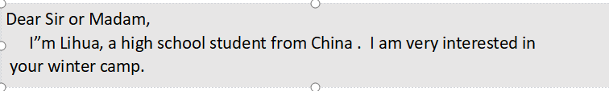

How to polish it? Have a try.

1. 举一反三 More sentences to express eagerness for an application.

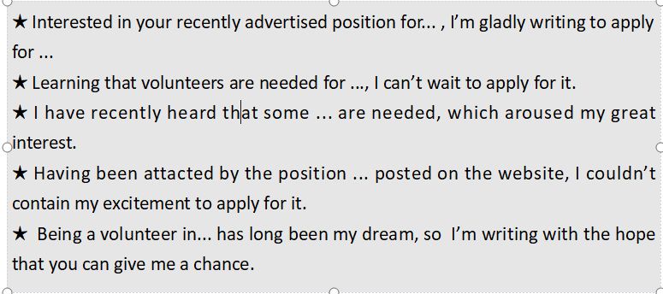 **Part 2 亮点出彩篇中句**

—— 阐述优势(资格、性格特征、语言能力、交际能力和相关经验）

Q: How to show your qualifications and advantages?

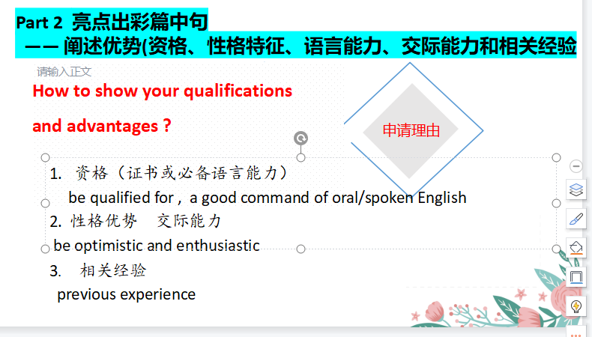

Work in groups and come up with as many sentences as you can .

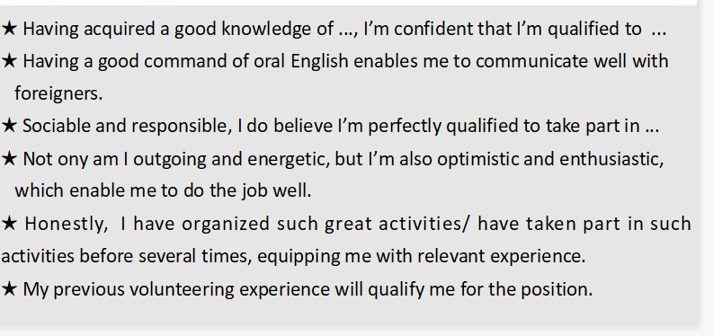

Practice 亮点出彩篇中句

1. have a good command of oral /spoken English (必备硬件：语言能力）

我认为我能成为一名好的冬令营成员。（总起）

I believe I am qualified to be a good member of the winter camp.

★ 首先，我英语非常流利，这使得我能够很好地/ 很轻松地与来自其他国家的成员进行交流。

Firstly, I have a good command of spoken English,_____________________________________.

( which enables me to communicate with other people with ease; enabling me to communicate with other people with ease)

★ 能够流畅地用英语进行交流，这是我优势之一。（v-ing 或者 with的复合结构）

__________________________ is one of my biggest advantages/strengths.

________________________ , I can communicate well with others.

( Being fluent in spoken English; With fluent spoken English)

1. be optimistic and enthusiastic 或 previous experiences （软件优势：性格特点或以前的经历）

★ 乐观又热情，我会积极地参与各种活动。

____________________, I will actively take part in various activities

（Optimistic and enthusiastic）

★ 我不仅善于交际，而且乐于承担责任，我会积极地参与各种活动。

____________________________________, which will contribute to my participation in all kinds of activities. ( Not only am I sociable, but also I am responsible)

★ 我曾经参与过类似的活动，我相信我可以向大家更好地介绍中国，同时也增进对他国文化的理解。

____________________________________, I’m confident that I can

introduce my country China to students from other countries, and meanwhile learn about their countries as well. ( Having acquired some relevant experiences ）

1. broaden my horizons as well as improve myself

★ 我相信这次活动不仅能拓展我的视野，更能给我提供一个好的交友的机会。

________________________________________, but also provide me with a good platform / opportunity to make more friends.

(I believe this activity will not only broaden my horizons )

★ 参加冬令营不仅能丰富我的阅历，而且能让我对其他国家的文化有更深刻的认识。

________________________________________, but also _____________________________.

(Not only will this activity enrich my life experience; help me gain a deeper glimpse of other cultures)

**Part 3 韵味无穷结尾句** （结尾点题，盼回复）

The ending of an application letter should be sincere, polite as well as concise.

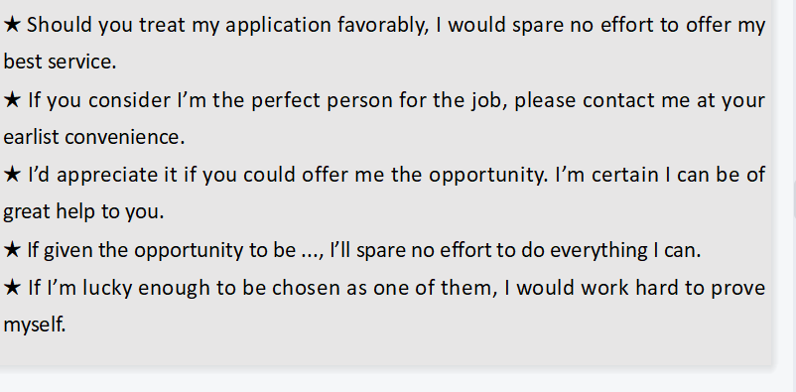

Practice 韵味无穷结尾句

★ 如果你认为我能成为一名合格的冬令营成员，请尽快联系我。

If you consider I’m the perfect person for the winter camp, please contact me at your earliest convenience.

★ 如果能给我这个机会，我将不胜感激。我不会让您失望的。

I’d appreciate it if I could be offered the opportunity, and I will not let you down.

★ 如果有机会成为冬令营的一员，我将竭尽全力做到最好。

If given the opportunity to be a member of the winter camp, I will spare no effort to do everything I can.

**四、Polish a student’s version**

**Compare the official version and teacher’s version**

1. **Homework**

假定你是李华，寒假在纽约学习，得知当地艺术家协会要举办中国书法展览。请写一封信请做志愿者。

内容包括：

1．写信目的；

2．个人优势；

3．能做的事情。

注意：（1）写作字数应为80左右。

（2）可以适当增加细节，以使行文连贯。