Unit 3 Diverse Cultures
Listening and Talking: Talk about ethnic minority cultures in China

WORKSHEET
Ⅰ Here is a webpage taken from the official website of Guizhou, China.

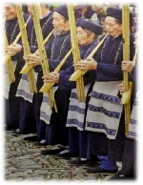
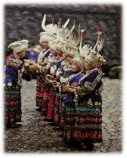
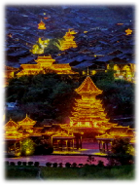

General Introduction
Guizhou is the perfect destination for people who are interested in China's ethnic minority groups and their culture. Visiting these minority groups is a wonderful experience.

The Miao
The Miao ethnic group is made up of many subgroups(分支) and are known mostly as hill people and rice farmers. Their clothing has special features which differ from place to place. During festivals, ethnic Miao girls wearing traditional costumes and various silver accessories usually greet guests with home-made rice wine and each man carries a lusheng (a bamboo-made music instrument) and stands in line to play the lusheng pipe music.

The Dong
Zhaoxing Dong Village, known as the biggest and oldest Dong village, is a wonderland for Dong festivals, songs and dancing. The most famous event is the Grand Song, a unique folk music tradition that has a history of over 2,500 years, which is listed as a UNESCO intangible(非物质的) cultural heritage. The village is also well-known for its five beautiful drum towers, five wind-and-rain/ flower bridges and five theater stages, belonging to five different groups of Dong people.
...
- Read and underline what might interest you if you were Justin.

Ⅱ Listening
- Task 1: Listen for basic information:
- What information did Justin learn about the Miao and the Dong? Write down some key words.
________________________________________________________________________________________________________________________________________________________________________________________
- Task 2: Listen for summaries:
- Part 1 Justin and ______ watched some ______ people play the ________. The instrument has a history of over _____ years and it is even mentioned in the oldest collection of Chinese poetry. Then they watched the ______________. Justin wanted to buy some hand-made _________ accessories as souvenirs. He was told that the price will depend on the percentage of ______.
- Part 2 They will go to a pretty ______ village called ___________. They will see the __________ and the _________________. They may also see a performance of the __________________ of Dong people.

Ⅲ Talking
- Group work: If one of you is Justin and the rest of you are his friends, make a conversation to talk about Justin's experience.
- Use the following expressions to show you are listening.
- Ask questions to cover as much as Justin’s travel experience.
- Present a complete conversation with everyone involved.
Friend A: So, Justin, how was your trip to Guizhou?
Justin: It was great._______________________________________________________________________
Friend B:_______________________________________________________________________________
Justin:_________________________________________________________________________________
Friend C:_______________________________________________________________________________
______:_______________________________________________________________________________________:_______________________________________________________________________________________:_______________________________________________________________________________________:_______________________________________________________________________________________:_______________________________________________________________________________________:_________________________________________________________________________________
Justin: Yes, from this travel, I truly understand what the sentence “The beauty of the world lies in the diversity of its people.” means!

Showing you are interested and listening
