# M1U5 Reading Elias’ story教学设计

**文本特征**

本文为记叙文，从南非黑人Elias的第一人称视角出发，第一部分的故事讲述了Elias从出生、辍学、得到曼德拉的帮助、到加入非国大青年联盟炸毁政府大楼为止。Elias幼时生活艰苦，而在受到曼德拉的无私帮助和理解了他的斗争后，他毅然支持曼德拉，投身黑人争取平权的事业中，整篇文章是通过guide& support这两个关键词所串联起来的，前两段解释了Elias为何需要帮助，第3-5段解释了曼德拉如何帮助他，以及Elias如何支持曼德拉，为什么Elias要支持他。

**Teaching Objectives**

During the class, students should be able to

1. understand Elias’ life experiences and analyze the events by the relationship between Elias and Mandela

2. think critically about the hero/heroine

3. express opinions on hero’s qualities and connect them with his life experiences

4. understand the hardships black people suffered during their quest for equal rights

**Teaching Procedure**

**Stage 1 Lead-in**

**Step 1** Have a guessing game (Who is my hero/heroine?) and help Ss imitate

Tips:

He/she discovered a new drug and selflessly tested it on himself/herself.

He/she saved millions of lives, mainly in Africa.

He/she was the first Chinese to win The Nobel Prize in Medicine.

**Step 2** Give the answer and ask Ss to play the guessing game with their partner about their hero/heroine.

**Step 3** Brainstorm the possible qualities of a hero/heroine.

**Stage 2 While-reading**

**Step 1** Skimming& scanning

1. Who is Elias?

2. When was he born? When did this story end?

3. Who is the story teller?

4. What’s the relationship between him and Mandela?

**Step 2** According to the key words (guide and support), fill in the blanks and summarize the main idea of the passage.

1. Why did Elias need Mandela’s guidance?

2. How did Mandela guide him?

3. How did Elias support Mandela?

4. Why did he support Mandela?

**Step 3** Reading for details

1. Read Para.1-2

* Answer the questions

(1) Why did Elias need Mandela’s guidance?

(2) Why did he receive little education?

(3) Which kind of people needed a passbook to live in Johannesburg?

(4) What if he didn’t get one? Is it just a problem for Elias?

2. Read Para.3-5

* Answer the questions

(1) How did Mandela guide Elias?

(2) How did Elias feel?

* Answer the questions

(1) How did Elias support Mandela?

(2) How did he feel?

(3) Why did Mandela organize the ANC Youth League?

Ss answer Q(3) by reading Quote 1 from Mandela together and ask them paraphrase it by filling in the blanks

Black people were not allowed to vote or choose their leaders, get the jobs they wanted and decide where to live, because laws stopped their rights and progress in the last thirty years.

* Invite Ss to describe what they see in pictures, and understand that black people have no equal rights for apartheid in a more direct way

Introduce Apartheid to Ss

* Read Quote 2 from Mandela together and analyze black people’s choice through a mind map

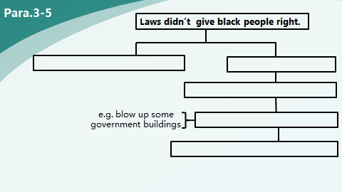

* Understand black people’s quest for equal rights

Why did Elias help Mandela even if he didn’t like violence?

Why did Mandela help Elias, just because he was poor?

**Stage 3 Post-reading**

**Step 1** Discuss with the partner about the good qualities of Elias and Mandela and the evidence from the passage.

Give tips to Ss and help them imitate:

1. Use some positive words to describe.

2. Connect it with what the person did and what people remember about him or her.**Step 2** Tell who is the hero and practice the sentence pattern:

He is such a _______ person that ___________.

I think _____ is my hero because ___________.

**Stage 4 Assignment**

Write a short passage to describe the good qualities of your hero and explain why you chose him as your hero. Try to use at least 5 words or expressions from below and underline them.

* helpful; generous; selfless; hopeful; devote;
* worry about; as a matter of fact; in trouble; be willing to; turn to