**The World**（**1101-1115**）材料分析和教学目标：

本次选用的材料：①*Los Angeles Times*的*TRUMP WINS 45TH PRESIDENT WILL BECOME THE 47TH*（特朗普赢得2024年美国总统大选，将成为美国第47任总统）、②*The Times*的Spain’s royals pelted with mud as flood anger erupts（西班牙国王亲临灾区遭愤怒民众围攻）、③、*BBC Wildlife*的*Tarsiers in Trouble*（眼镜猴处于困境）④*The Times*的*Eye scans will help prevent blindness from diabetes*（眼部扫描有助于预防糖尿病导致的失明）和⑤BBC的新闻报道。通过语法填空、阅读理解、分析长难句、翻译句子、听力填空和词汇拓展等方式，让学生从多角度提升学习兴趣，提高分析句子、运用词块和听力能力。外媒英语新闻可以让学生体验真实语境下的语言运用，拓展学生的国际视野，了解时事，逐步提升跨文化沟通能力，形成正确的世界观、人生观和价值观。

**教学思路：**

**Part 1:** **News Report 1** ***Los Angeles Times* (November 7 2024 A1)**

**TRUMP WINS 45TH PRESIDENT WILL BECOME THE 47TH**

**特朗普赢得2024年美国总统大选,将成为美国第47任总统**

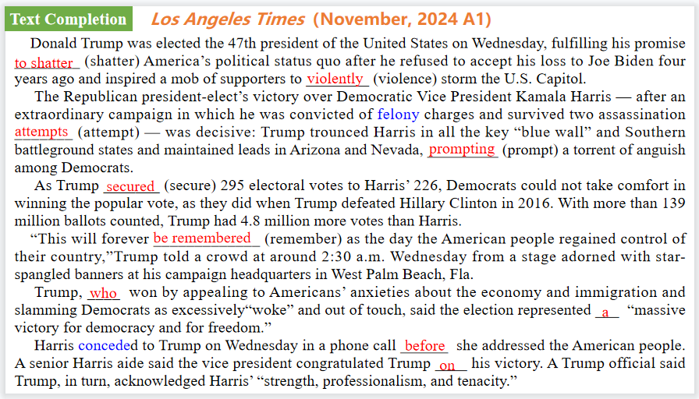

【设计意图】通过语篇填空的形式帮助学生理解新闻的主要内容，同时训练语言语法的运用能力：在语篇的视角下如何正确使用所给词汇，根据语法规则确定词汇的正确形式，使得文章通顺，激活学生的思维和语言。该新闻主题语境是关于“人与社会”中“社会热点问题”这一子主题，通过学习让学生了解特朗普赢得2024年美国总统大选，将成为美国第47任总统。

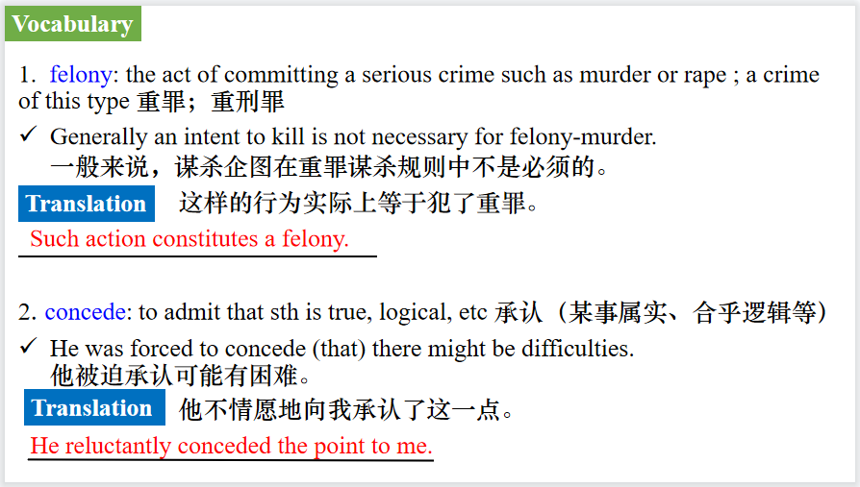

【设计意图】对文本中的词汇进行解读，并通过翻译句子对其进行巩固。

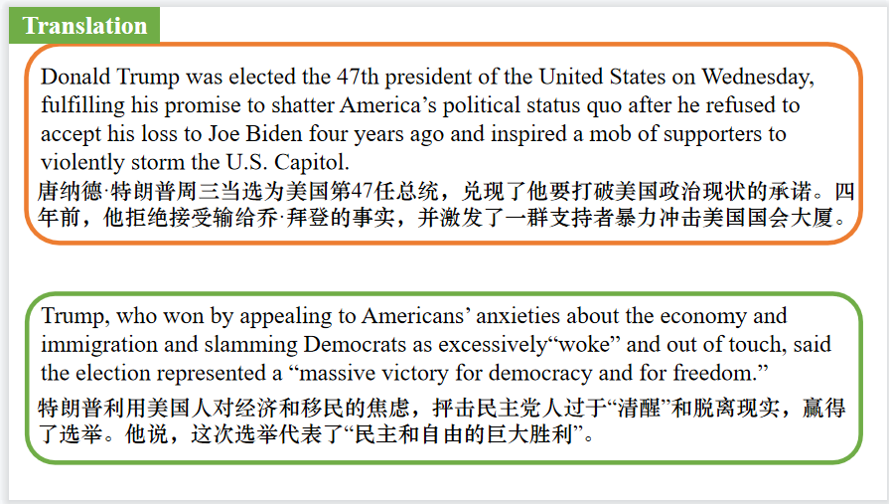

【设计意图】对文中的两个句子进行翻译练习，对其中单词、词组、句法进行巩固并关注句子结构。

**Part 2: News Report 2 *The Times* (November 4 2024 P5)**

**Spain’s royals pelted with mud as flood anger erupts**

**西班牙国王亲临灾区遭愤怒民众围攻**

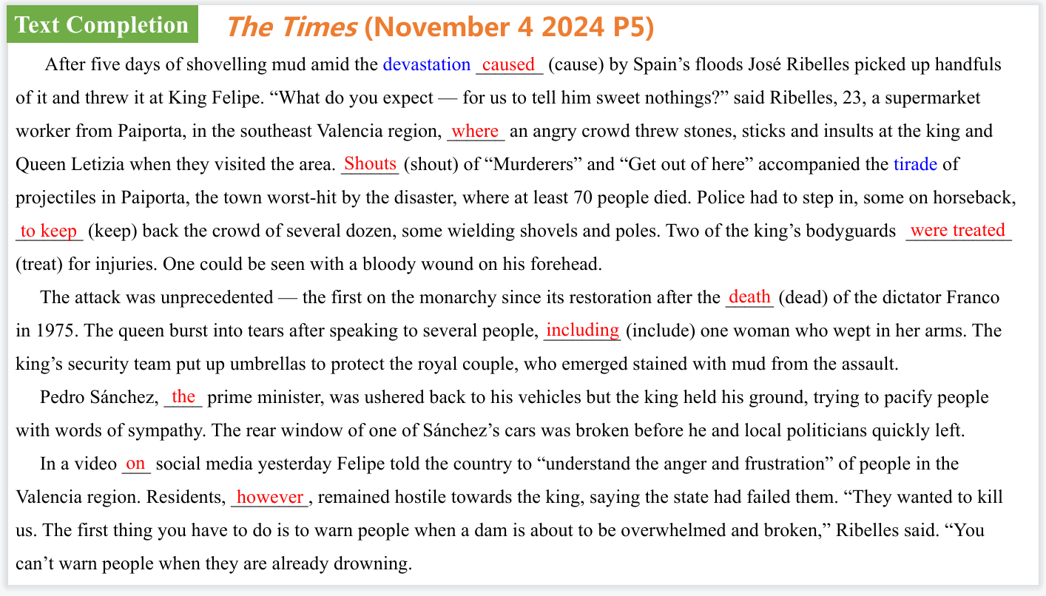

【设计意图】通过语篇填空的形式帮助学生理解新闻的主要内容，同时训练语言语法的运用能力：在语篇的视角下如何正确使用所给词汇，根据语法规则确定词汇的正确形式，使得文章通顺，激活学生的思维和语言。该新闻主题语境是关于“人与社会”中“社会热点问题”这一子主题，通过学习让学生了解西班牙国王亲临灾区遭愤怒民众围攻的新闻。

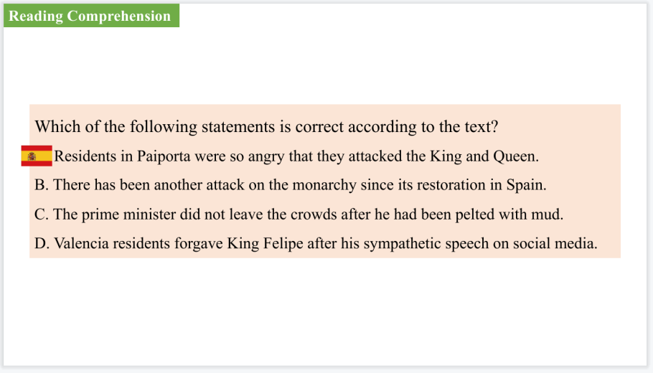

【设计意图】通过阅读理解的形式帮助学生理解新闻的主要内容。

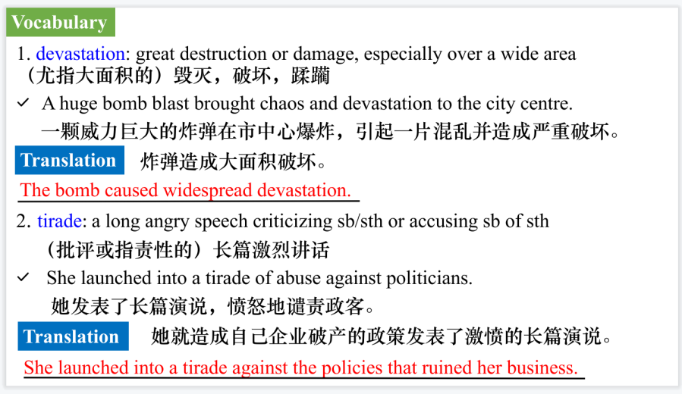

【设计意图】对文本中的词汇进行解读，并通过翻译句子对其进行巩固。

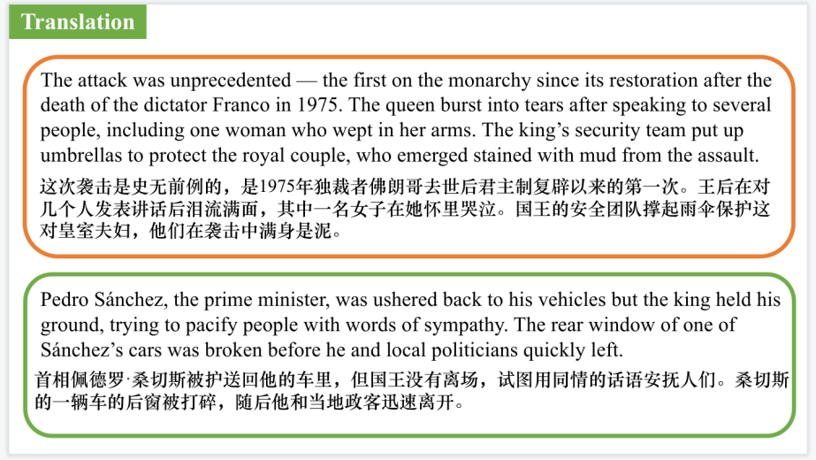

【设计意图】对文中的两个句子进行翻译练习，对其中单词、词组、句法进行巩固并关注句子结构。

**Part 3: News Report 3 *BBC Wildlife* (November, 2024 P13)**

**Tarsiers in Trouble 眼镜猴处于困境**

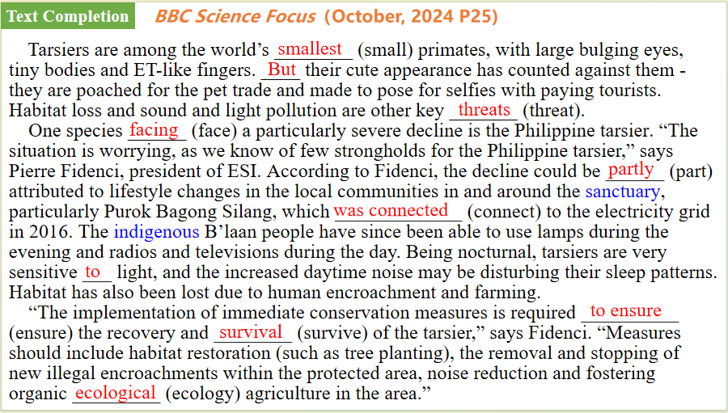

【设计意图】通过语篇填空的形式帮助学生理解新闻的主要内容，同时训练语言语法的运用能力：在语篇的视角下如何正确使用所给词汇，根据语法规则确定词汇的正确形式，使得文章通顺，激活学生的思维和语言。该新闻主题语境是关于“人与自然”中“人与动植物”这一子主题，通过学习让学生了解眼镜猴处于困境的情况。

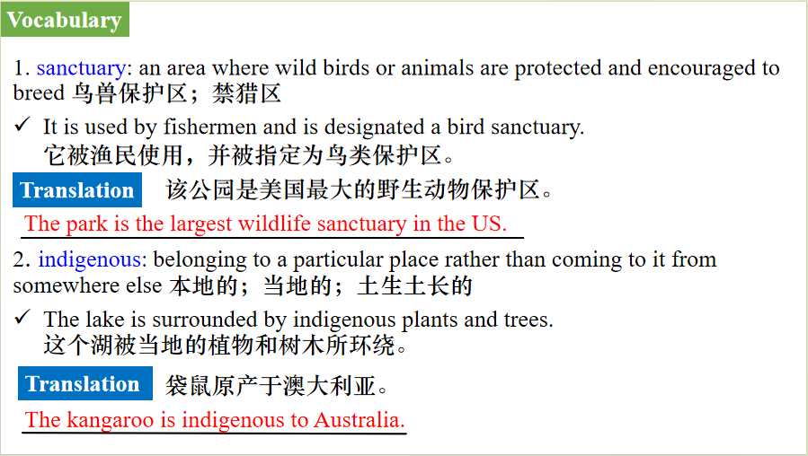

【设计意图】对文本中的词汇进行解读，并通过翻译句子对其进行巩固。

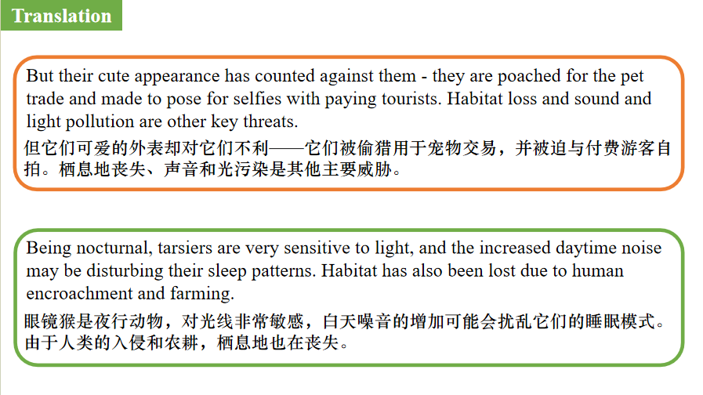

【设计意图】对文中的两个句子进行翻译练习，对其中单词、词组、句法进行巩固并关注句子结构。

**Part 4: News Report 4 *The Times* (November 18, 2024 P4)**

**Eye scans will help prevent blindness from diabetes**

**眼部扫描有助于预防糖尿病导致的失明**

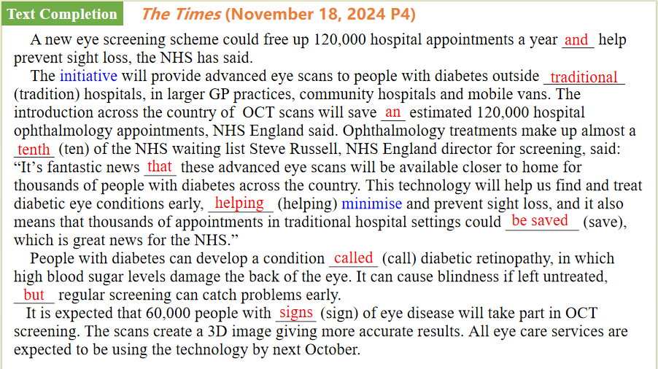

【设计意图】通过语篇填空的形式帮助学生理解新闻的主要内容，同时训练语言语法的运用能力：在语篇的视角下如何正确使用所给词汇，根据语法规则确定词汇的正确形式，使得文章通顺，激活学生的思维和语言。该新闻主题语境是关于“人与社会”中“科技发展与信息技术创新”这一子主题，通过学习让学生了解眼部扫描有助于预防糖尿病导致的失明的科技新发现。

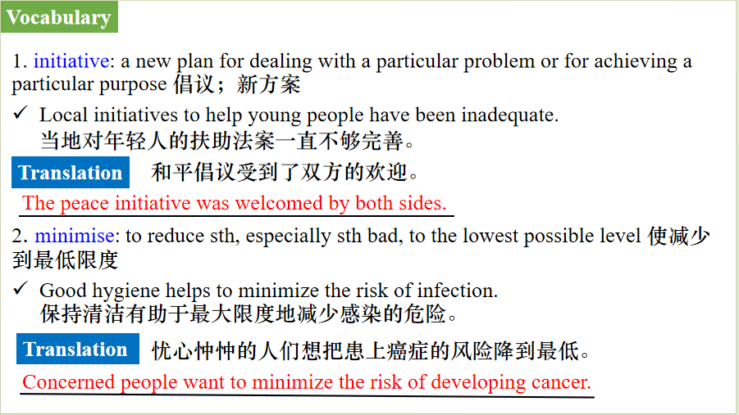

【设计意图】对文本中的词汇进行解读，并通过翻译句子对其进行巩固。

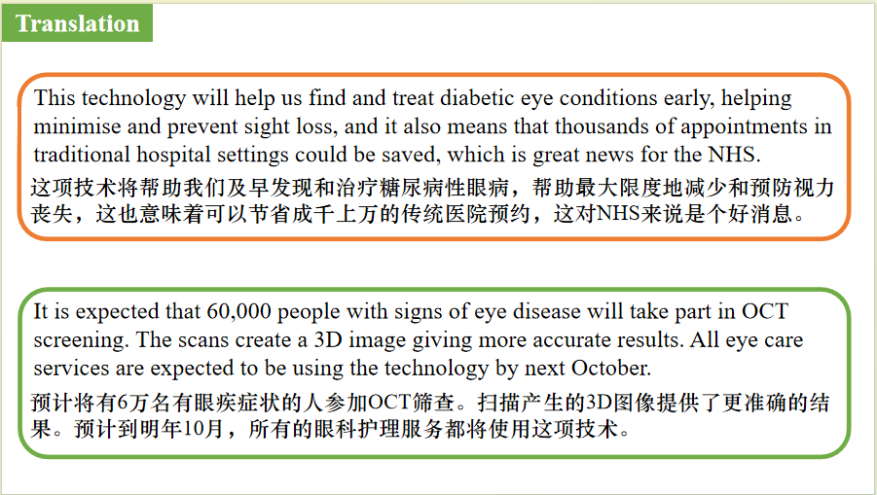

【设计意图】对文中的两个句子进行翻译练习，对其中单词、词组、句法进行巩固并关注句子结构。

**Part 5: BBC News 11/05/2024**

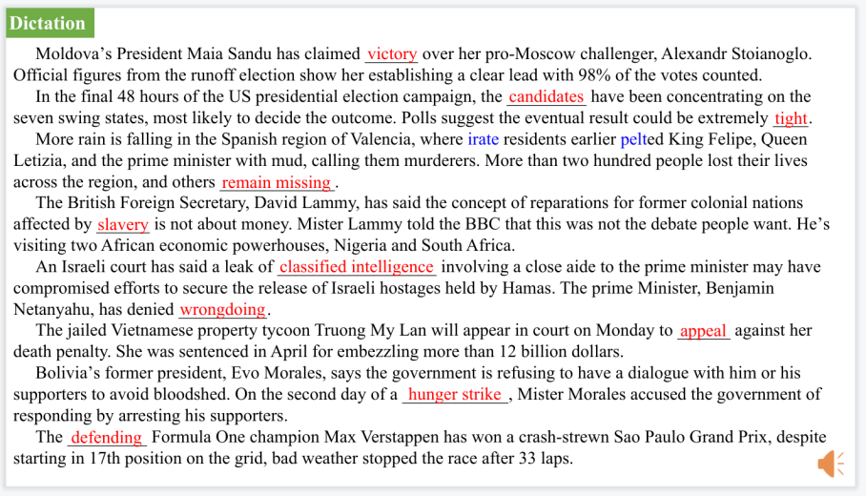

【设计意图】听一则材料，通过听力填空的方式理解文本，考察听力辨识词汇的能力。

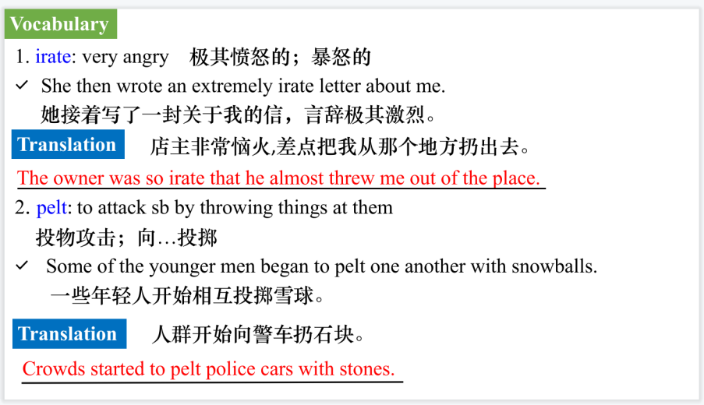

【设计意图】对文本中的词汇进行解读，并通过翻译句子对其进行巩固。

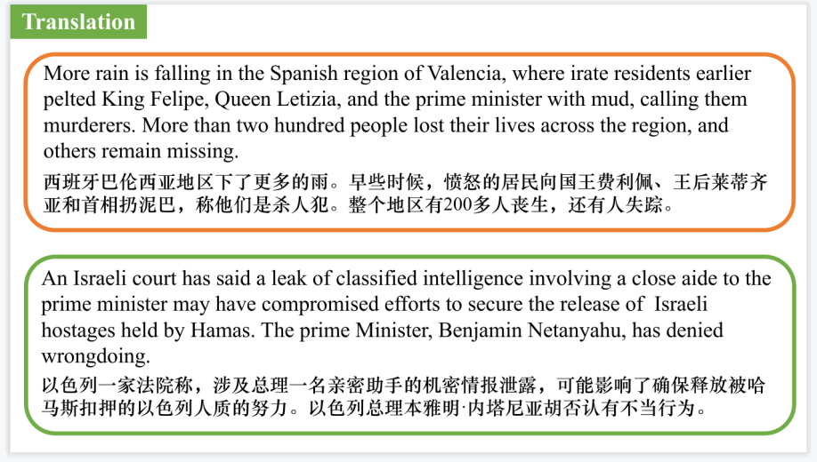

【设计意图】对文中的两个句子进行翻译练习，对其中单词、词组、句法进行巩固并关注句子结构。

附：外刊原文

**Part 1: News Report 1 *Los Angeles Times* (November 7 2024 A1)**

**TRUMP WINS 45TH PRESIDENT WILL BECOME THE 47TH**

**特朗普赢得2024年美国总统大选,将成为美国第47任总统**

Donald Trump was elected the 47th president of the United States on Wednesday, fulfilling his promise to shatter America’s political status quo after he refused to accept his loss to Joe Biden four years ago and inspired a mob of supporters to violently storm the U.S. Capitol.

The Republican president-elect’s victory over Democratic Vice President Kamala Harris — after an extraordinary campaign in which he was convicted of felony charges and survived two assassination attempts — was decisive: Trump trounced Harris in all the key “blue wall” and Southern battleground states and maintained leads in Arizona and Nevada, prompting a torrent of anguish among Democrats.

As Trump secured 295 electoral votes to Harris’ 226, Democrats could not take comfort in winning the popular vote, as they did when Trump defeated Hillary Clinton in 2016. With more than 139 million ballots counted, Trump had 4.8 million more votes than Harris.

“This will forever be remembered as the day the American people regained control of their country,”Trump told a crowd at around 2:30 a.m. Wednesday from a stage adorned with star-spangled banners at his campaign headquarters in West Palm Beach, Fla.

Trump, who won by appealing to Americans’ anxieties about the economy and immigration and slamming Democrats as excessively“woke” and out of touch, said the election represented a “massive victory for democracy and for freedom.”

“The people who voted for us, they came from all quarters — union, nonunion, African American, Hispanic American, Asian American, Arab American, Muslim American,” Trump said. “We had everybody,and it was beautiful. It was a historic realignment, uniting citizens of all backgrounds around a common core of common sense.”

Harris conceded to Trump on Wednesday in a phone call before she addressed the American people. A senior Harris aide said the vice president congratulated Trump on his victory. A Trump official said Trump, in turn, acknowledged Harris’ “strength, professionalism, and tenacity.”

**Part 2: News Report 2 *The Times* (November 4 2024 P5)**

**Spain’s royals pelted with mud as flood anger erupts**

**西班牙国王亲临灾区遭愤怒民众围攻**

After five days of shovelling mud amid the devastation caused by Spain’s floods José Ribelles picked up handfuls of it and threw it at King Felipe.

“What do you expect — for us to tell him sweet nothings?” said Ribelles, 23, a supermarket worker from Paiporta, in the southeast Valencia region, where an angry crowd threw stones, sticks and insults at the king and Queen Letizia when they visited the area.

Shouts of “Murderers” and “Get out of here” accompanied the tirade of projectiles in Paiporta, the town worst-hit by the disaster, where at least 70 people died. Police had to step in, some on horseback, to keep back the crowd of several dozen, some wielding shovels and poles. Two of the king’s bodyguards were treated for injuries. One could be seen with a bloody wound on his forehead.

The attack was unprecedented — the first on the monarchy since its restoration after the death of the dictator Franco in 1975. The queen burst into tears after speaking to several people, including one woman who wept in her arms. The king’s security team put up umbrellas to protect the royal couple, who emerged stained with mud from the assault.

Pedro Sánchez, the prime minister, was ushered back to his vehicles but the king held his ground, trying to pacify people with words of sympathy. The rear window of one of Sánchez’s cars was broken before he and local politicians quickly left.

In a video on social media yesterday Felipe told the country to “understand the anger and frustration” of people in the Valencia region.

Residents, however, remained hostile towards the king, saying the state had failed them. “They wanted to kill us. The first thing you have to do is to warn people when a dam is about to be overwhelmed and broken,” Ribelles said. “You can’t warn people when they are already drowning.”

His friend Francisco Javier Molina, 20, said: “The king and all came very clean and to look good in front of the town and cameras but this doesn’t help us at all. He should come here and get

rid of the mud and the dead that are in garages. And then he’ll be one of us.”

Ribelles showed mobile phone footage taken by his mother while she was stuck up a tree for six hours to escape the flood. “She nearly died but we rescued her before the water went higher. She couldn’t breathe,” he said. “In the supermarket where I work there were 12 deaths among my colleagues. The flood got them in the garage.”

As they spoke, another downpour of rain fell and rescue workers ran to take cover. A policeman closed off a municipal building from where emergency rations were issued. “The building is filling with water again,” he shouted.

The king and queen were due to move on to another badly hit town, Chiva, normally 20 minutes away by road. A crowd waited in front of the town hall but after several false alarms it was announced the couple had “postponed the visit”, fearing a similar reception.

In Chiva, people shouted “cowards” at the absent monarchs. Sheltering in a doorway during a break from clearing rubble and mud, María Tarín, 31, a teacher, said: “The king can shove it but it’s the Valencian government head Carlos Mazon and then Pedro Sánchez who are to blame. Better that they didn’t come because it wouldn’t have ended well for them.”

The bodies of a British couple were found in the Valencian municipality of Pedralba yesterday, taking the number of victims to 217.

In Chiva, José Tarín, 74, said the criticism of the king was “totally uncalled for”. He said: “This has nothing to do with the king or the government. It’s climatological. It’s the worst weather I have seen in my life.”

In Paiporta, as the downpour continued, José Villerta, 62, a waiter, was changing his clothes in a doorway as people ran for refuge. “The last days have been beyond words, I have seen bodies and I have seen lives saved,” he said. And what of the future? “Right now, I am going back to work in the restaurant,” he said. “You have to fight on.”

**Part 3: News Report 3 *BBC Wildlife* (November, 2024 P13)**

**Tarsiers in Trouble 眼镜猴处于困境**

Tarsiers are among the world’s smallest primates, with large bulging eyes, tiny bodies and ET-like fingers. But their cute appearance has counted against them-they are poached for the pet trade and made to pose for selfies with paying tourists. Habitat loss and sound and light pollution are other key threats.

One species facing a particularly severe decline is the Philippine tarsier - endemic to the archipelago that shares its name - as revealed by a survey in and around the tarsier sanctuary area of the Mount Matutum Protected Landscape.The research, carried out from 2023-24 by Endangered Species International (ESI), counted just five individuals, a significant decrease from the 33 counted in 2012-13 within the sanctuary area alone. No infants were spotted,whereas several were encountered in the earlier survey. “The situation is worrying, as we know of few strongholds for the Philippine tarsier,” says Pierre Fidenci, president of ESI.

According to Fidenci, the decline could be partly attributed to lifestyle changes in the local communities in and around the sanctuary,particularly Purok BagongSilang, which was connected to the electricity grid in 2016.The indigenous B'laan people have since been able to use lamps during the evening and radios and televisions during the day.Being nocturnal, tarsiers are very sensitive to light, and the increased daytime noise may be disturbing their sleep patterns.Habitat has also been lost due to human encroachment and farming.

“The implementation of immediate conservation measures [is required]to ensure the recovery and survival of the tarsier,”says Fidenci.“Measures should include habitat restoration (such as tree planting),the removal and stopping of new illegal encroachments within the protected area, noise reduction and fostering organic ecological agriculture in the area.”

**Part 4: News Report 4 *The Times* (November 18, 2024 P4)**

**Eye scans will help prevent blindness from diabetes**

**眼部扫描有助于预防糖尿病导致的失明**

A new eye screening scheme could free up 120,000 hospital appointments a year and help prevent sight loss, the NHS has said.

The initiative will provide advanced eye scans to people with diabetes outside traditional hospitals,in larger GP practices,community hospitals and mobile vans.

The introduction across the country of optical coherence tomography(OCI)scans will save an estimated 120,000 hospital ophthalmology appointments,NHS England said. Ophthalmology treatments make up almost a tenth of the NHS waiting list Steve Russell, NHS England director for screening, said:“It's fantastic news that these advanced eye scans will be available closer to home for thousands of people with diabetes across the country.This technology will help us find and treat diabetic eye conditions early, helping minimise and prevent sight loss, and it also means that thousands of appointments in traditional hospital settings could be saved,which is great news for the NHS.”

People with diabetes can develop a condition called diabetic retinopathy, in which high blood sugar levels damage the back of the eye. It can cause blindness if left untreated, but regular screening can catch problems early.

It is expected that 60,000people with signs of eye disease will take part in OCT screening. The scans create a 3D image giving more accurate results.All eye care services are expected to be using the technology by next October.