**【学习内容】寻找琥珀屋的历史奇缘** **B2 U1Cultural Relics——Reading: In Search of the Amber Room**

**【学习重点】**

1. We can analyze the history of the Amber Room and explore the relation between Germany and Russia correctly by skimming, scanning and study reading.

2. We can speak out our opinions and reasons about “Whether the Amber Room should be rebuilt” precisely by discussion.

**【学习目标】**By the end of this class:

1. We will be able to make our predictions bravely and obtain the main idea of each paragraph and main structure of the passage correctly by appreciating the material object, pictures and video, &skimming the title and the passage.

2. We can outline the history of the Amber Room, and analyze the relationships between countries quickly and precisely by scanning, careful reading and study reading.

3. We will be able to value the importance of peace and stimulate our love for cultural relics and encourage us to protect cultural relics unconsciously by reading the passage.

**【学习流程】**

**Lead in:** material object & video

**Part A （对应目标1）**

***Skim and match the main idea of each paragraph.***

Para.1 A. The Amber Room became a wonder of the world.

Para.2 B. The Amber Room got lost.

Para.3 C. The Amber Room was rebuilt.

Para.4 D. The Amber Room was built.

Para.5 E. The Amber Room was given to the Czar as a gift.

**Part B （对应目标2）**

***Scan para.1* (building)*and finish the ID card.***

**ID card**

Name : The Amber Room

Birthplace (出生地): ________________ Material (材料): ________________

Color : ________________ Style : ________________

Decoration : ________________ Builders : ________________

Time of building : ________________ History: ________________

***Scan para.2*(gift) *and finish the exercises.***

***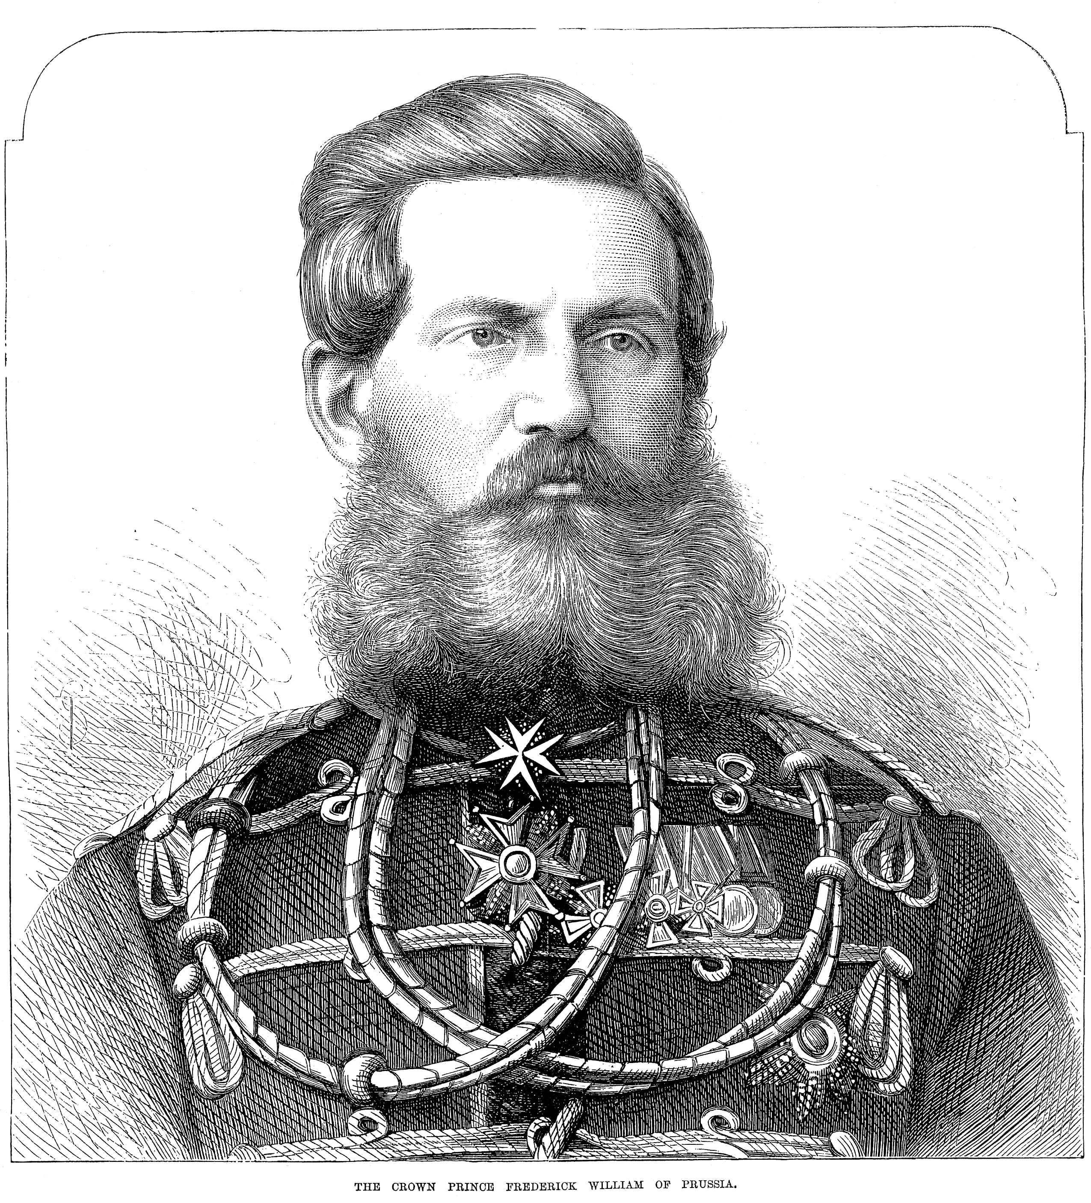* Frederick WilliamⅠ Peter the Great** 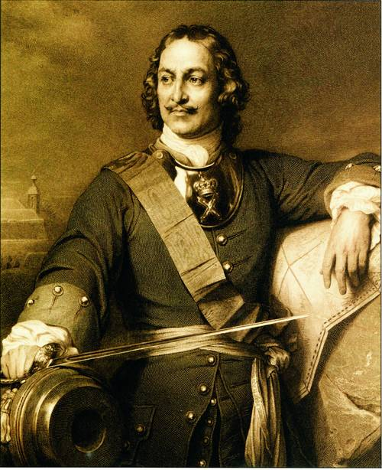

in return,______

_

give ______

Relation(Prussia &Russia)**?**

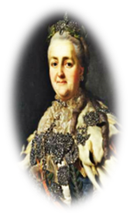 the former Germany

***Scan para.3*(wonder)*and fill in the blanks.*** CatherineⅡ

1. What did Catherine II do to make the room shine?

A. lighting 60 candles and gold B. lighting up the lights

C. adding almost 600 candles D. adding 6000 candles and gold

2. We can infer that Catherine II was a person who ______.

A. was cruel B. ignored the Amber Room

C. acted like a man D. loved beautiful things

***Scan para.4*(loss)*and answer the question.*** Nazi

What did Nazi army do to the Amber Room?

___________________________________________________________________________________________.

Relation(Germany &Russia)**?**

***Scan para.5*(rebuilding)*and answer the questions.***

Who rebuild an Amber Room? _______________________________________________________________.

Relation (Germany &Russia)**?**Why?**______________________________________________________________.**

**Part C （对应目标3）**

Group discussion: **Do you think the amber room is worth rebuilding or not?**

Take the following reasons into consideration

**“for “**

**“against”**

1. the cost
2. historical reason
3. difficulty
4. economy

…

|  |  |
| --- | --- |
| for | We agree with the opinion that. Firstly,…Secondly,…Thirdly,… |
| against | We disagree with the idea that…First of all,..what’s more,…besides… |

________________________________________________________________________________________________________________________________________________________________________________________________________________________________________________

**Part D (堂测) Summary**

*an amazing history*

**Fred.I→Fred.W.I→ Peter the Great→Catherine II→ Nazi army →?**

*an amazing friendship*

At first, the Amber Room _________ to Fredrick I. In 1716 Frederick William I gave it to Peter the Great as a _________ of friendship. In ___________, the czar sent him a troop of his best _______.

Later, Catherine II had it moved to the palace outside St Petersburg and told her artists to ________ more ________ to its design. Thus, the room was completed the way she wanted.

Sadly, in 1941 some of the Nazis secretly _________ it. This was a time when Russia and Germany were ____ ________. After that, what happened to the Amber Room remains a _________.

Recently, the Russians and Germans have _________a new Amber Room.