**Traditional Chinese Holidays**

**Lantern Festival**

**Ⅰ Watch the video and fill the blanks**

Lantern Festival, the earliest 1.____________(exist) carnival in China, falls on the fifteenth day of the first lunar month. Its arrival also marks the end of Spring Festival celebrations.

It is 2.____________(custom) to appreciate the beauty of Lanterns at night during Lantern Festival. Large scale lantern exhibitions are held throughout the country. The Zigong Lantern Show in Southwest China’s Sichuan province and Yuyuan Lantern Show in East China’s Shanghai are 3.____________(represent) lantern shows with traditional local characteristics. 4._________ increasing number of Chinese living abroad, the world is gaining interest and accepting Chinese culture. Lantern shows are held every year in many parts of the world 5.___________(celebrate) Lantern Festival.

There also regional differences in China’s lantern art culture. Lantern with lit candles are signatures of the South. In Northeast China, Lantern Festival in Harbin, HeilongJiang province, boasts 6._________ one-of-a-kind scenery. Glittering and translucent ice sculpture in different shapes create a fairytale of 7.____________(crystal) reflections of color and light.

In addition to 8.____________(view) lanterns, there is another custom of Lantern Festival that cannot 9.____________(miss), eating tangyuan or glutinous rice balls. The feelings can be sweet such sesame or jujube paste or savory, with minced meat. These sweet and round delicacies are molded from glutinous rice flour, symbolizing wholesomeness of family. Sometimes people will pick out a tangyuan and put in a special “stuffing” such as a coin. The one lucky person 10._________ bites onto that coin is said to be blessed with good luck in the new year.

Lantern Festival is the last day of Chinese New Year celebrations. For those working or studying away from home, it is time to **bid farewell** to their families and set out on a journey in a brand new year.

**ⅡCheck the answers and study the words**

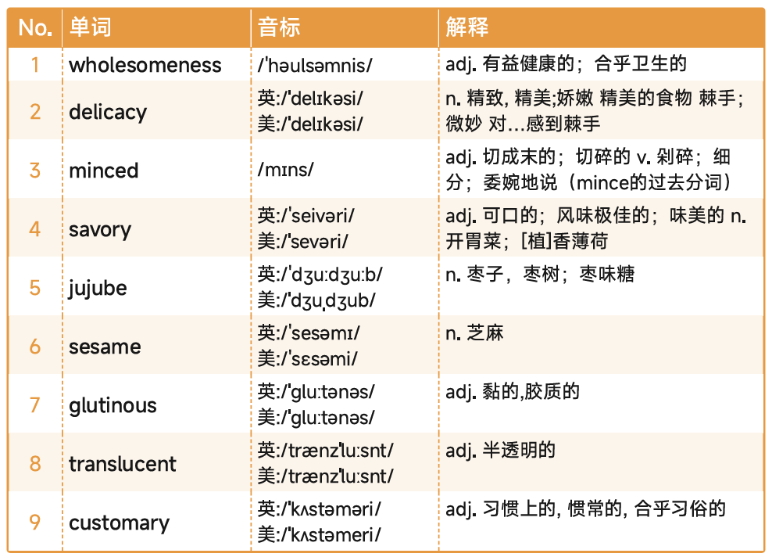

**Ⅲ listen to the whole passage and consolidate the relevant words with another passage and video.**

