Welcome, Xie Lei

Business Student Building Bridges
Textbook Analysis:
This reading text shows an exchanged student named XieLei, who went to the UK for a year-long exchange programme. At first, it is difficult for her to adapt to the life in the completely new surroundings, by studying on her own and seeking help from her tutor, she adapted to the life in the UK gradually, both in daily life and academic requirement. In this process, she embraced British culture and actively spread Chinese culture, building a bridge for Chinese-British cultural exchanges.
Learning objectives:

By the end of the class, students will

1. get to know Xie Lei’s challenges and solutions in the UK;

2. trace the changes of Xie Lei’s feelings;

3. introduce the four stages that Xie Lei experienced.
Teaching procedures:
Step1: Lead-in
- present a diagram of the increase in the number of Chinese students studying abroad from 2002 to 2022.
- Question: Have you ever wondered what challenges you will encounter when you come to a completely new country ?
Suggested answers: diet, accommodation, language barrier......

Step2: Detailed exploration
Activity 1: Listening
Task: Draw the words or expressions that describe time in the text.
Conclusion: written in order of time
Activity 2: Pay attention to the title,subtitle, picture, and the last para
Where do you think the text is from?
- a science magazine B. a school newspaper
- A travel journal D. an advertisement brochure
Suggested answers: B
Activity 3: para1--2: Honeymoon stage 留学蜜月期
Find the following elements：
when: who: what: how:
Conclusion: an experience
Suggested answer: uncertain/adventurous
Q: Is it easy for XieLei to adapt to the lives in the UK?
Famous saying: All things are difficult before they are easy
Growth is a life-long journey but not a predictable destination.
---Dr Thomas Fuller

Activity4: para 3 and para 5: Discomfort stage 留学不适期

Activity5: para 4 and para 6: Recovery stage 留学恢复期
to be an a learner
Suggested answers: autonomous
P15 exercise 4
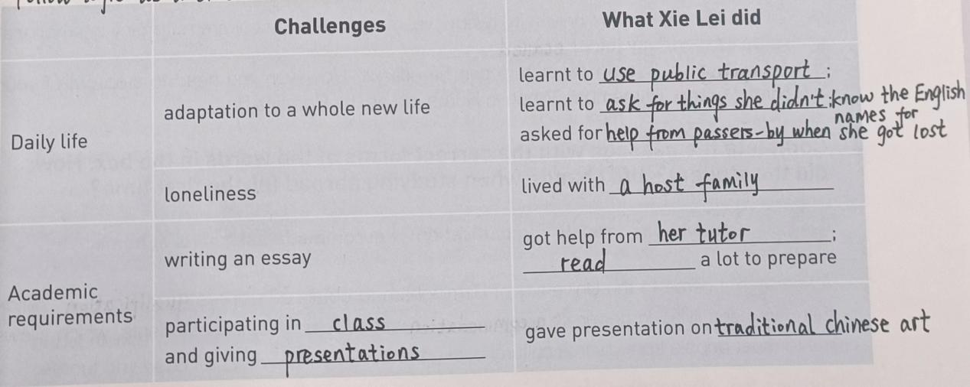
Critical thinking, logical thinking
Success factors:
external factors:
1. living with a host family
2. having a tutor’s guidance
internal factors:
Para2: “My ambition is to set up a business in China after graduation” she explained. ambitious
Para3: At first, XieLei had to adapt to life in a different country. “You have to get used to a whole new life,” she said. adaptable
Para3: “ I had to learn how to use public transport and ......,I ask them to repeat themselves a lot!”
independent
Para4: We take turns to cook each evening. They really love my stir-fried tomatoes and eggs! capable
Para6: What surprised her was that she found herself speaking up in class after just a few weeks.
capable, strong-willed, determined
Para6: “My presentation on traditional Chinese art was a great success, which boosted my confidence,” she said. capable, persistent
Para7: “As well as studying hard, I’ve been involved in social activities.
hard-working, active
Question: which is more important? external factors or internal factors?
The internal cause is the root of the development of things, and the external cause acts through the internal cause.
---Philosophical statement

Activity6: para7: Adaptation stage 留学适应期

Step4: Scan and circle the words to trace the changes of Xie Lei’s feelings.

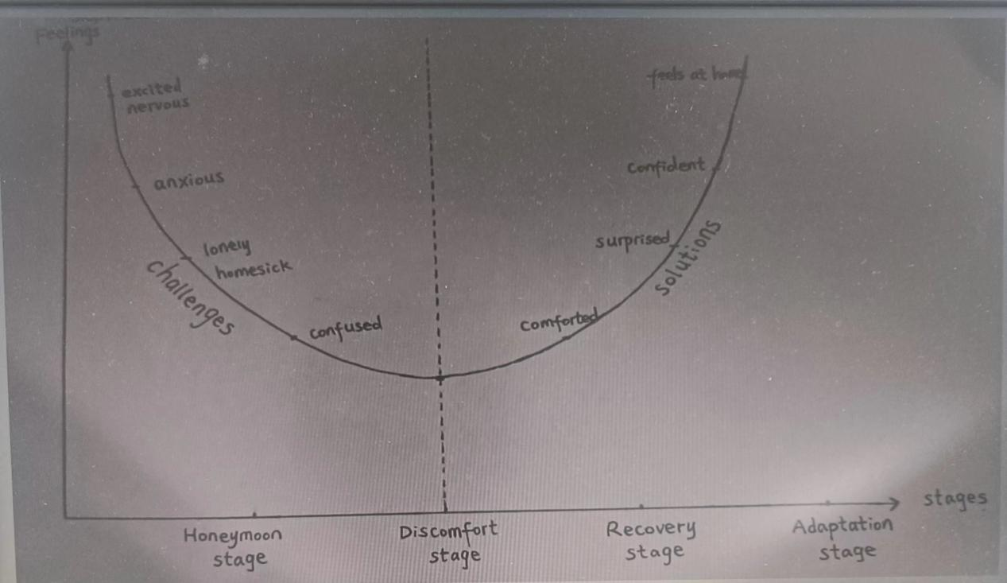

Question: why did XieLei experience discomfort stage?
Culture Shock: Culture shock is a natural phenomenon that occurs when one has a cross-cultural experience.Culture shock may cause homesickness. This refers to the feeling of longing for one's home.

Step5: Title
What bridges? a bridge of culture: shared Chinese culture (Chinese cuisine and art)and learnt foreign culture (global business, English and social activities)

Step6: deep thinking
XieLei experienced the four stages of studying abroad. When you go from middle school to senior school, do you have similiar experiences?Please make a dialogue with your partner based on the four stages ,you can refer to the expressions in BOOK 1 Welcome unit.

Step7: conclusion
T: with the improvement of China’s national strength and opening-up, as well as the formation of world economic integration, I strongly encourage you to have the opportunity to go abroad and study overseas. Before you study abroad, Let’s remember president Xijinping’s remarks : build a community with a shared future of mankind. Therefore, studying abroad is so much more than improving your own future, it’s also about shaping the future of our motherland---China, and the world we all share.

Step8: Homework

