Living legends (reading and thinking)教学设计
主题语境：人与社会-----体育与健康
语篇类型：人物传记
授课时长：45分钟
文本分析：
本文是一篇介绍体育健将的人物传记。该部分有两篇人物传记，分别介绍了有“铁榔头”称号的中国女排总教练----- 郎平。该部分以时间为顺序，主要从人物功绩,面临困难，迎头而上，最终荣获奥运金牌。第二篇介绍了“飞人”乔丹，主要从精湛的技巧，永不停止尝试的精神力量，乔丹本人坚守的信念，及其成功后回馈生活几个方面逐一介绍。
重点词汇master, captain, determination, graceful, honor glory, failure, fall apart, lose heart, give up主要涉及体育健将的身份、荣誉及其面临的困难时的态度。
本文的价值取向在于学生通过本文的学习，体会到“健康向上，不懈奋斗，团结协作”的体育精神，通过文本的梳理，人物的比对分析形成正确living legends的评判标准。
学情分析：
本班学生英语基础尚好，学习态度端正。多数学生具备获取细节信息的能力，部分学生能用英语表情达意。但是不少学生在逻辑推理，分析比对，总结评价等方面的能力较欠缺。此外学生虽然对体育话题兴趣盎然，但是本文两个人物与孩子有一定代沟，让孩子们在学习生活中移情，养成不畏艰难，团结协作的精神，并不能一蹴而就。
Teaching aims：
- Read quickly to get basic information about Lang Ping and Jordan; read deeply to understand why they can be called sports legends.
- Understand the meaning of some useful expressions in the context of the text .
3. Read and analyse concrete sentences, learning how to talk and write sports legends.
4. Through comparison, form the standards for judging the legendary figures and learn to choose the legendary sports stars we like.
Teaching important and difficult points：
- Master the basic structure of the text through global reading.
- Analyse the character of the living legends through digging the context.
- How to let students dawn on the methods of writing biography using the splendid expressions in the texts.
Teaching methods:
- Community Language Learning 2. Suggestopedia
3 Total physical response 4. Product-oriented approach
Teaching aids：
Multimedia, Blackboard, Chalk
Teaching Procedures:
Step1.Lead-in
- Present a video before class to make students excited and introduce the new words: impressed, impressive,unique etc.
- Show the honor and glory of No. 3 Middle School and have a small talk their schoolmates HuWeidong to let students know that living legends are not far away from them. In the meantime, I introduce the new words: honor,glory,master and set good examples for etc.
设计意图：
创设情境，引出关键词汇和主题。（互动模式：IW）
Step2. Pre -reading
1.Show the Word Cloud Art created by Tagul.
2.How can we predict the content before reading a new text?
①By looking at________________________________________________
②By looking at________________________________________________
③By.......
设计意图：
以 “字云”的形式提取文章关键词，有助于学生预测即将读到的内容，并且训练了学生的“看”的能力。(互动模式：IW)
Step3 .Global reading
Scan the text quickly to find the answers.
Lang Ping
- Achievements:Lang Ping is a successful player,________and person
- ________________:①One of the best player suffered ________
②The _________ had to leave because of heart problem
- Solutions: She didn't _______ ______,and had confidence in her players
- Results:They became world _________ in 2015 and 2016
Micheal Jordan
Fill in the information card based on the text.
Nickname:______________
Skills:____________________________________
Mental strength:____________________________
Words:①________________________________________
②______________________________________________
Actions:① ____________________________
②___________________________________
设计意图：
学生在有限的时间借助smart art图表和information card，将知识可视化，降低了认知负荷，初步形成对人物传记的整体结构的表象。（互动模式：IW&GW)
Step4.Close and critical reading
Read the passage again and try to figure out the answers to the questions in groups or pairs.
Lang Ping
- “As a player........As a coach..... As a person........” what rhetorical device(修辞手法）does the the author use?Why?
___________________________________________________________________________
- How do you find Lang Ping from the sentence “She has faced difficulties before.”?

- What can you learn from the sentence “ the young players could win if they worked together as a team.”?

- How does the author organize the content? Is it a time order or space order?
Micheal Jordan
- How do you understand the sentence “ time seemed to stand still”?

- What’s the function(功能）of the sentence “His skills were impressive, but his mental strength that made him unique.”?
___________________________________________________________________________3.Why does the writer use the words said by Micheal Jordan himself?

- What can we learn from Micheal Jordan?

- Compare Lang Ping with Michel Jordan, and summarize common qualities of successful athletes .Add more words.
Lang Ping: experienced___________ ____________ ____________ __________
Micheal Jordan: skillful____________ _______________ ____________ __________
Common qualities of living legends like them: athletic_________ __________ ________
设计意图：
首先，通过jigsaw reading，让学生互教互学，激发学生的阅读兴趣，提高阅读效率。
其次，依据语言处理三步骤理论，在掌握文本说了什么的基础上（what），文本学习的重点应放在弄清文本是如何（how)表达的及其为什么（why），故本部分以整体结构为依托，详细分析了人物传记的如何写，通过文章中具体句子设计问题，引导学生理解排比句的妙处，过渡句的承上启下的同时，也掌握了本文的有用表达，为后文自己撰写living legends搭好了脚手架。
最后，通过让学生比对分析郎平和乔丹品质的异同，总结出杰出运动员的共同品质，培养学生的批判性思维和正确的价值取向。
Step5 . Appreciate splendid expressions
Read the following sentence and figure out the answers.
1.The master of the garden is a master of language，who is said to have mastered 6 languages.
2.The captain of the football team joined the army and became a captain. After retirement，he became a captain of a ship.
3.The Boys and Girls Club which Jordan started in Chicago has been helping young people since 1996.
→How _____________ helping young people?
→He _____________ young people for approximately 25 years.
Exercises:
①The players _________________ every day and night for the last week.
②Her fingers are injured.She ________________ too hard recently.
Summary(现在完成进行时）:(学生自己先总结）
Find the proper expressions in the text to fill in the blanks in a correct form.
Fill in the blanks with correct forms.
At the very beginning of the new term, I was _________(determine) to be a ________(championship),however,when I fell far behind my classmates in every subject, my dream seemed ______(fall)apart suddenly. Fortunately,my head teacher, ____is a graceful lady,informed me that I should accept my_______(fail)and never give ____, because nothing is challenging if I put my heart into it. My teacher’s words were so_________(impression) that I took her advice after thinking about my ________ and weaknesses .I _________( practise) heart and soul since then. Finally, I achieved my dream ________ brought me honor and glory.
设计意图：
语言点的学习不能脱离语境，不能脱离生活，要在阅读中体会用法，在反复使用中掌握词汇，本节课的语言点的用法表面上看没有专门讲解，实际上每个环节都在反复使用这些词汇，让学生在潜移默化中掌握语言点。本文中学生已经学习了定语从句和动名词短语作主语，我把这一语法设计成三句口号，让学生去反复说，代替用处不大的指令“stop/time is up！”，及训练了句型，又巩固了生词。
Step6. Post-reading
Based on the biographies(传记）and the useful expressions , write a new living legend of Hu Weidong and send your suggestions to LLS@sports.net.
Nickname:China’s Jordan Birthplace: Xuzhou city, Jiangsu Province
Position: Forward(前锋） Skills：splendid bounces(弹跳），graceful moves and jumps
Player experiences:
- He became a professional basketball player in 1985.
- At the 1996 Olympics, Hu Weidong led the Chinese team to win the eighth place.
- In 1999, he was named the most valuable player in Asia.
Coach experiences:
- In 2004,2007 and 2011,he worked as head coach for Jiangsu Nangang Team.
- In 2012, he retired(退役）as head coach.
NBA experience:
In 1998 and 2000,he was offered a 10-day short-term contracts by the Dallas Mavericks and
the Orlando magic, but he failed to make the trips because of injuries.
设计意图：
本部分是成果产出，学生运用所学语篇结构和语言知识，仿写自己心目的体育健将，在语篇的层次上以书面形式使用所学语言知识，虽然难度较大，但对于巩固所学的语言知识及完成中心任务意义重大。由于时间紧迫，学生对胡卫东也不是那么了解，关于胡卫东的简介，我给出相关参考资料，这样做，学生可能会写出前篇一律的人物介绍，但是学生掌握了方法后，课后可以写各自心目中的living legends。
板书设计：

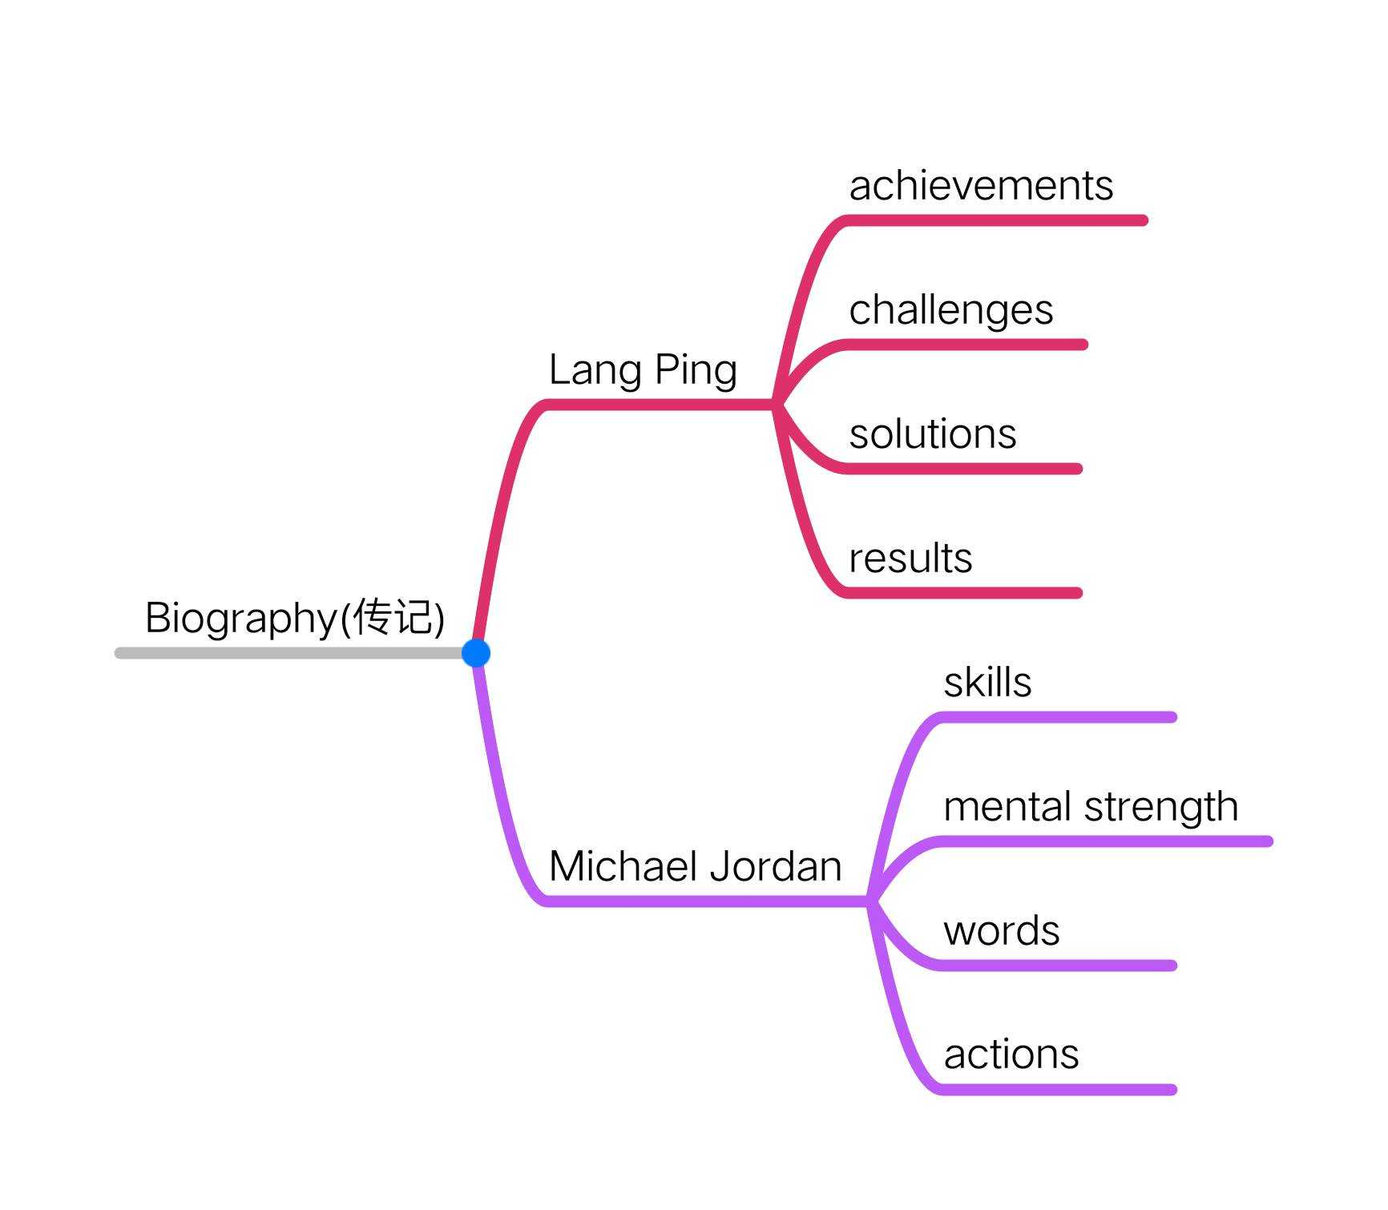
Splendid expressions:
Key words: athlete,master, honor, glory,championship, determination, injure, graceful,impressive,strength, failures
Key phrases:
Set good examples for, at home and abroad, because of, led... to, be known as,lose heart
Key sentence pattern:
①Attributive clause introduced by relative pronouns: who, which, that
②V-ing used as subject: “Losing ..... is......”
③have/has been doing...

