**如何最大效度开发利用一篇语法填空**

**导学案**

**PART 1 反思**

【题目呈现】

Whenever you have to write a paper, a letter, or any other document for work or school, you probably head toward the computer. Now, most people reach for ______（keyboard）faster than they pick up pens. In a Scottish primary school, however, Mr. Norman Lewis is taking a different approach He feels that neat handwriting ______（be） still an important skill, so he has his students write not only by hand but also______ old fashioned fountain pens.

Fountain pens______（use） in schools long ago and have been regaining popularity lately because they are refillable Today, a writer______（simple） throws an empty pen away and gets ______ new one.

So far, Mr. Lewis is pleased with the results of his experiment. He reports that his students are taking more care with their work, and their self-confidence has improved as well. He is happy with the_____ （improve） he sees in his students’ writing ______ in his own writing He knows that computers are here ______ （stay） and that they will not disappear However, he believes that the practice with fountain pens helps students to focus, to write faster, and they can feel proud of （they）.

**完成训练后，提出几个有价值的易错反思问题。既可以是答题方面，也可以是命题底层逻辑。**

Q1: _______________________________________________________________________

Q2:_______________________________________________________________________

Q3: _______________________________________________________________________

Q4: _______________________________________________________________________

**【高质量问题释疑】**

**Q1：58题做错，那什么时候才能考虑平行结构？**

平行结构: 指的是相同的语法结构，它要求有同等重要的思想、概念，并列的句子成分要用同类的语法形式来表达，平行结构是一种修辞手法。它可以使句子前后保持平衡和协调，从而增加语言的连贯性。**它要求词与词、短语与短语、句子与句子一一对应)**

... so he has his students write not only by hand but also with old-fashioned fountain pens. (学生容易基于not only...but also这个平行结构，前面有by hand，后面就想当然选择了by foutain pens，就算最后一段“**with fountain pens**”结构复现时都没有考虑纠错)

**比较下面两题：**

①After more than 20 drafts, the final design of the medal features the natural landscape of Hangzhou in the style of a traditional painting --- ________(mist) hills, a rippling lake, and rolling mountains on the front, and the back face features the logo of the Olympic Council of Asia.

②Censorship prevents a movie from being shown or a book ___________(sell).

**Q2：62题为什么不能用improvements？**

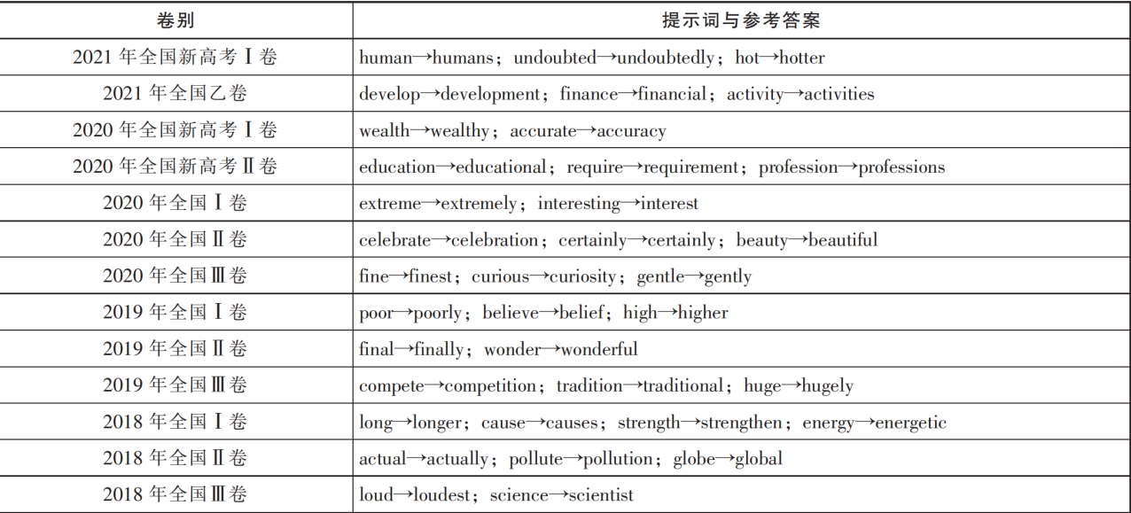

命题潜规则：提示词一般都是经过_______________得到正确答案。

【2021年新高考】 The hot spring at the foot of the mountain is something you must try after the climb. It will _________________ (undoubted) help you get refreshed!

**Q3：64题该如何理解清楚to stay? 如何溯源出处？**

【牛津】be here to stay/have come to stay: **to be accepted or used by most people and therefore a permanent part of our lives**

【朗文】here to stay: **if something is here to stay, it has become a part of life and will continue to be so**

【剑桥】here to stay: If something is here to stay, **it has stopped being unusual and has become generally used or accepted:**

【训练】It's not uncommon for individuals who are new to online investment platforms to fall ______ some schemes promising unrealistically high returns, only to discover later that they have been deceived.

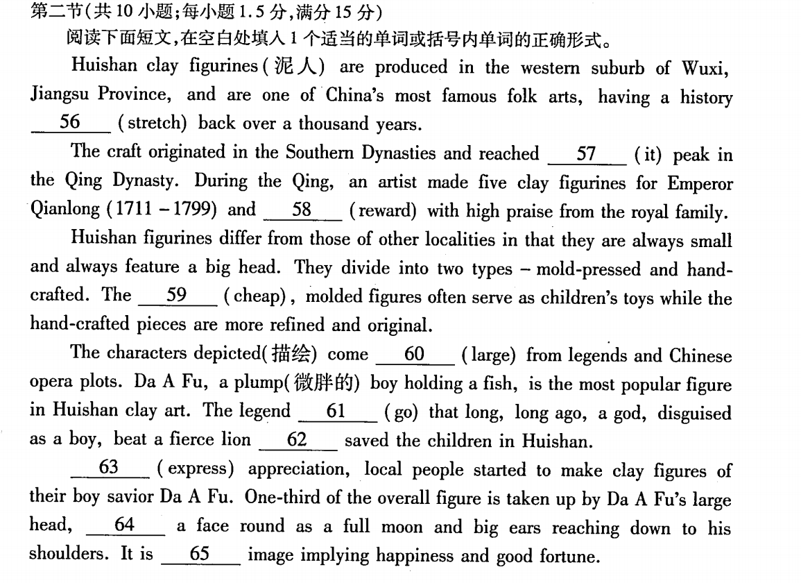

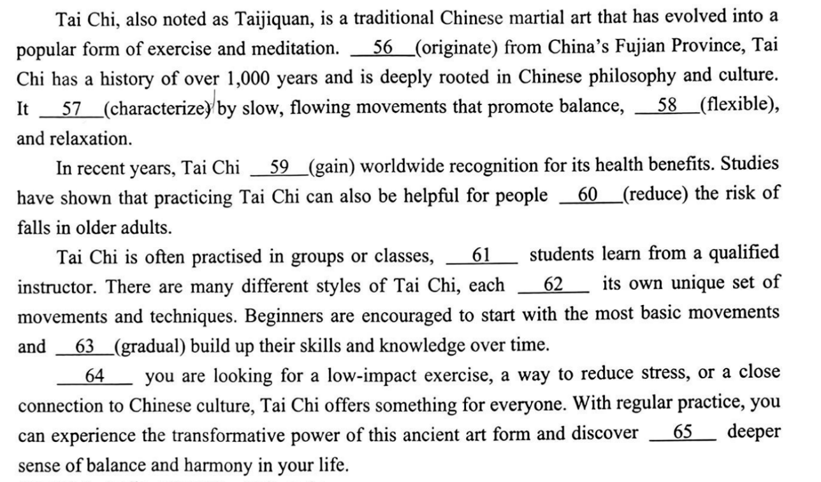

**PART 2 换位**

**请你对2024年1月浙江真题进行基于自我认知和命题研究的再次命题。**

**【列出10个考点即可】**

The shelves in most supermarkets are full of family-size this and multi-buy that. However, if you’re shopping for one, buying extra to benefit from price ___56___ (reduction) doesn’t make sense. Either your shopping is then too heavy ___57___(carry) home or you can’t use what you’ve bought while it’s still fresh.

Of course, shops are not charities — they price goods in the way which will make them the ___58___ (much) money. If most of their customers are happy to buy ___59___ (large) quantities, that’s what they’ll promote. But that leaves the solo (单独) customers out of pocket and ___60___(disappiont).

Many supermarkets are no longer doing “buy one get one free” promotions because of the criticism ___61___ they lead to waste. Consumers prefer money off individual items. However, though it’s nice to get a few cents off a pack of sausages, ___62___ would help even more if they could sometimes be offered in smaller packs. Even the biggest sausage fan doesn’t want to eat them every day

If your supermarket sells loose produce, then ___63___ (buy) smaller quantities is easier. Over the last two years, some supermarkets have started selling chicken or salad in packs designed with two halves containing separate portions (份). Then, when you use one section, the other ___64___ (stay)fresh.

Who knows, perhaps some of the more forward-looking ones may yet come out with ___65___ whole range of “just for you” pack sizes with special offers as well.

**对比真题形式，比较你的命题尝试与真题的区别，注意考点的数量控制。**

**PART 3 语料**

|  |  |  |
| --- | --- | --- |
| **English Vocabulary** | **中文翻译** | **词性** |
| document |  | n. |
| probable-probably |  | adj/adv. |
|  | 键盘 | n. |
| approach |  |  |
|  | 整洁的 | adj. |
| popularity |  | n. |
| refillable | 可再次填充的 | adj. |
|  | 自信心 | n. |

head toward/towards __________________

reach for __________________

pick up pens __________________

neat handwriting__________________

old fashioned__________________

fill-refill-refillable__________________

the practice with__________________

采取一个不同的方法__________________

重新流行__________________

对……感到满意__________________

稳定存在下去__________________

对……感到自豪__________________

**PART 4 链接**

【24浙江首考】If your supermarket sells loose produce, then buying smaller quantities is easier. Over the last two years, some supermarkets have started selling chicken or salad in packs designed with two halves containing separate portions . Then, when you use one section, the other stays fresh.

【23.6新高考一卷】Xiao long bao (soup dumplings), those amazing constructions of delicate dumpling wrappers, encasing hot, tasty soup and sweet, fresh meat, are far and away my favorite Chinese street food.

应用文简略语境假设：

____________________________________________________________________________

应用文简略语境假设：

____________________________________________________________________________

【24浙江首考】However, he believes that the practice with fountain pens helps students to focus, to write faster, and they can feel proud of themselves.

应用文简略语境假设：

____________________________________________________________________________

**课后补充练习：能力检验与题目开发设计讲解**

Debates 56 the subject of carbon capture have been going on recently. Scientists, especially engineers and geologists, have strongly criticized green groups who claimed that carbon capture and storage (CCS) schemes are costly mistakes.

The scientists insisted that such schemes 57 （become）vital weapons in the battle against global heating. They also warn that failure to set up ways to trap and store carbon would make it 58 （possible）to meet the emissions target by 2050. “CCS is going to be the only effective way in the short term 59 （prevent） our steel industry,manufacture（基础设施）and many other processes from continuing to pour emissions into the atmosphere,” said Professor Stuart Haszeldine, of Edinburgh University. “ 60 we are to have any hope of keeping global temperature increases down below 2 degrees Celsius, we desperately need to develop ways to capture and store carbon dioxide.”

Green groups claimed CCS would not make “a meaningful contribution to 2050 climate targets”. They say CCS was not reliable to decarbonize（脱碳）the energy system and that CCS has 61 history of over-promising and under-delivering. Instead, they urged the construction of more renewable energy plants 62 （give）priority.

But the claims 63 （dismiss）by engineers and geologists. “These claims are quite unfair,” said Michael Stephenson, director at the British Geological Survey.

A government spokesman for the Department of Energy and Climate Change said, “We are committed to meeting our climate change targets in a way which is affordable 64 can provide secure energy to families and businesses. We are considering the role that CCS could play in decarbonization of the UK. But we also need to take government spending into 65 (consider). CCS had better come down in cost.”

on the subject of __________________

carbon capture __________________

costly mistakes __________________

meet the emissions target__________________

pour emissions into the atmosphere__________________

urge sth. to be given priority__________________

be committed/devoted/dedicated to doing__________________

在对抗……的战役中__________________

作出一次有意义的贡献__________________

有着……的一段历史__________________

把……考虑进去__________________

**\*课后可以自行对本篇文章进行命题方面的再开发探索。【列出10个考点即可】**