Lesson5 户外活动 Outdoor Activities
（ Hiking / Cycling / Driving / Fishing / Camping / Outdoor survival ）
一、导与思：看下面三张图片，试着描述图片中所显示的情感。
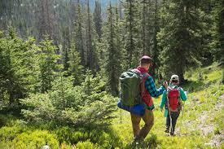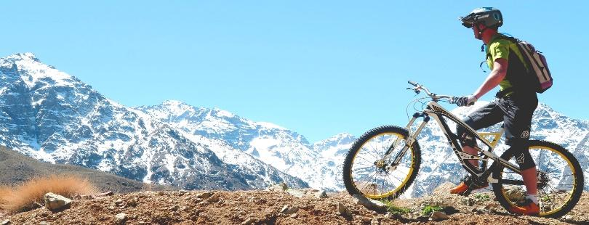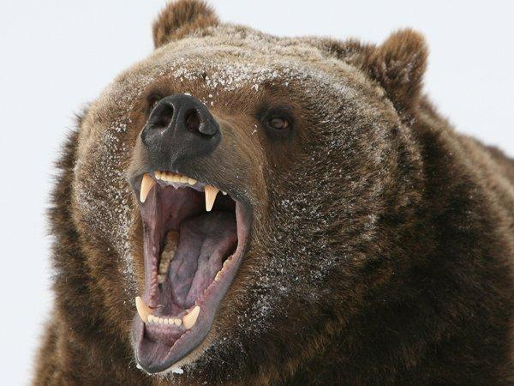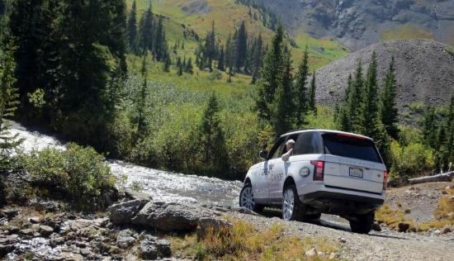
Picture1：

Picture2：

Picture3：

Picture4：

- 学与记：学习和积累相关语料，建立适合自己的语料库。
1. Related Vocabulary
Nouns：

Adjectives：

Verbs：

Expressions：
Rescue
抓住绳子
搭起帐篷/搭起避难所
发动机轰鸣着发动起来
猛踩刹车
抛锚或爆胎/换胎
生火
投下救生圈
摇下窗户
（用力地）拉开门
（用力地）推开门
使劲把门撞开
宁可事先谨慎有余，不要事后追悔莫及
In the wild
互相扶着，蹒跚地走向卡车
沿着泥泞的小路艰难地行进
涉水进入洪水
被树根绊倒了
穿过陡峭岩壁的小道
潺潺的小溪
刻在陡峭山坡上的粗糙台阶
鞋子在岩石小道上沙沙地响
食品包装袋被打开时的噼啪声
燃烧发出噼啪声的篝火
正在弹奏的吉他
绑在肩上的笨重的背包
蒙在脚或鞋上的灰尘
Wildlife
松鼠叽叽喳喳，在树干上乱蹦乱跳
马用鼻子蹭手掌 狼凶猛地向我们咆哮
狗喘着粗气大声吠叫
发出令人毛骨悚然的咆哮
毒蚊的瘙痒
多刺的荆棘
鸟儿鸣叫
昆虫嗡嗡叫
遇到危险动物(灰熊、美洲狮)
吓得斑点小鹿跑过马路
2.Using Vocabulary：用所学词汇，再次对三张图片进行描述。
Picture1：

Picture2：

Picture3：

三、赏与析：欣赏、分析和积累关于“Hiking / Cycling / Driving / Fishing / Camping / Outdoor survival”的描述性语言的句子和表达技巧。
1.Use similes and metaphors and other rhetorical devices（使用修辞手法，尤其是表达情感的隐喻）
表达情感的隐喻
情感  是  对手 | 1我怒火中烧。  2他克制住了愤怒。  3我太激动了。  4他异常好奇。  5我感到愤怒和痛苦。
情感  是  统治者 | 1他焦虑万分，难以入睡。  2我激动得什么话都说不出来。  3她感到心情抑郁，甚至惊恐不安。
情感  是  人手 | 1她心中充满恐惧。  2她妒火中烧。  3她突然惊慌失措。  4她焦虑不安，身心憔悴。  5我好几周都沉浸在愤怒和痛苦中。
情感  是  液体 | 1他惶恐不安。  2他满怀喜悦。  3我感到怒火中烧。  4一阵惊恐袭上她的心头。  5从那以后他们一直沉浸在悲伤中。
情感  是  光线 | 1他喜上眉梢。  2她喜气洋洋，容光焕发。  3老板今天心情很好。  4她这周心情一直不好。  5听了这个消息，他满脸愁云。
情感  是  动物 | 1他喜上眉梢。  2他慢慢感到一丝恐惧。

2.Rhetorical devices (修辞手法) suitable for this Lesson
Metaphors隐喻 / Similes 明喻/ Personification 拟人
阳光 | 1太阳快要下山了，但是在仲夏的天空中，有一层淡淡的柔和的薄雾。  2他们躺在草地/海滩上，沐浴在和煦的阳光中。  3在烈日下暴晒了一天后，我的皮肤开始脱皮。  4一缕阳光落到路上，好像在表达对他们的鼓励与祝福。  5当我涉过水晶般天蓝色的轻柔的水时，日落就像蓝色画布上的橙色颜料。  6逗留在天际的最后一缕阳光被迅速落下的夜幕擦除，就像是天空被一层漆黑的幕布覆盖。  7灿烂的太阳像一颗金色的宝石挂在树上。  8炽热的阳光像一把刀刺进我的皮肤，汗水流淌在我的额头上。  9太阳透过金黄的叶子俯视着他们；岩石为他们准备好了铺满青苔的座位；小鸟和松鼠好奇地看着他们，嘀咕着这些奇怪的人到底在它们的树林里做什么。
风/云/雨 | 1.微风轻拂着我的脸颊。  2柔和的微风摇动着树叶，树叶随风起舞。  3一面旗子在狂风中哗哗啦啦地抖个不停。  4不祥的阴霾在头顶上汇聚。  5微风给我们送来花的芳香。  6巨大的乌云预示着暴风雨即将来临。  7雨疾落在我们脸上。/雨点啪啦啪啦打在窗户上。/大雨噼里啪啦地打在挡风玻璃上。  8风怒吼着，把雨打在窗户上。  9大雨倾盆，狂风怒吼。  10听到树在呼啸的寒风中吱吱作响，雨水打在车窗上，我的手心都冒汗了。  11雨水不停敲击着窗户，向最后一缕阳光告别。 （大雨即将来临）  12雨水疯狂地溅在他身上，我看到的是一个英雄般的身影……  13咄咄逼人的冷风像一只无家可归的狗渴望着美味的骨头一样呼啸。  14芬芳的微风轻轻抚摸着我的脸庞，仿佛抚慰着我所有的的疲惫和恐惧。  15雨滴疯狂地打在挡风玻璃上，天空笼罩在一片灰色之中，我几乎看不清卡车里的人影。  16一阵狂风刮过我的头皮，树叶在小径上胡乱飞舞，把我的头皮变成了一片橘红色的狼藉。
黑暗/晚上 | 1黑暗轻轻地哼着摇篮曲。  2黑暗笼罩着我。  3暮色消失在黑暗中。  4但是再也没有直升机飞来，天又黑了。立刻，一片漆黑笼罩着森林。  5一个模糊的庞然大物在雾中隐约出现。  6在黑暗中可以看见两个闪烁的人影。  7午夜湛蓝的天空点缀着闪烁的星星，给周边场景一种童话般的质感。  8漆黑的雨夜，风雨交加，电闪雷鸣，我全然被这种力量镇住了。  9无尽的黑暗吞噬了一切。  10黑暗如漆黑的墨汁流淌在大地上。  11黑暗象一条蛇似的潜入森林。  12夜空像最深的海洋一样漆黑。
烟/火 | 1.烟盘旋上升。  2熏烟几乎使我窒息,使我的眼睛感到剧痛。  3火星点燃了干木柴，我们可以看到融融的火焰，散出温暖。  4红色的火焰像树枝一样伸展到天空。  5大火像恶魔一样吞噬了森林。
水 | 1小船任由汹涌的波涛摆布，很快就被吞没了。  2当我们的船驶往大海时，海岸离我们越来越远。  3我们费力地溅着水花趟过潺潺的溪流。  4不幸的是，水灌了进来，漫过了我的腰。  5那个湖对于钓鱼者来说,一年四季都是天堂。  6湖水呈深蓝色，阳光照在清澈如镜的湖面上闪闪发光。  7山谷的水直冲平原，像无数奔腾的野马发出雷鸣般的咆哮声。（夸张）  8水不停地涨，仿佛要把我活吞下去。
车 | 1.刹车失灵，自行车撞到了墙上。  2拖拉机/卡车/货车在崎岖起伏的小道上颠簸。  3汽车停下时刹车发出尖利的声音。  4在某个时刻，我们发现自己置身高处，彷佛骑车穿越云层。  5如释重负，我开车回到家——沿着蜿蜒曲折的道路行驶，沿途风景如画，令人赏心悦目。  6我们沿路行驶时，轮胎下的碎石发出劈啪声。我们的前灯照亮了狭窄的道路，在沟渠中闪了两道亮光。  汽车/自行车飞快地穿过马路。  7 汽车像一阵风似地疾驰而去，后面扬起一阵尘土。  8骑手以极快的速度奔向目的地。  9汽车/自行车像病人一样慢了下来。  10车子像一片树叶一样颤抖着，随时都有可能被洪水冲走，这使我寸步不动。  11虽是秋天，但是西藏已开始下雪了。我们的腿又沉又冷，感觉就像大冰块。 你看到过雪人骑自行车吗？  12这匹狼就像玩游戏一样追逐着汽车。Paul立即加快车速，Mac的心依旧像小鹿一 样跳个不停(紧张、心有余悸)。  13当那些过路的司机不停车就从我们身边疾驰而过时，我们从未失去再试一次的希望——鼓起我们的勇气大声叫喊，因为我们害怕会错过一辆面包车。
伤痛 | 1一阵剧痛爬满全身。  2剧烈的疼痛遍布全身,使我蹦跳起来。  3血流如注。  4血从伤口涌出。  5有一个很大的伤口，这个伤口好像就等着被发现呢，因为布鲁诺一看见它，它就开始流血。  6我的背部突然一阵刺痛，像地震一样。  7血液像蜂蜜一样缓慢地扩散。
野外/宿营 | 1半夜里，天空变得晴朗了。夜晚很安静，几乎没有风，只有大自然的声音和篝火的火焰与我们作伴。  2静得连针掉在地上都能听见。  3山那边传来猫头鹰的叫声——不吉利的声音！  4他唱歌时山谷发出回声。  5他的声音在岩壁中回响。  6这条小路陡峭地通向山顶。  7爬上悬崖后，壮丽的景色展现在我们面前。我们在一个突出的狭窄岩石上匆匆架起一个帐篷过夜。  8树林里的空地上有一圈十间小屋。每扇门旁都有玫瑰花丛，柔滑的花朵上点缀着大黄蜂。微风从周围的树林吹进来，吹动着每扇窗户的窗帘，撩起了我手臂上的毛发。  9星星像钻石一样闪闪发光。  10狂风像饿狼一样咆哮着，他们在帐篷里挤作一团取暖。狮子哀鸣的声音使他们毛骨悚然。  11月亮像一盏昏暗的灯，从上面照下来，星星也好奇的眨着眼。  12空气中散发着枯叶、冰冷的树皮和即将到来的冬天的味道。
自然/风景 | 1 亨特①马上被眼前的风景虏获/②完全沉浸在大自然的美丽中，迫不及待的要去探索。  2如果你有足够空闲时间，你会惊奇发现大自然创造了一场视觉盛宴。  3恐惧使他加快了脚步。  4王鹏受到好奇心的驱使，走了进去。  5第二天早上，在她们的车窗外到处是灌木丛和枫树，挂满朱红、赤金和橘黄色的叶子，地面覆盖上一层薄霜，表明秋天已经来到了加拿大。  6漫步在林荫小道，树叶在我脚下嘎吱作响。偶尔，有叶子会从我身边掉下来，轻轻地摇晃，缓缓落到到地面。  7周围被一片漆黑所笼罩。我被大自然咆哮的力量攫住了，一种恐惧感向我袭来。我立刻转过身，溜进被窝，蜷成一团。

3.户外运动--- “helicopter rescue”的描述高分赏析
At that very moment, the helicopter arrived.
(2020年7月浙江高考读后续写第二段开头)
1....The loud drone scared the bear to step back a few inches. A rope ladder was put off from the helicopter, Elli gripped it swiftly and climbed up and it was my turn.
2....The buzz hovering over our head, a soft ladder dropped off. Words failed to express our utter merriment and we climbed up into the helicopter with the camera embracing tightly in my arms.
3....The whir of the 's propellers scaring the bear away, the helicopter zoomed down and the rescuers rushed to us soon.
4....The helicopter hovered over the camp, the deafening noise disturbing the bear. The huge wind blew the bear unsteady on his feet. The bear pounced at Elli and me with a snarl when rescuers in the helicopter fired a drugged bullet at the bear, the bear fell to the ground.
5....The gusting wind from the hovering vehicle swept away our choking fear immediately. Out of the helicopter descended a rope to haul us up. Thrilled yet relieved, we clutched the rope and eventually landed on the helicopter safe and sound.
4.户外运动--- “Outdoor survival”的描述高分句型
✍With jaws clenched, I resolved to keep edging closer, inch by inch.
✍To our dismay, all these efforts were in vain.
✍“I’m sorry, and I should have taken your advice,” I murmured, head drooping. Joe chuckled in relief, “You are safe. That’s enough.”
✍Then he threw a thick rope so that I could hang on to it and walk straight toward him. I opened the door, grabbed it and inched out.
✍A sudden surge of relief sweeping over me, I exclaimed at Elli, “We're safe now!”
✍Picturing the road cracked and the car was flooded away, I felt more frightened and sensed death was waiting for me. “Jump out of the car and ran to me!” Joe yelled and got off the truck, waiting for my action.
✍The moment we pulled ourselves out of the water, the car was washed away. What a narrow and an unforgettable escape!
✍That was a lucky miss.
✍We only just missed/ escaped having a nasty accident.
✍It's a marvel that I escaped unhurt.
5.户外运动--- “fishing” 的片段描述赏析
It was a still, sweet day of early summer; the long afternoon shadows of the trees lay cool across our path; the leaves seemed greener, the flowers brighter, the birds merrier, than ever before.
My uncle, who knew by long experience where were the best haunts of pickerel, considerately placed me at the most favorable point. I threw out my line as I had so often seen others, and waited anxiously for a bite, moving the bait in rapid jerks on the surface of the water in imitation of the leap of a frog.
Suddenly something pulled at my line. Off with it swept the line into deep water倒装. Pulling it up as quickly as I could, I saw a fine pickerel wriggling in the sun. “Uncle!” I cried, looking back in uncontrollable excitement, “I've got a fish!” “Not yet,” said my uncle. As he spoke, I saw the fish shooting into the middle of the stream and there was a splash. My hook hung empty from the line. I had lost my prize.
6.户外运动--- driving 的片段描述赏析
Suddenly, in the middle of nowhere my mom pulled over, hopping out of the car and grabbing the flowers from the back seat. “It’ll just be a minute,” she called back through the open windows. My eyes impatiently skimmed the edge of the road before settling on a little sign showing that it was a nursing home. I looked back to the building, somewhat annoyed, as my mom reappeared— empty-handed．
Before she started the car, curiosity drove me to ask, “Do you know someone there?” She shook her head. “Then what did you do with the flowers?” She smiled slightly, “I gave them to the receptionist. “What?” She laughed at my confusion. “I told the receptionist to give the flowers to whoever needed them, especially who hasn’t gotten any in a while.”

7. Sublimate the theme of the article （升华文章的主题）
1）What do you think is the meaning of traveling or outdoor activities?

- Learn six ways to sublimate the theme of the article ( 升华文章主题的六种方法 )
浙江高考续写 —— 有关户外活动的主题意义探究
1.201610  丛林逃生  （场景特点：丛林、溪流、直升机、外套) | ☆ Seeing Tom, she excitedly told him how much she missed him and only when she was in such helpless situation was she aware that her beloved Tom meant so much to her. Tom gave her the warmest and longest hug she had ever received.  ☆ Tom got off the helicopter and dashed to his beloved wife at once. “Oh, my dear Tom! I will never leave you again!” The couple hugged tightly. After this life-risking journey, they realized the precious love between them could conquer every difficulty in life.  ☆ It was the narrow escape that made Jane perceive that love was priceless. Over the next years, a change came over the couple. Reasoned discussion replaced fierce arguments and politeness replaced contradiction. They treasured the life and love more.
2.201706  狼口脱险  （场景特点：夏日下午、公路、自行车、汽车） | ☆ On the way home, night breeze made him at ease and he couldn’t wait to share his experience with his wife and daughters and show the kindness of the world.  ☆ The story of this narrow escape had vividly and dramatically demonstrated that nothing could be intimidating if you are calm and brave enough.
3.201710  健忘妈妈旅行记  （场景特点：开车旅行探亲、宿营、沿途风光） | ☆ Through this trip, I discovered that，despite my occasional anger towards her, I actually felt proud of Mom. This was the trip of my life.  ☆ Though she did love going camping, she presented that poor boy with this tent out of sympathy. It was Mom that made my childhood colorful. And it was also she that showed me the true meaning of giving.  ☆ Seemingly absent-minded and forgetful as she was, she never failed to demonstrate the beauty of life to her children, and endowed us with a fun-filled childhood and a never-drained passion to embrace life.  ☆ This thrilling, memorable trip reminded every now and then that Mom was not all about an absent-minded, forgetful person, but was someone who was fully aware of how to add color to daily life. It dawned on me that once we explored, life would embrace you.  ☆ I gradually realized that I was not reluctant to set out for trips any more. Anyway, it was such a wonderful way to broaden our horizons and explore the outside world. Finally,when we reached our destination, I was even eager to set out once again. Undoubtedly, it was all my mom's magic to shape me into a travel lover!
4.201806  父子寻路  （场景特点：农场、河流、兔子、骑马） | ☆ Never had I experienced such a thrilling yet dangerous vacation before. The special trip to the Wild West was deeply engraved in my mind forever.  ☆ Reflecting on this memory, I regarded this experience as my special adventure with my dad.  ☆ Back in the farm house, we reflected on the exciting yet dangerous experience, which was carved in our mind permanently.  ☆ Finally, we arrived home safely just in time for supper, but what an experience! It turns out there’s always a way out of any plight as long as we stay calm.
5.202007  北极熊营地拍照遇险  （场景特点：营地、北极熊、拍照、直升机） | ☆ After we calmed down, the locals told us that the bears were losing their homes and food because of human activities and climate changes. On the way back home, I checked the precious pictures in the camera, lost in thought.  ☆ It was a tremendously nail-biting experience, from which I realized that we should keep harmony with wild animals and maintain a safe distance to protect ourselves as well as to avoid hurting them.  ☆ Once safe, I took out my camera and admired the pictures. Only then did we figure out that the bear was not out of malevolence but so starving as to be murderous. Seeing this, I sank into silence. Maybe it was human's invasion that drove bear to search food desperately.  ☆ To our surprise, so perfect was the last picture that we thought it did deserve our life-risking effort. Initially what seemed like a nightmare ultimately turned out to be a rich reward. “Surprise hides everywhere.” Elli blurted. “Maybe it's just the most secret and attracting part of life.” I replied. Smile blossomed on both of our faces.

四、练与讲：写小片段，比较不同水平的表达。
Use at least 3 similes or metaphors and the outdoor living vocabulary you have learned to continue the piece of writing below. Add between 50 - 75 words in the space below to continue the story. Your writing should use at least five items from the vocabulary chart. Aim to use compare objects, feelings and descriptions to something else to paint a picture. Complete this task in no more than 20 minutes.
The weekend had finally arrived, and Glenn and Macy decided to go for a bike ride in the mountains. They strapped on their helmets and cycled onto the open road. The scenery was like a painting by a famous artist. The waves on the lake danced with the wind. All of a sudden, Macy’s front tire popped, and she tumbled onto the rocky ground.

Glenn’s eyes widened when he saw the blood running down Macy’s leg.

五、测与评：实战演练，学会合理的支架搭构和丰富的语言表达。
阅读下面短文，根据所给情节进行续写，使之构成一个完整的故事。(2018年6月浙江高考试题)
It was summer, and my dad wanted to treat me to a vacation like never before. He decided to take me on a trip to the Wild West.
We took a plane to Albuquerque, a big city in the state of New Mexico. We reached Albuquerque in the late afternoon. Uncle Paul, my dad’s friend, picked us up from the airport and drove us up to his farm in Pecos.
His wife Tina cooked us a delicious dinner and we got to know his sons Ryan and Kyle. My dad and I spent the night in the guestroom of the farm house listening to the frogs and water rolling down the river nearby. Very early in the morning, Uncle Paul woke us up to have breakfast. "The day starts at dawn on my farm," he said. After breakfast, I went to help Aunt Tina feed the chickens, while my dad went with Uncle Paul to take the sheep out to graze(吃草). I was impressed to see my dad and Uncle Paul riding horses. They looked really cool.
In the afternoon, I asked Uncle Paul if I could take a horse ride, and he said yes, as long as my dad went with me. I wasn’t going to take a horse ride by myself anyway. So, my dad and I put on our new cowboy hats, got on our horses, and headed slowly towards the mountains. "Don’t be late for supper," Uncle Paul cried, "and keep to the track so that you don’t get lost!" "OK! " my dad cried back. After a while Uncle Paul and his farm house were out of sight. It was so peaceful and quiet and the colors of the brown rocks, the deep green pine trees, and the late afternoon sun mixed to create a magic scene. It looked like a beautiful woven(编织的) blanket spread out upon the ground just for us.

注意：
1. 所续写短文的词数应为150左右；
2. 至少使用5个短文中标有下划线的关键词语；
3. 续写部分分为两段,每段的开头语已为你写好；
4. 续写完成后，请用下划线标出你所使用的关键词语。
Paragraph 1:
Suddenly a little rabbit jumped out in front of my horse. ________________
______________________________________________________________________________________________________________________________________________________________
______________________________________________________________________________________________________________________________________________________________
______________________________________________________________________________________________________________________________________________________________
______________________________________________________________________________________________________________________________________________________________
_______________________________________________________________________________
Paragraph 2:
We had no idea where we were and it was getting dark.
______________________________________________________________________________________________________________________________________________________________
______________________________________________________________________________________________________________________________________________________________
______________________________________________________________________________________________________________________________________________________________
______________________________________________________________________________________________________________________________________________________________
_______________________________________________________________________________

