Ice-breaking Drawing 破冰素描

---2024-11 金华十校

*Knock-knock-knock*. “Hello? ” I called timidly through my cousin Anita’ s bedroom door. No answer. There's no way she forgot I was moving in today, right? I thought. “Anita? It's me, Norah! ” I called again.

I had only met my cousin once a couple of years ago when Anita and Aunt Sonam had flown to California to visit. **Mom had hoped Anita and I would be friends. But all Anita wanted to talk about was soccer, which was practically a foreign language to me. Secretly, I had felt relieved when the visit was over.**

Now, I was standing in my aunt's tiny apartment in New York City, and there was still no answer from Anita. I knocked again, a little louder this time. Finally, Anita opened the door. She apologized, saying she had been listening to music. **But instead of inviting me in, Anita frowned at my massive suitcase.**

Behind her, I could see a blue beanbag chair crowded next to a bunk bed（上下铺）. In my old room in California, I'd had a double bed all to myself, and my original artwork had covered all the walls. **Anita's walls, on the other hand, were covered with posters of the U. S. women's soccer team. I didn't see any free space to hang anything else.**

“C-can I come in? ” I asked, blushing. Anita nodded, but she barely moved. I had no choice but to squeeze by her into the room. **I put my stuff against the wall and Anita started bouncing the soccer ball from her foot to her knee and back again.** Suddenly, her foot kicked the ball at an odd angle, and it accidentally flew toward me. “Whoops! ” Anita called. “Think fast! ”

**But I was still taking in the surroundings, so the ball caught me off guard and bounced off my shoulder. Forcing a smile, I pretended it didn't bother me. Unsure of what to do, I took out my sketchbook（素描本） and colored pencils and sat down.** Just holding my sketchbook made me feel more at ease. I started sketching aimlessly while Anita went back to bounce her ball.

Para1: Suddenly, it dawned on me that I could draw Anita in action.

Para2: Anita studied the drawing carefully.

一、设计理念：

1. 本文人物：主角： 我 & Anita 配角： my mom & Aunt Sonam

2. 所给原文内容： 原文矛盾冲突为数年前因爱好迥异，Norah 和Anita 这对表兄妹没有如妈妈们所愿成为好朋友。

3. 情节构思：①Norah 画画要观察，画的内容回扣原文Anita颠球则可；

②结局设计考虑回扣原文妈妈们的愿望，表兄妹会成为好朋友。

二、教学过程

Step1: Analyze characters

I ： passionate about drawing ;

Anita: enthusiastic about soccer

Step2: Sort through the plot of the story

Conflict : A couple of years ago, I didn’t make friends with Anita because I didn’t like soccer.

Solution : I respected her hobby and she respected my drawing and we finally befriended each other.

Step3: Read for clues for the new plot of the continuation writing

Use hidden clues to create logical and reasonable details for the continuation.

Step4: Design plots for each paragraph

Possible Version:

Para1: Suddenly, it dawned on me that I could draw Anita in action. A faint smile appearing at the corner of my mouth, I quickly flipped to a blank page. Listening to the ear-catching rhythm of Anita’s hitting the football, I intently observed Anita bouncing her ball from her foot to her knee and back repeatedly. She was completely immersed in her soccer with her eyes locked onto the ball all the time. Never in my wildest dream had I imagined that Anita maintained her enthusiasm for soccer for so long. Colored pencils dancing happily on the page, an overwhelming sense of admiration for Anita welled up inside me. As I was occupied in capturing every detail of her dynamic movements, my initial embarrassment and awkwardness gave way to calmness and ease. Time fleeting, a vivid drawing took shape, which attracted Anita’s attention. (130)

*Para2: Anita studied the drawing carefully.* As her eyes scanned the drawing, her face cracked into a radiant smile. Eyes sparkling with excitement mingled with joy, Anita exclaimed, “It's amazing, Norah! You make me look like a super football star!” Casting an appreciative glance at me, she asked me if she could have it and put it on the posters. Wearing a proud smile on my face, I nodded readily, offering to help her to paste it onto the wall. Staring at the newly-added drawing, Anita declared confidently and enthusiastically, “I hope to join the US women's soccer team in future! Thank you for bringing my dream closer!” 结尾一：*Thanks to the drawing, I found a subtle way to bridge the gap between us. Meanwhile, a seed of a beautiful friend was sown in our hearts despite our distinct differences in hobbies.* (135) 结尾二：*Knowing the ice between us began to melt, I breathed a sigh of relief, convinced that my devotion to art and her dedication to soccer would make us befriend each other.*

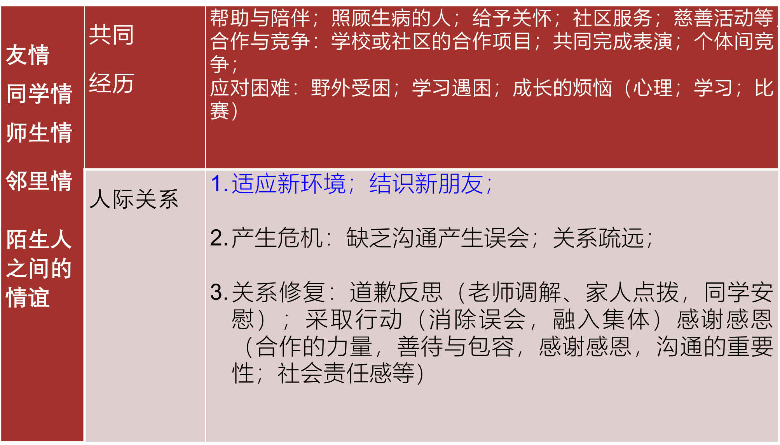

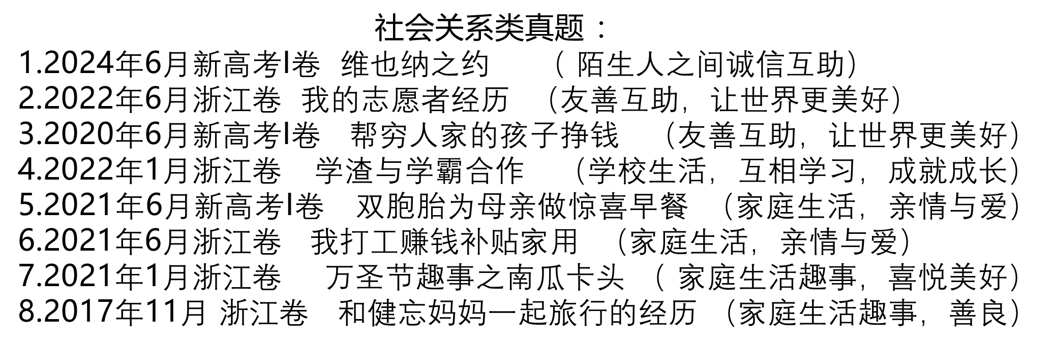

*该类文章语料：*

*1. Luckily, we children learnt a valuable lesson from the experience --- It is care and love that make the world a beautiful place to live in. ( 关爱)*

*2. This experience taught our kids a very important lesson --- it is love that works miracles. （关爱）*

*3. That Halloween was the funniest, the most scary and the most fruitful that I had experienced, which made me an online celebrity. （趣事）*

*4. What happened on that September cold, wet and unforgettable evening served as a beautiful reminder of how trust can bring people closer together. （信任）*

*5. Our joint project ended, I felt blessed/ fortunate/ lucky to befriend such a remarkable guy. （友谊）*

*6.* *When it came to the time I gave out another half to the family, my Dad’s dry eyes were moistened. That mid-70s summer was my first step of growing up. （责任）*

*7. Sweeping me tightly into his arms, he praised me for my sense of responsibility. From that day, I understood father more and thankfully our mutual understanding was strengthened. （ 责任 亲情 ）*

*8. Ice melting, a beautiful friendship began to blossom in their heart. As time went by, the cousins were closely bonded like peas and carrots.*