**山重水复“续”有路，读析“写”评又一村**

**2025年1月首考读后续写：真假小偷**

------杭二中树兰高中 郭合英

**第二节（满分25分）**

阅读下面材料，根据其内容和所给段落开头语续写两段，使之构成一篇完整的短文。

Kevin was pretty bored. His mother was at work, and his father had been away on business. Therefore, he was left in the care of Mrs. Hill, an old lady who lived next door. His parents had raised the 12-year-old to be a good boy. He never got into trouble, though sometimes he wanted to do risky things. Mrs. Hill was asleep. Kevin sighed (叹息) and hoped something exciting would happen. Suddenly, a movement outside caught his eye.

Mrs. Hill’s front window faced Mr. and Mrs. Green’s house across the street. The couple had both gone to work, so it was strange that someone was over there. Kevin stared at the man at their front door. Suddenly, the man jumped through an open window into the house. With his heart in his mouth, Kevin grabbed Mrs. Hill’s home phone and called the police.

Thinking that the man might get away with whatever he wanted before the police arrived, Kevin decided to do something. He rushed out of Mrs. Hill’s house and crossed the street quickly. Grabbing a branch from a cut-down tree, he jumped in through the window. “Stop right there! You must leave right now!” he called out, holding the branch with both hands.

The man froze for a second, but when he saw the skinny boy he breathed a sigh of relief. “Hey, kid, put that down. It was my home. My parents used to live here and my father’s watch was here,” he explained, trying to lift a floorboard.

At that moment, the sounds of a police car echoed (回响) in the air. The man stood up in a panic, then ran through the house toward the window and jumped out. Kevin followed out and told the arriving police officers what had happened. They pursued and arrested the man.

Kevin went back to Mrs. Hill’s house. Somehow he wasn’t sure he had done the right thing. “What if he has told the truth?” he thought to himself. The man’s words sounded pretty convincing.

注意：

1．续写词数应为150左右；

2．请按如下格式在答题卡的相应位置作答。

Paragraph 1:  *When Mr. and Mrs. Green got home, Kevin went to talk to them.*

Paragraph 2:  *Kevin and Mr. Green took the watch they had found to the police station.*

**该篇续写的理论依据：读—析—写—评**

为解决当前英语读写教学中 “为读而读、 为写而写” 的问题，文章结合读后续写高考写作新题型构建了 “读—析—写—评” 的教学路径， 本文通过2025浙江首考读后续写详细诠释了 “解构语篇逻辑， 理解主题” “梳理关键信息，搭建支架” “建构情节发展，表达主题” “立足评价标准， 反思修改” 四个教学步骤。

1. **文本解读**

阅读：解构语篇逻辑，理解主题

**Step1: To find the information and finish the table（5W1H）.**

|  |  |  |
| --- | --- | --- |
| 基本  要素 | Who |  |
| When |  |
| Where |  |
| 核心  要素 | What |  |
| 拓展  要素 | Why |  |
| How |  |

**Step2: Summarizing the main idea**

Kevin’s parents were wrapped up in their own business, therefore, he was left 1 (take) after by his neighbour, Mrs. Hill. Kevin was always feeling 2 (bore), hoping something exciting would happen.

Mrs. Hill’s front window faced Mr. and Mrs. Green’s house across the street. The couple 3 (go) to work. Suddenly, Kevin found a man jumping through an open window into the house. 4 his heart in his mouth, Kevin grabbed Mrs. Hill’s phone and called the police. Thinking that the man might escape 5

the police arrived, Kevin decided to do something. 6 (grab) a branch, he jumped in through the window, ordering the man to stop and leave right now. However, the man said his parents 7 (use) to live here and his father’s watch was here.

At that moment, the sounds of a police car echoed in the air. The man ran through the window in 8 panic. Kevin told the police 9 (officer) what had happened. They pursued and arrested the man. Somehow Kevin wasn’t sure he had done the right thing because the 10 (man) words sounded pretty convincing.

1. **搭建支架(析)**

**分析：梳理关键信息,搭建支架**

**Step 3: 构建人物关系图**

Mrs. Hill

Kevin’s parents

Kevin

Mr. and Mrs. Green

a man

**Step 4: 根据契诃夫发则，挖掘矛盾**

|  |  |
| --- | --- |
| 原文句子 | 故事发生的过程 |
| Kevin was pretty bored. … Kevin sighed (叹息) and hoped something exciting would happen. |  |
| Kevin stared at the man at their front door. Suddenly, the man jumped through an open window into the house. … Kevin grabbed Mrs. Hill’s home phone and called the police. |  |
| … Kevin decided to do something. … Grabbing a branch from  a cut-down tree, he jumped in through the window. … |  |
| It was my home. My parents used to live here and my father’s watch was here,” he explained, trying to lift a floorboard. |  |
| the sounds of a police car echoed. The man … ran through … the arriving police officers pursued and arrested the man. |  |
| …Somehow he wasn’t sure he had done the right thing. “What if he has told the truth?”The man’s words sounded pretty convincing. |  |

**Discussion**

1. Is that man a thief？
2. “ Suddenly, the man jumped through an open window into the house.” What is the function of

this sentence?

**Step 5 : 利用原文线索，搭建“性格”支架**

|  |  |
| --- | --- |
| 原文句子 | 人物性格 |
| Kevin sighed and hoped something exciting would happen. |  |
| With his heart in his mouth, Kevin grabbed Mrs. Hill’s home phone and called the police. |  |
| Kevin decided to do something. He rushed out of Mrs. Hill’s house and crossed the street quickly. Grabbing a branch from a cut-down tree, he jumped in through the window. |  |
| Somehow he wasn’t sure he had done the right thing. “What if he has told the truth?” he thought to himself. The man’s words sounded pretty convincing. |  |

**Step 6: 利用逆推法，搭建故事支架**

|  |
| --- |
| Paragraph 1: When Mr. and Mrs. Green got home, Kevin went to talk to them.  Paragraph 2: Kevin and Mr. Green took the watch they had found to the police station. |

**Step 7 : 利用故事走向，推动Kevin的心理活动**

|  |  |
| --- | --- |
| 原文句子 | Kevin的心理活动 |
| The Greens found the watch from the floorboard. |  |
| Kevin and Mr. Green took the watch they had found to the police station. |  |
| After the truth was clarified, the man was released. |  |
| Although there was a misunderstanding, he received praise and thanks from the police, the man, and the Green couple. |  |

三、**建构语言**

Paragraph 1: When Mr. and Mrs. Green got home, Kevin went to talk to them.

1. (与给出句的衔接)他把事情的经过绘声绘色地向Mr. and Mrs. Green描述了一番。

2. 在听了Kevin的描述之后，格林夫妇很是惊讶并真诚地向Kevin表示感谢。

3. kevin自豪地说不用谢，但同时也表达了自己的怀疑-他不确定这个男人说的是否属实。

1. 当Mr Green夫妇把Kevin所说的细节拼在一起的时候，他们环顾四周，确定家里未丢任何东西。

5. 于是，他们决定按照Kevin所说的去验证一下地板下面是否真的有手表（与原文协同）。

6. 令在场所有人惊讶的是，他们在地板下面真的找到了一块手表。

7. 经过格林夫妇反复确认，这块手表真的不是他们的，这足以说明那个男人不是小偷。

8. Kevin意识到自己冤枉了人，这让他感到自责。他急切地请求格林夫妇带上这块手表去警察局说明真相。（带上手表与下文给出句协同）

Paragraph 2: Kevin and Mr. Green took the watch they had found to the police station.

1. 他们向警察说明了情况，并把手表交给了警察。警察联系了前房东并仔细核对了手表的细节特征。

2. 所有的细节都和那个男人交代的一模一样。难怪他一直向警察说自己是无辜的。

3. 警察把手表还给了男人，释放了他，但也提出了一些警告: 拿回自己的东西一定要通过正当的方式切不可“破窗而入” 。

4. 看到男人被释放，kevin终于松了一口气。感到欣慰的同时他也不好意思地走上前去向这个男人道歉。

5. 令人感到意外的是，这个男人不仅没有责怪Kevin，反而夸他勇敢、善良。格林先生也拍着Kevin的肩膀，在他面前竖起了大拇指。

6. 听到他们的表扬，kevin异常的开心，他觉得正是自己的勇敢和考虑周到让他做了正确的事情。

四、习作点评

作品1

When Mr. and Mrs. Green got home, Kevin went to talk to them. He described the whole process to Mr. and Mrs. Green in a vivid and lifelike manner. With Kevin’s description over, the Greens stood jaw-dropped, thanking him a thousand and one times. Kevin said no thanks with pride, but at the same time he expressed his doubts as well - he wasn’t sure whether the man had told the truth. When the Greens pieced together the details Kevin had mentioned, they looked around, confirming that nothing had been stolen from the house. So, they decided to check if there was really a watch as Kevin had said. Surprise came over everyone who was on the spot. They really found a watch just lying under the floor. Repeatedly confirmed by Mr. and Mrs. Green, the watch was really not theirs, which was enough to show that the man was not a thief. Surprise and self-accusation visited Kevin, who realized he had done wrong to the man. He eagerly asked the Greens to go to the police station with the watch to tell the truth.

Kevin and Mr. Green took the watch they had found to the police station. They explained everything to the police and handed over the watch. The police contacted the former landlord, checking carefully the details concerning the watch. All the details were exactly the same as what the man had stated. No wonder he had been telling the police all the time that he was innocent.The police returned the watch to the man, released him, and warned him that he must get back his own property through proper means and that he shouldn’t “break into the house through the window”. Seeing the man released, Kevin finally breathed a sigh of relief. At the same time, he also walked up to the man awkwardly to apologize to him. Surprisingly, the man didn’t blame Kevin, but praised him for his bravery and kindness. Mr. Green also patted Kevin on the shoulder, giving him a thumb up before him. Hearing their praise, Kevin was over the moon, feeling that it was his bravery and consideration that led him to do the right thing.

作品2

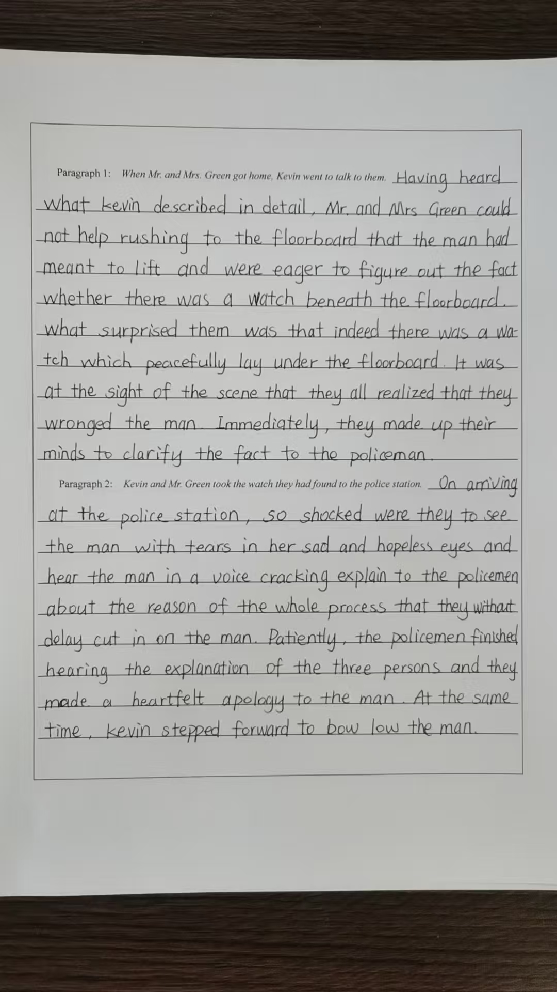

**作品3**

When Mr. and Mrs. Green got home, Kevin went to talk to them. With a trembling voice, Kevin began to describe everything that had just happened. Hearing the man’s claim about the watch， Mr. Green’s brows knitted tightly in deep thought, murmuring, “We did buy this house from an old couple. Perhaps the man had been telling the truth all along.” Down sank Kevin’s heart, as if it had been plunged into an icy river. “Let’s open the mystery under the floorboard .” Mr. Green suggested. Then they lifted the loose floorboard. There, tucked away in a dusty corner like a forgotten secret, was an old box. Inside it was a silver watch, its hands frozen in time. Kevin, staring at it, felt his guilt welling up like a surging wave. Gently patting his shoulder, Mrs. Green said, “Thank you for protecting our home, Kevin. How brave you are!” But her words did little to assuage his guilt. Determined, they prepared to return the watch.

Kevin and Mr. Green took the watch they had found to the police station. Only after they had made their fingers to the bones to explain the situation to the officers did the truth come to light. It turned out that the man was none other than the son of the previous owners. Desperate as he was to retrieve his father’s watch, he had to take such a rash act. Out came the police, warning him before setting him free. Before leaving, the man gave Kevin a thumbs up and praised him for his bravery. A strange mixture of relief and embarrassment washed over Kevin like a wave. It was Mr. Green who smiled at him, saying “It is your good intentions that matter, kid.” Nodding his head, Kevin realized that even mistakes could serve as a stepping stone to learning, and that bravery can take countless forms. On the surface, Kevin had misunderstood the man, but in fact, his actions made the light of justice shine.