**教学设计**

**Teaching Objectives：**

By the end of the class, students will be able to

1. know common trouble student’s have with English learning
2. have a good understanding of how to write a blog about English learning problems and recommendations with various expressions
3. know their trouble with English learning and form positive attitude to it

**Teaching Important and Difficult Point：**

1. How to make students reflect on themselves and summarize their difficulties in English.
2. How to make students write a blog about English learning with various expressions

**Teaching Procedures:**

**hundred**

**thousand**

**million**

**____________关于**

**Step 1: Lead-in**

Student will be asked to look at a poster and answer the following questions:

1. What’s the poster about?
2. Where can we exchange ideas?
3. How to organize your speech on an online forum.

（通过一张海报直接且简洁地导入话题）

**Step 2: Read for main idea**

Students will be asked to look through the passage and answer the questions:

1. Who puts forward the question “What are your biggest problem …”?

2. Who replies to the question?

3. What is the blog mainly about?

（快速阅读，帮助学生了解文本的大致内容，有一个心理准备）

**Step 3: Read for details**

Students will be asked to read the content carefully and fill in blanks

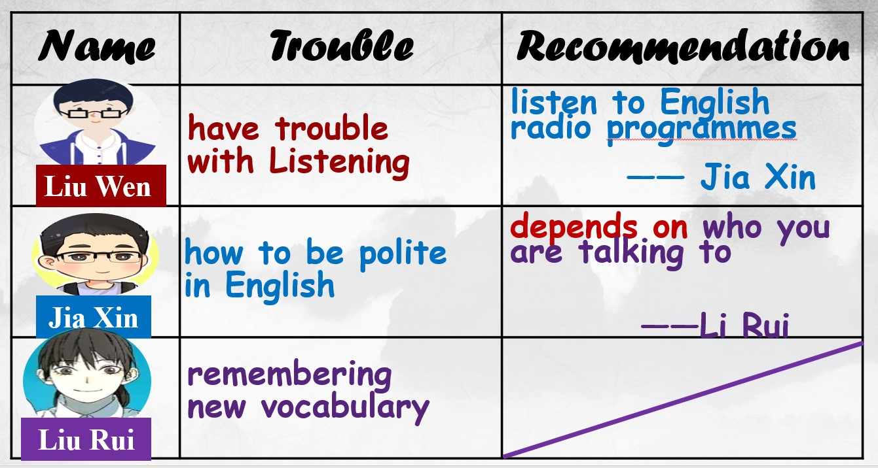

（快读、细读相结合，帮助学生了解文本的内容，对自己接下来的写作方向有一个心理准备）

**Step 4: Read for organization**

1. Students will be asked to read the passage again and answer the questions:

How do they organize their trouble and recommendations？

1. Teacher takes the Jia Xin’s post for example to work out the organization with students together
2. Summary of the organization

**Problem + example（they have met in study）**

**Trouble:**

**Advice + supporting details**

**Advice:**

1. How to put forward advice？

（通过读结构，帮助学生明白关于英语学习的blog是怎么构成的，有意识的在接下去的活动中朝着这个方向准备）

**Step 5: Discussion and drafting**

1. Students will be asked to express their trouble and offer recommendations to their partners’ trouble.

**A sample:**

**A: What are your biggest problems with learning English?**

**B: …is the biggest headache for me. I have no idea… Sometimes I believe… but in effect, I fail to…**

**A: If I were you, I would… It’s important to … That works for me.**

1. Then students will be asked to choose one problem from their partners and writer a blog about it.

**While writing, you should**

1. **Discribe the problem clearly**

**(problem+example, using various expressions)**

**b. Write one or two ideas on solving the problem**

**(advice+supporting details, using various expressions)**

**Step 6: Exchange drafts**

Students will be asked to assess each other's work according to the checklist.