**Book 4 Unit 1 People of Achievement: project -- writing a book report**

**Teaching Design of 40 minutes [教学设计]**

|  |  |  |  |  |
| --- | --- | --- | --- | --- |
| Title: Unit 1 project--writing a book report, Book 4 | | | | |
| Type of lesson | | Activity+ Reading + writing | | |
| Teaching aids | | Chalk, blackboard, powerpoint | | |
| Students: Class , grade 1 | | | | |
| Time & Date: | | | | 40minutes |
| Teacher: |  | | School: |  |

1. **Analysis of Teaching Contents and Design Concept [教学内容与设计思想分析]**

This part is a project that asks students to read a biography and then make a book report. The key points lie in how to write and polish a book report. This class is designed to be the second period of this project----the students having finished reading a biography and a report already. And the focus is on the common mistakes in students’ writing. The teacher should instruct the students to dig out authentic expressions in the text and ask students to polish the sample writings by imitating the text sentences. In the end, the students will get 3 writing polish skills and put them into use to write a recommendation.

1. **Analysis of Students [学情分析]**

Students have learned the relevant passages in the early parts of the unit, so they can understand the passage easily, but it’s still hard for them to summarize the words and expressions that can be uesd in the writing.

* In terms of language ability, the students are in the first grade senior high school. Students have got some knowledge on the usage of words in the culture and life, so they can get the main idea of the passage, but it’s still hard for them to summarize the words and expressions that can be uesd in the writing.
* In terms of learning ability, students develop a good habit of preparation and review, and most students are willing to participate in classroom interaction and expression. Students can accept group cooperative learning.
* Through this lesson, students have a general understanding of some writing skills, and their ability to put them into use are improved.

**Ⅲ Teaching Objectives [教学目标]**

* **Subject Qualities [学科素养]**
* Learn to be a person of value
* Learn to write a book report
* Learn to summarize some useful and authentic expressions from the text.
* Grasp some writing polish skills to put them into use.
* Find out a life principle to carry it forward
* **Key Abilities [关键能力]**
* Enable students to polish a book report and write a recommendation.
* Put three writing skills into use to write a recommendation.
* **Core Values [核心价值]**
* Be aware of the meaning of “achievement” and learn to be a person of value.
* Help the students find their life principles to carry through.
* Develop a good habit of reading books.

**Ⅳ Learning Strategies [方法与策略]**

* Use Social/affective strategies, Cognitive Learning Strategies and process-oriented method
* Do self-check and example -learning.

**Ⅴ Presupposed Process [预设过程]**

|  |  |  |
| --- | --- | --- |
| **Process** | **Activity** | **Skills** |
| **Lead in** | A group figures comparison | Listening&speaking |
| **Before-writing** | Sharing and discussion | Speaking&summarizing |
| **While-writing** | * Reading and Polishing | Reading&summarizing |
| * Conclusion * Imitating and writing | Summarizing  Writing |
| **Post-writing** | * Student’s job | Example-learning |
| * Thinking & homework | Summarizing |

**Ⅵ Difficult Points [教学重难点]**

* How to put the language materials into practical use.

**Ⅶ Teaching Procedure [教学过程]**

***Step one: warming-up* (2min)**

* What does “people of achievement” mean to you?
* How to get more detailed information of a great person?

***Step two: Lead-in (8min)***

* Group work: Share the books you have read about the people you admire.
* Q1. What does the book tell?
* Q2. How does the book make you feel or think about the person?
* Structure of a book report: a brief introduction + comments

***Step three: while-writing* (15min)**

* Preparations

Learn the useful expressions from the text to polish and correct the three common mistakes in students’ writings

* Learning authentic language expressions and correct tense from the texts.

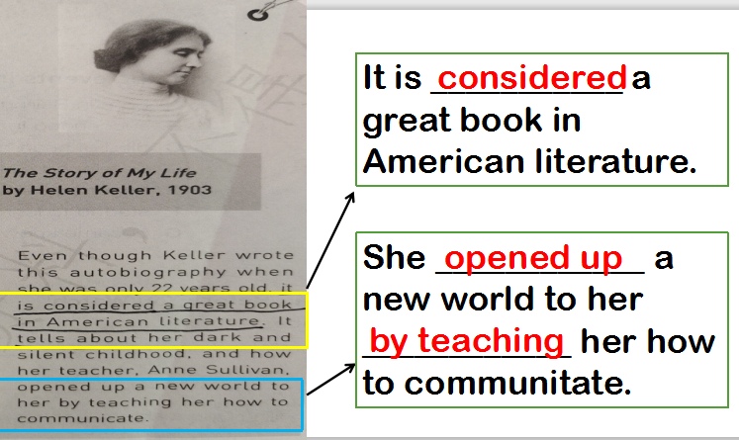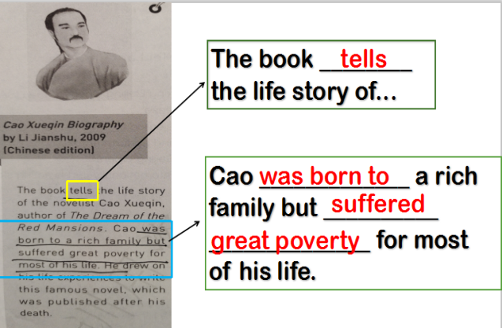

* Structure incompleteness

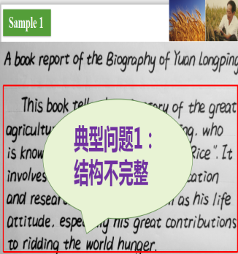 A book report of the Biography of Yuan Longping  
 This book tells the life story of the great agricultural scientist Yuan

Longping, who is known as “the Father of Hybrid Rice”. It involves his

family background, education and research experience as well as his life

attitude, especially his great contributions to ridding the world of hunger.

**The book is worth reading. It give us a deeper insight of Yuan**

**Longping’s life and how he made great achievements despite so many**

**difficulties, which inspires us to work hard to achieve my goal and make**

**contributions to society.**

* Tense misuse

A book report of the Biography of Tu Youyou

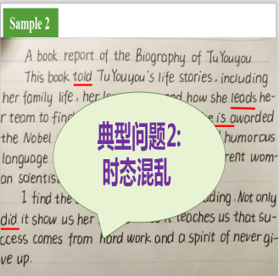 This book **tells** Tu Youyou's life stories, including her family life, her

love stories and how she **led** her team to find artemisinin, for which she

**was** awarded the Nobel prize. With a lot of pictures and humorous

language the writer **describes** a very different woman scientist to the

readers.

I find the book really worthwhile reading. Not only **does** it show

us her life but also it teaches us that success comes from hard work and a

spirit of never give up.

* Improper expressions

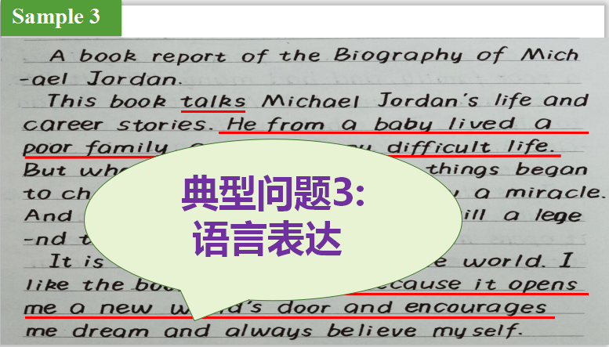 A book report of the Biography of Michael Jordan

This book **tells** Michael Jordan's life and career stories. **He was born to a poor family, and suffered great poverty.** But when he came into NBA, things began to change. The whole world saw a miracle. And Michael Jordan's name is still a legend today.

**It is considered a great book** in the whole world. I like the book very much, **because it opens up a new world to me by encouraging me**

to achieve my dream and always believe myself.

* Conclusion : three key points in writing
* Complete structure
* Correct tenseTense misuse
* Authentic expressions
* Writing--高考链接

假设你是李华，你校英文杂志Youth向你征稿，请你推荐一本伟人传记，内容包括：

1. 这本书的简介；

2. 推荐的理由

注意：词数80词左右；可适当增加细节使行文流畅

***Step four: post-reading* (12min)**

* Share and appreciate the students work.
* Thank more about the great persons in the world:
* What do they have in common?
* Do you want to be a person like them?
* What preparations are you going to make?
* **Self-check and homework**

By the end of the class, I can……

|  |  |  |  |
| --- | --- | --- | --- |
|  | Excellent | Good | Just so-so |
| Know about the biography of a great person |  |  |  |
| Know how to write a book report |  |  |  |
| Grasp and put three writing polish skills into use:  Complete structure, Correct tense, Authentic expressions |  |  |  |

* Homework:

After class, please make a book report in your class and introduce the biography you have read to your classmates.

* **Life principle: Everybody stands up and reads the spirit**

No matter what you choose, stick to your original aspiration!

(无论你选择什么，请坚持你的初心)

* **Teaching reflection**