教学设计
Discovering useful structures
Unit 1 Module 1

龚金萍
语言结构：Noun Phrase(NP)、Adjective Phrase (AdjP)、Adverb Phrase(AdvP)
语言功能：用于具体、形象、生动地描述人或者物或者一件事
活动目的：用于该语法结构的新授、操练和运用
活动形式：describing experiences
活动步骤：
Step 1: Free Talk
Questions:
1. What do you think of the military training in the first week?
2. How many students joined in the training in your class?
3. What was the weather like during those days?
4. How many hours have you been trained each day?
5. What do you think of your drillmaster?
Possible answers:
- The military training was (extremely/pretty) hard/challenging.
- 640 students joined in the training.
- It was quite hot during those days.
- We spent 6 hours in total being trained each day.
- Our drillmaster was an extremely humorous young man.

设计意图：从学生的亲身经历入手，激活学生熟悉的话题，在此基础上进行语法知识（名词
短语、形容词短语和副词短语）的归纳和总结。
核心素养提升点：语言能力——在熟悉的语境中表达个人见解和情感。
Step 2
Task 1: Complete the following passage with suitable words. (Two of them are extra)
An impressive experience of military training
Following/more/new/quite/nonstop/sudden/enough/ heavy/per/dazzling/tired/tough
Sep.6th Thursday Sunny
With the _____ school semester around the corner, 640 students in our school attended the seven-day-long military training. It was really a ______ trial(考验) to freshmen. We were trained ________ for six hours ______day in marching and walking in the hot, _______ sunshine. Presently(不久), a ______ shower worsened the situation. Beaten by the steady drops of the rain, we were almost ______ to death. However, our strict drillmaster(教官) pushed us to move on, saying “All your sweat and efforts will pay off in the end! Hold on!” Hearing the words, we hardened our will, and became ______ diligent in the ______ days. Strangely _______, we didn't feel painful any more. And finally to our joy we receive an award in the military parade.

Possible answers:
new; tough; nonstop; per; dazzling; sudden; tired; more; following; enough
Task 2: Observe the words in red and explore the structure of the phrases

Sep.6th Thursday Sunny
With the new school semester around the corner, 640 students in our school attended the seven-day-long military training. It was really a tough trial(考验) to freshmen. We were trained nonstop for six hours per day in marching and walking in the hot, dazzling sunshine. Presently(不久), a sudden shower worsened the situation. Beaten by the steady drops of the rain, we were almost tired to death. However, our strict drillmaster(教官) pushed us to move on, saying “All your sweat and efforts will pay off in the end! Hold on!” Hearing the words, we hardened our will, and became more diligent in the following days. Strangely enough, we didn't feel painful any more. And finally to our joy we receive an award in the military parade.

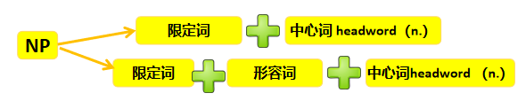
Sep.6th Thursday Sunny
With the new school semester around the corner, 640 students in our school attended the seven-day-long military training. It was really a tough trial(考验) to freshmen. We were trained nonstop for six hours per day in marching and walking in the hot, dazzling sunshine. Presently(不久), a sudden shower worsened the situation. Beaten by the steady drops of the rain, we were almost tired to death. However, our strict drillmaster(教官) pushed us to move on, saying “All your sweat and efforts will pay off in the end! Hold on!” Hearing the words, we hardened our will, and became more diligent in the following days. Strangely enough, we didn't feel painful any more. And finally to our joy we receive an award in the military parade.

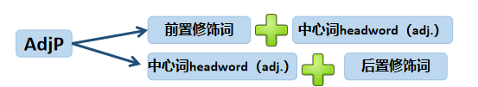
Sep.6th Thursday Sunny
With the new school semester around the corner, 640 students in our school attended the seven-day-long military training. It was really a tough trial(考验) to freshmen. We were trained nonstop for six hours per day in marching and walking in the hot, dazzling sunshine. Presently(不久), a sudden shower worsened the situation. Beaten by the steady drops of the rain, we were almost tired to death. However, our strict drillmaster(教官) pushed us to move on, saying “All your sweat and efforts will pay off in the end! Hold on!” Hearing the words, we hardened our will, and became more diligent in the following days. Strangely enough, we didn't feel painful any more. And finally to our joy we receive an award in the military parade.

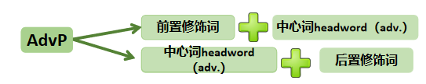

设计意图： 将来自生活的语篇引入教学既能让枯燥的语法结构在语境中变得生动又能使学生通过连贯的意义理解语法项目，并在有意义的语境中亲近、接触、了解与熟悉它们，进而更好地理解、内化以及在实际语言环境中进行交流和运用。
核心素养提升点：思维品质——注意观察、比较所给语篇中的不同短语，提取共同特征，归
纳共同要素，提出自己的看法。

Step 3:
- Brainstorm the question: What have you learnt during the military training?
- Compare the following two sentences and tell which one gives you more
information? Then discuss with your partner: What are the functions of a/an NP、
AdjP、AdvP?
A: I learnt that nothing is impossible to a willing heart.
B: The seven-day training was an unforgettable memory that was really
meaningful to each newly-admitted students. So tough as it might be, we
became more endurant through it.
Possible answers:
- they make your writing/speaking more specific
- they make your writing/speaking more visual /vivid
- they make your writing/speaking more vivid

设计意图： 通过教师提供解决问题的任务，让学生在讨论、交流的同时解决该问题，最后进行总结，从而引导学生发现和深入理解名词短语、形容词短语、副词短语的功能。培养学生自主观察、运用相关语言知识与技能来学习相关语法知识。
核心素养提升点：学习能力——自主学习和合作学习。

Step 4: Practice
- Describe the following pictures with NP/AdjP/AdvP
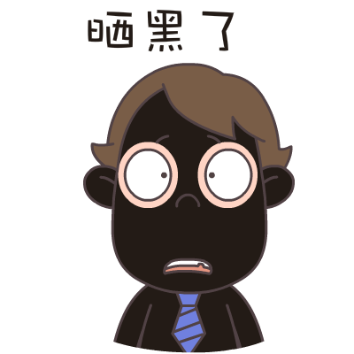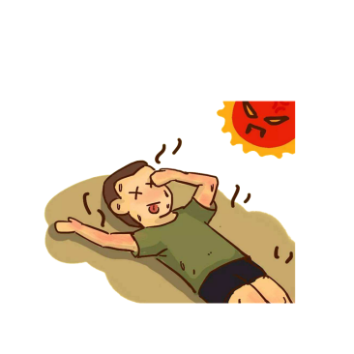
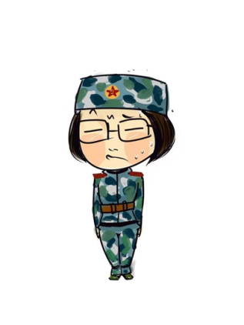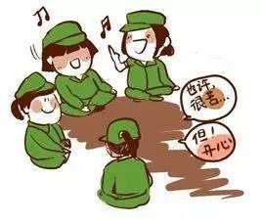
Possible answers:
图一：Beneath the extremely hot sun, beads of sweat continued to roll down my
sunburnt face.
图二：After two-hour tedious physical training, one of my classmates, Lihua, fainted
in the blazing heat.
图三：The most terrible part of the military training is to stand still for almost two
hours each day. The longer I stood, the more stiff I felt my body become.
图四：The military training made us united as a team. We shared our sweat and tears,
happiness and sorrows through daily ups and downs.

- Group work: A. Use NPs/AdjPs/AdvPs to shapen the following surroundings:
- The school contains flowers and plants that can ease tiredness.
__________________________________________________
Possible answer:
What was so amazing to see is that the fresh, lush school contains a variety
of bright, colorful flowers and strong, green plants along the playground that
can ease our tiredness.
Step 5: Discussion
- Work in group, discuss the question: Is military training necessary for freshmen?
- Try to finish the following worksheet with proper words:
A new understanding of military training:
The military training is a way to
T______ our bodies;
R______ our faith;
A______ our indolence(懒惰)；
I ______ our military spirit;
N_____ the distance between classmates
Possible answers: toughen; restore; abandon; inherit; narrow

设计意图: 通过让学生讨论“有没必要对新生进行军训”这一话题，来进行德育浸润：军训虽然苦但也是一个让学生磨砺意志、增强责任感以及树立科学人生观的好机会。
核心素养提升点：思维品质——独立思考，就讨论话题表达自己的看法和见解。

Step 6: Homework
B.Use NPs/AdjPs/AdvPs to concretize the following event
下文是Amy 所写的军训通讯稿,缺少生动、具体的描写。现在Amy求助你帮她改写文章，请你用合适的名词短语、形容词短语、副词短语丰富稿件内容，使描述对象/事件更加具体、生动、突出。

We began our military training with fear. Actually, I prayed that it would rain so we could miss it and stay indoors. But I was wrong. The training continued even it rained cats and dogs. What's worse, exhausted as we were, there was much for us to improve.
Suddenly, a girl fainted. I took her to the room. When she came to life, she cried and complained. I tried to calm her down and explained reasons to her. To my joy, she returned to continue the training with me.

Possible answer:
As planned, we began our one-week military training with increasing fear day after day. To be honest, every single day I prayed in my heart that it would rain heavily so we could miss it and stay indoors. But I was totally wrong. The training continued even it rained cats and and dogs. What's worse, extremely exhausted as we were, there was still much for us to improve.
What impressed me most was a girl beside me who fainted in the dazzling sun. I took her to the medical room immediately. When slowly she came to life, she burst out crying and complained a lot about the harsh training. I tried to calm her down and explained the positive reasons to her. To my great joy, with my encouragement, she returned to continue the training with me.
Recalling the past seven days, I learnt that the military training made us united as a real family. We shared our sweat and tears, happiness and sorrows through daily ups and downs. The strict discipline and hard training were real challenges, but it was these sufferings that strengthened our minds, and tightened our friendships.

设计意图： 通过利用名词短语、形容词短语、副词短语描述图片，学生进一步熟悉和根据实际情况操练、使用该语法结构。巩固所学语法结构并为学生的自主表达做好铺垫。
核心素养提升点：文化意识：联系生活，提出自己观点。
语言能力：在具体情境中综合利用所学语法结构进行表达。

