Teaching plan for Reading after Writing (Period 1)
温州市第五十八中学 张锦瑶
- Teaching objectives
- Students are able to better understand the story by answering the questions set by the teacher according to Labov’s mode of narrative analysis(six parts of model: abstract; orientation; complication; evaluation; resolution; coda)
- Students are able to write the outline for the two paragraphs after reading based on the information generated in class.
- Students are finally able to write the whole ending after reading in the homework part by referring to the outlines generated in class.
- Teaching key points
Students are able to write an imaginative ending which is also consistent with the given part of the story (“resolution” 结局) by answering questions related to the orientation(指向), complication(进展) and evaluation(评议) in the narrative.
- Teaching difficulties
Students are able to fully understand the evaluation(评议) buried in the narrative so that they can write an imaginative ending which is also consistent with the given part of story although there are directional questions raised by the teacher. This may be solved by T-S interaction involved in class.
- Teaching method
Task-based Teaching & Method Communicative Teaching Method
- Teaching procedure
- Lead in.
1) Watch the video clip from the film “Flipped”.
  - Explore what happened between the boy and the girl.
- Read the given part of story and answer the twelve questions raised on the worksheet.
Questions directed to “orientation” in the six parts of model:
  - Where was Dannis?
  - When did he see the black-haired girl?
  - Who was the black-haired girl?
  - What was Dannis’ attitude towards the balck-haired girl?
  - How did the black-haired girl react(反应) when she found Dannis staring at her?
Questions directed to “complication” and “evaluation” in the six parts of model:
  - When did Dannis see the black-haired girl again?
  - What was the black-haired girl doing at that time?
  - When did Dannis see the black-haired girl for the third time?
  - What was the black-haired girl doing at that time?
  - How did the black-haired girl react when Dannis talked to her?
  - Later, what happened to Dannnis and what did he decide to do?
  - What was the black-haired girl doing at that time?
- Based on the information you get from these questions, discuss whether the black-haired girl was a thief or not, list your reasons.
- She was a thief.
——“She was pushing Dannis when the latter was buying a magazine.”
——The given sentence of paragraph 2 says “The girl ran and Dannis ran after her.”
- She was not a thief.
——“The black-haired girl wore a leather coat and boots of soft leather which may be expensive.”
——“The black-haired girl was not interested in Dannis’ attention to her.”
——“When Dannis thought she stole his wallet, the girl was still absorbed in a book instead of running away with the stolen wallet.”
- Based on the two questions for writing, write the outline of paragraph 1 after the given sentence.
- What would Dannis say or do to the black girl after he occupied the seat beside her?
——Since Dannis gritted his teeth, he must be very angry. He would question her where his wallet was. Or he would even yell at her.
- If the girl was the thief, how would the girl react? If not, how would she react?
——If the girl was the thief, she would be nervous and frightened. So that’s why she ran, which is mentioned in paragraph 2.
——If the girl was not the thief, she would be totally confused about the situation and even embarrassed because Dannis’ loud questioning and yelling might arouse the crowd’s attention. That’s why she ran, which is mentioned in paragraph 2.
- Pair work: Based on the two different versions of outlines of paragraph 1, finish writing the outline of paragraph 2. (choose two groups to show their different versions of paragraph 2)
1) If the girl was the thief and she ran with Dannis following her, what would happen later? (focus on the wallet——solve the problem so as to give a resolution to the story)
2) If the girl was not the thief and she ran, what would happen later?
6. Homework
Based on the outline(提纲)，finish writing the two paragraphs. Pay attention to the connection between paragraph 1 and paragraph 2.
VI. Blackboard design:

课前：
Reading after Writing—Period 1
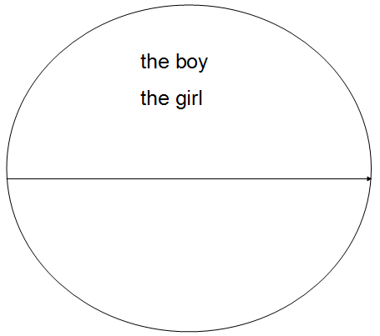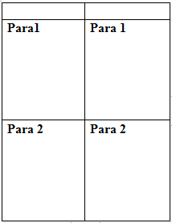

课堂生成：
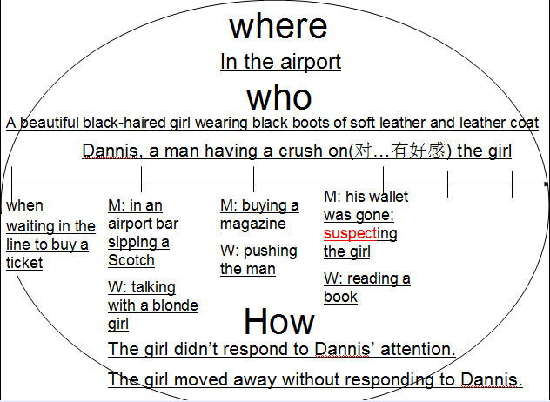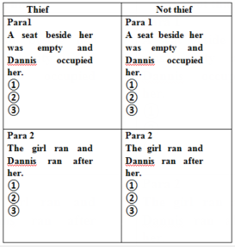

教学思路：
在新一轮的高考改革中，高考英语试卷写作部分增加了读后续写这一新题型。读后续写属于一种学术型写作任务，因此可见其难度。这是一种 “阅读+写作”的复合型任务，因此对高中生的阅读理解能力、逻辑创新能力和书面表达能力均提出了很高的要求。读后续写是指根据学生的语言水平选择一篇阅读材料，删掉结尾，让学生在理解剩余部分的基础上进行创造性续写。读后续写任务将理解与产出结合，让学习者在模仿前文语言的基础上，对后文进行内容创造，推动学以致用，因而更有利于学生语言学习。
但是，无论是良好的谋篇布局能力，语言衔接能力，语言运用能力还是逻辑创新能力，都是我校学生特别缺乏的。由于语言基础薄弱，我校学生在阅读和理解所给的材料上存在很大的困难，学生能看懂故事主要发生了什么，但是要写出具有创新性同时又与原文吻合贴切的结尾，却十分的困难。
因此，教师所教授的读后续写的第一课时：阅读与写作，就应该帮助学生学会如何去梳理所给材料的叙事内容，为学生铺垫后续的写作任务。所以，我将这篇材料拿过来作为读后续写的第一课时来设计（其中，Period 2—写作与评析：段落间衔接以及段落内衔接；Period 3—润色与提升：情绪类描写）。

