- Reading
Fan Jinshi: Daughter of Dunhuang
Born in Beijing and raised in Shanghai, Fan Jinshi was assigned to work in Dunhuang, and now serves as president of Dunhuang Academy. It has been 51 years since Fan began studying and protecting the Dunhuang Grottoes as well as popularizing Dunhuang culture. “I was meant to be part of Dunhuang,” she says.
Fan will never forget when she first visited Dunhuang in 1962. However, the land that appeared so dreamy in books turned her expectations upside down. Growing up in a modern big city, Fan could hardly become accustomed to local conditions and soon fell ill. Still, she didn’t hesitate to accept any opportunity to go to Dunhuang after graduating from Peking University in 1963.
Along with sharing the values of many young people of the time, who desired to serve the country, Fan was also driven towards her path by inspiration from Chang Shuhong who devoted his life to the study of Dunhuang culture with extremely poor living conditions. Fan was so moved by Chang’s persistence and perseverance that she followed his path and devotedly guarded the caves for over half a century.
The most fundamental task related to the study of the Dunhuang Grottoes is investigation and measurement of caves. Fan started her Dunhuang career from scratch and eventually completed the chronicling of the Dunhuang Caves dating from different period. Not only has her achievement in dating the caves been widely praised, but it also laid a solid foundation for further study of the caves.
Fully devoted in the search, Fan does not have much to do with the modern-day hustle and bustle. “Alongside academic research, preserving the caves and
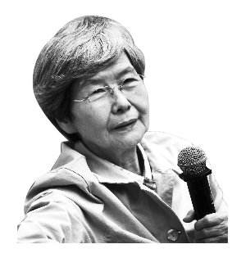
prolonging their lifespan is our top priority,” says Fan, who has also
been a key editor of papers, books and publications on Dunhuang
over the years.
“The benefits of Fan’s work are beyond measure,” commented
Ji Xianlin, a great master of Chinese culture, at the celebration of
the 100th anniversary of the discovery of the Dunhuang Grottoes in 2000. Now she has got a new name: the Daughter of Dunhuang.

► Words and Expressions

assign | /əˈsaɪn/ | v. | to give someone a particular job | e.g. Madison was assigned to  investigate a balloon accident.
popularize | /ˈpɔpjʊləraɪz/ | v. | to make something well known and liked | e.g. The programme did much to  popularize little-known  writers.
hesitate | /ˈhezɪteɪt/ | v. | to pause before saying or doing sth. because you are nervous or not sure | e.g. Please do not hesitate to  contact me if you have any  questions.
inspiration | /ˌɪnspɪˈreɪʃən/ | n. | a good idea about what you should do, write, say etc | e.g. He draws inspiration from  ordinary scenes.
devote | /dɪˈvəut/ | v. | to use all your time, effort etc in order to do something | e.g. He wanted to devote his  energies to writing films.
persistence | /pəˈsɪstəns/ | n. | determination to do sth. | e.g. His persistence finally paid off.
perseverance | /ˌpə:sɪˈvɪərəns/ | n. | determination to keep trying to achieve sth. in spite of difficulties | e.g. The only way to improve is  through hard work and dogged  perseverance.
fundamental | /ˌfʌndəˈmentl/ | adj. | the most basic and important parts of something | e.g. There is a fundamental  difference between the two  points of view.
measure | /ˈmeʒə/ | v. | to judge the importance, value, or true nature of sth. | e.g. Doctors say it is too early to  measure the effectiveness of  the drug.
scratch | /skrætʃ/ | v. | to rub your skin with your nails because it feels uncomfortable | e.g. John yawned / jɔ:n / and  scratched his leg.
*chronicle | /ˈkrɒnɪkl/ | v. | 把…载入编年史 | /
prolong | /prəˈlɔŋ/ | v. | lengthen | e.g. They prolonged their visit by a  few days.
priority | /praɪˈɔrɪti/ | n. | the most important | e.g. Education is a top priority.
comment | /ˈkɔment/ | v. | an opinion that you express about someone or something | e.g. She made helpful comments  on my work.

be accustomed to | be used to | e.g. Her eyes quickly became  accustomed to the dark.
date from | to have existed since a particular time in the past | e.g. The church dates from the 13th century.
hustle and bustle | /ˈhʌsəl//ˈbʌsəl/ busy and noisy activity | e.g. They could not bear the hustle  and bustle of the market place

► Reading Comprehension
- Answer the questions.
- What makes Fan decide to work in Dunhuang?
- What’s the most important in Fan’s work?
- What does Ji Xianlin’s comment mean?
- What adjectives can we used to describe Fan?

- Fill in the chart according to the first text.
Element | Example
headline | .
the place line. | .
the lead | .  .
Body | .  .  . .  .
Quotes | .  .  .
Attributions | .  .  .

- Writing Skills
How to Write a News Report?
A news report is similar to a news article. It is the basic facts of a story that is currently happening or that just happened. News can be divided into hard news and soft news. The former is how journalists refer to the news of the day, while the latter is for all the news that isn’t time-sensitive.
- The Inverted Pyramid Form
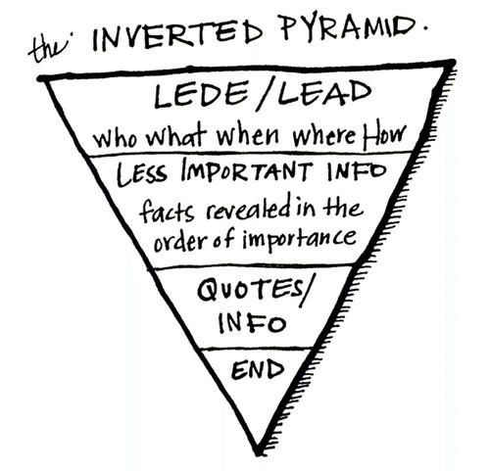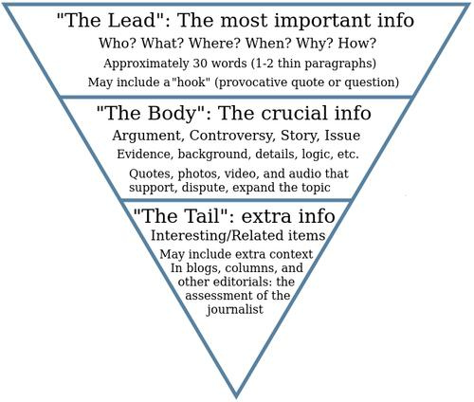

- Elements of a news report
Element | Explanation | Example
headline | Headline is the title, which should be accurate and clear. | 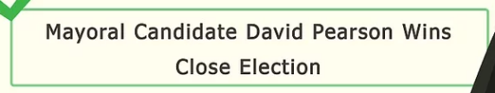
the place line. | The placeline is where the article takes place. | 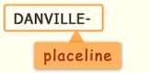
the lead | A news lead is the opening paragraph of a report or article and is often considered the most important part, containing who, what, when, where, why, and how. | 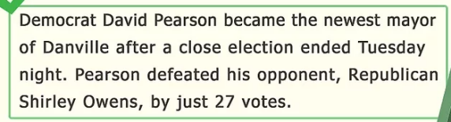
Body | Body consists of the facts, but more detailed and specific than in your lead. Use the information you collected and gathered at the scene and in interviews. | 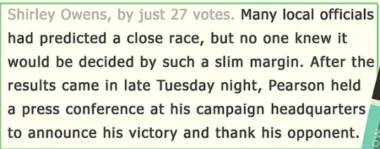
Quotes | Quotes can be included in your news report to convey information. | 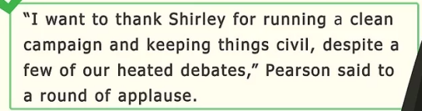
Attributions | / | The woman ran out of the house at 11 p.m. when she heard the burglar enter, police said.

- Writing
I. Writing.
Write a news report on Fan Jinshi according to the following structure and information from the text within 200 words.
Headline  Lead Sentence | ▪ Write a title to get the readers’  attention  ▪ Tell the readers who, what, where,  and why
Body  Tell the reader the facts,  details, examples, etc. | ▪ Explain what Fan Jinshi does.  ▪ Explain why Fan Jin shi does this.  ▪ Use relative clauses  ▪ Use quotes
Ending | ▪ End with a short summary to help  the readers remember the main  idea.

.
.
.
.
.
.
.
.
.
.
.
.
.
.
.

.

