M5U5 Ellipsis
Grammar学案
Learning aims:
1. To know the definition, functions and types of ellipsis;
2. To learn the use of ellipsis;
3. To be able to use ellipsis correctly.
Teaching procedures:
- Activity1: Complete the song.
________of you then I ooh
Dream to stay with you ooh
______ memory by willow
My hurry _______ from the branches ________
Was the price of telling me _____
The afterglow touched the passer's hair
He chose to give up missing
Beneath bridge
Lover of pre-life
________was carved
I can see tear _________from your eyes wow
Buddha______
Don't be stupid
How can I follow all this right in peace
...
Resent love is short and _______ in pain ooh...
Leaves stay in vain _______flying away ooh
Love means nothing and ___does your swear
What I wish for
Sow lots of lotuses...
They grow in all well beings
______ mortal world to give answer
The rosary meets the sand of time
Abandoning reading of mercy
...
- Activity 2: Find out at least 2 sentences with ellipsis from the Reading:
__________________________________________________________________________________________________________________________________________
- Activity 3: Discuss the functions of ellipsis
- Activity4: Explore the rules of the use of ellipsis with different types:
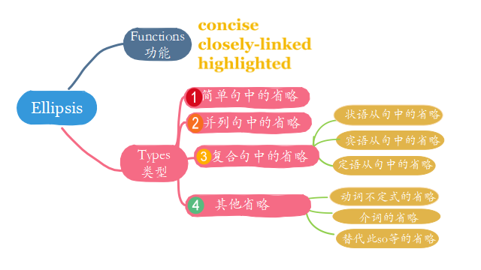
- Activity5: Practice
- Rewrite the poem to make it more concise.
Little deeds different ends
Your little gestures of resistance against us
Your little signs of silence against us
Though miles apart between you and us
Still chill a heart of us

Your little words of care about us
Your little gifts of share with us
In the darkness of the year 2020
Help to warm lives here in our country

Your deeds are so weeny (微小的)
And tiny they may be
Your deeds can make the world
A different being

You should do the little good deeds
You should spread the virtue seeds
May the blossoms of deeds and seeds blooming
Till the changes are looming

- Find out the information left out in the news:
1. “...and the second ___________soon followed.”
2. China held a top-level meeting on the outbreak___________.
3. ...6,000 medical workers ________________ landed at Wuhan's airport.
4.“..._________________carrying 1400 more medics from the army”
5. “...and some_________________ laid down their lives to save others.”
“...while ____________preparing another 70,000 beds at quarantine
site....no one was left unattended ___________.”
- (2020•1月浙江卷语法填空) The first is declining birth rates, which means old generations are large60.___________ (compare) to younger generations,

