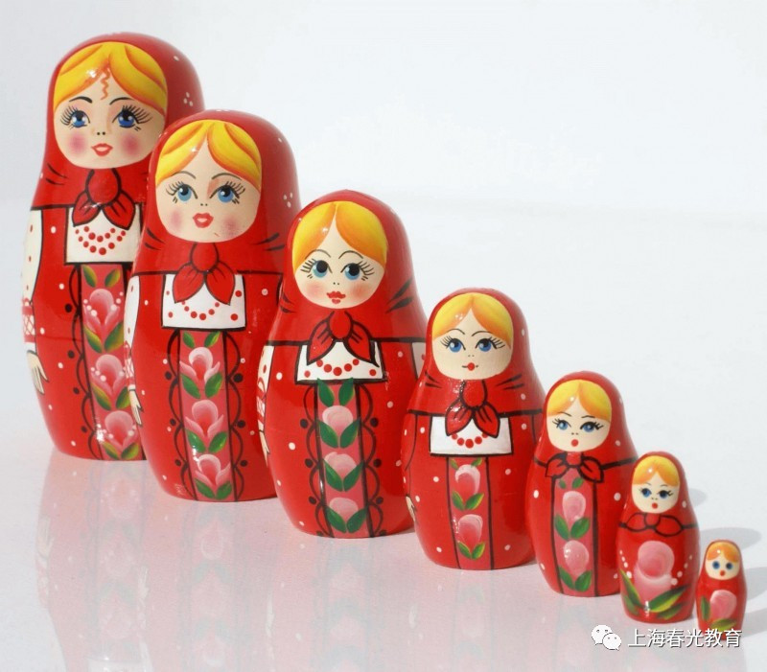
There’s a hole in the bottom of the sea.
There’s a hole in the bottom of the sea.
There’s a hole. There’s a hole.
There’s a hole in the bottom of the sea.
There’s a log in the hole
in the bottom of the sea.
There’s a log in the hole
in the bottom of the sea.
There’s a log. There’s a log.
There’s a log in the hole
in the bottom of the sea.
There’s a branch on the log in the hole
in the bottom of the sea.
There’s a branch on the log in the hole
in the bottom of the sea.
There’s a branch. There’s a branch.
There’s a branch on the log in the hole
in the bottom of the sea.
There’s a bump on the branch on the log
in the hole in the bottom of the sea.
There’s a bump on the branch on the log
in the hole in the bottom of the sea.
There’s a bump. There’s a bump.
There’s a bump on the branch on the log
in the hole in the bottom of the sea.
There’s a frog on the bump on the branch
on the log in the hole in the bottom of the sea.
There’s a frog on the bump on the branch
on the log in the hole in the bottom of the sea.
There’s a frog. There’s a frog.
There’s a frog on the bump on the branch
on the log in the hole in the bottom of the sea.
There’s a speck on the frog on the bump on the branch
on the log in the hole in the bottom of the sea.
There’s a speck on the frog on the bump on the branch
on the log in the hole in the bottom of the sea.
There’s a speck. There’s a speck.
There’s a speck on the frog on the bump on the branch
on the log in the hole in the bottom of the sea.
There’s a flea on the speck on the frog
on the bump on the branch on the log
in the hole in the bottom of the sea.
There’s a flea on the speck on the frog
on the bump on the branch on the log
in the hole in the bottom of the sea.
There’s a flea. There’s a flea.
There’s a flea on the speck on the frog
on the bump on the branch on the log
in the hole in the bottom of the sea.
In the hole in the bottom of the sea.

