Book 7 Unit 3 Using Language 学案
云南民族大学附属中学 黄新

Learning Outcomes:
By the end of the class, students will be better able to:
- specify the type of writing under the teacher’s guidance; generalize the main idea by the students themselves; sort out the organization of the multi-mode text with the help of a mind map.
- analyze the techniques of description and the tips of expressing feelings by the individual thinking, group discussion and under the teacher’s guidance; acquire them by using them in writing—an e-mail to Mom to tell her the experience and share her the feelings while and after touring Yunnan Wildlife Park organized by our school.
- strengthen the awareness of protecting the fantastic world under the sea.
- develop the ability to think logically by analyzing the writing style, ideas and organization; think critically and creatively by writing their own experience.

Learning Focuses and Difficulties:
♦ Learning Focuses:
- Sort out the key information and specify the writing type, summarize the main idea and the organization while reading.
- Analyze the language techniques applied in the vivid descriptions of the creatures and the tips to express feelings in the whole text. Apply them to writing the specific experience and feelings.
♦ Learning Difficulties: Analyze the language techniques and the tips to express feelings.

A new dimension of life
19th January
I'm sitting in the warm night air with a cold drink in my hand and reflecting on the day — a day of pure magic! I went snorkeling on the reef offshore this morning and it was the most fantastic thing I have ever done. Seeing such extraordinary beauty, I think every cell in my body woke up. It was like discovering a whole new dimension of life.
The first thing I became aware of was all the vivid colours surrounding me — purples, reds, oranges, yellows, blues and greens. The corals were fantastic — they were shaped like fans, plates, brains, lace, mushrooms, the branches of trees and the horns of deer. And all kinds of small, neat and elegant fish were swimming in and around the corals.
The fish didn't seem to mind me swimming among them. I especially loved the little orange and white fish that hid in the waving long thin seaweed. And I also loved the small fish that clean the bodies of larger fish — I even saw them get inside their mouths and clean their teeth! It seemed there was a surprise waiting for me around every corner as I explored small caves, shelves and narrow passages with my underwater flashlight: the yellow and green parrotfish was hanging upside down, and sucking tiny plants off the coral with its hard bird-like mouth; a yellow-spotted red sea-slug was sliding by a blue sea-star; a large wise-looking turtle was passing so close to me that I could have touched it.
There were other creatures that I didn't want to get too close to — an eel with its strong sharp teeth, with only its head showing from a hole, watching for a tasty fish (or my tasty toe!); and the giant clam half buried in some coral waiting for something to swim in between its thick green lips. Then there were two grey reef sharks, each about one and a half metres long, which suddenly appeared from behind some coral. I told myself they weren't dangerous but that didn't stop me from feeling scared to death for a moment!
The water was quite shallow but where the reef ended, there was a steep drop to the sandy ocean floor. It marked a boundary and I thought I was very brave when I swam over the edge of the reef and hung there looking down into the depths of the ocean. My heart was beating wildly — I felt very exposed in such deep clear water.
What a wonderful, limitless world it was down there! And what a tiny spot I was in this enormous world!

Step 1: Reading for ideas
1. What kind of passage is it?
A. an advertisement B. a piece of news C. a diary entry D. a book review
2. The passage mainly talks about the writer’s fantastic snorkeling experience under the sea.
Step 2: Reading for organization
1. The topic of each paragraph (Link them)
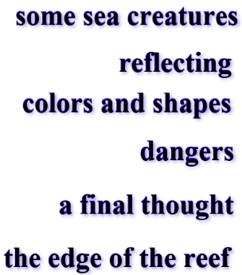
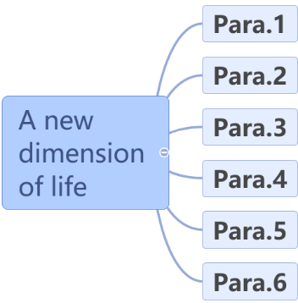

2. Read quickly to answer the questions.
How many creatures are mentioned in this diary? What are they?
Nine. Coral, anemone fish, parrotfish, sea-star, sea-slug, turtle, eel, clam and reef shark.
Step 3: Reading for language
- A vivid description was given to each creature and the techniques of description
corals
The corals were fantastic — they were shaped like fans, plates, brains, lace, mushrooms, the branches of trees and the horns of deer.
And all kinds of small, neat and elegant fish were swimming in and around the corals.
Tip 1: simie

little orange and white fish
I especially loved the little orange and white fish that hid in the waving long thin seaweed. It seemed there was a surprise waiting for me around every corner ...
Tip 2: Non-finite verbs serve as attributives

parrotfish
... the yellow and green parrotfish was hanging upside down, and sucking tiny plants off the coral with its hard bird-like mouth.
Tip 3: Compound words serve as adjectives.

a yellow-spotted red sea slug
… a yellow-spotted sea-slug was sliding by a blue sea-star .
a turtle
a large wise-looking turtle was passing so close to me that I could have touched it
Tip 4: Use subjunctive mood

an eel
There were other creatures that I didn't want to get too close to — an eel with its strong sharp teeth, with only its head showing from a hole, watching for a tasty fish (or my tasty toe!)
Tip 5: With-structure serves as adverbial

a giant clam
... the giant clam half buried in some coral waiting for something to swim in between its thick green lips.
Tip 6: Non-finite verbs serve as adverbials

two grey reef sharks
... there were two grey reef sharks, each about one and a half metres long, which suddenly . appeared from behind some coral. I told myself they weren't dangerous but that didn't stop me from feeling scared to death for a moment!
Tip 7: Use exaggerations

2. What’s the writer’s feelings after seeing these creatures?
What a wonderful, limitless world it was down there! And what a tiny spot I was in this enormous world!
Other sentences: (In the text)

Tips to express one’s feelings: By using exclamatory sentences,
adjectives, adverbs, the superlative of adjectives, exaggeration, negative sentences, etc.

Step 4: Beautiful Expressions appreciation again
中 | 英
充满魔力的一天 | a day of pure magic
奇特的美景 | extraordinary beauty
我所做的最奇妙的事 | the most fantastic thing I have ever done
心跳得厉害 | My heart was beating wildly.
全身的细胞都被唤醒了 | Every cell in my body woke up.
我觉得吓得要命。 | I felt scared to death.
犹如发现了生活中崭新的一面。 | It was like discovering a whole new dimension of life．
在这个巨大的海洋世界中我是多么的渺小！ | What a tiny spot I was in this enormous world!
- I felt scared (scare) to death.
- What a tiny spot I was in this enormous world!
- Every cell in my body woke up.
- It was like discovering a whole new dimension of life．

3. Fill in the blanks, trying to feel the author’s feelings again.
I'm sitting in the warm night air with a cold drink in my hand and reflecting on the day — a day of pure magic! On the morning I went snorkelling, which was the most fantastic thing I have ever done. Seeing (see) such extraordinary beauty, I think every cell in my body woke (wake) up. I became aware of all the vivid colors and all kinds of fish. It seemed there was a surprise waiting (wait) for me around every corner. There was a parrotfish hanging upside down and a yellow-spotted red sea-slug sliding (slide) by a blue sea-star. I even have touched a large wise-looking turtle. There were other creatures (creature) that I didn’t want to get too close to, such as an eel, a giant clam. And two 1.5 metres long grey reef sharks appeared from behind some coral, and they almost scared me to death (die). My heart was beating wildly (wild) when I swam over the boundary between the offshore and the deep ocean. After the trip, I felt what a tiny spot I was in this enormous world.

Step 5: Reading for writing
Writing task：
学校组织了一次春游活动。请用英文给此时身在他乡的妈妈写一封电子邮件，讲述本次经历，要点提示：
1. 春游时间、目的地；
2. 春游所观所感等。
注意：1. 词数120左右；2. 可适当增加细节，以使行文连贯。
1. Finish the following sentences by using what has been learned.
1) 今天星期天。坐在安静的家里，我在回想这一天----神奇的一天。去年4月份，我和同学们、老师们去参观了云南野生动物园。这是我所做的最奇妙的事。
It’s Sunday today. Sitting at our quiet home, I’m reflecting yesterday---- a day of pure magic. I went to visit Yunnan Wildlife Park with my classmates and teachers. It was the most fantastic thing I have ever done.
2) 我首先注意到的是令人惊叹的鹦鹉。它们为我们表演了它们的绝活。
The first things I became aware of were the amazing parrots, which performed their unique skills for us.
3) 在去狮虎山的路上，当我们的车从一个陡峭的山坡(drive down a steep slope)开下去时，我感觉要吓死了。我的心急剧地跳动。
On the way to the Lion and Tiger Hill, I felt scared to death when our electric bus drove down such a steep slope. My heart beat wildly.
4) 看到园中美景，可爱或凶猛的动物们，我全身的每个细胞都苏醒了，就像发现了生活中崭新的一面。似乎每个角落都有惊喜在等我。
Seeing such extraordinary beauty, cute or fierce animals in the park, I think every cell in my body woke up. It was like discovering a new dimension of life. It seemed there was a surprise waiting for me around every corner.
5) 那儿多么美妙！我们玩的多么开心！这次旅行是对于学习和玩乐很好的结合 (a good combination of fun and learning )。
What a wonderful world it is! And what a good time we had in it! The trip was really a good combination of fun and learning!

添加开头和结尾，连句成篇，巩固所学：
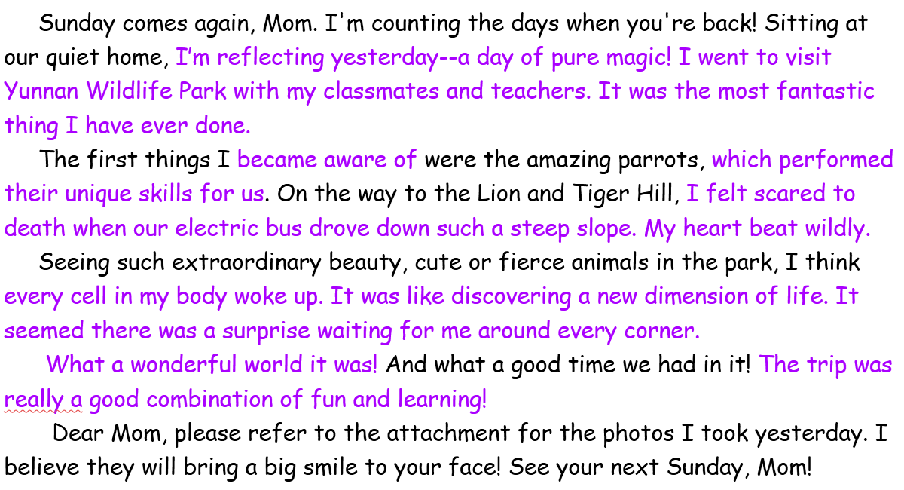

- Homework
Please choose one of the two tasks of writing:
1) Prefect your writing and contribute to our school Broadcasting station.
2) Write a journal to share one of your most unforgettable experiences of journey.


What have I learned today?
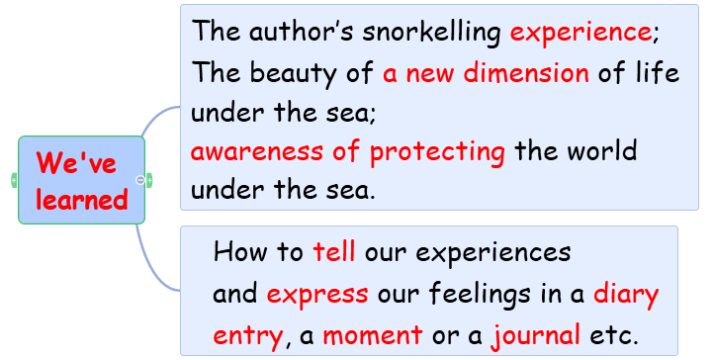
Seven techniques of description & five tips to express feelings
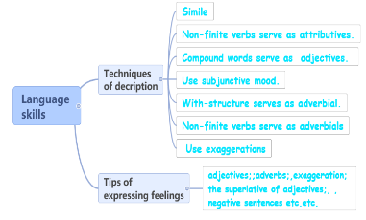

More…

