M6U5 Using language 学案
Learning aims(学习目标)：
After learning learning this passage, you are able to:
- Have a basic knowledge about Changbaishan and Tianchi, such as their locations,
heights, and so on.
- Know the structure to describe a place.
- Develop writing skills of composing a coherent and vivid article.
- Master the use expressions to introduce a place.

Teaching procedures:
Step 1: Pre-reading
A quiz about Changbaisha
Changbaishan is named after a great poet.
Changbaishan was formed after volcano eruptions.
Tianchi lies on the top of Chabaishan with an altitude of more than 2000 meters.
Tianchi is the largest crater lake in China and the deepest mountain lake
around the world.
The best time to visit Tianchi is in winter.
Step 2：Read for operation (写作目的)
This article is written to ___________
introduce a place
explain an opinion
compare and contrast two places
argue for and against a position
Step 3: Read for content
Read para.1 and answer the questions:
- What has the writer introduced about Changbaishan?

- How does the writer lead to the following para.?

Read para.2 and answer the questions:
- What does Tianchi mean according to para.1?

- Considering the above-mentioned disadvantages, is Tianchi worth visiting?

Read para.3 and answer the questions:
- What is the main idea of this paragraph?

- What is the connection between the Manchu people and Tianchi?

Read para.4 and answer the questions:
- What's advised to do when we reach the Lake of Heaven?

- What's the meaning of dropping a coin into Tianchi?

Step 3: Read for structure
Para.1 The introduction of _________
Body
conclusion
introduction

Para.2 The introduction of _________
Para.3 ________ about Tianchi

Para.4 ________ to guarantee love

Step 4: Read for writing
Dear Li Hua,
In our last letter I introduced my school as well as the beautiful sightseeing places in the neighborhood to you. And you once told me that the place you studied is a real heaven. So I can't wait to learn more about your school. Would you please tell me more about it, such as its main geographic features and the most attractive scenic spot around it ?
Looking forward to your reply email!
Sincerely yours, Joe
Useful tips:

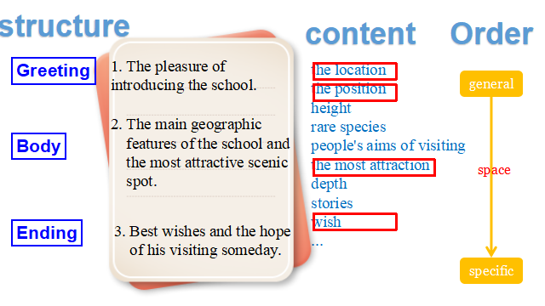

Writing tips:
- Use the linking sentence(s) to make sure of the coherence between paragraphs. \
- Use transition words to connect ideas.
- Use logical order to develop the article

Useful expressions:
- 引人入胜的
- 由...到...不等
- 是...的家园
- 据说...
- 最能激起人们欣赏欲望的是...
- ...要...多少时间
- 不仅可以看到清澈的湖水还可以看到...
- 最著名的是关于...
- 如果你有幸...别忘了...

_____________________________________________________________________
_____________________________________________________________________
_____________________________________________________________________
_____________________________________________________________________
_____________________________________________________________________
_____________________________________________________________________
_____________________________________________________________________
_____________________________________________________________________
_____________________________________________________________________
_____________________________________________________________________
_____________________________________________________________________

Step 5: Homework
1. Retell the introduction of the Lake of Heaven
2. Complete and polish your writing.

