Extra Good Luck教学设计
嵊州市高级中学 尹 娟
Teaching Aims:
By the end of the class, the students will have:
- appreciated the powerful love from mothers.
- understood the theme of the passage
- learnt to appreciate their ow parents’ love and be gratitude to their own parents.
- known how to read between lines and make prediction by analysing the given information.

Teaching Important and Difficult points:
- How to help the Ss analyse the theme of the passage.
- How to cultivate the Ss’ logical thinking by analysing the given information.
- How to make the Ss show gratitude to their own parents for what they have done for them.
- How to enable the Ss to develop their confidence to overcome all the difficulties.

Teaching Aids:
- The blackboard
- The CAI

Teaching Procedures:
Step one: Greeting and Warming up
Show the picture about two dollar bill and have a brief brainstorm:
Suppose you are given a two dollar bill, what will you do with it?
【设计意图】通过直观的2美元的图片导入，让学生思考他们会用这2美元做什么，从而引出文章的话题，让学生的思维火花和文章作者的思维产生碰撞，让他们明白我们可以将无形的精神礼物寄托在小小的物件之中。

Step Two: Read for background information
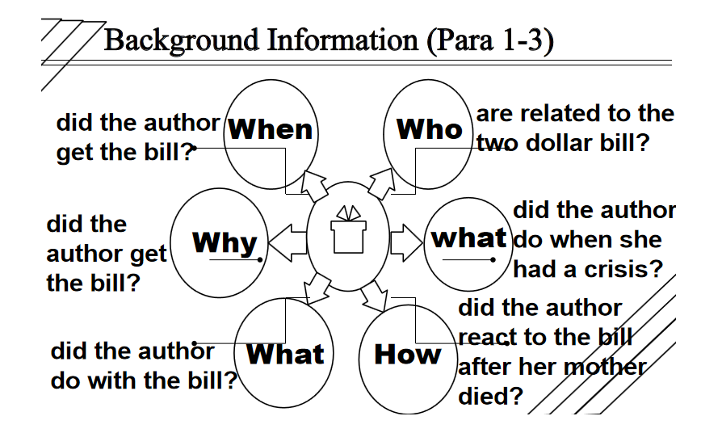
Tip One: Try to figure out the elements of the story & get the background information.
【设计意图】在阅读过程开始前，提供一些特殊疑问词，这些特殊疑问词均围绕记叙文的几个核心要素提出，目的在于让学生在阅读之初有意识地去关注记叙文的背景内容介绍，这将帮助学生在解读接下去的文章时，有一个更清晰的全面观，能够清楚地知道故事的起始。
Step Three: Read for the detailed formation of the story
Question:
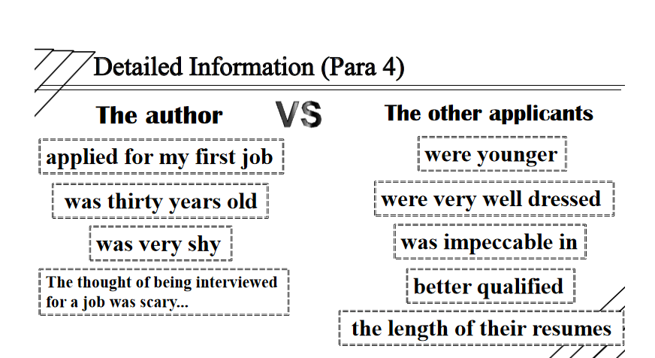
Did the author have advantages over the other applicants for applying for the job?
Tip Two: Analyse the detailed information and make contrast if necessary.
【设计意图】有了背景内容介绍的铺垫，对文章的进一步细节处理就有了抓手。第四段文本最重要的一个特征就是作者与其他应聘者的对比，从对比中不难看出其他应聘者的优势，以及作者相对应的劣势，这样强烈的对比，让读者不禁要为作者捏一把汗，读者会觉得作者获得工作的机会非常渺茫。因此，在解读原文过程中，我们需要利用文章中出现的对比，进行逻辑的推进，以此来更好地突出文章的重点。
Detailed Information (Para 5)
Question: What makes the author feel she is qualified for the job?
- I really needs this job and there is nothing I cannot do.---honest & sincere & confident
(2) As I exited her office, I turned around and said... ---value every chance
(3) I learn quickly and can be a very productive member of the team.---confident & promising
(4) I thanked her and went home ...---polite
(5) Tomorrow would be another day.---optimistic
Tip Three: Read between lines & analyse the implied meaning.

Step Four: Prediction & Appreciation (Para 6)
The given sentence:
That evening as I was getting ready for bed, I received a phone call from Mrs. Martin.
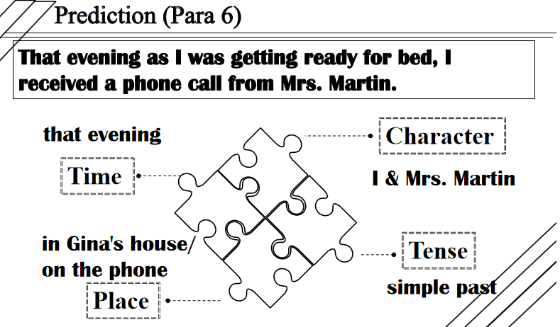
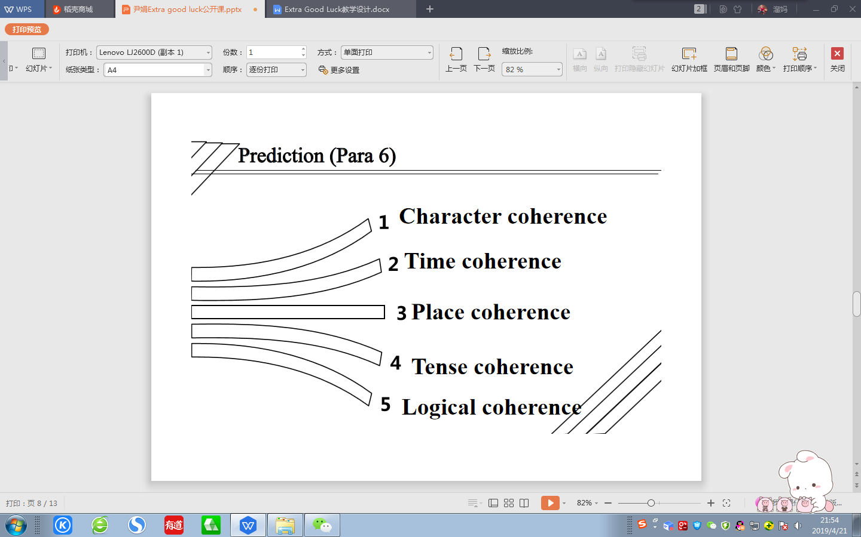
Tip Four: Pay special attention to the various coherence of the passage.
【设计意图】本环节是基于文本阅读之后的续写构思预测，旨在让学生能够在阅读的基础上，获得逻辑上的情节发展趋势，并根据所给首句，进行合理的情节推测。在推测的过程中，让学生特别关注角色协同、时间协同、地点协同、时态协同以及语言协同。合理推测在学生阅读过程中起着举足轻重的作用，它能帮助学生培养利用所提供的文本进行合理的推断和情节的延伸，这对于训练学生的读后续写能力有很大帮助。学生在品读文本时养成推测的习惯，这将有助于学生续写时思路清晰，下笔通顺。

Question:
(1) What was the result?
- How did Gina feel about the result ?
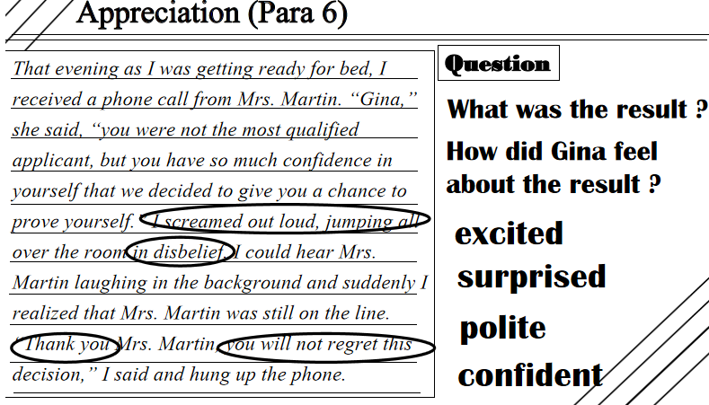
Tip Five: Try to show rather than tell when trying to describe something.
【设计意图】在上个预测环节的基础上，本环节是赏析文本。让学生结合所给文本，对自己的预测进行交叉对比，让学生检测他们自己的构思和文本构思的相似或是相异，在比较的过程中，了解自己的预测构思是否合情合理。

Step Five: Prediction & Discussion (Para 7)
The given sentence:
I got my wallet and took out my two dollar bill.
【设计意图】本环节旨在再次利用推测的基本要素，再一次将几个读与写中的协同利用起来，进行最后一段的情节预测。学生根据之前所学，进行实践操作，巩固理论知识，强化读与写之间千丝万缕的联系。让学生带着思考赏文本，带着逻辑品文本，带着作者的意图析文本。通过与同学的思维交流，碰撞出主题的火花。让学生学会读与写相融合，已读促写，以写促读。
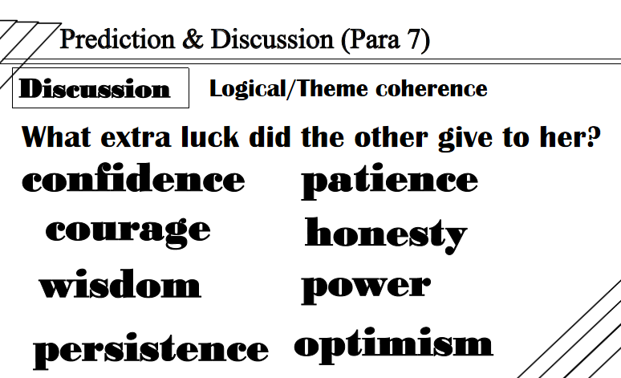

【设计意图】本环节通过对最后一段的预测来呼应标题的Extra Good Luck，让学生从本节课的解读过程中分析出标题的涵义，以What extra good luck did the other give to her?为问题，让学生能进行主题的升华。

Step Six: Conclusion & thinking
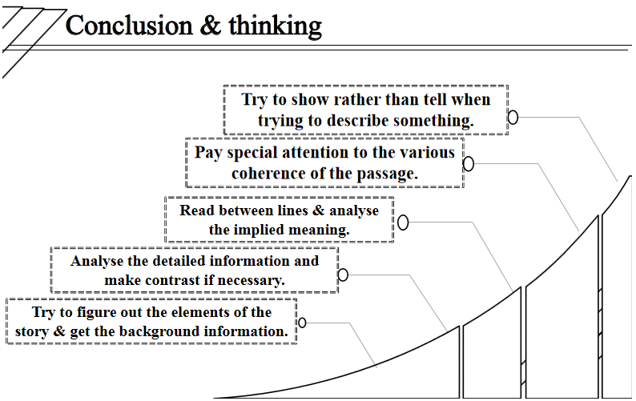
【设计意图】本节课结束之前，巩固总结课堂的读写技巧，让学生有一个系统的读写思路，在今后读与写的过程中可以更加具有目的性、整体性和逻辑性，而不是盲目的过程。在读的过程中，只有读懂读通读透原文，才能理解作者的思路和作者通过作品想要表达的主题和内涵；在写的过程中，只有关注人物、时间、时态、地点、逻辑、主题等方面的协同性、一致性，才能更好地完成写的任务。

Step Seven: Homework (Writing)
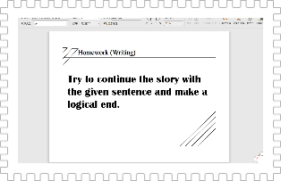
【设计意图】本篇文章的总体思路就是让学生读写中关注读与写之间的联系。因此，这篇文章的结尾成为一个开放式的结尾，让学生通过之前的思维碰撞和头脑风暴进行最后写作的完成。在充分输入的前提下，能有有效的输出。

