Unit 3 Book 2 学案
- blog [blɒɡ]n. _______,____________vi.________
blog post________,____________
blogger[ˈblɒɡə(r)]n.___________;________

- go through ______;_______;_______;_______
易混形近词：
though [ðəʊ]adv. _______;_______conj. _______;_______
through [θruː]prep. _______;_______;________
thorough ['θʌrə]adj. ________;________;________
thought [θɔːt]n. ________;________;________

- tough [tʌf] adj. _______,_______;_______,_______;_______
形近助记：though去掉h(house) 助记：______没有_______，________他仍不觉得_______。

- province ['prɒvɪns] n. _____;_________
词根词缀：pro-(向前)+-vinc-(征服)+e：向前征服的领域——_______
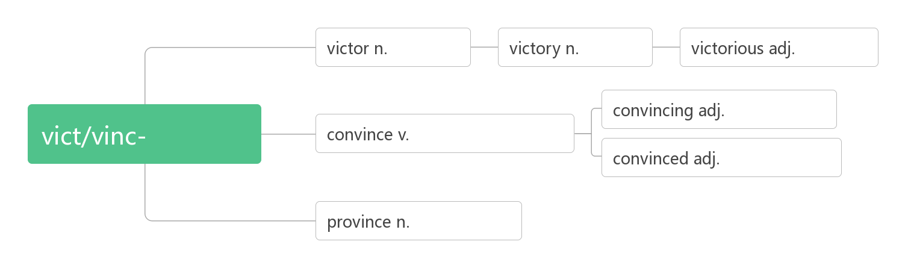
- conference ['kɒnf(ə)r(ə)ns]n. _______;________;________
词根词缀：con-(一起)+fer-(拿来)+-ence：拿到一起来______——_______;_______
- resident ['rezɪdənt] n.______;__________adj. ________;_________
词根词缀：re-(强调)+sid-(坐)+-ent(名词或形容词后缀)：坐在某处不走的人——_______;________
residence ['rezɪdəns] n. 住宅，住处；居住

- plus [plʌs]n. ______,_______;_______adj. ______;________prep. _____,_______

- function ['fʌŋkʃən] n. ______;_______vi. 运行；行使职责
词根词缀：func-(做)+-tion(名词后缀)：“做”的行为——实施“_____”；行使“______”
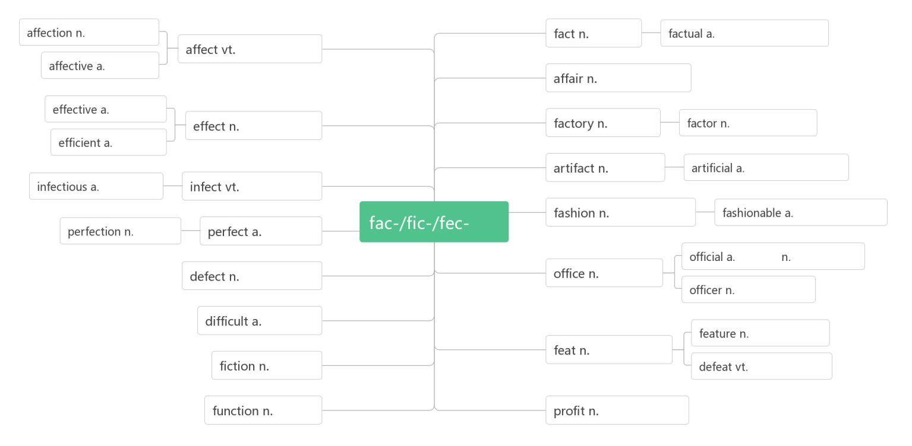
- battery ['bæt(ə)rɪ]n.______,________
词根词缀：batt-(beat打)+e(电子)+ry(名词后缀)：打出电子的东西——______

- confirm [kən'fɜ:m]vt. _______;_______;_______
词根词缀：con-(强调)+firm(坚定的，牢固的)：使某事变的确定无疑——_______;_______

- press [pres]n. vt. &vi.________;_______n._______;______;________
press conference ____________
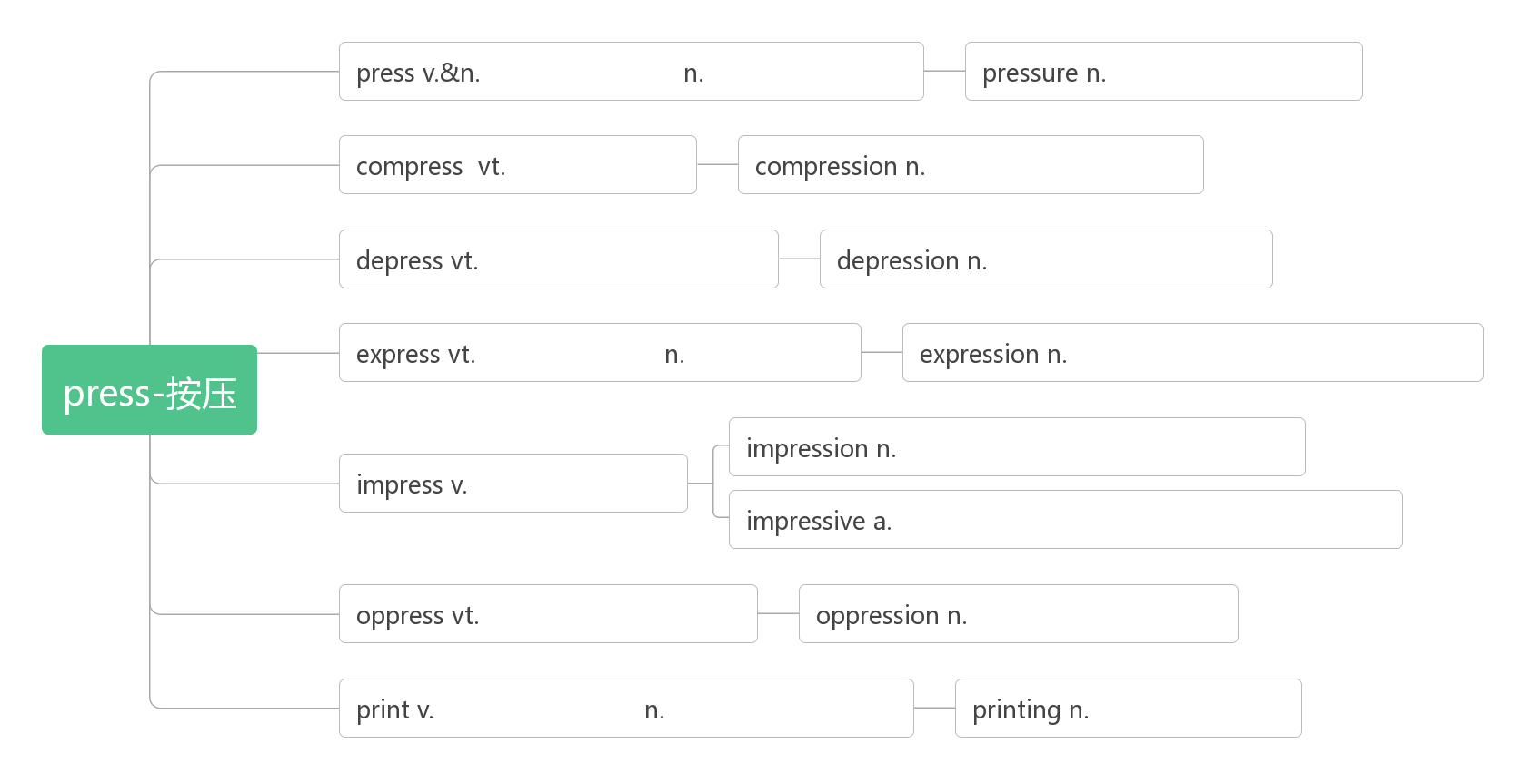

- button ['bʌt(ə)n]n. _______;_______vt. _______;_______
破拆法：butt(屁股)+on(上)：裤子上的_______要_______，要不屁股就会露出来。
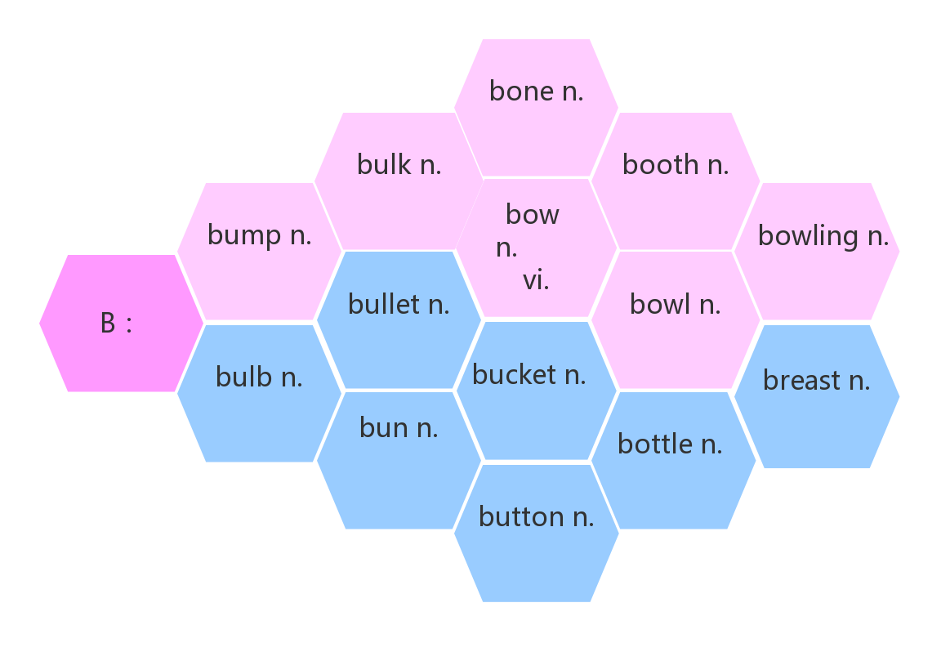
- file [faɪl]n. _______;_______;__________
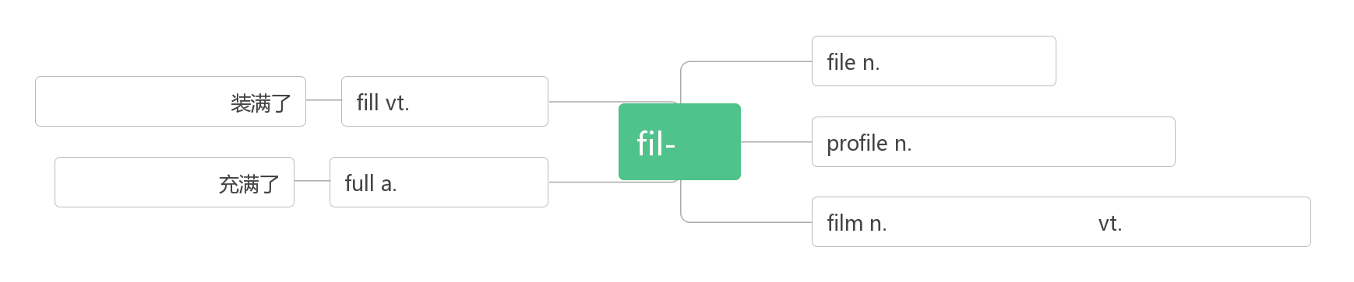
- shape [ʃeɪp]n. ______;______;_______vt.&vi._______;________
_____________状况良好, 身材好

- track [træk] n. _______;_______;_______;_______vt.& vi. _______;_______
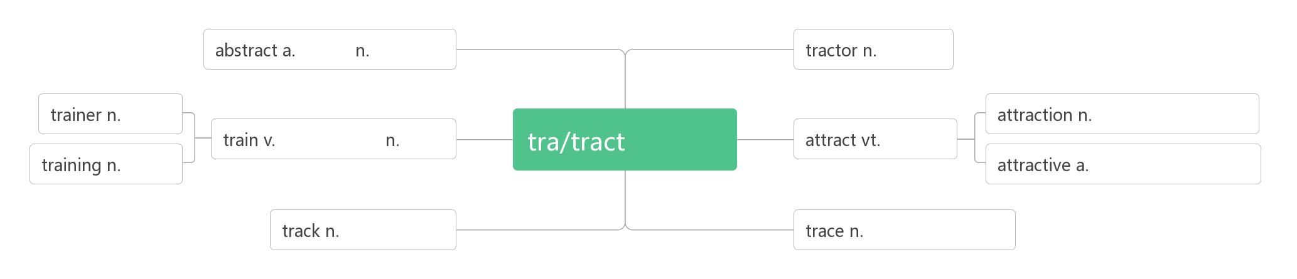
__________________记录，了解……的动态
__________________田径

- discount ['dɪskaʊnt] n. ______vi.& vt. ________
词根词缀：dis(否定:不)+count(数,计算)：不计算在内的价格——_______
_______________以折扣价

- account [ə'kaʊnt]n.______;______;_______ vi.______;______;______
account for_______, ______;______;_______
on account of _______;_______
take ...into account ________________
on no account _______
of account _______
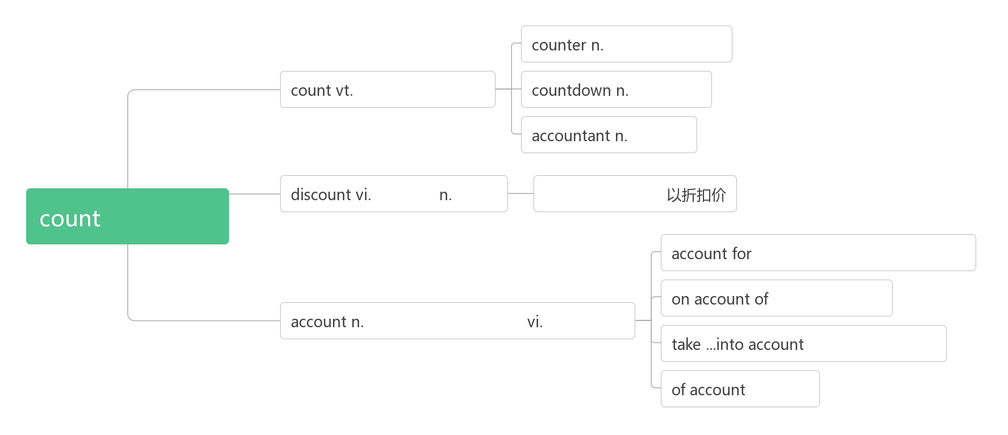
- click [klik] n. vt. & vi._______

- privacy ['praɪvəsi]n. ______;_______;_______;________
词根词缀：priv-(私人)+-acy (名词后缀)：私人的空间：_______;_______
___________ ['praɪvət]adj. 私人的；私有的；私下的n. 列兵
privilege ['prɪvɪlɪdʒ] n._______;_______
It's such a privilege to be a part of these kids’ lives, even just for a few hours, getting to know them and hearing their stories. (2019北京) 能成为这些孩子生活的一部分，哪怕只是几个小时，去了解他们，听他们的故事，是一种特权
Her responsibility, her privilege, would be to rescue it. (2019江苏) 她的责任，她的特权，将是拯救它。
They tell us to ignore privilege, power, and deep pockets.(2013江苏) 他们告诉我们要忽略特权、权力和金钱。

- theft [θeft]n. ______;______
破拆法：the(特指)+-ft(left) 助记：the left, (贼)留下的东西——______——______
_______[θiːf]n. 小偷，贼

- rude [ruːd]adj. ________;________
_____________对……粗鲁

- target ['tɑːgɪt]n. ______;_______vt. ______;__________
破拆法：tar-(它)+get(获得) 助记：获得它就是我的_______

- troll[trəʊl]n.(北欧神话)_______；__________
破拆法：t-(它)+roll(滚动) 助记：不管是______还是______，统统让它滚。

- cyberbully [ˈsaɪbərbʊli] n.______vt. & vi.__________
破拆法：cyber(网络的)+bully(欺凌;恶霸)：______;_________

- false [fɔːls] adj._______;_______;_______
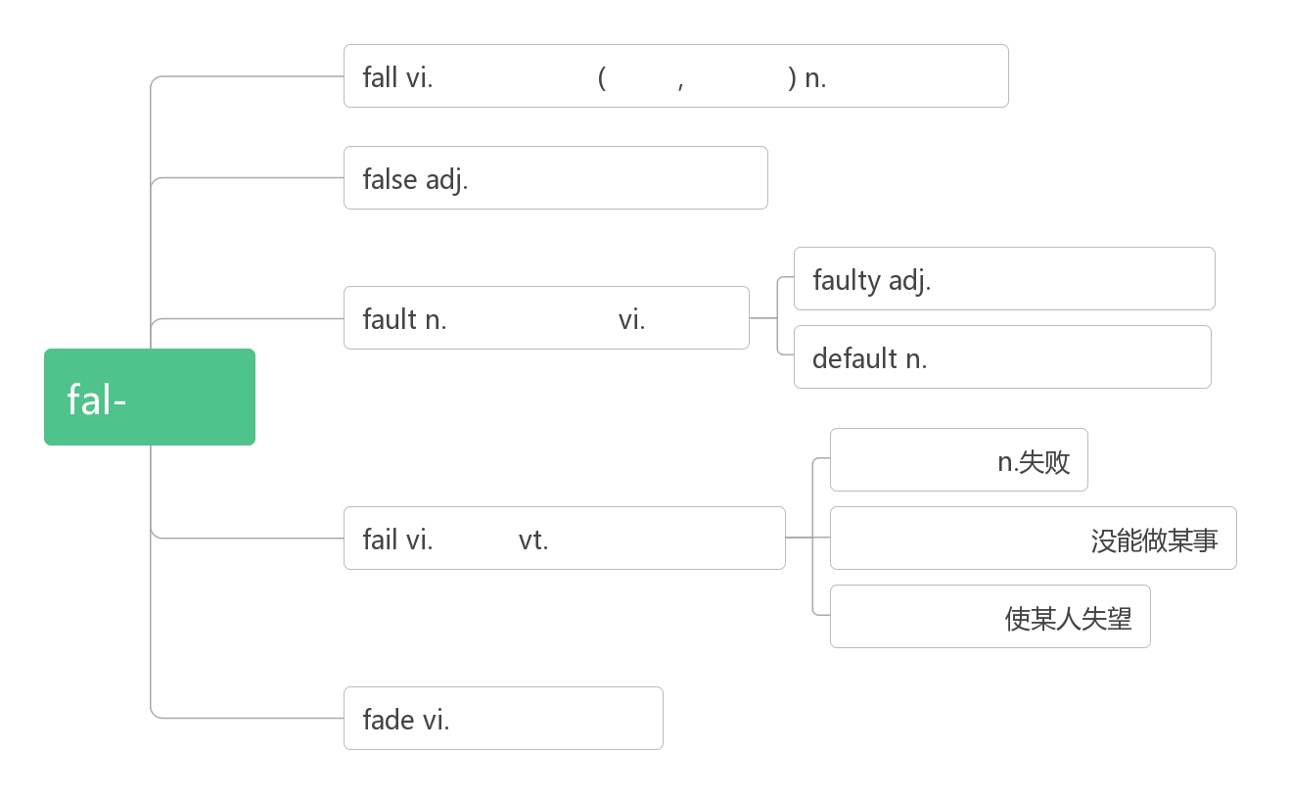
- particular [pəˈtɪkjələ(r)] adj. ______;______;______;______n. __________;________
词根词缀：part(部分)+-ic(形容词后缀)+(-ular属性)：有自己特定属性的——_______;_______
______________________ 对……讲究，对……挑剔
An intelligent person be particular about trifle(小事). 聪明的人是不会与人斤斤计较的.
_____________ [pəˈtɪkjələli] adv. 尤其；特别；异乎寻常地

- embarrass [ɪmˈbærəs] v. (尤指在社交场合) _________,_________
词根词缀：em-(=in进入)+barr-(栅栏)+-ass(动词后缀)：把人放入栅栏与栅栏之间，使进退两难——________
________________ [ɪmˈbærəsmənt] n.尴尬；窘迫； 难堪
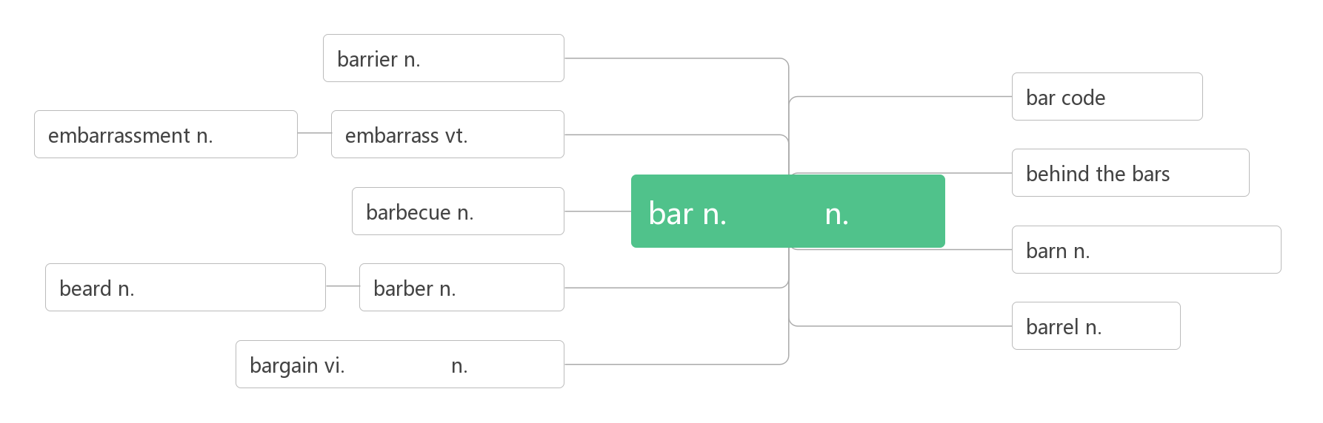
- make fun of________,________
have fun (with) (与……一起)__________

- upset [ʌpˈset]vt._______;_______;________(_______, _______) adj. _______;_______;_______ n._______;_______
词根词缀：up(向上)+-set (sit坐)：底朝天——_______;______;_________
____________________对……感到难过/沮丧

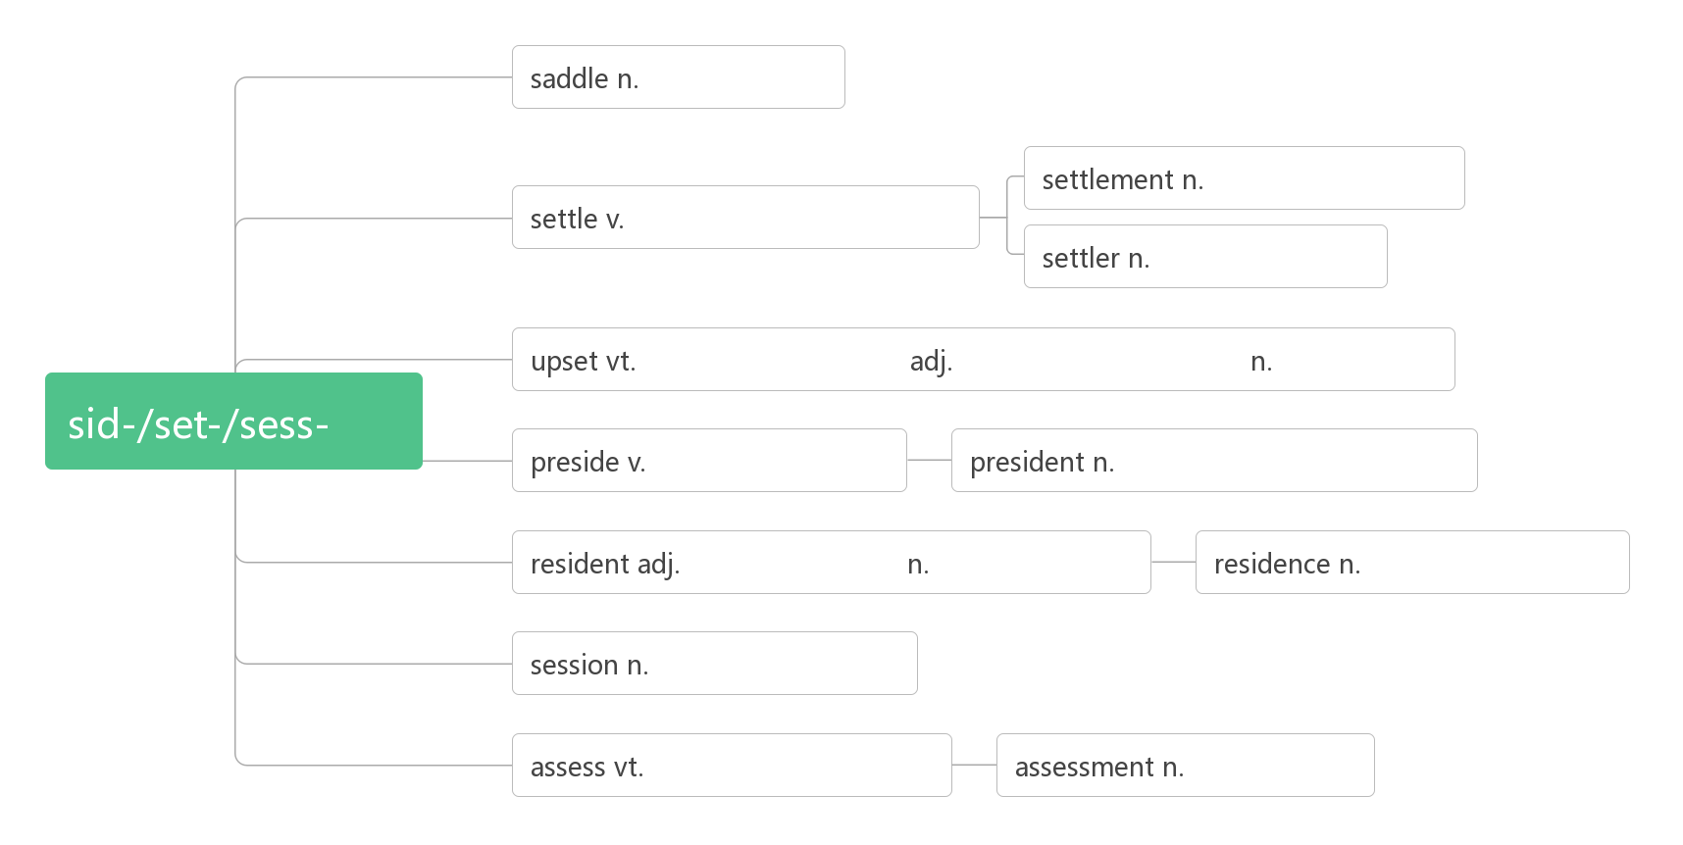
- guide [ɡaɪd] n._______;_______;_______ vt. _______;________
guideline [ˈɡaɪdlaɪn] n. _______;__________

- author [ˈɔːθə(r)]n. _______;_______;_________
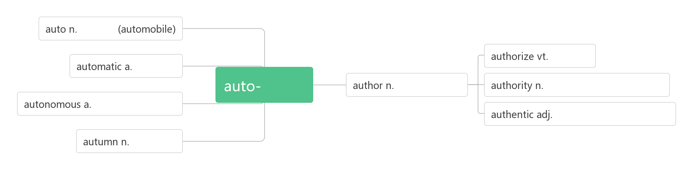
- tip [tɪp] n. ______;______;_______;_______v.______;_______;________
助记：要听他在刀___上表演_______的______和______，必须给_______。

- familiar [fəˈmɪliə(r)] adj. _______;________;________n. _______;_______
___________________对……熟悉
___________________ 为……所熟悉
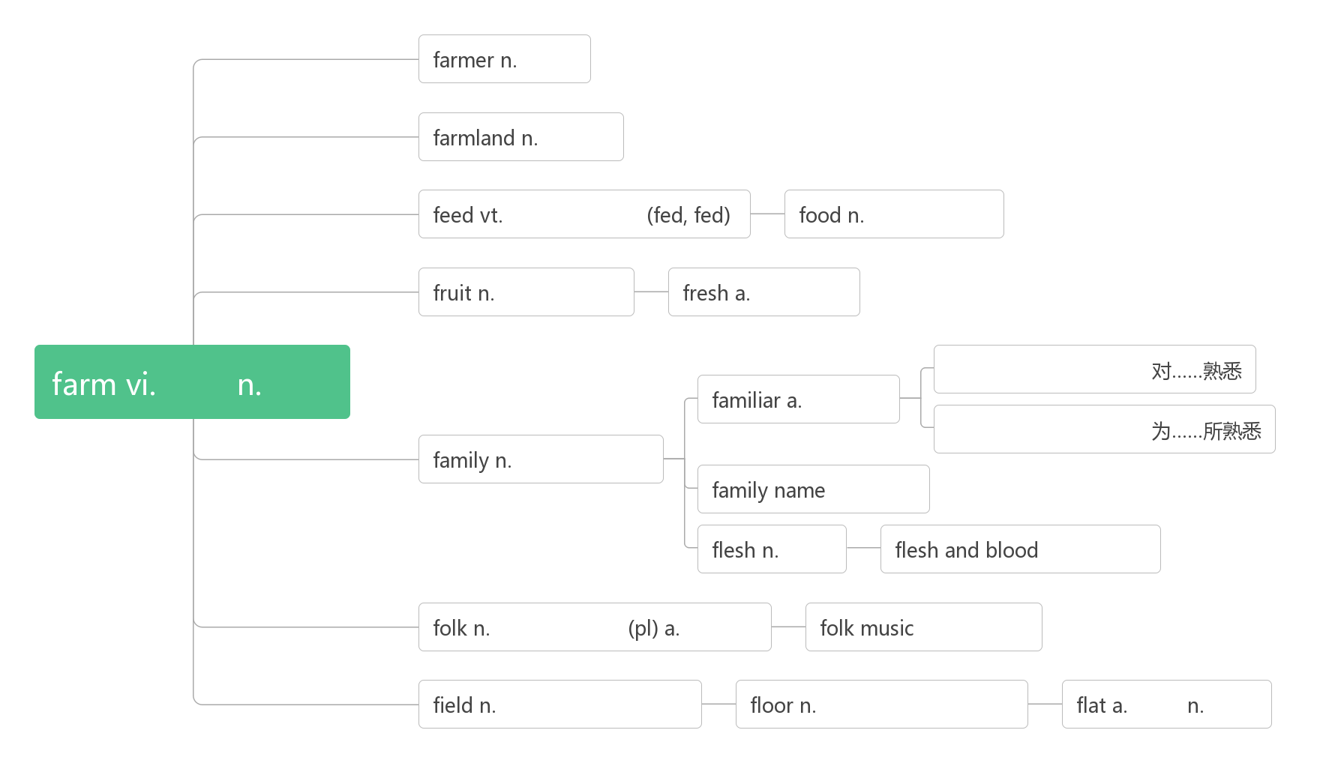
- ______________________ 记住，牢记

- define [dɪˈfaɪn]vt. _______;________;__________
词根词缀：de-(强调)+fine(限定)：对……的内涵加以限定——________;_______
_____________ [ˌdefɪˈnɪʃn] n.定义
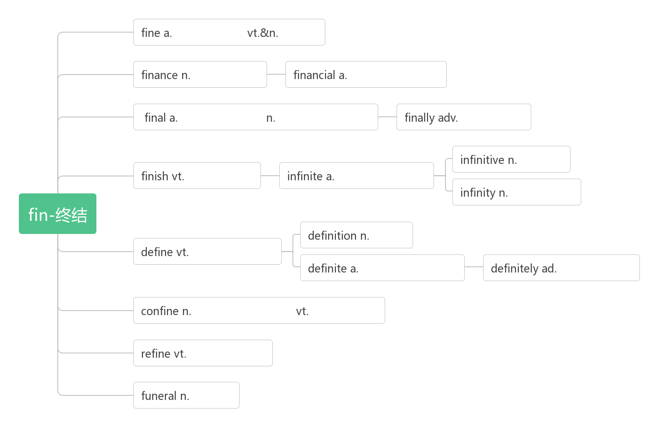
- case[kei]n._____;_____;_______;_______
in case (of/that) ___________,___________
in no case________
in this/that case____________________

- the World Wide Web (abbr. www) _________

