Unit 3 Book 2 导案
- blog [blɒɡ]n. 博客，网络日志vi.写博客
blog post博文；博客帖子
blogger[ˈblɒɡə(r)]n.博客作者；博主

- go through 穿过；经历；体验；浏览；检查
This view is especially evident on Kilimanjaro as climbers go through five ecosystems(生态系统) in the space of a few kilometers. (2019全国I) 这种观念在乞力马扎罗山上尤为明显，因为登山者要在几公里的空间内穿越五个生态系统。
Suddenly another thought went through Kate's mind like an electric shock.（2016浙江）
突然，另一个想法像电击一样穿过凯特的脑海。
Visitor items over 17×26 inches must go through additional checks.（2008江苏）
访客物品超过17×26英寸必须通过额外检查。
You must be in good health and prepared to go through a period of body exercises.（2008全国II）
你必须身体健康，准备进行一段时间的身体锻炼。
She started to go through the bundle of letters. 她开始浏览那一叠信件。
Lily went through her purse in search of the keys to her apartment. 莉莉翻遍了她的钱包，寻找她公寓的钥匙。
易混形近词：
though [ðəʊ]adv. 不过；然而conj. 虽然；尽管
through [θruː]prep. 通过；穿过；凭借
thorough ['θʌrə]adj. 彻底的；完全的；周密的
thought [θɔːt]n. 思想；思考；想法

- tough [tʌf] adj. 艰苦的，困难的；坚强的，坚韧的；严厉的
形近助记：though去掉h(house) 助记：尽管没有房子，坚强的他仍不觉得艰苦。
But life must be pretty tough for his family now.（2019全国I）但是现在他的家庭生活一定很艰难。
A tough man can tolerate suffering.（2019天津卷）坚强的人能忍受苦难。
When the going gets tough,the tough get going. 艰难之路，唯勇者行。
Life is tough, but I'm tougher. 生活本艰难，但我更坚强。

- province ['prɒvɪns] n. 省；行省
词根词缀：pro-(向前)+-vinc-(征服)+e：向前征服的领域——行省
His office is located at the Xiangshan campus of the university in Hangzhou, Zhejiang Province.
他的办公室位于浙江杭州大学象山校区。
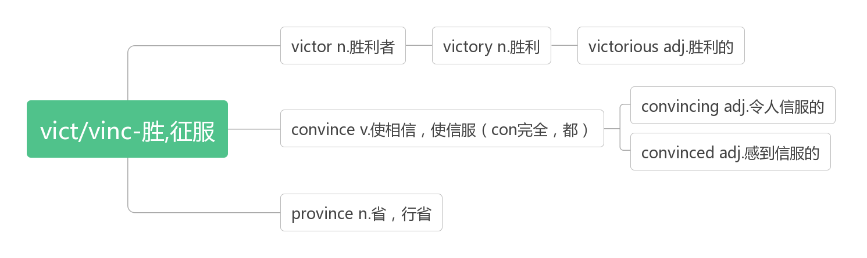
- conference ['kɒnf(ə)r(ə)ns]n. 会议；讨论；协商
词根词缀：con-(一起)+fer-(拿来)+-ence：拿到一起来讨论——会议；协商
Reading makes a full man, conference a ready man and writing an exact man.——Francis Bacon
读书使人充实，讨论使人机敏，写作使人严谨。——弗兰西斯.培根
The manager was worried about the press conference his assistant was giving in his place but, luckily, everything was going on smoothly. (2011浙江) 经理很担心他的助理替他举行的记者招待会，但幸运的是，一切都进行得很顺利。
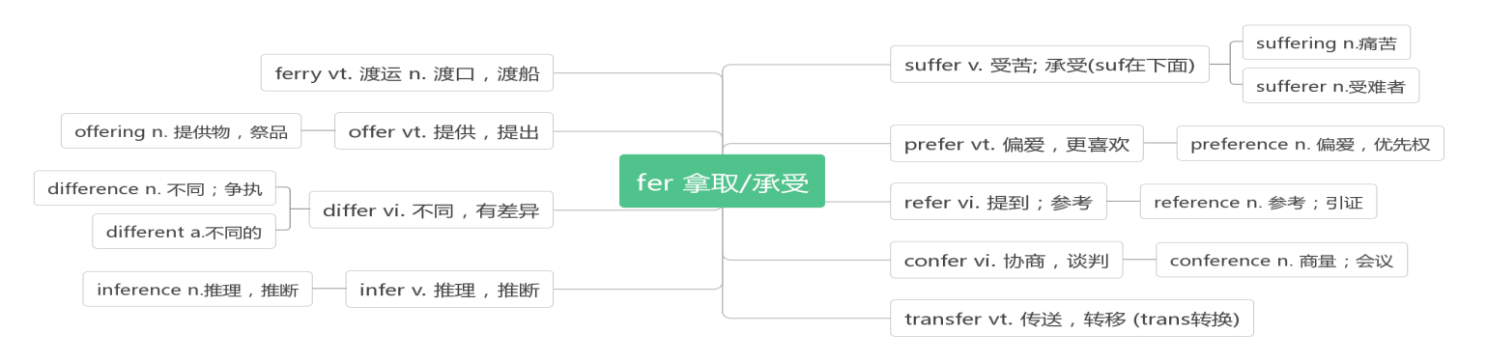
- resident ['rezɪdənt] n.居民；驻院医师adj. 居住的；定居的
词根词缀：re-(强调)+sid-(坐)+-ent(名词或形容词后缀)：坐在某处不走的人——居民；定居的
The Office of Residence Life may change the door lock combination at any time at the expense of the resident if it is found that the student has shared the combination with others.（2015天津）
如果发现学生与他人共用门锁密码，居住生活办公室可以随时更换门锁密码，费用由居住者承担。
residence ['rezɪdəns] n. 住宅，住处；居住
A fire drill will be conducted in your residence hall every semester.（2018天津）
每学期宿舍楼都会举行一次消防演练。
同源词：见28 upset

- plus [plʌs]n. 正号，加号；优势adj. 正的；附加的prep. 加，加上
Two plus four is six. 二加四等于六
At the end of the year the loan plus the interest must be repaid. 年底必须偿还贷款和利息
All apartments have a small kitchen plus private bathroom. 所有的公寓都有小厨房和私人浴室
Companies put losses at $500,000 plus. 公司估计损失超过50万美元。

- function ['fʌŋkʃən] n. 功能；职责vi. 运行；行使职责
词根词缀：func-(做)+-tion(名词后缀)：“做”的行为——实施“功能”；行使“职责”
This function of the Internet is particularly striking when I'm writing.（2016江苏）
当我写作的时候，互联网的这种功能尤其引人注目。
They believe the selection is mostly a result of their function and use in daily life.（2014江苏）
他们认为，这种选择主要是由于它们的功能和在日常生活中的应用。
There is a practical aspect to this: it helps society to function efficiently, and encourages a general level of self-discipline that simplifies day-to-day interaction.（2014江苏）
这有一个实用的方面:它帮助社会有效运作，并鼓励普遍的自律水平，简化日常互动。
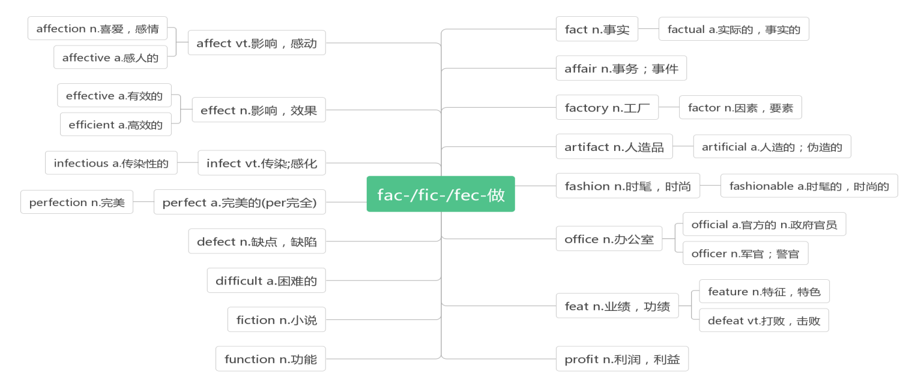
- battery ['bæt(ə)rɪ]n.电池，蓄电池
词根词缀：batt-(beat打)+e(电子)+ry(名词后缀)：打出电子的东西——电池

- confirm [kən'fɜ:m]vt. 确定；证实；批准
词根词缀：con-(强调)+firm(坚定的，牢固的)：使某事变的确定无疑——确定；证实
Before choices are finalised, parents/careers will be asked to sign to confirm their child’s choices.(2018全国II)
在最终决定前，家长/职业人士须签署，以确认子女的选择。
The report confirms that a diet rich in vitamin C can help to prevent cataracts(白内障).
报告证实，富含维生素C的饮食有助于预防白内障。

- press [pres]n. vt. &vi.按压；逼迫n.新闻；出版社；印刷机
Didn’t you know his secretary leaked the secret report to the press? (2018江苏)
你不知道他的秘书把秘密报告泄露给新闻界了吗?
The steam-powered printing press was still in its early stages; the literacy(识字) rate in England was under 50%.(2018浙江)
蒸汽印刷机仍处于早期阶段；英国的识字率不到50%。
In any unsafe situation, simply press the button and a highly-trained agent will get you the help you need.(2018北京)
在任何不安全的情况下，只要按下按钮，一个训练有素的特工会帮你得到你需要的帮助。
To do CPR, you press on the sick person's chest so that blood moves through the body and takes oxygen to organs. (2017北京) 做心肺复苏术时，你要按压病人的胸部，使血液流经全身，将氧气输送到各个器官。
press conference 记者招待会
The manager was worried about the press conference his assistant was giving in his place but, luckily, everything was going on smoothly. (2011浙江) 经理很担心他的助理替他举行的记者招待会，但幸运的是，一切都进行得很顺利。
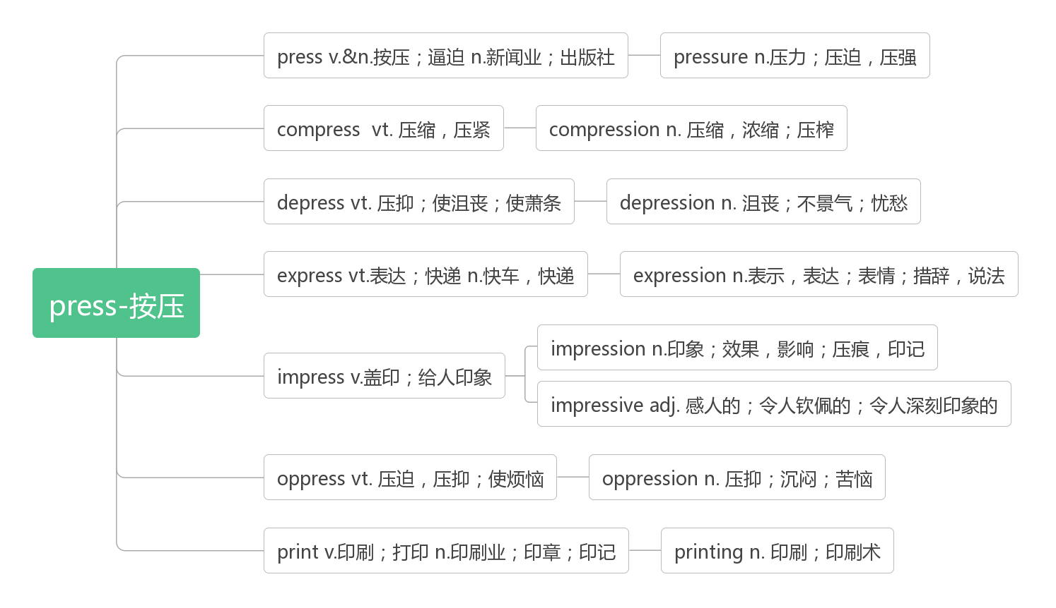
- button ['bʌt(ə)n]n. 按钮；钮扣vt. 扣住；扣紧
破拆法：butt(屁股)+on(上)：裤子上的扣子要扣好，要不屁股就会露出来。
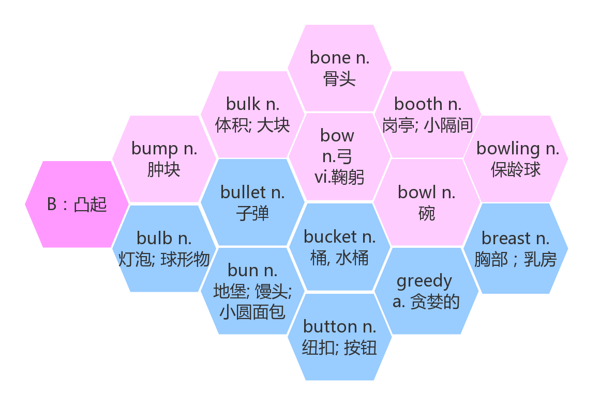
- file [faɪl]n. 文件；档案；文件夹
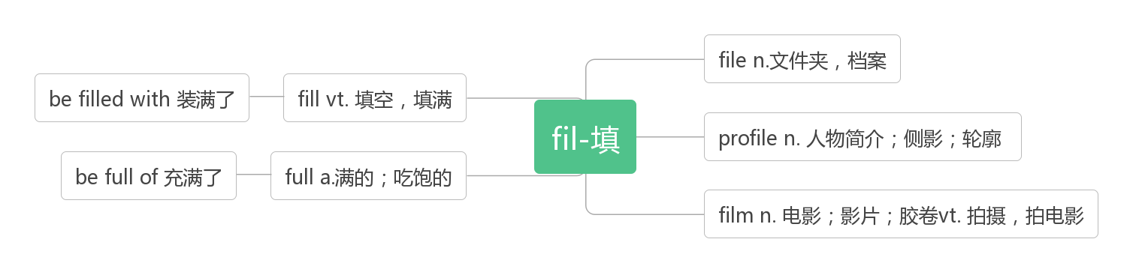
- shape [ʃeɪp]n. 形状；身材vt.&vi. 形成；塑造
It would help shape a realistic and serious attitude to life.(2019天津) 它将有助于形成一个现实和严肃的生活态度。
A quick review of successes and failures at the end of year will help shape your year ahead.(2017江苏)
在年底快速回顾一下成功和失败的经验，这将有助于你在新的一年里有所作为。
By choosing to keep the outside of the home in great shape, you will help to improve the look and feel of the area.(2018浙江) 通过选择保持房屋外部的良好外形，你将有助于改善该地区的外观和感觉。
It had gotten into such bad shape that the city just let it stay that way.(2010浙江)
它已经发展到如此糟糕的地步，以至于这个城市只能任其发展下去。
in shape状况良好, 身材好
I’ve found a lot of better ways to stay in shape.(2018浙江) 我发现了很多更好的保持身材的方法。
Tom always goes jogging in the morning and he usually does push-ups too to stay in shape.(2014江苏)
汤姆早上总是慢跑，他也经常做俯卧撑来保持体形。

- track [træk] n. 跑道；轨道；足迹；路径vt.& vi. 跟踪; 追踪
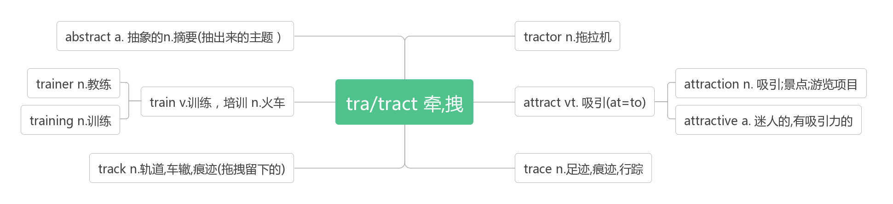
"Don’t be late for supper," Uncle Paul cried, "and keep to the track so that you don’t get lost!"（2018浙江）
“吃晚饭不要迟到，”保罗叔叔喊道，“要顺着路走，不要迷路!”
Moreover, the USA has a track record of successfully accepting immigrants. (2017江苏）
此外，美国有可查询的成功接收移民的记录。
This included digging up the road, laying the track and then building a strong roof over the top. (2017全国II)
这包括挖掘道路，铺设轨道，然后在上面建一个坚固的屋顶。
Eventually, they start to lose track of who they really are, seeing themselves the way their fans imagine them.(2013北京)
最终，他们开始迷失自己，把自己看作粉丝们心中想象的形象。
Neither a wise man nor a brave man lies down on the tracks of history to wait for the train of the future to run over them.
智者和勇者都不会躺在历史的轨道上等待未来列车碾压他们。
keep track of记录，了解……的动态
Keep a record and evaluate it weekly. Keep track of your efforts and write down how you feel.(2017全国III）
做好记录，每周评估一次。记录下你的努力，写下你的感受。
We had to keep track of our belongings, and if something was lost, it was not replaced.（2016浙江）
我们得保管好自己的随身物品，如果有什么东西丢了，就不能换新的。
Begin keeping track of the time, and try to make dinner last at least 30 minutes. （2015全国II）
开始记录时间，尽量让晚餐至少持续30分钟。
track and field 田径
- discount ['dɪskaʊnt] n. 折扣vi.& vt. 打折
词根词缀：dis(否定:不)+count(数,计算)：不计算在内的价格——折扣
Now we have a special offer for 10 days, during which you can enjoy a half price discount and a free delivery. (2013北京)
现在我们有一个10天的特价，在此期间你可以享受半价优惠和免费送货。
Don’t allow the terrible things in your life to discount the positive ones.
不要让生活中那些糟糕的事来抵消高兴的事。
at a discount以折扣价
Buying a new pair of shoes at a discount price won't break the bank.
以折扣价买双新鞋不会让你倾家荡产。
同源词：见16. account

- account [ə'kaʊnt]n.计算；账户；说明 vi.说明；解释;占比
account for 解释；说明；导致；占比例
on account of 因为；由于
take ...into account 把……考虑在内
on no account 绝不
of account 重要
I opened a bank account after I made﹩1,000 by doing a part-time job during the summer vacation．(2011天津)
我在暑假打工赚了1 000美元后，开了一个银行账户。
Many world-famous structures such as the Chicago Art Institute and the Statue of Liberty account for it. (2014江苏)
许多世界著名的建筑，如芝加哥艺术学院和自由女神像都说明了这一点。
He was brought before the Board to account for his behavior. 他被带到董事会对他的行为作出解释。
Social security accounts for about a third of total public spending. 社会保障约占公共支出总额的三分之一。
Well, if I pass away tonight, it will probably be on account of overwork and not as a result of hunger.
嗯，如果我今晚去世，可能是由于工作过度，而不是因为饥饿。
The example in Paragraph 4 suggests that donators should take people's essential needs into account.(2019江苏)
第4段中的例子表明，捐赠者应该考虑到人们的基本需求。
They now need to take into account the extent of firms' data assets(资产) when assessing the impact of deals. (2017江苏)
在评估交易的影响时，他们现在需要考虑公司数据资产的规模。
The professor warned tie students that on no account should they use mobile phones in his class.(2019天津)
教授警告他的学生们绝对不要在课堂上使用手机。
The size of your body is of little account, the size of your brain is of much account, the size of your heart is of the most account of all. 身体的大小无关紧要，头脑的大小非常重要，心灵的大小至关重要。
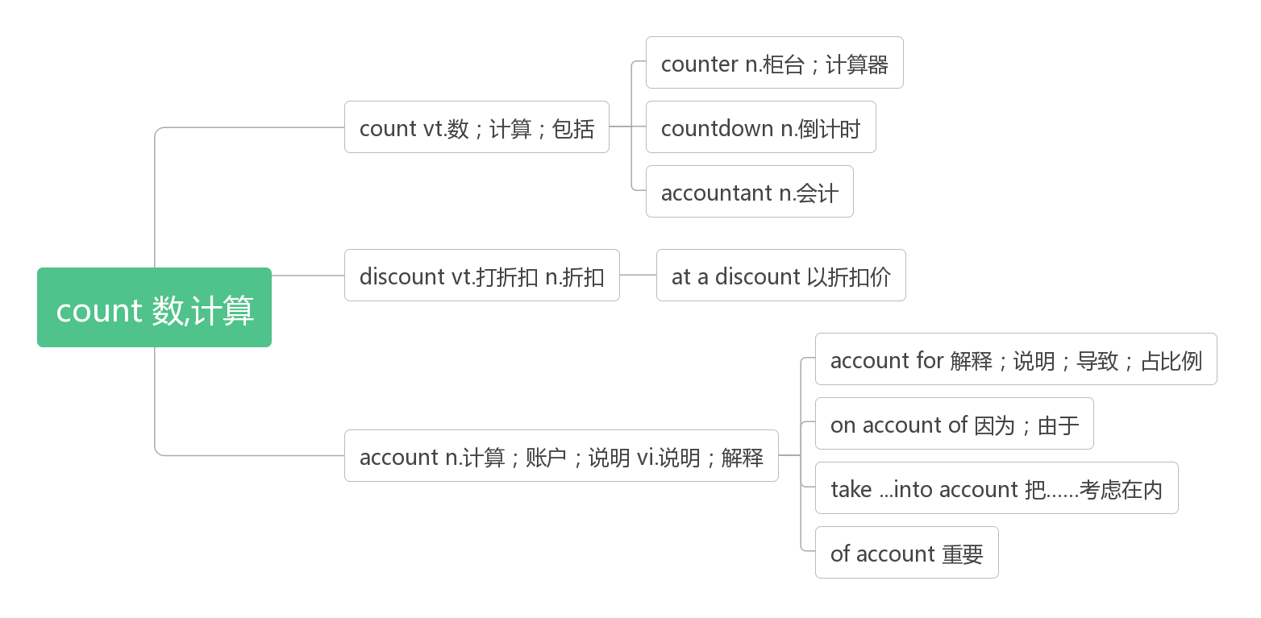
- click [klik] n. vt. & vi.点击
音意相通：拟声词，模拟鼠标点击的声音
Click the left mouse button twice. 双击鼠标左键。
When we click on download it says it will hurt our files. 当我们点击下载时，它提示说这会损坏我们的文件。
- privacy ['praɪvəsi]n. 隐私；隐秘；隐居；隐居处
词根词缀：priv-(私人)+-acy (名词后缀)：私人的空间：隐私；隐秘
Let them know you are there to help in any way that’s acceptable, while still respecting the privacy of your neighbor.(2018浙江) 让他们知道你随时可以以能够接受的方式帮助他们，同时又尊重你邻居的隐私。
Choose a campsite with privacy and minimum influence on others and the environment.(2009北京)
选择一个隐秘的，对他人和环境影响最小的宿营地。
private ['praɪvət]adj. 私人的；私有的；私下的n. 列兵
As data and identity theft becomes more and more common, the market is growing for biometric(生物测量)technologies—like fingerprint scans—to keep others out of private e-spaces.(2019全国I) 随着数据和身份盗窃变得越来越普遍，像指纹扫描这样的生物识别技术的市场正在增长，以防止其他人进入私人电子空间。
On the last day of our week-long stay, we were invited to attend a private concert on a beautiful farm on the North Shore under the stars, listening to musicians and meeting interesting locals.(2019全国III) 在我们为期一周的逗留的最后一天，我们应邀参加了在北岸一个美丽的农场举行的私人音乐会，在星空下聆听音乐家的演奏，并与有趣的当地人见面。
privilege ['prɪvɪlɪdʒ] n. 特权；优待
It's such a privilege to be a part of these kids’ lives, even just for a few hours, getting to know them and hearing their stories. (2019北京) 能成为这些孩子生活的一部分，哪怕只是几个小时，去了解他们，听他们的故事，是一种特权
Her responsibility, her privilege, would be to rescue it. (2019江苏) 她的责任，她的特权，将是拯救它。
They tell us to ignore privilege, power, and deep pockets.(2013江苏) 他们告诉我们要忽略特权、权力和金钱。

- theft [θeft]n. 盗窃；赃物
破拆法：the(特指)+-ft(left) 助记：the left, (贼)留下的东西——赃物——盗窃
As data and identity theft becomes more and more common, the market is growing for biometric(生物测量)technologies—like fingerprint scans—to keep others out of private e-spaces.(2019全国I) 随着数据和身份盗窃变得越来越普遍，像指纹扫描这样的生物识别技术的市场正在增长，以防止其他人进入私人电子空间。
He offers two independent sets of figures on car theft; both show a small rise in some parts of the country.(2011浙江)
他提供了两组关于汽车盗窃的独立数据;这两项数据在美国的一些地区都有小幅上升。
thief [θiːf]n. 小偷，贼
Security marking your bike can act a deterrent(威慑) to a thief. 自行车上的安全标志可以起到威慑小偷的作用。

- rude [ruːd]adj. 粗鲁的；无礼的
音意相通：(粗)鲁的
be rude to对……粗鲁
However, Mexicans may use silence when instructions are given by a person in authority rather than be rude to that person by arguing with him or her.（2016全国）
然而，当权威人士下达指令时，墨西哥人可能会保持沉默，而不是粗鲁地与之争吵。
Once upon a time, people hated the book because it struck them as rude.（2013江苏）
从前，人们讨厌这本书，因为它给他们的印象是粗鲁的。

- target ['tɑːgɪt]n. 目标；靶子vt. 瞄准；把……作为目标
破拆法：tar-(它)+get(获得) 助记：获得它就是我的目标
Google initially used the data collected from users to target advertising better.（2017江苏）
谷歌最初使用从用户收集的数据来更好地定位广告。
But because success is a moving target—as soon as you hit your target, you raise it again—the happiness that results from success does not last long.（2012江苏）但是因为成功是一个不断变化的目标——一旦你达到了目标，你就会再次提高它——所以成功带来的快乐不会持续太久。

- troll[trəʊl]n.(北欧神话)巨怪；网络喷子
破拆法：t-(它)+roll(滚动) 助记：不管是巨怪还是喷子，统统让它滚。

- cyberbully [ˈsaɪbərbʊli] n.网霸vt. & vi.网络欺凌
破拆法：cyber(网络的)+bully(欺凌;恶霸)：网霸；网络欺凌
Children may be reluctant to admit to being the victims of cyberbullying.
孩子们可能不愿意承认自己是网络欺凌的受害者

- false [fɔːls] adj.错误的；伪造的；假的
Being able to read people helps kids from misreading a situation and jumping to false conclusions.(2014全国I)
能够理解别人可以帮助孩子们避免误读形势并得出错误的结论。
False fire alarms are illegal and may lead to imprisonment.(2018天津) 谎报火警是非法的，可能会导致监禁。
It was proved that the aphasics(失语症者) were far ahead of the normal people in recognizing false speeches.(2007浙江)
事实证明，失语症患者在识别假话方面远远领先于正常人。
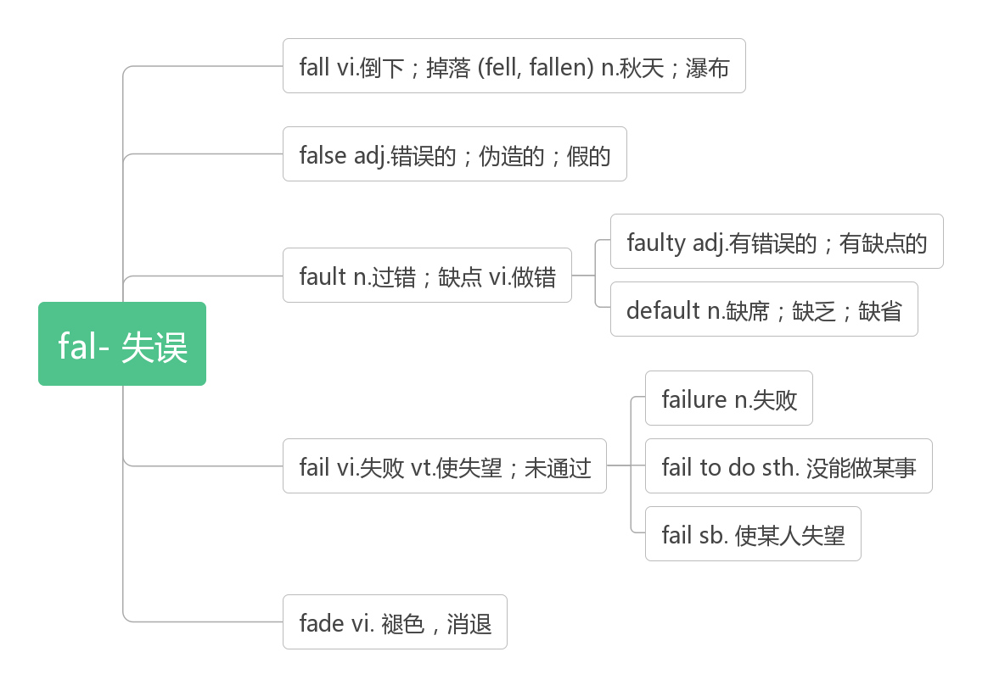
- particular [pəˈtɪkjələ(r)] adj. 特定的；详细的；独有的；挑剔的n. 详细说明；个别项目
词根词缀：part(部分)+-ic(形容词后缀)+(-ular属性)：有自己特定属性的——特定的，独有的
The students feel that they belong to a particular group.(2019浙江) 学生们觉得他们属于一个特定的群体。
Students should be able to extend the logic of each to their particular circumstance.(2018全国III)
学生应该能够将每个人的逻辑扩展到他们特定的环境。
Particular scents also have an effect: diners who got the scent of lavender(薰衣草)stayed longer and spent more than those who smelled lemon, or no scent.（2018江苏）
特殊的香味也会产生影响：闻到薰衣草香味的食客停留的时间更长, 花的钱也比那些闻到柠檬味或没有香味的人多。
be particular about 对……讲究，对……挑剔
An intelligent person be particular about trifles (小事). 聪明的人是不会与人斤斤计较的.
particularly [pəˈtɪkjələli] adv. 尤其；特别；异乎寻常地
This is particularly true in the US.(2020浙江一月) 在美国尤其如此。
What's particularly interesting is the attitude various cities have toward Dubanchet’s cause.(2019浙江)
特别有趣的是各个城市对Dubanchet事业的态度。
- embarrass [ɪmˈbærəs] v. (尤指在社交场合) 使窘迫，使尴尬
词根词缀：em-(=in进入)+barr-(栅栏)+-ass(动词后缀)：把人放入栅栏与栅栏之间，使进退两难——使尴尬
I feel embarrassed that I complain about not having enough child-free time to work. (2010天津)
我抱怨没有足够的不照看孩子的时间可以工作，这让我感到很尴尬。
I felt such a sense of relief that I would no longer have to be embarrassed when I returned to school.(2010浙江)
我有一种如释重负的感觉，当我回到学校时，我再也不必感到尴尬了。
The more embarrassing or shameful the secret is, the juicier the gossip it makes. (2016浙江)
这个秘密越是令人尴尬或羞耻，它所制造的流言蜚语就越令人津津有味。
A more embarrassing situation occurs when a student starts falling into sleep and the weight of the head pushes the arm off the desk, and the movement carries the rest of the body along. 一个更尴尬的情况出现了：一个学生睡着了，它的头部的重量将手臂了推离桌子，结果他身体的其他部分也随之移动了。(2011全国卷)
embarrassment [ɪmˈbærəsmənt] n.尴尬；窘迫； 难堪
Team leaders must ensure that all members get over their natural desire to avoid the embarrassment associated with making mistakes.(2013江苏) 团队领导必须确保所有成员克服他们的本能欲望，避免犯错误带来的尴尬。
To my embarrassment, the words kept coming out.(2009浙江) 令我尴尬的是，这些话不停地脱口而出。
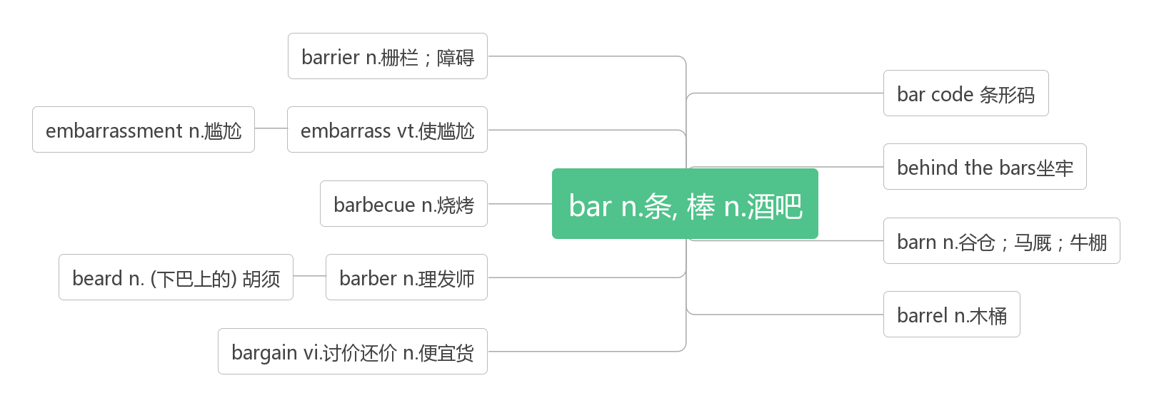
- make fun of取笑；戏弄
Both of us had the qualities and virtues that are typical of American actors: humorous, aggressive, and making fun of each other—but always with an underlying affection.(2017全国II)
我们俩都有美国演员典型的特质和美德:幽默、好斗、互相取笑——但总是带着一种潜在的感情。
Whether from jealousy or fear of someone who looked so different, my older brothers sometimes teased(戏弄) me about my unpleasing skin, or made fun of my clumsy walk.(2014江苏) 不知是出于嫉妒，还是因为害怕长得跟自己不一样的人，我的哥哥们有时会取笑我不好看的皮肤，或者取笑我走路笨手笨脚。
have fun (with) (与……一起)玩得开心
Then go outside and work out a plan to translate your childhood memories into your grown-up garden. Have fun.(2016全国II)
然后走出去，制定一个计划，把你的童年记忆转化成你的成年花园。玩得开心。
Did you have fun with your schoolmates for the weekend? 和校友一起度周末开心吗?

- upset [ʌpˈset]vt.打翻；扰乱；使心烦(upset, upset) adj. 烦恼的；沮丧的；难过的 n.烦恼；混乱
词根词缀：up(向上)+-set (sit坐)：底朝天——打翻，扰乱，使心烦
Uncontrolled human activities greatly upset ecosystems. (2019天津)
不受控制的人类活动极大地扰乱了生态系统。
A passenger realized he couldn’t find his ticket and became quite upset. (2014浙江)
一位乘客意识到他找不到他的票了，于是变得很烦恼。
The task was so hard, and Steve, angry and upset, said he was quitting. (2019江苏)
这个任务太难了，史蒂夫又生气又沮丧，说他不干了。
People who have personality traits that connect with competitiveness and low upset tolerance are much more likely to get angry. (2018北京) 那些具有竞争性和低焦虑耐受性个性特征的人更容易生气。
be upset about对……感到难过/沮丧
She was more upset about the effect on her family than herself. 她因对家庭的影响比对她自己影响感到更难过。
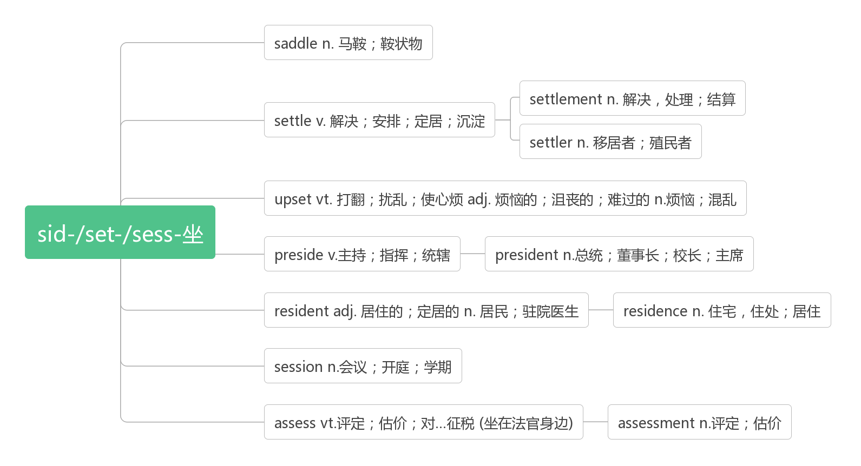
- guide [ɡaɪd] n.向导；导游；指南 vt. 引导；带领
Your guide will provide a history lesson about the trees and the famous monuments where they blossom.(2018全国I)
你的导游会告诉你有关树木以及它们所在的著名古迹的历史。
For just a small donation you can take a tour with our garden guide.(2018全国III)
只需一笔小小的捐款，你就可以和我们的园艺向导一起游览。
Below is a housing guide for students going to London. (2010浙江)
下面是给去伦敦的学生的住房指南。
Only then did I truly begin to appreciate Dad and his faith that guided us through the hard times.(2013天津)
直到那时，我才真正开始感激父亲，感谢他的信念，引导者我们度过了困难的时期。
guideline [ˈɡaɪdlaɪn] n. 准则；指导方针
This is not a question that can easily be answered, but some general guidelines can be offered.
这不是一个容易回答的问题，但是可以提供一些通用的准则。
And now it has issued guidelines to drivers to make sure they are fit for the road.
现在，它已经向司机发布了指导方针，以确保他们适合上路。

- author [ˈɔːθə(r)]n. 作者；作家；创始人
Many factors contributed to the decline, said Patrick Mclntyre, an ecologist who was the lead author of the study.(2019浙江)
这项研究的主要作者、生态学家Patrick Mclntyre说，很多因素导致了这种下降。
Why did the author refuse the help from the man in the house? (2018天津) 为什么作者拒绝了房子里的人的帮助?
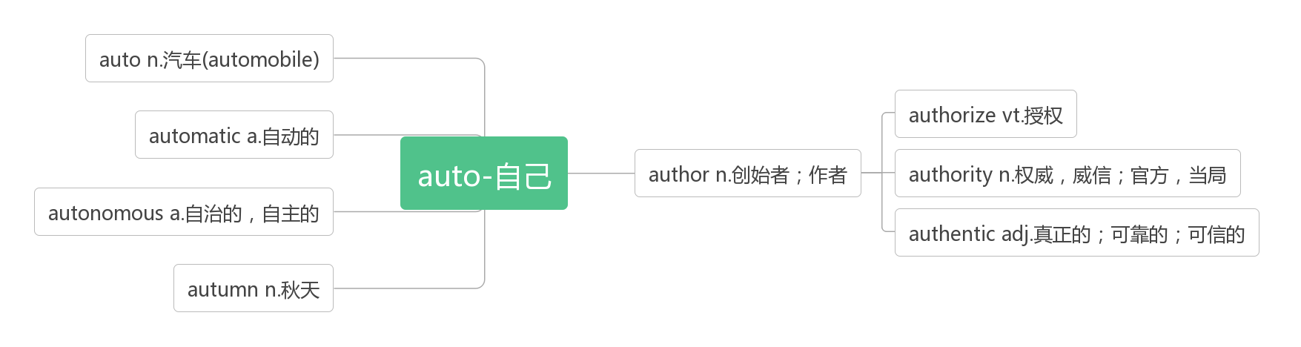
- tip [tɪp] n. 尖端；小费；建议；诀窍v.倾斜；倾倒；给小费
助记：要听他在刀尖上表演倾倒的诀窍和建议，必须给小费。
Here is the most effective tip to make you a superstar in environment protection.(2010浙江)
下面是让你成为环保巨星的最有效的建议。
Baby hoatzins (麝雉) have a claw on the leading edge of each wing and another at the end of each wing tip.(2010海南)
小麝雉在每只翅膀的前缘都有一只爪子，在每只翅膀末端都有另一只爪子
The hay caught fire when the candle tipped over. 蜡烛倾倒时干草着火了
It can be hard enough to know how much to tip waiters, porters, and taxi drivers in the UK.
在英国，要知道给服务员、搬运工和出租车司机多少小费可能很难。

- familiar [fəˈmɪliə(r)] adj. 熟悉的；常见的；亲近的n. 常客；密友
be familiar with对……熟悉
be familiar to 为……所熟悉
When serious illness visits your household, it's not just your daily routine and your assumptions about the future that are no longer familiar. (2015浙江) 当严重的疾病造访你的家庭时，你不再熟悉的不仅仅是你的日常生活和你对未来的设想。
It also doesn't require a new type of technology that people aren't already familiar with.(2019全国I)
它也不需要一种人们不熟悉的新技术。
Small color choices are the ones we’re most familiar with.(2018全国I) 小的颜色选择是我们最熟悉的。
Though the plot is familiar to me , it was the language of light and warmth of life details that moved me a lot.
虽然情节对我来说很熟悉，但让我非常感动的是乐观的语言和生活细节的温暖。
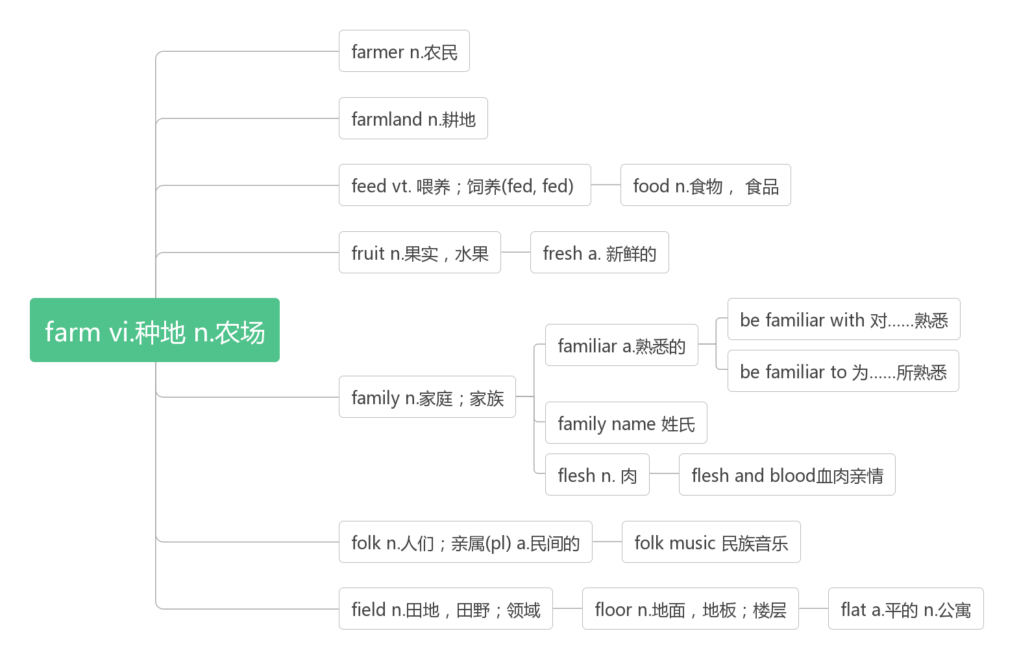
- keep/bear... in mind 记住，牢记
Another way of setting realistic goals is to analyze your short and long term objectives, keeping in mind your beliefs, values and strengths.(2019全国II)另一种设定现实目标的方法是分析你的短期和长期目标，牢记你的信念、价值观和优势。
You must keep these points in mind while setting your goals.(2019全国II) 在设定目标时，你必须牢记这些要点。
But it is useful to bear in mind that all such changes come from the technology and not some imagined desire by parents to keep their children under their wings.(2015北京)
但值得注意的是，所有这些变化都来自科技，而不是父母想要把孩子养在自己羽翼下的幻想。
Always bear in mind that your own resolution to succeed is more important than any one thing. ——Abraham Lincoln
永远记住：你自己的取得成功的决心比什么都重要。——林肯

- define [dɪˈfaɪn]vt. 定义；规定；使明确
词根词缀：de-(强调)+fine(限定)：对……的内涵加以限定——定义；规定
They would define the driver's role in such cars and govern how such cars perform in crashes where lives might be lost.
(2017天津) 他们将定义司机在此类车辆中的作用，并管理此类车辆在可能造成人员伤亡的撞车事故中的表现。
There is only one person who can define success in your life, and that’s you. 只有一个人能界定你的成功，那就是你自己。
You must not let anyone define your limits because of where you come from.不要因出身低就让别人限制了你发展的机会。
No matter what label is thrown your way, only you can define yourself. 不管你被贴上什么标签，只有你才能定义你自己。
definition [ˌdefɪˈnɪʃn] n.定义
The idea “happiness”, to be sure, will not sit still for easy definition.(2014江苏)
可以肯定的是，“幸福”这个概念并不是一个简单的定义。
My definition for happiness is “the capacity for enjoyment”. (2013天津) 我对幸福的定义是“享受的能力”。
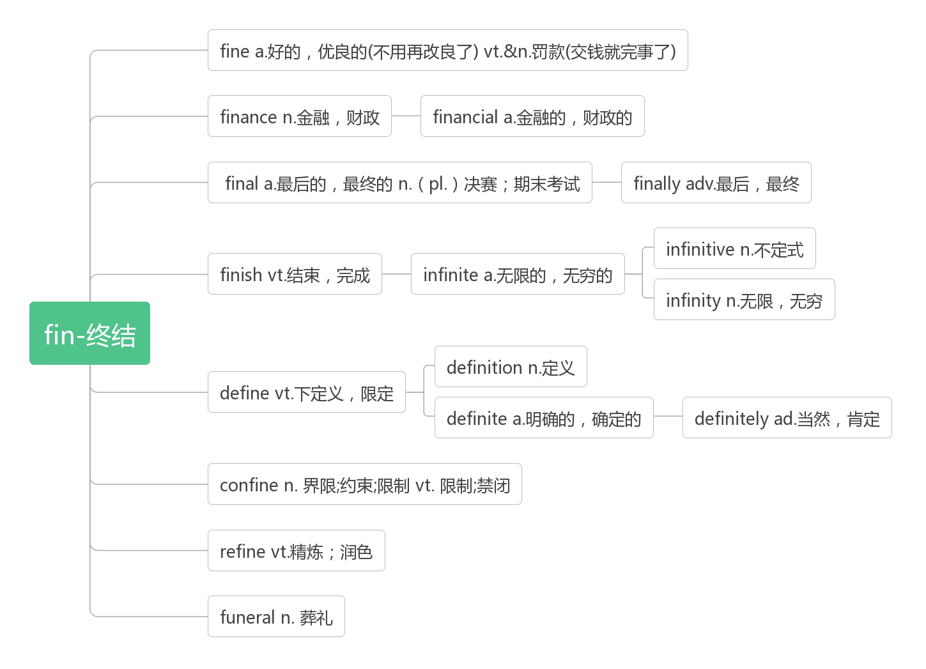
- case[kei]n.盒；箱；情况；案件
in case (of/that) 以防……，以防万一
in no case绝不
in this/that case在这种/那种情况下
The truth is that we are lucky enough to have clean water whenever we want, but this is not the case for many people around the world. (2020浙江一月) 事实上，我们很幸运，随时都能得到干净的水，但世界上很多人都不是这样。
It is often the case that anything is possible for those who hang on to hope.(2016江苏)
通常情况下，对于那些坚持希望的人来说，任何事情都是可能的。
The doctor shares his phone number with the patients in case they need medical assistance.(2019江苏)
医生把他的电话号码告诉病人，以防他们需要医疗帮助。
This time, we stayed together, in case anything else unusual happened. (2018天津)
这一次，我们呆在一起，以防有什么不寻常的事情发生。
I guess we’ve already talked about this before but I’ll ask you again just in case.(2010浙江)
我想我们之前已经讨论过这个问题了，但是为了以防万一，我再问你一次。
In case of fire, all exits must be kept clear.(2007天津) 万一发生火灾，所有的出口必须保持畅通
In that case, ask to speak in person as soon as possible and say sorry.(2017天津)
在这种情况下，请求尽快当面向对方道歉。

- the World Wide Web (abbr. www) 万维网；

