Chapter 2 A Bad Child
- Discuss the Question
- Can you recall some happy events during your childhood? Share with your classmates.
- How would you describe your childhood?

- Read by Yourself

¹slam /slæm/ v.
(使…) 砰地关上

²waddle /ˈwɒdl/ v.
(鸭子似地) 摇摆地行走

³barge /bɑ:dʒ/ n.
驳船(运河、河流上运载客货的大型平底船)

⁴orphan /ˈɔ:fn]/ n.
孤儿

My life has been full of ups and downs, and during my childhood the downs seemed to rain on me like a never-ending storm. When I look back on those years, I can’t believe that any grown-up would behave in that way to a child. But they did.
My story starts in Suffolk with the first noise I ever heard—the slamming¹ of our front door.
My great-aunt, Betsey Trotwood, had been quite sure I was going to be a girl. When she was told I was a boy, she got up in a rage and stormed out. My poor mother! She was all alone in the world, except for me and our housekeeper, Peggotty. My father had died six months before I was born.
My early childhood was very happy. I remember watching geese waddle² around our back yard and reading picture books with Peggotty. Peggotty was not pretty, like my mother, Clara, but she was kind and loving, and I adored her as much as I adored my mother.
Then one evening at a friend’s house, my mother met Mr Murdstone. He had black hair and a hard, cold, handsome face. My mother seemed to light up in his company, but even though I was very young, I could tell Mr Murdstone didn't like me at all. And I didn’t like him. Before long, this unpleasant man began to visit our house more and more often.
So I was very happy when Peggotty took me on a holiday to the seaside where her brother, Dan Peggotty, lived. I fell in love with his house, which was in an upside-down boat—a large black barge³, with an iron funnel blowing out chimney smoke. I also fell in love with his little orphaned⁴ niece, Emily, who lived with him. She was bold and pretty with a wildness that completely captured my heart.
I often think that if I hadn’t met Emily, some of the terrible things that happened to her in later life may never have taken place. But you can’t know these things at the time.
Dan Peggotty also looked after an orphaned nephew named Ham, a tall boy with a wide smile, who was several years older than I was.

After Mr Murdstone’s coldness, the friendliness of Dan’s family made me very happy. Best of all, I loved playing on the beach with little Emily. I had a very heavy heart when Peggotty and I had to leave them all and return home. But nothing could have prepared me for the awful news that was waiting for me.
While I’d been away, my mother had married Mr Murdstone. From now on he was going to live with us. I felt as if the air had been strangled⁵ out of me. Mr Murdstone was the kind of man that smothers all hope and happiness.
Now that they were married, he ordered my mother around and bullied her until I couldn’t bear to watch. If she showed me kindness, he’d say, “Don’t be so weak, Clara. You must be frm with the boy.” He said I was a bad child and that he was determined to crush me.
“David,” he said one day, beckoning⁷ me over to him, “what do you think I do if I have a dog or a horse that doesn't do what I tell them?”
“I don’t know,” I whispered nervously.
“I beat it,” he replied, with an evil glint⁸ in his eyes.
I shivered⁹ with fear, knowing that if I gave him the slightest excuse, he would beat me.
Peggotty was very upset about Mr Murdstone, and she tried talking to my mother. But my mother was too afraid of her new husband to do anything that might make him angry—she was totally in his power. I could never get my mother on her own any more—Mr Murdstone was always there.
Things got worse when Mr Murdstone’s sister came to live with us. Miss Murdstone looked just like her brother. Her face was full of gloom¹⁰ and cruelty. “I don't like boys” were the first words she spoke to me, and it seemed that whatever I said or did was wrong in her eyes.
If it were possible, she was even harsher towards my mother than her brother. My poor mother now had two jailers¹¹ instead of one. `The Murdstones scolded her day and night. I never saw my mother speak her mind again, unless she had first checked with those two that they agreed.
I was not allowed to play with other children, because the Murdstones thought all children were vipers¹². The only escape I had was to lose myself in the small collection of books my father had left us. As I read, I imagined myself as the hero of each story and the Murdstones as the evil characters, always getting into trouble.

⁵strangle /ˈstræŋɡl]/ v.
扼死; 勒死

⁶smother /ˈsmʌðə(r)/ v.
使窒息而死; 闷死

⁷beckon /ˈbekən/ v.
招手示意; 举手召唤

⁸glint /ɡlɪnt/ n.
闪光；闪亮

⁹shiver /ˈʃɪvə(r)/ n.
颤抖，哆嗦

¹⁰gloom /glu:m/ n.
忧郁; 愁闷

¹¹jailer /ˈdʒeɪlə(r)/ n.
监狱看守; 狱卒

¹²viper /ˈvaɪpə(r)/ n.
蝰蛇(一种小毒蛇)

Mr Murdstone insisted I did lessons with my mother, but he and Miss Murdstone would stand over me, frowning¹³ and telling my mother to be firmer. Every day I found it harder to work, with these two evil people watching my every pencil stroke¹⁴. And every day they would punish me for being “stupid”.
One morning, Mr Murdstone looked even sterner¹⁵ than usual and I saw he was gripping¹⁶ a thin cane in one hand. “You must be extra careful today,” he warned me, pointing the cane at me.
That day, I made mistake after mistake. My body was shaking with fear. Before long, Mr Murdstone jumped up, shouting, “We can’t expect Clara to put up with the worry David is causing her today!”
My mother started crying and reached out towards me.
“Stop it at once, Clara!” ordered Miss Murdstone.
My mother fell silent as Mr Murdstone turned his steely¹⁷ gaze on me. “You and I will go upstairs now, David,” he said.
I walked up the stairs with my knees trembling. Mr Murdstone’s heavy footsteps followed right behind me. As soon as we entered my bedroom he shut the door.
“Why are you doing so badly in your lessons?” he demanded.
I shook with terror. I had to give an answer, but the only one I could think of was the true one and I knew it would end in disaster.
“I...I...can’t do my work,” I spluttered¹⁸, “when...when you and Miss Murdstone are there.”
No sooner had these words left my mouth than he grabbed hold of my head and began slapping me. I had to fight back—I had to. All those weeks of bullying and loneliness exploded in me.
I sank my teeth deep into his right hand—the one holding my neck—and tasted the salty and sour texture¹⁹ of his skin. He yelled in pain and sprang backwards, letting go of my head in shock. He stared down in horror at the deep bite marks on his hand.
The next instant, he rushed at me, hitting me with both hands on my head, on my back, on my chest. I held my arms over my face, dizzy with pain and shock. I was only ten years old, and I couldn’t defend myself against a fully-grown man.
I heard my mother and Peggotty screaming on the stairs outside my room, begging Mr Murdstone to stop. But he took no notice. How ong the attack lasted, I don’t know, but by the time he finished, I collapsed²⁰ in a heap²¹ on my bedroom floor.

¹³frown /fraʊn/ v.
皱眉; 蹙额

¹⁴stroke /strəʊk/ n.
(打、击等的) 一下

¹⁵stern /stɜ:n/ adj.
严厉的; 苛刻的

¹⁶grip /ɡrɪp/ v.
紧握; 紧抓

¹⁷steely /ˈsti:li/ adj.
强硬的; 冷冰冰的

¹⁸splutter /ˈsplʌtə(r)/
v. 气急败坏地说

¹⁹texture /ˈtekstʃə(r)/
n. 质地; 手感

²⁰collapse /kəˈlæps/
v. 突然) 倒塌，坍塌

²¹in a heap
颓然（倒下）; 重重地（倒下）

For five days I was kept a prisoner in my room, with Miss Murdstone acting as jailer.
On the fifth night, I heard Peggotty outside my room. “They’re sending you away to a boarding school in London,” she whispered through my door.
“When am I going?” I asked.
“Tomorrow,” she answered, “first thing in the morning.”

- Check Your Understanding
- How do you understand “ups and downs” in Paragraph 1?

2. Can you figure out who they are according to the descriptions in the story.
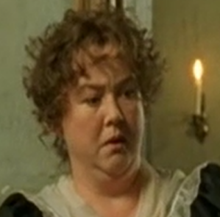 | 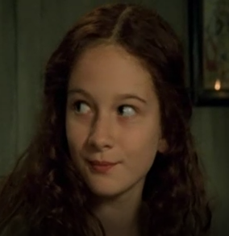 | 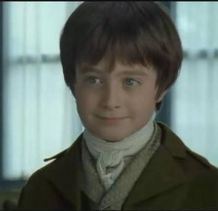 | 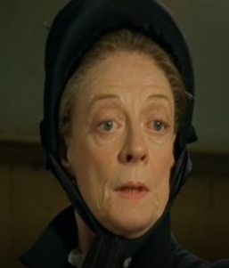
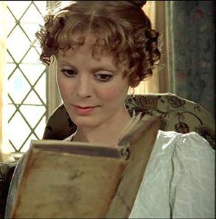 | 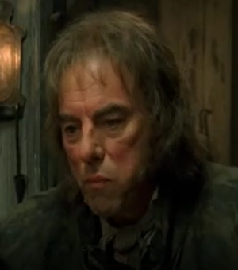 | 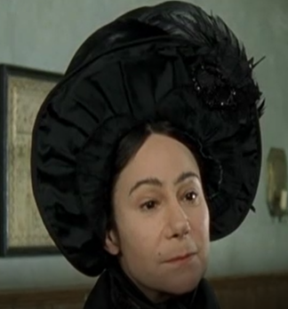 | 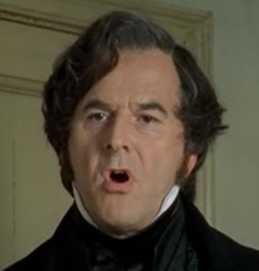
- What does David think of his childhood?

- Why was David’s early childhood happy?

- Why was David’s childhood become unhappy?

6. How does the writer describe Mr Murdstone and Miss Murdstone?
Name | Appearance | Character
Mr. Murdstone
Miss. Murdstone

- How was David’s feeling toward Mr. Murdstone? How does the writer describe it?

8. Try to find the sentence describing the following feelings: “happy”, “unhappy”, “angry”,
“desperate”, and “frightened”.

- Share Your Opinion
- The title of Chapter 2 is “A Bad Child”. Do you think David Copper is a bad child according to
how he behaved in the story? Gve your reasons.

