Topic Sentence in Summary Writing
—by 李婷婷 常山县紫港中学
- 学情分析：高三学生在概要写作时，经常会利用主题句把握文章大意，段落大意。但是，对于主题句的位置、功能认知，学生还是存在一定的刻板印象，而这些刻板印象会使学生在概要写作时产生一些惯性思维，最终导致概要写作要点的偏离或者次要点缺失。因此，本次概要写作注重关注如何去寻找主题句、以及利用主题句收集次要点和如何集合要点撰写主题句。
2. 教学目标：1) To find the existing topic sentences in the text.
2)To write topic sentences with the key words and logical relationships.
3) To learn the functions of topic sentences and have a new understanding of topic sentences.
3. 原题分析：本篇概要是一篇议论文，全篇由四段组成，主要讨论了充足睡眠对学生的学习的重要性。文本第一段通过一个社会现象导入文章主题，即充足睡眠对青少年学习是很重要的；第二段通过一个专家书中的话解释了睡眠与学习之间的具体关系，即越大量的学习需要越多的睡眠时间，而这对于取得学习上的成功也是很关键的。第三段则通过一个研究报告回答了青少年每日应有的睡眠时间和缺乏睡眠会产生的危害。最后一段主要关于父母如何改善孩子睡眠习惯的建议。
4. 教学步骤：
Step1：Lead-In
Think about the four questions about topic sentence.
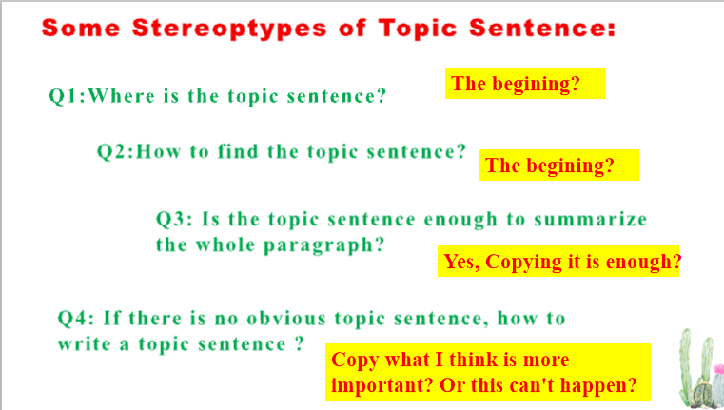
（Aims: To elicit the topic and find some stereotypes of topic sentence.）
Step2: Summarize the main idea of each para.
- To read the summary writing and find the topic sentences in this text by thinking two questions:
To figure out the structures within a Paragraph.
Para | Structure of the Para | Topic Sentence
1 | Phenomenon+Cause+Topic | Unfortunately,it is often counterproductive(适得其反的)because with fewer hours to sleep,the teen brain doesn't get enough time to lay down what they've studied the night before.
2 | An expert’s words+ An Opinion | Basically the more we learn,the more we need to sleep,which is why a good sleep is of great importance in achieving success at school.
3 | Two Questions + Two Answers | ..., but the Austrian Centre for Education in Sleep(ACES)suggests 8 to 10 hours per day for high school adolescents.  poor sleep will have all sorts of negative effects on teenagers...
4 | A Question+ An Answer | Not only is your job to help make changes,it's also to ride the wave with them.
- Based on the structure, write the Key Points in your own words.
Step3: Make coherence
- Think about the logical relationships between each paragraph.
- Add proper connecting words.
Step 4: Summary
Think about the four questions put forward before.
Q1:Where is the topic sentence?
Q2:How to find the topic sentence?
Q3: Is the topic sentence enough to summarize the whole paragraph?
Q4: If there is no obvious topic sentence, how to write a topic sentence ?
Para | Structure of the Para | Topic Sentence | How to find topic sentence or key points.
1 | Phenomenon+Cause+Topic | Unfortunately,it is often counterproductive(适得其反的)because with fewer hours to sleep,the teen brain doesn't get enough time to lay down what they've studied the night before. | Unfortunately话语标记词；  现象导入后
2 | An expert’s words+ An Opinion | Basically the more we learn,the more we need to sleep,which is why a good sleep is of great importance in achieving success at school. | 例子后面；构成例证关系
3 | Two Questions + Two Answers | ..., but the Austrian Centre for Education in Sleep(ACES)suggests 8 to 10 hours per day for high school adolescents.  poor sleep will have all sorts of negative effects on teenagers... | 问题后面，以答案概括
4 | A Question+ An Answer | Not only is your job to help make changes,it's also to ride the wave with them. | 过渡句同时也是主题句

Step5: Homework
Polish the draft.

