A letter to an architect 读写学案
Task 1 Talking
What possible problems will there be if our school life comes back to normal?
Considering such problems, what are the possible solutions?

Task 2 Brainstorm
What makes a good letter of advice?

Task 3 Prediction
How many parts do you expect to read in a letter of suggestion?
What does each part talk about?

Task 4 Reading for information
Read and answer:
- Who is the letter from?
- What’s the name of the architect?
- Why does Alice Major write the letter?
- How many suggestions are given here?

Task 5 Reading for writing strategies & language

Draw a mind map to include the key aspects of each paragraph and the according key expressions.

Task 6 Tip summary
What are the four tips mentioned in this lesson?
Tip1:________________________________________________________________________________________
Tip2:________________________________________________________________________________________
Tip3:________________________________________________________________________________________
Tip4:________________________________________________________________________________________

Task 7 Brainstorming
In groups, brainstorm as many relevant expressions as you can.
background |  | reason |  | transition
benefit |  | purpose |  | appreciation
problem |  | hope |  | suggestion

Task 8 Writing
Writing Task
针对即将到来的复课，学校正在广泛征求各位同学的建议，请以一名高二学生的身份，就校园复课的潜在隐患给校长写一封建议信。信中应包含以下内容：
1. 写信目的
2. 对校园复课可能潜在的问题简要评述。
3. 针对问提题出建议。

Step 1 Draw a mind map to include the main topic for each paragraph. the key aspects of each paragraph and the according key expressions.

Step 2 First draft writing
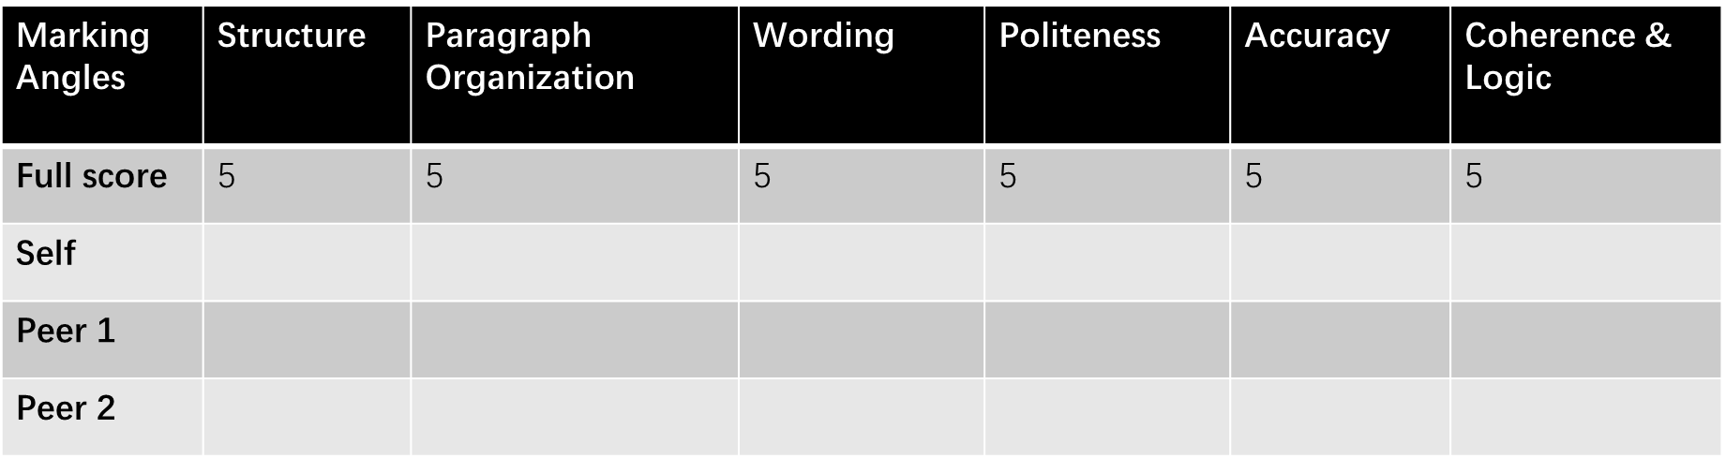
Draft 1
_____________________________________________________________________________________________________________________
_____________________________________________________________________________________________________________________
_____________________________________________________________________________________________________________________
_____________________________________________________________________________________________________________________
_____________________________________________________________________________________________________________________
_____________________________________________________________________________________________________________________
_____________________________________________________________________________________________________________________
_____________________________________________________________________________________________________________________
_____________________________________________________________________________________________________________________
_____________________________________________________________________________________________________________________
_____________________________________________________________________________________________________________________
_____________________________________________________________________________________________________________________
_____________________________________________________________________________________________________________________
_____________________________________________________________________________________________________________________
_____________________________________________________________________________________________________________________
Step 3 Peer editing
Highlight 1:
Highlight 2:
Highlight 3:
Mistake 1:
Mistake 2:
Mistake 3:
Homework: Polish Draft 1 to create Draft 2.

