Unit 2 Book 1 导案
- castle [ˈkɑ:sl] n.城堡;堡垒
拆破法：cast(抛掷)+le(了) 助记：抛掷了的武器都被城堡挡了下来。
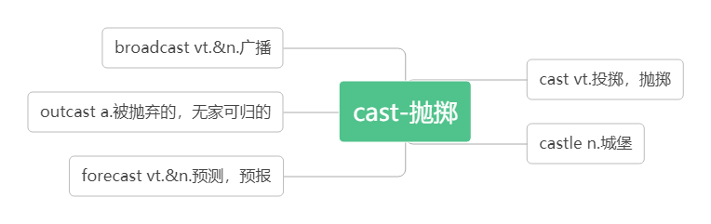
Visitors to the castle are asked not to take photographs.来城堡参观者不得拍照。
Most castles were built on hilltops. 多数城堡建在山顶上。
Every year a large number of tourists come to visit Windsor Castle, which is beautiful.
每年都有大量的游客来参观美丽的温莎城堡。
My hut is my castle. Wind comes in, rain comes in, kings don't come in.
我的小屋就是我的城堡。风能进，雨能进，国王不能进。

- apply [əˈplaɪ] vi.申请vt. 应用;涂抹
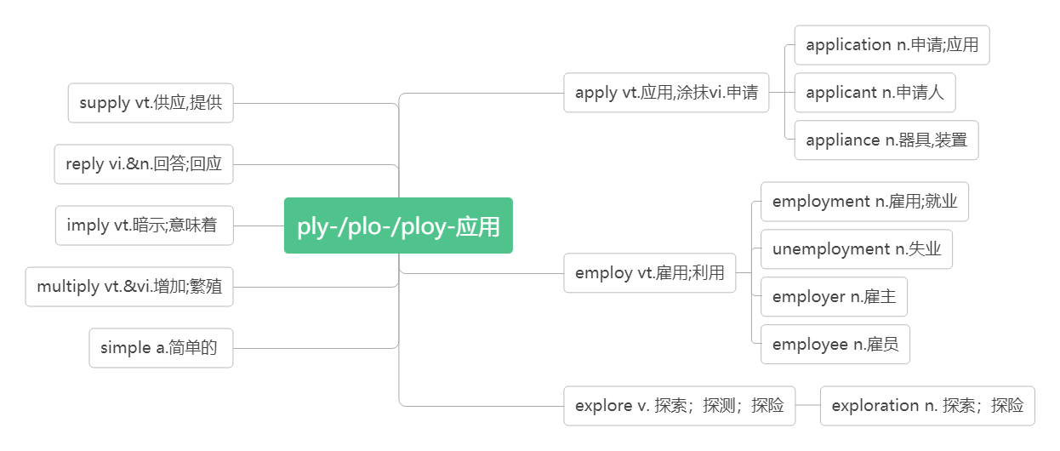
You should apply in person. 你应该当面申请。
They may apply to join the organization.他们可以申请加入该组织。
apply to sb. for sth. 向某人申请某物
apply sth to sth 把某物应用于/涂抹在...上
To study abroad, you should apply for a visa first.要出国留学，你应该先申请签证。
She only applied to one university and was accepted. 她只向一所大学提出申请并被录取了。
Don't forget to apply sun cream. 不要忘记涂上防晒霜。
You can apply theory to practice. 你可以把理论用于实践。
The new technology was applied to farming. 这项新技术已应用于农业。
She applied the cream to her face and neck.她把乳霜抹在脸和脖子上。
If you don’t take charge of shaping your own destiny, others will apply their agenda(计划,日程表) to you.
你若不主动建构自己的命运，别人将会把他们的计划加诸在你身上。
application [æplɪˈkeɪʃn] n. 申请；应用，用途
Send a full CV with your job application. 寄上求职申请书和详尽的个人履历。
an application letter/form 申请信/申请表
Since the 1970s many new applications have been found for me.
从二十世纪七十年代起，我又被开发出了很多新的用途。
We have learned the application of new technology to teaching. 我们学会了将新技术应用于教学上。
applicant [ˈæplɪkənt]n.申请人，求职人
There were over 500 applicants for the job.

- visa [ˈvi:zə] n.签证
词根词缀：vis-(看)+a(去)：去给别人看的东西——签证
apply for a visa 申请签证
tourist /entry/ exit visa 旅游/入境/出境签证
To travel abroad, you 'll have to get a passport, and you'll also need a visa.
要出国旅游,你必须申办护照, 同时还需要有签证。

- rent [ rent] vt.租用；出租vi.出租n.租金
rent a car 租一辆车
a high/low rent 高的/低的租金
She rents a house with three other girls. 她和其她三个女孩合租一套房子。
We rented a car for the week and explored the area. 我们租了一个星期的车游历这个地区。
She rented rooms to university students. 她把房间租给了大学生。
The apartment rents for $500 a month. 这套房间每月租金为500 元。
She worked to pay the rent while I went to college. 在我读大学期间，她打工挣钱来付租金。
The landlord has put the rent up again.房东又提高房租了。

- pack [pæk]vi. & vt.打包；收拾n.包裹
pack (sth.) up 将(东西)装箱打包
When I was 17, I packed my bags and left home. 17岁时, 我背起行囊离开了家。
I should pack for the trip. 我该打包上路了。
You either pack up and go home, or keep fighting!要不你就打包回家，要不就继续奋斗！
I need to pack up my things into the suitcase very quickly.我需要快速把这些东西放到手提箱里。
The tea is packed and sent to many different countries. 茶叶被打包运往不同的国家。
He put too many things into his pack. 他放太多的东西在他的包里。
a pack of 一包；一盒；一群；一堆
a pack of cigarettes/gum/green tea 一盒香烟/口香糖/绿茶
a pack of dogs/ foxes 一群狗/狐狸
He told you a pack of lies. 他对你说了一堆谎言。
We were first greeted with the barking by a pack 63 dogs, seven to be exact.(2019全国卷III）
迎接我们的是一群狗的吠叫，确切地说是七只狗。

- amaze [ əˈme ɪz ]vt. 使惊叹；使惊奇
amazing [əˈme ɪzɪŋ ] adj. 令人惊叹的;令人惊奇的 (现在分词表示主动内涵，意为令人……的)
amazed [əˈme ɪzd ] adj. 感到惊叹的;感到惊奇的 (过去分词表示被动内涵，意为感到……的)
be amazed at 对……感到惊叹
I'm sure the boy's rich knowledge will amaze you. 我相信那个男孩渊博的知识会使你们吃惊。
The child amazed us with his ability in art, math and other areas.
这个有天赋的孩子在艺术、数学和其他领域的能力使我们吃惊。
It amazed everyone that Yang Chenyu gained a mark of 730 in the 2019 Entrance Examination.
杨晨煜在 2019 年高考中获得 730 分的成绩使大家很惊讶。
an amazing discovery/success/performance 惊人的发现/成功/表演
It was one of the most amazing films I've ever seen. 这是我看过的最精彩的电影之一。
I saw her amazed look. 我看到了她惊愕的神情。
I was amazed at his speed of working.他办事之麻利让我深感叹服。
The teacher was amazed to find that a lazy student had gained a mark of 100 in the test.
老师惊奇地发现一个懒惰的学生在这次考试中得了100 分。
While there are amazing stories of instant transformation, for most of us the changes are gradual and require a lot of effort and work, like cleaning up a polluted river.（2014全国I）尽管有惊人的关于快速改变的故事，但对于我们大多数人来说，变化是逐渐的，并且需要很多努力和工作，就像清理被污染的河流一样。

- arrange [əˈre ɪnd ʒ ]vt.安排; 筹备
词根词缀：ar-(去)+-range(排列):去排列好——安排
The party was arranged quickly. 聚会很快就安排好了。
They had no time to arrange their own wedding. 他们没有时间筹备自己的婚礼。
arrange for 安排
We will arrange for a car to pick you up.我们将安排一辆车来接你.
Would you like to arrange for a personal interview? 你是否想安排一次亲自会见?
arrangement [əˈreɪndʒmənt]n.安排；筹备
Actually, I’ve just finished the travel arrangements! 实际上,我刚刚完成了旅行安排！
Please tell him the arrangements for his trip in Italy. 请告诉他在意大利旅行的安排。
I'll make arrangements for you to be met at the airport. 我会安排人到机场接你。
Her teacher made a special arrangement to discuss her progress at school once a month.
她的老师作了特别安排，每月讨论一次她在学业上的进展情况。

- extreme [ɪkˈstri:m]adj.极端的
破拆法：extre-(extra格外的)+me(我) 助记：一个格外自我的人是比较极端的。
The earth will experience extreme weather. 地球将会遭受极端天气。
We are working under extreme pressure at the moment.目前我们正在极大的压力下工作。
The suffering of the people was extreme.人们遭受的灾难极为深重。
extremely [ ɪkˈstri:mli ] adv.极其，非常
Jiuzhaigou is an extremely beautiful place. 九寨沟是一个非常美丽的地方。
My mobile phone is extremely useful. 我的手机非常有用。
She found it extremely difficult to get a job. 她发觉找工作极其困难。
Everything is going on extremely well.一切进展得非常顺利。
They sold their land at the extremely low prices. 他们以极低的价格卖掉土地。

- source[sɔ:s]n.来源;出处;源头
拆破法：s(水)+our(我们的)+ce(测) 助记：我们要测出我们的河水的源头。
What other sources of information can you find about Peru?关于秘鲁，你能找到其他信息来源吗？
The library is a useful source of information.图书馆就是很好的资料来源。
What is their main source of income?他们的主要收入来源是什么？
The source of the Mekong is in Qinghai Province.湄公河的源头在青海省。
For me, music is a great source of enjoyment. 对于我来说，音乐是我快乐的源泉。

- narrow [ˈnærəʊ]adj.狭窄的vi.& vt.（使）变窄
拆破法：n(门)+arrow(箭)：谁能把箭射入窄门内？
PERU is a country on the Pacific coast of South America with three main areas: narrow, dry, flat land running along the coast, the Andes Mountains, and the Amazon rainforest.秘鲁是南美洲太平洋沿岸的一个国家，有三个主要区域：沿着海岸狭窄干旱的平坦陆地，安第斯山脉和亚马逊雨林。。
They were climbing up a narrow mountain road 他们正沿一条狭窄的山路向上爬。
She slowed the car and began driving through the town's narrow streets.她放慢车速，开始穿过该镇狭窄的街道。
This is where the river narrows. 这条河就是在这里变窄的。
The gap between the two main parties has narrowed. 两大主要政党之间的差距已经缩小了。
We need to narrow the gap between the rich and poor. 我们需要缩小贫富差距。

- flat [ flæ t ]adj. 平坦的; 扁平的 n.公寓; 单元房
The driver stops the car on a flat platform and gets out.司机把车停在一个平坦的平台上，然后出来了。
People used to think the earth was flat. 人们曾经认为地球是平的。
Do you live in a flat or a house? 你住的是公寓还是独立住宅？
Before they got married, they had the flat decorated. 他们结婚前把公寓装修了一遍。

- power[paʊə]n.力量；能力；政权；能源；动力
come to/into power 上台执政
beyond one’s power 超出某人的能力
nuclear/wind/solar power 核能/ 风能/ 太阳能
power cut/failure 断电/停电
As is known to us, knowledge is power.众所周知，知识就是力量。
It is beyond my power to finish the task in two hours.两个小时之内完成这项工作超出了我的能力。
The Republican Party came to power in 2016.美国共和党是在2016 年上台执政的。
powerful [ˈpaʊəfl ]adj. 强有力的；有权势的；有影响力的
In the 1400s and 1500s, Peru was the centre of the powerful ancient Inca Empire.
在 15 世纪和 16 世纪，秘鲁是强大的古代印加帝国的中心。
His speech was a powerful attack against the enemy. 他的演说是对敌人强有力的抨击。
His grandfather once was a rich and powerful man. 他的爷爷曾经是一个有钱有势的人。
China is wealthier and more powerful than ever before.中国比以往任何时候都更加富有和强大。

- empire[ˈempa ɪə(r)]n.帝国
the Inca/ Roman Empire 印加/罗马帝国
The Thirty Year's War caused the end of the empire. 30 年的战争导致帝国的灭亡。
emperor[ˈempərə(r)]n.皇帝
The Inca emperor lived in the now-famous site Machu Picchu. 印加皇帝曾住在现在著名的遗址马丘比丘。
Qinshihuang was the first emperor of China in history. 秦始皇是中国历史上第一位皇帝。
When the emperor died, his three sons shared the empire. 当皇帝去世后, 他的三个儿子共同分享帝国。
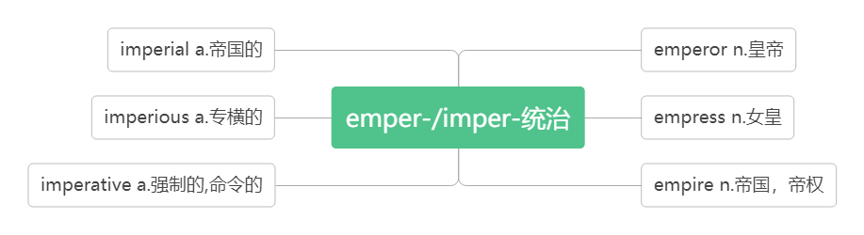
- site [saɪt ]n.地点；位置；现场
web site 网站
A good site has been chosen for the new school.已为新学校选好了校址。
The bar is built on the site of an ancient castle . 这家酒吧建在一个古代城堡的遗址上。
They put up their tent at the camping site.他们在营地上搭起了帐篷。
He was a worker on a building site. 他在工地做过建筑工人。
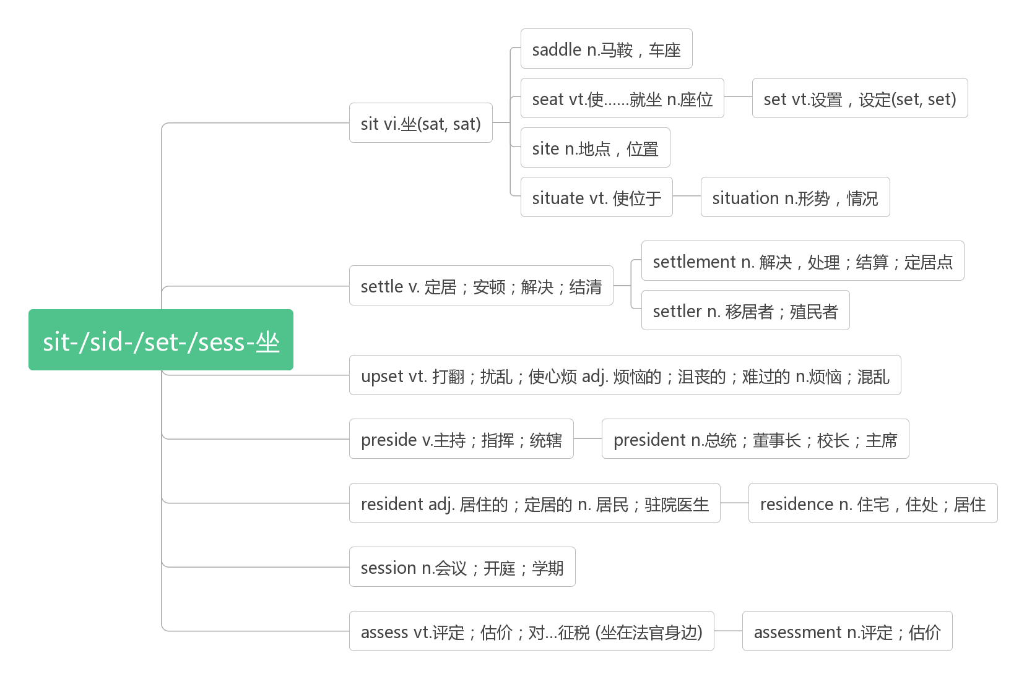

- control [kən'trəʊl]vt.&n. 控制；管理；抑制
词根词缀：contr-(相反)+-rol(滚轮)：让……反着滚——抑制，控制
Instead of letting circumstances control and defeat you, use them to push you into action so that you can change your present situation. 不要让生活控制或打败你，你要把压力变成动力去改变目前的处境。
You can do anything you decide to do. You can act to change and control your life; and the procedure, the process, is its own reward.你可以做任何你决定的事，你可以采取行动改变或控制你的人生；而这程序、过程，本身就是报偿。
To get a thorough understanding of oneself is to get a full control of one's life. Then one will find one's life full of color and flavor.悟透了自己，才能把握住自己，你生活才会有滋有味！
take control of 控制; 接管
Spain took control of Peru in the 16th century and ruled until 1821. 16世纪西班牙控制了秘鲁并统治到1821年。
In the night, they successfully take control of the city. 在夜里他们成功控制了那座城镇。
I can't take control of the boat.这船我控制不了。
I decided to take control of my life. 我决定控制自己的人生。
After his father died, he took control of the company. 他父亲死后，他接管了公司。

- official [ə'fɪʃl] adj. 官方的；正式的; 公务的 n. 政府官员
It's for this reason that Spanish is the main official language of Peru.正因为如此, 西班牙语才是秘鲁的主要官方语言。
English is used as an official language in many countries.英语是许多国家的官方语言。
The President made a four-day official visit to Mexico.总统到墨西哥进行了为期四天的正式访问。
His grandfather is an officer in the army while his father is an official in the government.
他的爷爷是部队军官，而他的爸爸是政府官员。
officially adv. 官方地；正式地
The college is not an officially recognized English language school.那所学院不是官方认可的英语学校。
The title will be officially given to me at a ceremony in London. (2016全国卷I语法填空）
在伦敦举行的一个仪式上，这个头衔将被正式授予我。
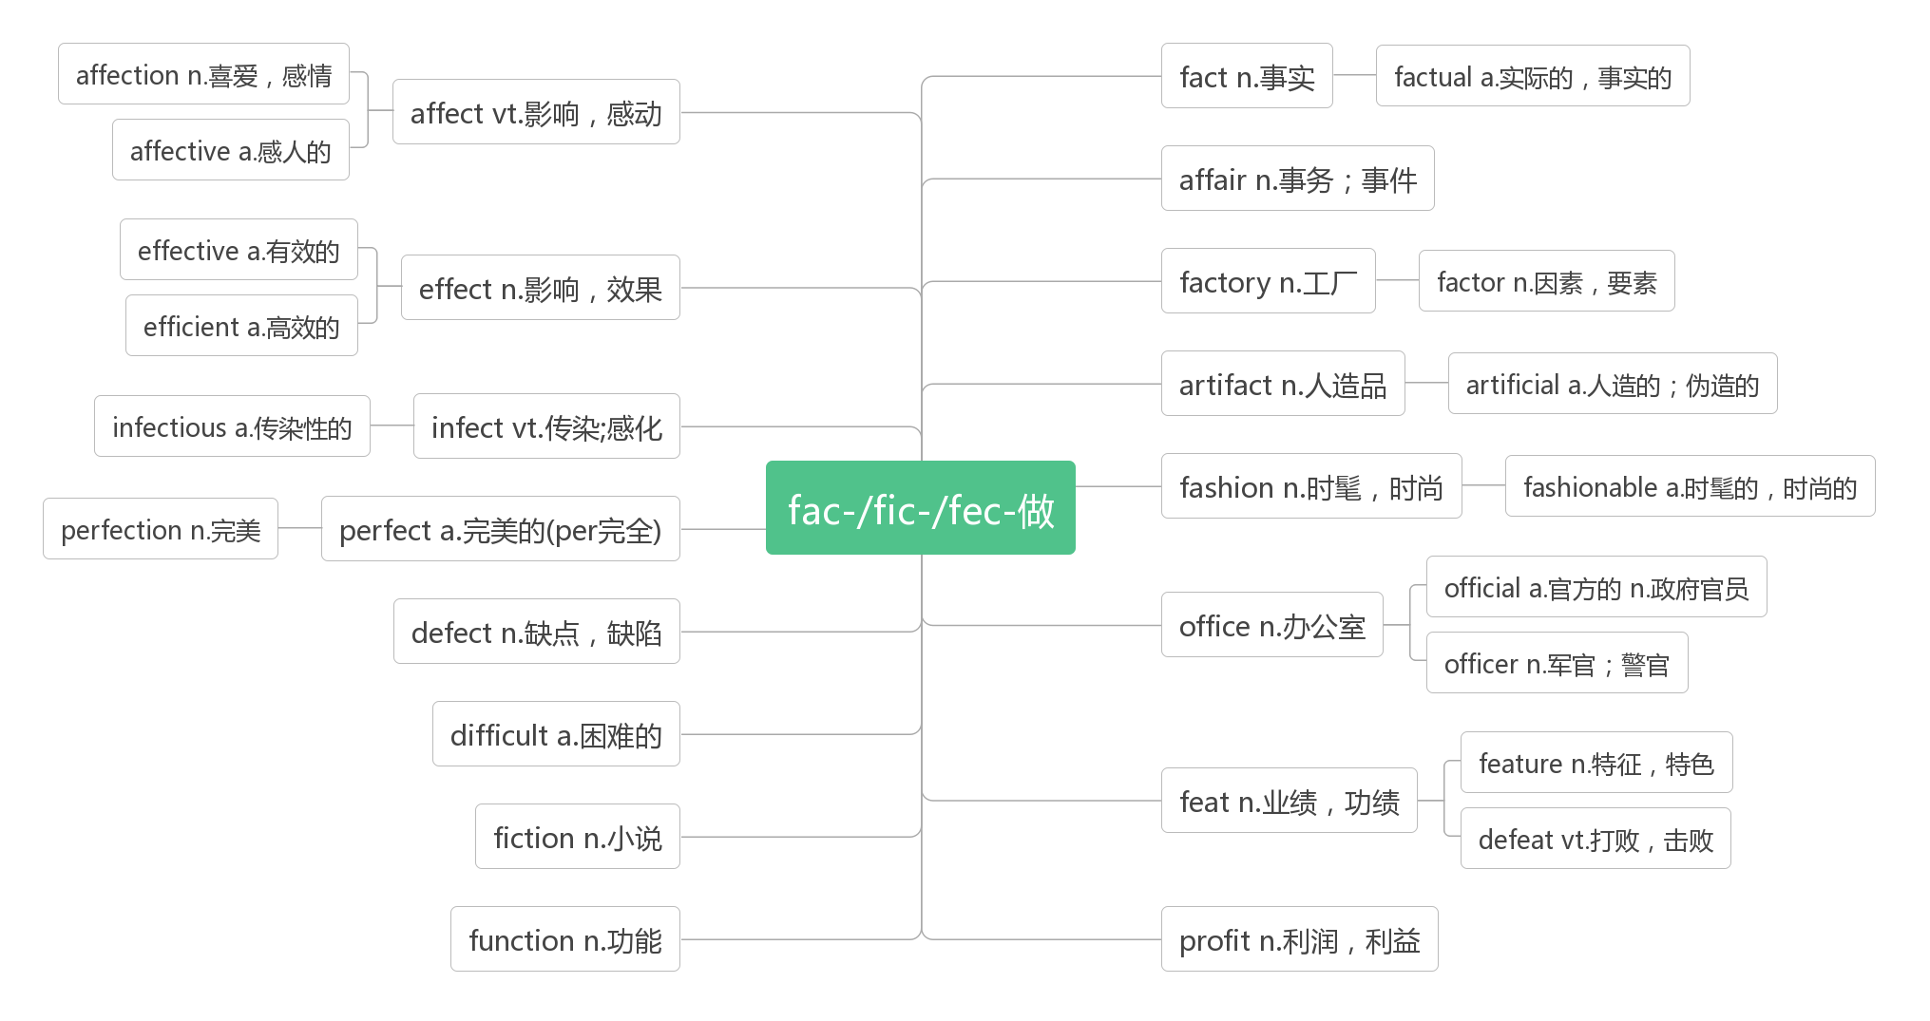
- recognise[ ˈrekəgnaɪz] vt. 辨别出;承认, 认可 (NAmE-ize)
词根词缀：re-(再次)+co-(都)+gn-(知)+-ise(动词后缀)：再次都知道——认出；承认
I recognised him as soon as he came into the room. 他一进屋我就认出了他。
Though they hadn’t met for many years, they recognized each other at the first sight.
虽然他们多年没见面，他们第一眼就认出了对方。
The doctor tried to get his work recognised in the medical circles.
这个医生试图让他的工作在医学圈内得到认可。
recognise …as/to be 把……当做；承认…… 为
We recognise Xi Jinping as/to be a great leader. 我们认为习近平是一位伟大的领袖。
recognition[rekəgˈnɪʃn] n. 认出; 承认；认可
to seek international/official/formal recognition 寻求国际上的/官方/正式的承认
She passed close by me without a sign of recognition. 她与我擦肩而过,却没认出我.
At last, her father's work has received popular recognition.最后，她父亲的工作得到了大众的认可。
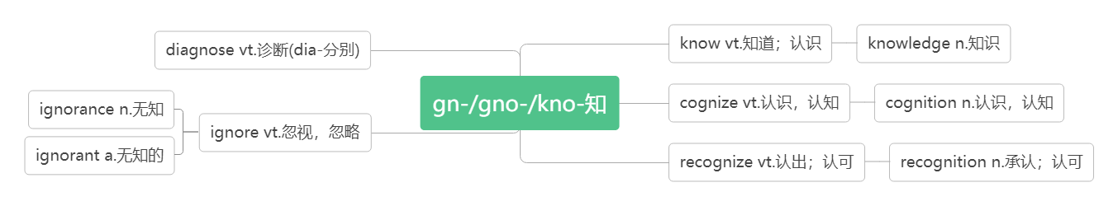
- type [taɪp]n.类型; 种类 vi. & vt. 打字
typist[taɪpist]n.打字员
There are various types of the disease. 该疾病有各种类型。
I love these types of books.我喜欢这些种类的书籍。
Have you done this type of work before?你以前做过这种活儿吗？
How fast can you type? 你打字有多快？
I can type this article for you. 我可以帮你把文章打出来。
Many women applied for the post of typist. 许多妇女应征这个打字员的职位。

- flight [flaɪt]n. 航班；航程，航行
The flight will take four hours.这次航行要飞 4 个小时。
I arrived just in time for my flight to London.我及时赶上了飞往伦敦的航班。
Flight BA 4793 is now boarding at Gate 17. BA 4793航班现在正在17号登机口登机。
This flight was more comfortable than I had expected. 这次飞行比我预想的更舒服。

- accommodation[əˌkɒməˈdeɪʃn] n.食宿，住宿；住处
词根词缀：ac-(去)+com-(共同)+mod-(模式)+-ation(名词后缀)：去用共同的模式吃住——食宿；住处
From there, you’ll spend one day travelling by boat to your accommodation in the middle of the forest.
从那里，你将花一天的时间乘船前往森林中央的住处。
Hotel accommodation is included in the price of your holiday.你度假的价款包括旅馆住宿在内。
First-class accommodation is available on all flights.所有班机都备有一等舱位。
More and more travelers are looking for accommodations in private homes.
愈来愈多的旅行者在寻找由私人住户提供的膳宿服务。
accommodate[əˈkɒmədeɪt] vt.&vi.容纳；调节，(使)适应
The school was not big enough to accommodate all the children. 学校没有足够的地方容纳所有的学生。
There is usually room to accommodate up to 80 visitors. 空间通常最多可以容纳80名来宾。
accommodate (onself) to 适应
I needed to accommodate to the new schedule. 我需要适应新的时间表。
Some students find it hard to accommodate themselves to the new environment. 有些学生觉得很难适应新环境。
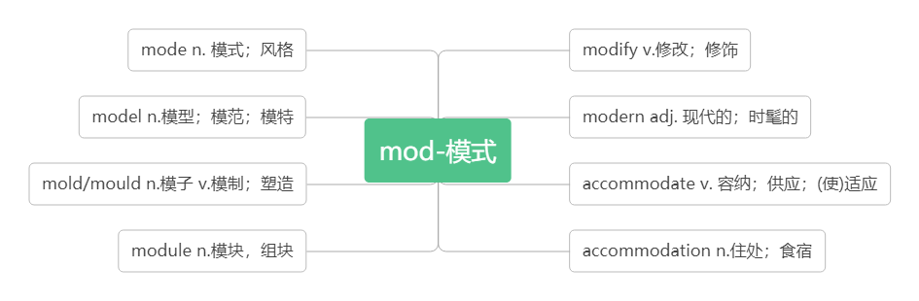

- unique [juˈni:k]adj. 唯一的; 独特的;特有的
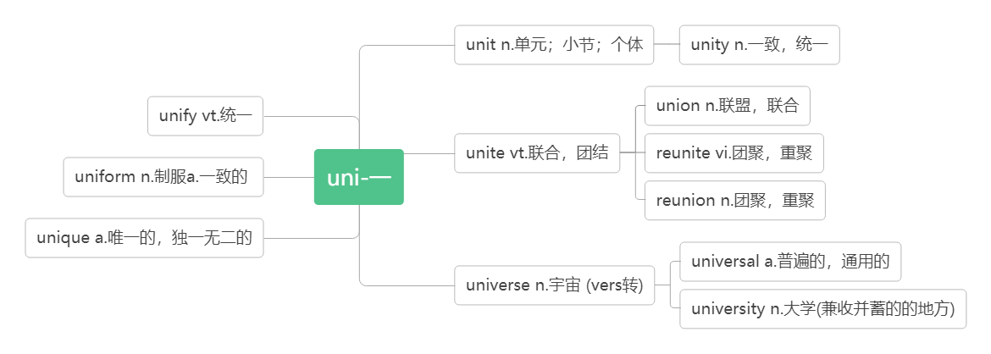
You can then spend three days exploring the rainforest with a local guide and enjoying the plants and animals unique to the rainforest.然后,你可以花三天时间和当地导游一起探索热带雨林, 欣赏热带雨林独有的植物和动物。
Everyone's fingerprints are unique. 每个人的指纹都是独一无二的。
Dollywood is one of the most unique theme parks in the world.多莱坞是世界上最独特的主题公园之一。
unique to sb /sp. 是某人/某地特有的
This flower is unique to the area. 这种花儿是这一地区特有的。
The koala is unique to Australia. 树袋熊是澳大利亚特有的。

- path [pɑ:θ] n.小路; 路线; 道路
This four-day walking tour will take you on amazing paths through the Andes Mountains on the way to the city of Machu Picchu. 这四天的徒步旅行将带你走上穿过安第斯山脉前往马丘比丘的奇妙之路。
They followed the path to the village. 他们顺着小路来到那个村子。
We walked along the path, enjoying the natural scenery. 我们沿着小路行走，欣赏着自然风光。
I saw our flight path would be over this famous mountain.我看到我们的飞行路线要经过这座著名山峰。
Our country is on the path to economic recovery. 我们的国家正走上经济复兴之路。
- destination[destɪˈne ɪʃn] n.目的地；终点
词根词缀：de-(下)+stin-(站=stand)+ation(名词后缀):下一个要站的地方——目的地
After reaching your destination, you will have a day to explore and be amazed by this ancient city.
到达目的地后，您将有一天的时间去探索，并对这座古城感到惊叹。
Spain is still our most popular holiday destination. 西班牙仍是我们最喜爱的度假去处。
Life is a journey with an unknown destination. 生活是一次不知目的的旅行.
You can check your baggage all the way through to its final destination.你可以把行李直接托运到终点。
After many difficulties and dangers, we finally reached our destination.
经过了许多艰难险阻之后, 我们终于到达了目的地.
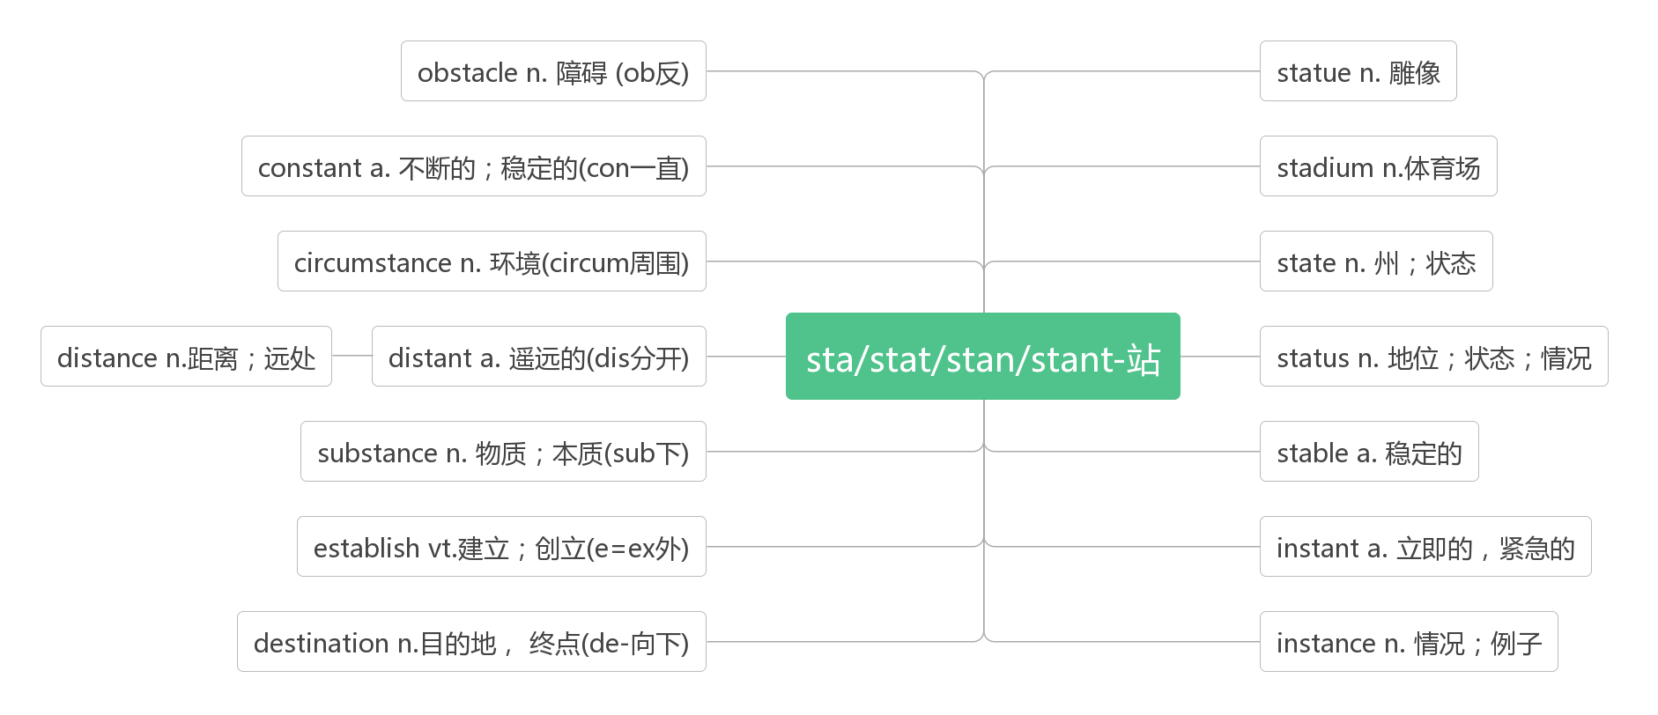
- other than 除…以外
Inca builders cut stones to exact size so that nothing was needed to hold walls together other than the perfect fit of the stones. 印加建筑工人把石头切割成精确的尺寸，这样，除了石头的完美贴合之外，不需要任何东西来将墙壁固定在一起。
There is nobody here other than the teacher. 这里除老师外再无别人。
I have not studied foreign languages other than English. 除了英语外，我没学过其他外语。
You can't get there other than by boat.除了坐船,你无法去那里。
I cannot do anything other than say sorry to you.我除了向你说声对不起，已经不知道该做些什么了。

- admire [ədˈmaɪə(r)]vt. 欣赏，赞赏；钦佩
词根词缀：ad-(去)+mir-(惊叹)：去惊叹——欣赏；钦佩
音意互通：我的妈呀 助记：我的妈呀，你做的事太令人钦佩了。
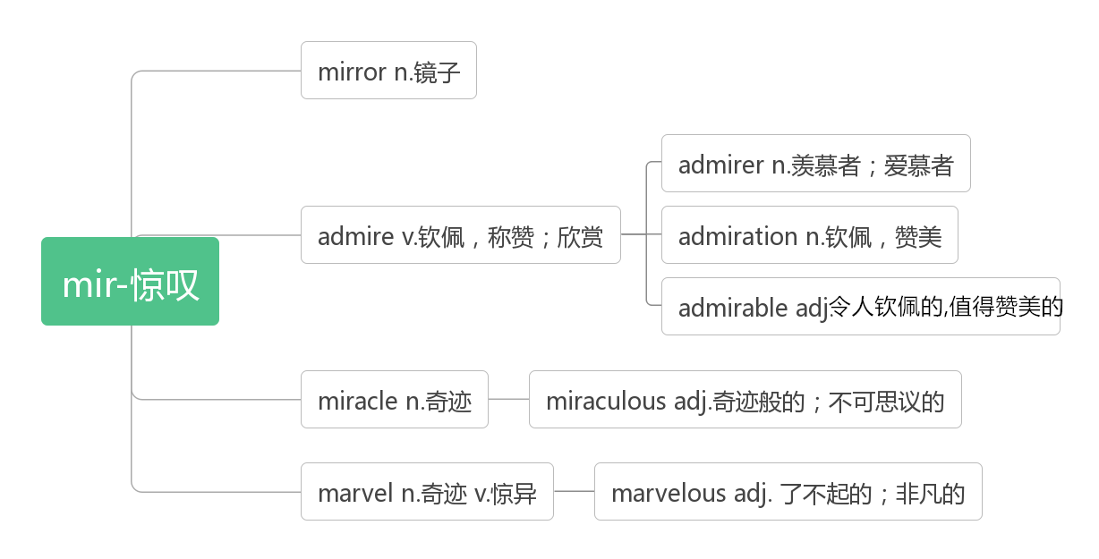
Stay in a local hotel, visit the museums, admire the architecture, enjoy the excellent local food , and go shopping at the local markets.入住当地酒店，参观博物馆，欣赏建筑，享受当地美食，去当地市场购物。
China and Japan have mid-autumn festivals, when people admire the moon and in China, enjoy mooncakes.
中国和日本都有中秋节，这时，人们会赏月。在中国，人们还品尝月饼。
He walked along the river, admiring the beautiful scenery. 他沿河边走欣赏美丽的景色。
Honesty is a quality that everyone admires. 诚实是人人都赞赏的品德。
admire sb for (doing) sth. 因(做)某事而钦佩/ 羡慕某人
All those who knew him admired him for his work. 所有认识他的人都敬佩他所做的工作。
The school is widely admired for its excellent teaching. 这所学校教学优秀，远近称誉。
admiring [əd'ma ɪərɪŋ] adj.赞赏的；钦佩的
He gave her an admiring glance. 他向她投以钦慕的目光。
admirable[ ˈædmərəbl] adj.令人钦佩的; 值得赞扬的
He was an admirable chairman. 他是一位令人钦佩的主席。
Her devotion to her work was admirable. 她对工作的奉献精神可钦可佩。
admiration [ˌædməˈreɪʃ n]n. 钦佩；赞赏；羡慕
I have great admiration for her as a writer. 我十分钦佩她这位作家。
do sth. in admiration 钦佩地做某事

- architect [ˈɑ:kɪtekt ] n.建筑师，建筑设计师
词根词缀：archi-(拱形)+-tect(铸造，织造)：建造拱形建筑的人——建筑师
Lin Huiyin was not only a professor of Qinghua University but also a famous architect.
林徽因不但是清华大学的教授，而且还是一位著名的建筑设计师。
The new building was built from the design of a famous architect.
这座新楼是根据一位著名建筑师的设计建成的。
architecture [ˈɑ:kɪtekt ʃə(r) ]n. 建筑设计；建筑学
The house is a textbook example of modern architecture. 这所房子是现代建筑设计典范。
I'm interested in Roman architecture. 我对古罗马建筑风格感兴趣。
At first he studied architecture in college. 起先，他在大学里学习建筑学。

- brochure [ˈbrəʊʃə(r)] n.手册
音意相通：布鲁塞尔 助记：在布鲁塞尔旅游，你需要一本旅行手册。
a travel brochure 旅游手册
For more brochures about other package tours around Peru, contact us at tourinfo@travelperu.org.
想获得关于秘鲁其他包价旅游的更多资料手册，请与我们联系：tourinfo@travelperu.org。
Do you have a sightseeing brochure for this town? 在这个镇上有观光手册吗 ?
This hotel looked wonderful from the brochure. 这家旅馆从广告手册上看很棒。
Our company culture is introduced in the brochure. 在这个宣传册介绍了我们的公司文化。

- package[ˈpækɪdʒ]n. 包裹;包装盒 vt.将…包装好
词根词缀：pack(包装)+-age(名词后缀)：包裹；包装盒
Fast-food robots will probably cook and package food. 快餐机器人很可能会烹煮和包装食物。
Foods were already packaged and ready to be sent. 食物已包装好待运。
He sat with the package on his knees 他坐着，将包裹放在腿上。
This kind of package is very green.这种包装盒很环保。
a package of 一包/盒/袋
The little boy opened a packages of cookies at Walmart. 那名小男孩在沃尔玛超市里打开了一包曲奇饼干。
a package tour 包价旅游
We're planning to go on a package tour to Japan. 我们计划参加包价旅游去日本。
I prefer a package tour, and we don't have to worry about accommodation and meals.
我喜欢包价旅游，不用操心住宿和吃饭

- contact [ˈkɒntæ kt ]vt.联络；联系n. 联系；接触
词根词缀：con-(一起)+-tact(接触)：接触到一起——联系。
For more brochures about other package tours around Peru, contact us at tourinfo@travelperu.org.
想获得关于秘鲁其他包价旅游的更多资料手册，请与我们联系：tourinfo@travelperu.org。
For more information , please contact John Smith. 了解更多信息，请与约翰史密斯联系。
He never contacted his children after he went to Australia.他去了澳大利亚以后没联系他的孩子。
I don't have much contact with my uncle. 我和叔叔很少联系。
There is little contact between the two organizations. 这两个机构相互之间没有什么联系。
Have you kept in contact with your friends from college？你和你大学里的朋友还保持联系吗？
She's lost contact with her son. 她和儿子失去了联系。
I finally made contact with her in Paris. 我最终在巴黎与她取得了联系。

- transport [ˈtræ nspɔ:t]n.交通；运输vt. [trænˈspɔ :t]运输；运送
词根词缀：trans-(转)+port-(运)：转运——运输；交通
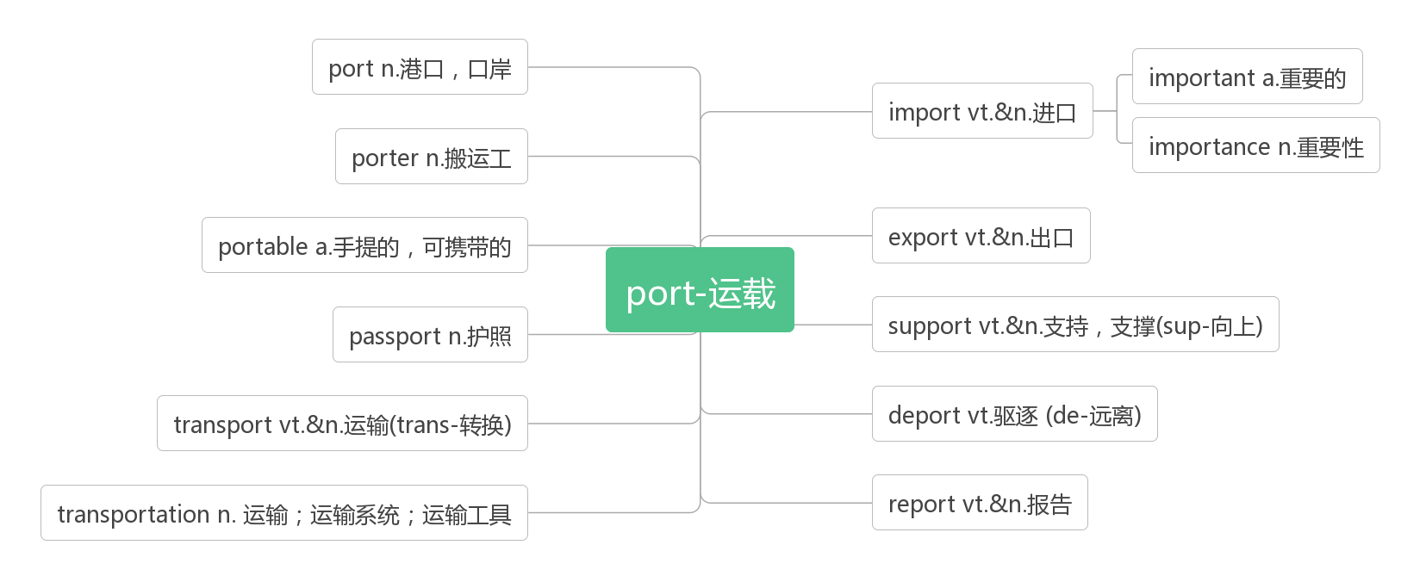
air/road transport 空运/路运
public transport 公共交通；公交车辆
Most of us use public transport to go to work. 我们大多数人都乘公交车辆上班。
The extra money could be spent on improving public transport system.多余的资金可以用于改善公共交通系统。
Mr Black was made transport minister.布莱克先生被任命为交通部长。
transport goods/passengers 运送货物/旅客
They transport oil to other countries. 他们把石油运到别的国家。
Blood transports oxygen around the body. 血把氧气输送到全身。

- hike [haɪk ]vi.&n.远足;徒步旅行
They ate a quick lunch, drank some water, and began to hike.
他们匆匆地吃过午饭，喝了点水，然后就开始徒步旅行。
They are going to hike to the top of a mountain. 他们打算徒步旅行到一座大山的顶端。
The students planned to hike the Rockies. 学生们计划去落基山脉远足。
They went on a ten-mile hike through the forest. 他们做了一次穿越森林的十英里徒步旅行。
We'll go on a hike next week. 我们下个星期会出去徒步旅行。
go hiking 远足；徒步旅行
If the weather's fine, we'll go hiking this weekend. 如果天气好，我们这个周末就去远足。
hiker [ˈhaɪkə(r) ] n.远足者；徒步旅行者
Early in the morning, hikers pack everything that they will need for the day's hike.
一大早，徒步旅行者们把当天旅行所需的一切都装进包里。

- make up 组成；占比；编造；化妆；和好
be made up of 由……组成/ 构成
make up for 弥补
Eleven players make up a football team. 11 个队员组成一个足球队。
Women make up 30 percent of the teachers of our school. 我们学校女教师占30%。
She spent too much time making herself up. 她在化妆上花去了太多时间。
She came back and they made up. 她回来了，他们和好了。
We should work harder to make up for the lost time. 我们应当更加努力工作，以弥补损失的的时间。
A football team is made up of eleven players. 一个足球队由 11 个成员组成。
He isn’t telling the truth. He is just making the story.他没说实话，他只是在编故事。

- soldier /ˈsəʊldʒə (r)/ n.士兵; 军人
破拆法：sold(sold)+-ier(人) 助记：士兵就是把自己出售给国家的人
My brother is a brave soldier. 我的哥哥是一名勇敢的士兵。
Difficult only exists before the weak, but can not prevent the experienced soldier.
困难只存在于弱者面前，挡不住久经考验的士兵。

- economy[ ɪˈkɒnəmi] n.经济;节约
词根词缀：eco-(家)+nom-(管理)+-y(名词后缀)：对家的管理——经济
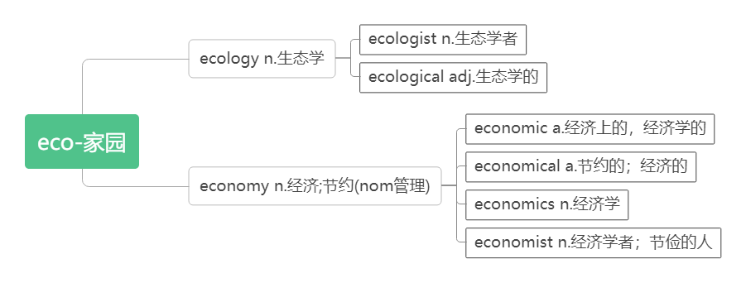
a market economy 市场经济
economy class（客机）经济舱
Would you travel business class or economy?您乘坐商务舱还是经济舱？
The Chinese economy grows at a rate of 10 percent every year. 中国经济每年增长10%。
It was a small economy to walk to work every day.每天步行上班是一种小节约。
economic [,iːkə'nɒmɪk; ek-]adj. 经济的，经济上的；经济学的
economic growth/cooperation/development/reform 经济增长/合作/发展/改革
Coffee is the economic plants of this country. 咖啡是这个国家的经济作物。
The signs of the economic recovery are only just beginning. 经济复苏的迹象刚刚开始显现。

- credit [ˈkredɪt] n.贷款；信用；称赞；学分
词根词缀：cred-(相信)+-it(去)：去让人信任——信用
助记：有了信用才能贷款上学，要获得老师的称赞就要拿到学分。
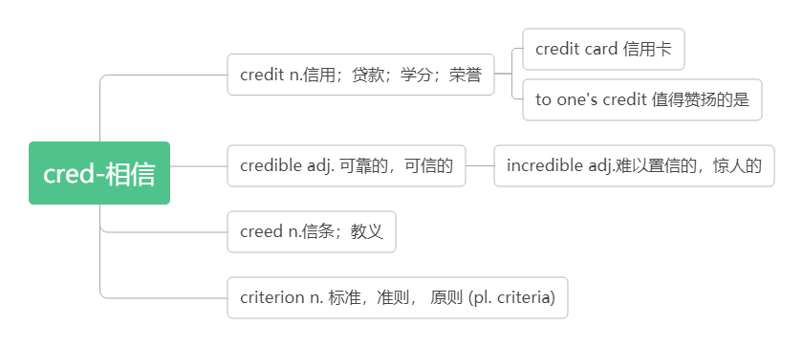The family was forced to live on credit from local merchants.这家人不得不靠向当地商人赊账生活。
Small companies can't get the credit they need. 小公司不能获得他们想要的贷款了。
This factory keeps up its good credit, so its products sell very well.
这家工厂保持着良好的信誉，所以产品销售很好。
We did the work well and got all the credit.我们工作做得很好，得到了称赞。
Students attend "short terms" in May and June to earn the credits required for graduation.
学生在 5月和 6月参加“短期”课程，以获得毕业所需的学分。
to one’s credit 值得赞扬的是
To his credit, Jack never told anyone exactly what had happened. 杰克对所发生的事守口如瓶，值得赞扬。
To his credit, a few years later Dole apologized to me. 值得称道的是，几年之后，多尔向我道了歉。
credit card 信用卡
by credit card 用信用卡支付

- detail [ˈdi:te ɪl ] n.细节；详情；细微之处 vt. 详述
破拆法：de-(下)+tail(尾巴)：秋毫之末——细节
Contact the Tourist Information Bureau for more details. 了解详情请联系旅游信息处。
Don’t ignore small details while reading. 阅读过程中不要忽视了小的细节。
Please mark the main ideas and important details with a pen.请用钢笔标出要点和重要细节。
The man detailed to us all the wonders he had seen in his travels.那人向我们详述了他旅途所见之奇事。
Happiness hides in life’s small details. If you are not looking, it becomes in visible.
快乐隐藏在生活的细节里，不留意就难以察觉。
in detail 详细地
She described the accident in detail. 她详细地叙述了那次事故。
- check in (在旅馆、机场等)登记进入
I'll ring the hotel. I'll tell them we'll check in tomorrow.我来给旅馆打电话，通知他们我们明天入住。
If you want to stay at a hotel, you have to check in. 你想住旅馆，就得办理登记手续。
Passengers must check in at the airport an hour before the plane leaves.
旅客们必须在飞机起飞前一小时到机场办理登机手续.
He checked in at the Capital International Airport for a flight to America.
他在首都国际机场办好了登机手续，准备飞往美国。
check out (在旅馆等)结账离开
When I got to the hotel, he had just checked out. 当我到达旅馆时，他刚退房走了。
They packed and checked out of the hotel. 他们收拾好东西，办理了退房手续。
Guests must check out before noon, or they will be charged for the day.
旅客必须于中午前办清手续离开, 否则将收取全日费用。

- request [r ɪ'kwest]n.&vt.(正式或礼貌的)要求；请求
词根词缀：re-(强调)+quest-(寻求):寻求许可——要求，请求
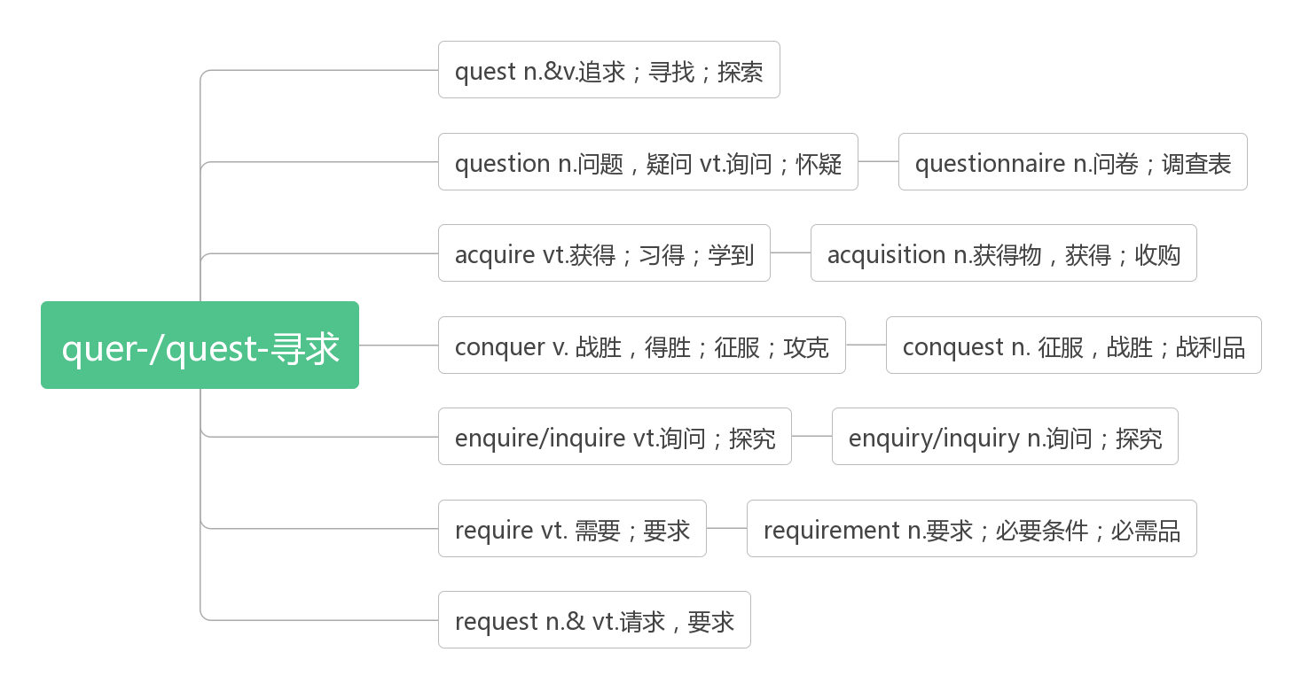
request to do sth.请求做某事
request sb. to do sth.请求某人做某事
request (that) sb.(should) do sth. (request跟宾语从句的搭配)
at one’s request 应某人的请求
If you have any special requests about your room, please contact the reception.
如果您对您的房间有特殊的要求，清联系接待处
Finally they had to make a request for help. 最后他们只好请求帮助。
He went there at their request. 他应邀前往。
The woman came to the party at her friend's request.应朋友的请求，这个妇女参加了聚会。
They requested him to leave. 他们要求他离开。
Visitors are requested not to smoke here. 参观者请勿在此吸烟。
They requested that help (should) be sent at once. 他们请求立即施以援助。

- view [vju:]n.视野；景色；看法 vt.看；看待
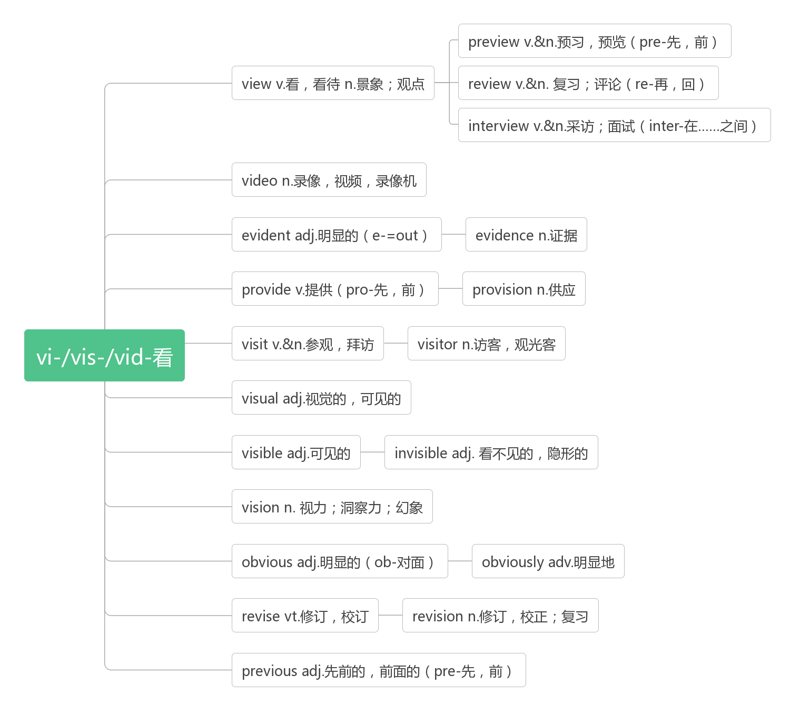
a sea/mountain view 海/山景
I'd like a room with a view. 我想要一个可以观看风景的房间。
The view from the top of the hill was more beautiful. 从山顶远眺景色更美丽。
The lake soon came into view . 那湖很快映入眼帘。
The sun disappeared from view . 太阳看不见了。
You should make your views known to your friend. 你应该让你的朋友了解你的观点。
in one's view在某人看来
In my view, it was a waste of time. 依我看, 这是浪费时间。
In my view, the greatest happiness lies in one's satisfaction with one's life.
在我看来, 最大的幸福在于人们对生活的满意程度。

- sight [saɪt]n. 景象; 视野; 视力
in sight 在视野中，看得见
out of sight 在视野外，看不见
catch sight of 看到
lose sight of 看不到了,失去……的踪迹
at the sight of 一看到……就……
at first sight 第一眼就……
The Terracotta Army is an amazing sight.兵马俑是一副令人惊叹的景象。
The sunset was a very beautiful sight. 那次落日真是一幅美景。
The Great Wall is one of the most amazing sights in the world. 长城是世界上最惊奇的景象之一。
She went out to see the sights of Paris. 她去巴黎观光了。
A bicycle came into sight on the road. 路上出现了一辆自行车。
We waved until the car was out of sight. 我们一直挥着手，直到汽车驶出了我们的视野。
He has very little sight in his right eye. 他右眼视力极弱。
My sight is failing, and I can't read any more. 我的视力在下降，看不了书了。

- statue [ ˈstæ tʃu:] n.雕塑；雕像
Each statue has a different face, leading researchers to believe that each one is a copy of a real soldier.
每尊雕像都有一张不同的面孔，使得研究人员认为每尊雕像都是一个真实的士兵的复制品。
They set up a statue in memory of him. 他们立了一座雕塑纪念他。
There is a bronze statue in the central park. 在中心花园有一座青铜像。
同源词：见23 destination

- tomb [tu:m ] n.坟墓
音意相通：土墓
More than 700,000 people worked for nearly 40 years to build this tomb.
超过七十万人为建造这座坟墓工作了将近40年。
There are more than 8,000 terracotta statues in the tomb of the Chinese Emperor Qinshihuang.
在中国皇帝秦始皇的陵墓里有8000 多个陶俑。
A group of students placed a wreath at the tomb of the national hero.
一群学生在那位民族英雄墓前献上花圈。

- unearth [ʌnˈɜ:θ] vt. 挖掘；发掘
词根词缀：un(不)+earth(土壤)：不留在土壤中——挖掘。
The statues fill only one part of the emperor's huge tomb, which still has not been completely unearthed.
这些雕像只占巨大的秦始皇坟墓的一部分，坟墓还没有完全被挖掘出来
They have unearthed the bones of an elephant which was 500,000 years old.
他们发掘出了一具大象骨骼，距今已有50 万年。
Red diamonds have been unearthed here. 在这儿发掘了红钻石。

- comment / ˈkɒ ment /n. vi.& vt.评论
词根词缀：com(一起)+ment(mind)：把想法拿到一起——评论
Revise your draft according to your partner's comments.根据同伴的评论修改你的草稿。
You really can't comment till you know the facts. 知道真相之前，不要发表任何意见。
Swap summaries with your partner and give each other comments.
与同伴交换一下概述，并且互相作出评论。
comment/make comments on/upon sth. 对……发表意见/作出评论
I don't really know so I can hardly comment on it 我不了解实情，所以我不能就此发表意见。
How does the author comment on Peter Smith's new book? 作者对皮特史密斯的新书有何评论？
So far, he has not made comments on these reports. 到目前为止，他仍未就这些报道发表评论。
She made helpful comments on my work. 她对我的工作提出了有益的意见。
He made comments on the economic reform.他对经济改革作出了评论。
no comment 无可奉告
No comment. I don't know anything.无可奉告。我什么都不知道。

