Book 1 Unit 3
- fitness /ˈfɪtnəs/ n.健康;适合
Sports and Fitness 运动与健康
a fitness center 健身中心
They're doing exercises to improve their fitness. 他们为增强体质而做体操。
I hired a fitness coach, and I began to eat small and healthy meals.(2017天津)
我雇了一个健身教练，开始了量少而健康的饮食。
fit vt. 安装；适合；符合 adj. 适合的；健康的；胜任的
be fit for 胜任
There is no “one-size-fits-all” adaptation.(2017江苏) 没有所谓的“百搭”这种应用。
Embryonic learning(胎教) helps mother birds to identify the baby birds which fit the environment better.(2017江苏)
胎教帮助母鸟们鉴别出更好地适应环境的幼鸟。
Working out in the morning provides additional benefits beyond being physically fit.(2018全国I)
晨练提供了除了身体健康以外额外的好处。
Thus, these well－equipped people survived because they were the fittest.(2016北京卷)
这些准备充分的人们胜出因为他们是最适应的。
She and her family bicycle to work, which helps them keep fit.(2018北京卷）
她和家人们骑自行车去上班，这有助于他们保持健康。
词语辨析：
fit | 强调尺寸、大小或形状上的吻合。
suit | 强调颜色、款式、品味等适合某人。
match | 多指两个物体相互之间很匹配，显得很协调。
This coat fits me very well.这件外套我穿起来很合身。
These shoes don’t fit me. Have you got a larger size?这鞋我穿不合适。你们有大点的吗？
That haircut suits you.那种发型很适合你。
It’s a small house but it suits our needs.这是一栋小房子，但它符合我们的需要。
The carpets should match the curtains.地毯应该和窗帘相配。
Do these shoes match my dress?这鞋子与我的衣服配吗？

- soccer /ˈsɒkə(r)/ n.足球
a soccer game/match /team 足球比赛/队
soccer players 足球运动员
Would you like to go to the soccer game?你想去看足球赛吗？
I like watching soccer games.我喜欢看足球赛。
I play soccer in my free time.我空闲时会踢足球.
补充知识：
soccer是美国人对足球的叫法，在美国football通常指的是橄榄球，而英国人把足球叫做football，英国人很少使用soccer这种叫法。

- stadium /ˈsteɪdiəm/ n.体育场;，运动场
a football/sports stadium 足球/运动场
To hold the Olympic Games, several stadiums have been built for competitions.
为了举办奥运会，建了好几个供比赛用的体育场。

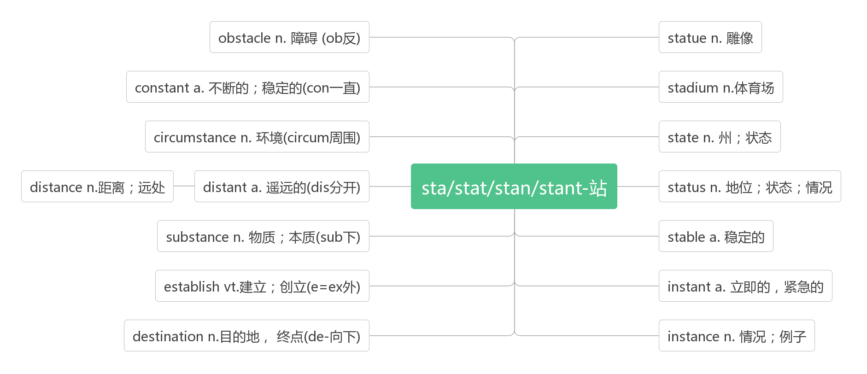
- boxing /ˈbɒksɪŋ / n.拳击
a boxing match 拳击比赛
heavyweight boxing重量级拳击
Do you want to watch the boxing match? 你想看拳击比赛吗？
Boxing matches were very popular in England two hundred years ago.两百年前拳击比赛在英国就很盛行。

- badminton /ˈbæ dmɪnt ən/ n.羽毛球运动
破拆法：bad(不好)+min(民众)+ton(疼) 助记：腿不好的民众打羽毛球会腿疼。
How about watching badminton this afternoon? 今天下午去看羽毛球比赛怎么样？
Let's go to the badminton match. 咱们去看羽毛球比赛吧。
He can play badminton quite well now. 他羽毛球打得很好。

- marathon /ˈmærəθən/ n.马拉松赛跑
Beijing International Marathon Day 北京国际马拉松日
Full Marathon and Half Marathon 全程和半程马拉松赛
Why not run an exciting marathon? 为什么不参加刺激的马拉松赛跑？
He set up a new national record in the marathon race.他创造了马拉松赛跑的全国新记录。

- event/ɪˈvent/ n. 大事；盛事；赛事
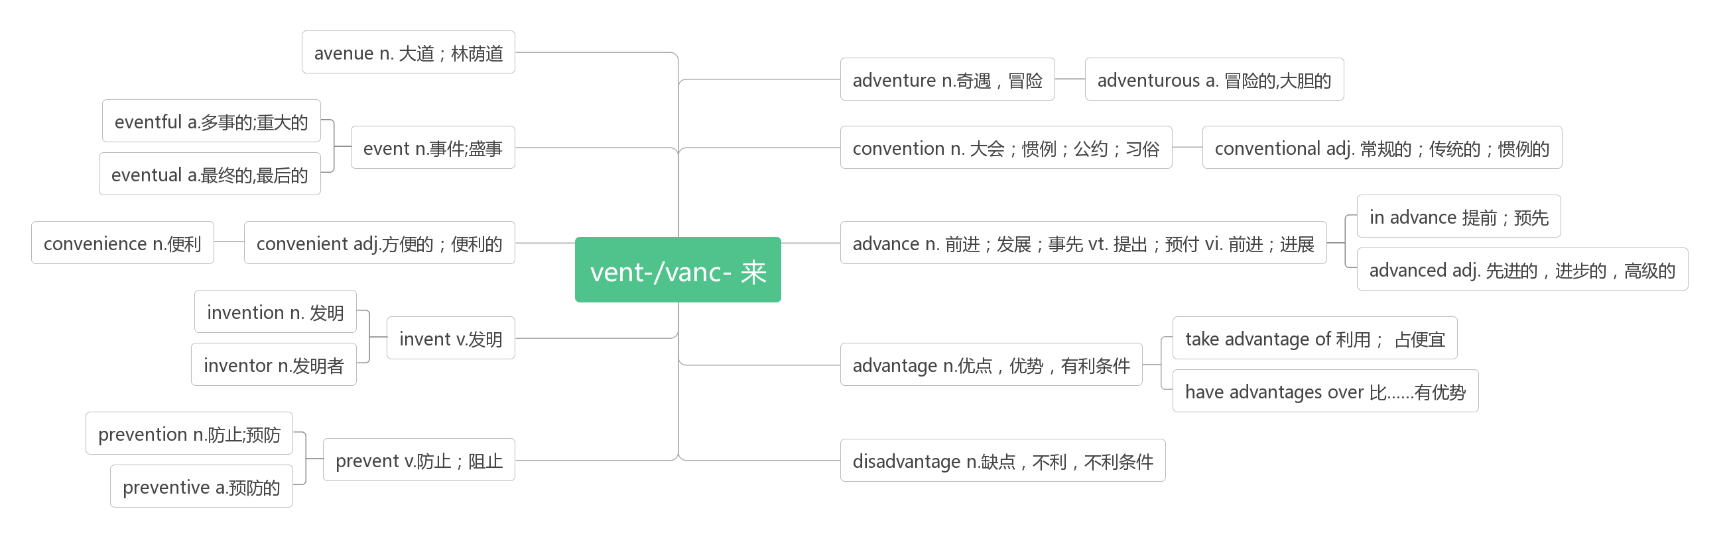
an e-sports event 电子竞技项目
Badminton is traditional advantage event in China.我国羽毛球是传统优势运动项目。
The 800 metres is the fourth event of the afternoon. 800米赛是下午的第四项比赛。
Holding the Olympic Games is a big event for China.举办奥运会对中国是一件大事。
Greenpeace arranged a special social event. 绿色和平组织举办了一次专门的社交活动。

- come along 过来；到来；进步；赶快
Would you like to come along? 你一起来吗？
There's a big party tonight .Would you like to come along?今晚有一个大型的聚会，你一起来吗？
Come along with me, boys, don’t keep everybody waiting.孩子们跟我来, 大家都在等你俩呢。
When the right opportunity comes along, you must take it. 适当的机会来临时，你要抓住它。
Your English has come along a lot recently.你的英语最近进步很大。
Come along or we'll miss the train. 快点，不然就会赶不上火车。

- ski /ski:/ vi.&n. 滑雪
ski race滑雪比赛
ski boots 滑雪靴
He went on a ski trip with some friends.他和一些朋友滑雪去了。
I like to ski on the snow. 我喜欢在雪上滑雪。
He skied down the mountains. 他从山坡上滑了下来。
go skiing 去滑雪
They go skiing in Switzerland every winter. 他们每年冬天去瑞士滑雪。
The students often go skiing during winter vacation. 学生们在寒假期间经常去滑雪。

- host /həʊst/vt.举办；主持 n.男主人，东道主；主持人
Zhangjiakou will host the Youth Ski Race in December.十二月份张家口要举办青年滑雪比赛。
Does anyone want to host the Olympic Games? 会有人想承办奥运会吗？
He has dreamed of hosting a pop music programmer. 他梦想着主持一个流行音乐节目。
Our host introduced us to the other guests. 主人把我们介绍给了其他客人。
I am the host of a live radio programme. 我是一个电台直播节目的主持人。
Most people think being a television host is exciting. 很多人认为当电视节目主持人是一件刺激的事情。
host family 寄宿家庭（人们出国时所借宿的家庭）
Do you want to learn to speak English well? Why not go to England and stay with a host family?
你想学说一口好的英语吗？为什么不去英国与房东一家人住在一起呢？
hostess/ˈhəʊstəs/ n.女主人; 女主持人
Mary was always the perfect hostess. 玛丽总是最殷勤的女主人。

- track /træk/ n.跑道；足迹；轨道 vt.& vi. 跟踪，追踪
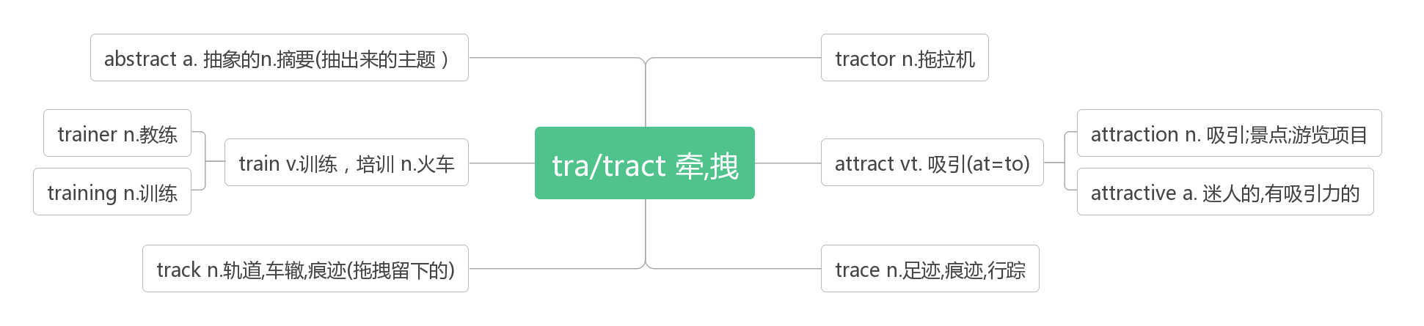
track and field 田径
track-and-field lover 田径爱好者
What are the most important competitions in track and field? 最重要的田径比赛有哪些?
Are you also taking part in the track - and - field events today?你今天也要去参加田径比赛吗 ?
Suddenly an athlete fell on to the running track.突然一名运动员摔倒在赛跑跑道上。
We followed the bear's tracks in the snow. 我们跟着熊在雪地上留下的足迹走。
After the earthquake, the railway tracks were useless pieces of steel. 地震之后，铁轨成了一条条废钢。
Neither a wise man nor a brave man lies down on the tracks of history to wait for the train of the future to run over them.
智者和勇者都不会躺在历史的轨道上等待未来的列车碾压他们。
The hunter tracked this wolf and killed it. 猎人跟踪这只狼，并杀死了它。
Our radar began tracking the planes .我们的雷达开始追踪飞机的动向。

- gym/dʒɪm/ n.健身房; 体育馆
Come and work out at a gym! 来健身房锻炼吧！
I usually go to the gym during my lunch hour. 我通常在午休时间去健身房。
Our school has recently built a new gym. 我们学校最近新建了一个体育馆。
We played basketball in the gym because of rain.由于天气下雨, 我们在体育馆打篮球。
gymnastics/dʒɪmˈnæstɪ ks /n.体操(训练)
破拆法：gym-(健身房)+na(那)+st-(stand站)+-ics(科目)：站在健身房表演的科目——体操
Gymnastics is his favourite sport.体操是他最喜爱的运动。
She does gymnastics at school every day. 她在学校每天做体操训练。
I love gymnastics. I think it's more exciting than badminton.
我更喜欢体操, 我认为体操比羽毛球更刺激。

- work out 锻炼；计算出；解决
Come and work out at a gym! 来健身房锻炼吧！
I work out at a gym twice a week. 我一周去健身房锻炼两次。
You are fat, so you must work out regularly. 你太胖了，应该定期锻炼。
Work out how much all these things will cost. 算算这些东西要多少钱。
She find it difficult to work out the problem. 她发现很难解决这个问题。
I can't work out how to do it. 我无法解答怎么做这个。

- sweat/swet/ vi.出汗；流汗 n.汗水
破拆法：sw(是我)+eat(吃) 助记：是我在吃面，热的一身汗。
sweater/ˈswetə(r)/n.运动衫；毛衣
Sweat your way to good health. 用汗水保持健康。
The long hot climb made him sweat. 长距离的激烈攀登使他出汗了。
The weather in summer is very hot, so I always sweat.夏天的天气那么热，所以我总是在流汗。
The Great Wall was built with the blood and sweat of the labouring people.长城是用劳动人民的血汗建成的。

- make it 获得成功；准时到达
You can make it! 你会成功的！
Work hard and you can make it. 努力学习，你会成功的。
I believe anyone can make it if he tries hard. 我相信只要努力任何人都能获得成功。
I don't know whether I can make it in science. 我不知道我能否在科学上获得成功。
The flight leaves in twenty minutes—we'll make it. 再过二十分钟飞机就起飞了，我们会准时到达的。
I think we'll just make it if we hurry up! 如果抓点紧，我想我们能及时到达。

- legend /ˈledʒənd / n.传奇; 传说
词根词缀：leg-(说)+end(最后）：被人传颂到最后——传奇
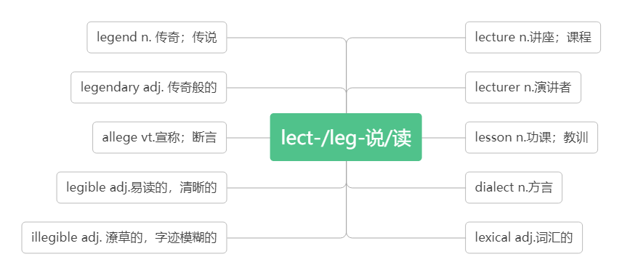
League of Legends 英雄联盟
living legends of sports 当今体育传奇人物
Yao Ming is a basketball legend. 姚明是一个篮球传奇人物。
He enjoys reading ancient Greek legends. 他喜欢读古代希腊传说。

- athlete /ˈæθli:t/ n.运动员；运动健儿
破拆法：ath-(Athens雅典)+let(让)+e(enter) 助记：让来自雅典的运动员入场。
Long Ping is not only a great athlete but also an outstanding coach.郎平不但是一位伟大的运动员，而且是杰出的教练。
She is a natural athlete. 她是个天生的运动健儿。

- master/ˈmɑ:stə(r)/n.高手; 大师；主人 vt.精通；掌握
Deng Yaping is a master of pingpang.邓亚萍是一个乒乓球高手。
He was named a "great master of language". 他被誉为“语言大师”。
The dog was running behind its master. 狗跟在它主人后面跑着。
She should be the master of her own future. 她应该把握自己的未来。
To the basketballers, the most important things is to master the skills of basketball.
对篮球队员来说，最重要的事是精通篮球技术。
Students are expected to master a second language. 学生应该掌握一门第二语言。
I want to travel all over the world, so I need to master English first. 我想周游世界，因此，首先我得精通英语才行。

- set an example 树立榜样
They must be athletes who are masters in their sports and also set good examples for others.
他们作为些远动员一定是他们领域的高手，并给别人树立良好的榜样。。
Famous people should set a good example for others.名人应该为别人树立好榜样。
Parents should set a good example for their children. 父母亲应该为孩子树立好榜样.
She arrived at the office early to set an example for the others. 她很早就来到办公室，作为他人的表率。

- honour /'ɒnə(r)/n.荣誉，荣幸；敬意 vt.尊敬；授予荣誉
音意互通：傲呢 助记：荣誉的事情值得骄傲呢。
We won the game and brought honour to our school. 我们赢得了比赛，为学校赢得了荣誉。
We compete against each other just for the honour of winning. 我们为了赢得荣誉而彼此竞争。
It was an honour to be invited here today. 今天承蒙邀请到此，深感荣幸。
India honors him as the Father of the Nation and his birth anniversary is a national holiday.
印度人将他敬为国父，并以他的生日为国庆日。
Virginia Hamilton is America's most honored writer of children's literature.
弗吉尼亚·汉密尔顿是美国最受尊敬的儿童文学作家。
in honour of 为了纪念，向……表示敬意
The Duanwu Festival is held in honour of the famous ancient poet, Qu Yuan . 端午节是为了纪念古代著名的诗人—屈原。
We celebrate Mother's Day in honour of our mothers. 我们庆祝母亲节是对母亲表示敬意。
They held a party in honour of the foreign visitors. 他们为国外来访者举办了晚会。

- glory /ˈglɔ:ri /n. 光荣；荣耀
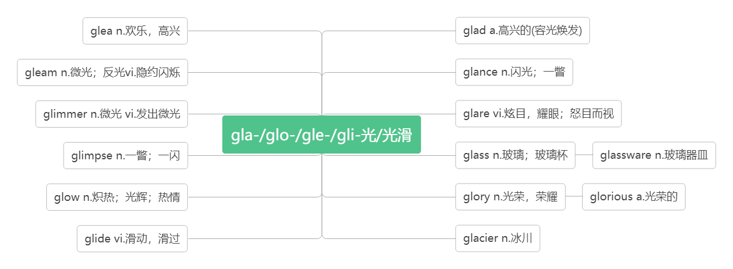
As a player, Lang Ping brought honour and glory to her country. 作为一个运动员，郎平为国家带来了无限荣光。
She won the game and was enjoying her moment of glory. 她赢得了比赛，享受自己的光荣时刻。
Glory belongs to the great motherland. 光荣归于伟大的祖国。

- medal/ˈmedl/n.奖章; 勋章
She won a gold medal in the Olympics. 她在奥林匹克运动会上赢得一枚金牌。
She is an Olympic gold medal winner. 她是奥运会金牌得主。
The young man was awarded a medal for bravery. 这个年轻人被授予一枚英勇勋章。
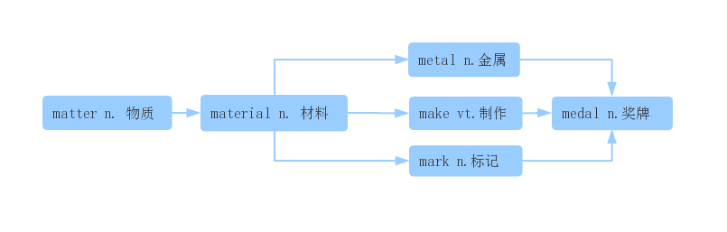
- champion /ˈtʃæmpiən/ n.冠军; 优胜者
Two weeks later they were world champions!两周后她们成了世界冠军。
At the age of eighteen, Ali was the world champion in boxing.18岁时，阿里已经是世界拳击冠军。
championship /ˈtʃæmpiənʃɪp / n.锦标赛; 冠军称号
As a coach, she led the China women's volleyball team to medal at world championships and the Olympics.
作为一名教练，她带领中国女排在世界锦标赛和奥林匹克运动会上赢得奖牌。
This year's national college football championship was won by Princeton. 今年全国高校足球锦标赛普林斯顿队获胜。
They've held the championship for the past two years. 他们在过去的两年里一直保持着冠军地位。
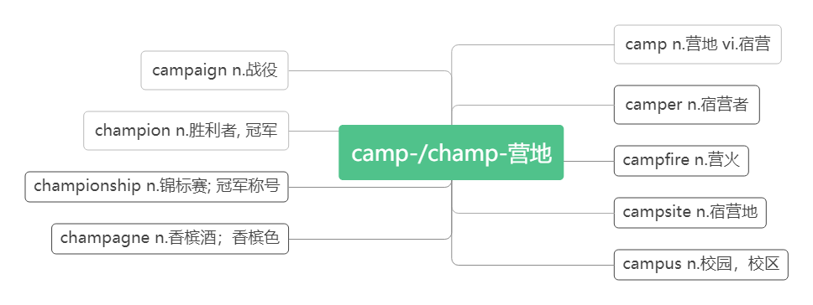

- determine/dɪ'tɜ:mɪn/vt.决定；确定；下决心
词根词缀：de-(强调)+termin(界限)+e：界定——决定；确定
They determined to start early. 他们决定早点出发。
A date for the meeting has not been determined. 会议日期尚待确定。
Shall we determine what we are going to do next? 我们来确定一下下一步该做什么吧?
determination/dɪtɜ:mɪˈneɪʃn/ n.决心；决定
When the Chinese team was preparing for the 2015 World Cup, her determination was tested.
当中国队正在备战2015年世界杯时，她的决心受到了考验。
He fought the illness with courage and determination. 他勇敢顽强地与疾病作斗争。
determined/dɪ'tɜ:mɪnd/adj.坚决的；意志坚定的
be determined to do sth. 决心做某事
A determined person always tries to finish the job, no matter how hard it is.
无论工作有多困难，一个有意志坚定的人总是会设法完成它。
She was determined to become a doctor and her hard work paid off. 她决心成为医生，她的努力取得了成功。
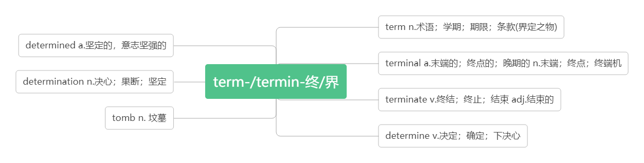
- apart/əˈpɑ:t / adv. 分离地，分开地
tell...apart 把……区别开
take apart 把……拆开
fall apart 破裂；破碎；崩溃
We're living apart now. 我们现在分开住了。
I can't tell the twins apart. 我分不出这一对双胞胎中谁是谁。
I needed to take apart my computer.我得把我的电脑拆开。
The team that Lang Ping had built was falling apart.郎平组建的队伍正在分崩离析。
The house is so old and it's falling apart.那座房子太破旧，都开始坍塌了。

- injure/ˈɪndʒə(r)/ vt. 伤害；损害
He injured his left foot playing football.他踢足球时伤到了左脚。
Three people were killed and five were injured in the crash. 撞车事故中有三人死亡，五人受伤。
injured /ˈɪndʒəd / adj. 受伤的；有伤的
One of the best players had been injure. 最好的球员之一受伤了。
Luckily, she isn't injured. 幸运的是，她没受伤。
Many of them died because they were so badly injured. 他们中很多人因伤势过重而死亡。
injury /ˈɪnd ʒəri / n. 伤害；损伤
Two players are out of the team because of injury . 两名队员因伤退出了比赛。
A racing injury made him in hospital for two weeks. 一次比赛中的受伤使他住院两周。
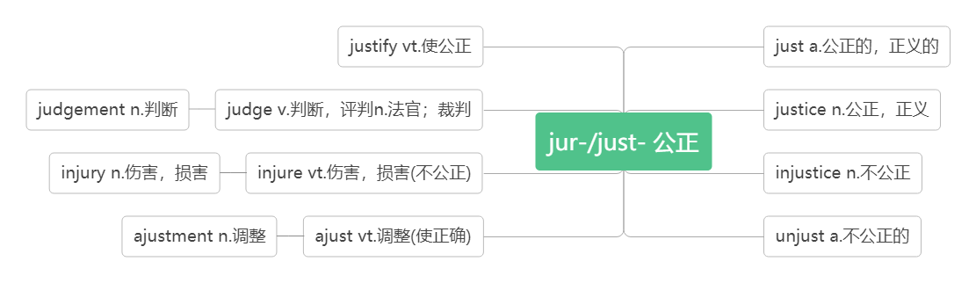
- captain /ˈkæptɪn / n. 队长；船长；上尉
词根词缀：cap(头)+tain(握/拿)：当头拿主意的人——队长；船长
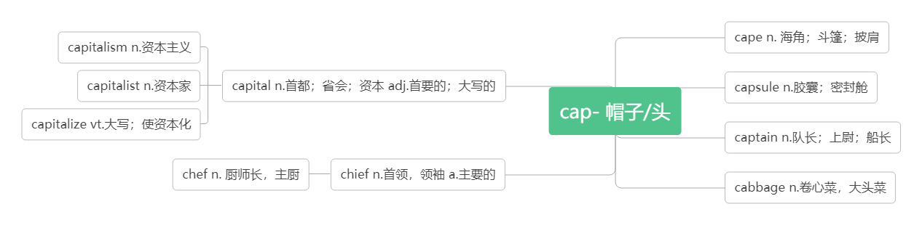
One of the best players had been injured, and the team captain had to leave because of heart problem.
最好的球员之一受伤了，并且队长因心脏问题不得不离开。
She was captain of the football team at school. 她过去是学校足球队的队长。
The captain ordered all the passengers into lifeboats. 船长命令所有乘客进入救生艇。

- lose heart 丧失信心，灰心
lose one's heart to 爱上
Losing two important players was a big challenge, but Lang Ping did not lose heart.
失去两名重要球员是一个巨大的挑战，但郎平没有灰心。
The scientist never lost heart when he was in trouble. 那位科学家遇到困难时从不灰心。
We shouldn't lose heart. We may have another try. 我们不应该灰心,我们可以再试一次.
Although he failed in this entrance examination, he didn't lose heart.
这次入学考试他虽名落孙山, 但他并不气馁.
When he was a child, he lost his heart to poems. 他是个孩子时就喜欢上了诗歌。
The first time he saw the girl he lost his heart to her. 他第一次看到这个女孩就爱上了她。

- graceful /ˈgreɪsfl / adj. 优美的；优雅的
词群：You need to gradually achieve the grade to graduate, and be grateful to hold your grace to live a graceful life.
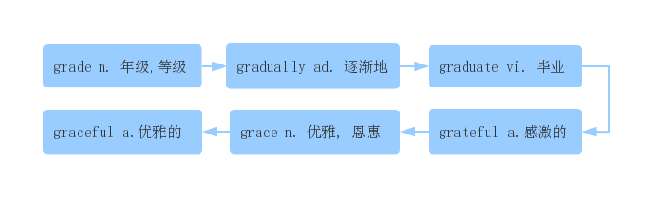
The player who became known as “Air Jordan” changed basketball with his graceful moves and jump.
这个被称为“飞人乔丹”的球员以他优雅的动作和跳跃改变了篮球。
The ballet dancers were all tall and graceful. 这些芭蕾舞演员都个子高高的，动作十分优雅。
His handwriting is flowing and graceful. 他的字写得流畅优美。
grace /ˈgreɪs/n.优雅；恩惠
Courage is grace under pressure. 勇气就是压力下的优雅。
She lived a life of activism, but also a life of dignity and grace. 她的一生积极向上，充满尊严与优雅。

- strength /streŋθ / n. 力量；力气；强项
Jordan's skills were impressive, but the mental strength that he showed made him unique.
乔丹的技能令人印象深刻，但他表现出来的精神力量使他与众不同。
Take into account your own strengths and weaknesses. 考虑一下你自己的长处和弱点。
I think you have to find an inner strength in order to feel good about yourself. 我觉得只有找到内心的力量才能有自信。
智美例句：
There will be no regret and sorrow if you fight with all your strength.只有全力的拼搏，才不会有遗憾。
The struggle you're in today is developing the strength you need for tomorrow. Don't give up.
今天做的一切挣扎都是在为明天积蓄力量，所以别放弃！
Difficulty is the nurse of greatness, who roughly rocks her children into strength.
困难是伟大的养育者，她粗暴地晃动摇篮，让子女长大成人。
You gain strength, courage and confidence by every experience in which you really stop to look at fear in the face.
你灵魂中每一点力量、勇气与自信的积累，都来自于你一次又一次地直视恐惧、面对恐惧。
Great works are performed not by strength but by perseverance.大业成于百折不挠，不论力量大小。
strengthen /ˈstreŋθn/vt.加强；巩固；使坚强 vi.变强
The exercises are designed to strengthen your stomach muscles.这些活动目的在于增强你的腹部肌肉。
Our bodies are strengthened by taking exercise. 参加锻炼可以增强我们的体质。
Repairs are necessary to strengthen the bridge. 这座桥需要加固。
The wind strengthened overnight. 夜里，风更大了。
Courage is like a muscle. We strengthen it with use. —Ruth Gordon 勇气像肌肉，我们经由使用来强化它。
To avoid knee pain, you can run on soft surfaces, doing exercise to strengthen your leg muscles (肌肉).（2018全国卷I）
为了避免膝盖疼痛，你可以在柔软的表面跑步, 做运动来增强腿部肌肉。
strong/strɒŋ/adj. 强壮的; 坚强的
He's strong enough to lift a car! 他力气大得能抬起一辆汽车！
We should be strong enough to deal with any difficulty. 我们应该足够坚强，能够处理任何困难。

- failure / ˈfeɪljə(r) / n. 失败；失败的人/事物
Jordan says that the secret to his success is learning from his failures.乔丹说他成功的秘诀是从失败中吸取教训。
The success or failure of the plan depends on your determination.这项计划的成败取决于你的决心。
智美例句：
I can accept failure,but I can't accept not trying.我可以接受失败，但我不能接受从不去尝试。(迈克·乔丹)
A failure is something from which we intend to learn.所谓失败，实为学习之源
Success is the ability to go from one failure to another with no loss of enthusiasm.(Winston Churchill)
成功是，你一次又一次失败，却仍没有失去热情。
Failure is the mother of success. 失败是成功之母。
fail /feɪl/ vi. & vt. 失败；未通过；未能（做到）
She failed to get into art college. 她未能进入艺术学院。
He failed（in）his driving test. 他未通过驾照考试。
智美例句：
Winners are not those who never fail but those who never quit. 成功者不是从不失败，而是从不放弃。
Try and fail, but don't fail to try. 尝试后可能会放弃，但千万不能放弃尝试。
Happiness will never come to those who fail to appreciate what they already have.
幸福不会降临在那些不懂感激自己所拥有的人身上。

- give up 放弃；认输
Losing games taught him to practise harder and never give up.输掉比赛教会了他更努力训练，永不放弃。
She doesn't give up easily. 她决不轻易认输。
I give up—tell me the answer. 我放弃了，把答案告诉我吧。
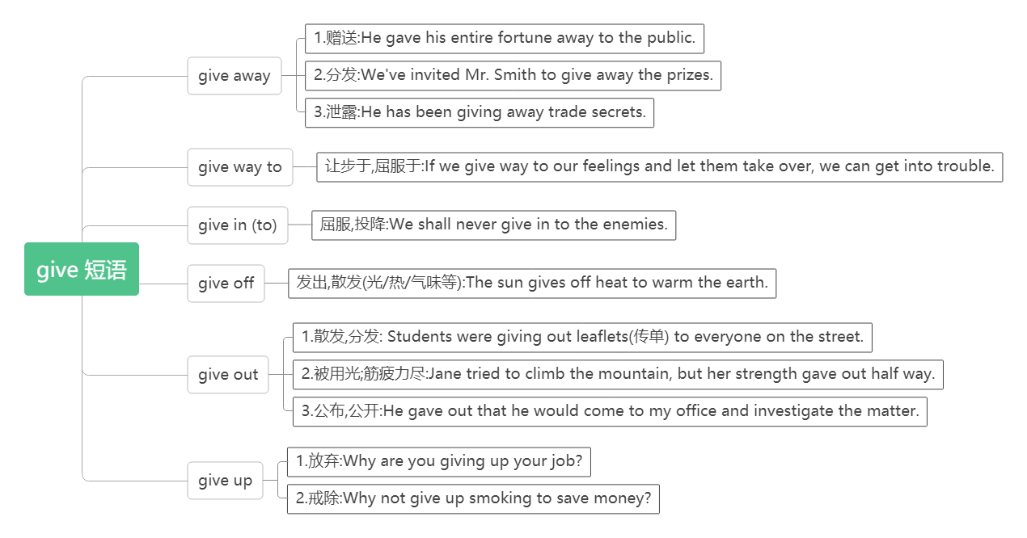
- compete /kəmˈpi:t/ vi. 竞争，比赛
词根词缀：com-(共同)+pete-(寻求):大家都来追求——竞争，比赛
compete for sth. 为……竞争
compete in sth. 参加……比赛
compete with/against sb. 同某人比赛/竞争
An athlete should think about honour and his/her fan if he/she is competing for his/her country.
如果为国家参赛，运动员应该考虑荣誉和他的球迷。
How many countries competed in the ancient Olympic Games?有多少个国家参加古代奥林匹克运动会？
He's hoping to compete in the London marathon. 他期盼着参加伦敦马拉松比赛。
Our Greek cities used to compete against each other just for the honour of winning.
我们希腊各个城市之间曾经为了赢得荣誉而彼此竞争。
They competed with each other to attract more customers. 他们互相竞争以吸引更多的顾客。
competition /kɒmpəˈtɪʃn/ n. 比赛；竞争
Instead there are competitions like skiing and ice skating which need snow and ice.
相反却有像滑冰和滑雪这类需要冰雪的比赛项目。
in competition with 与……处于竞争中
We are in competition with four other companies for the contract.我们在与其他四家公司竞争这项合同。
When they were free from work, they invited us to local events and let us know of an interesting competition to watch, together with the story behind it.（2019全国卷III）
当我们不工作时，他们邀请我们去看当地的赛事，让我们了解一项值得一看的有趣的比赛，以及其背后的故事。
competitor /kəmˈpetɪtə(r) /n.竞争者
More than 10,000 competitors from different countries came to Beijing to compete with each other in the Olympic Games for medals. 来自不同国家的一万多名参赛选手来到北京参加奥运动会为了奖牌而相互竞争。
competitive /kəmˈpetət ɪv/ adj. 竞争的；有竞争力的
We need to work harder to remain competitive with other companies.我们必须更加努力工作以保持对其他公司具有竞争力。
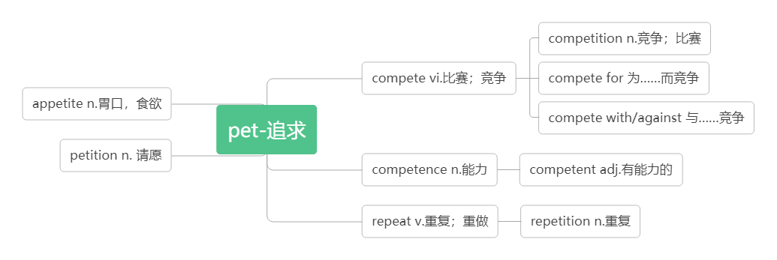
- sense /sens/n.感觉；意义；理智 vt. 感到
make sense 有道理；讲得通
That doesn't make any sense!这个行不通/没有意义。
This sentence doesn't make sense. 这句话没意义。
It doesn't make sense to argue with him. 和他争论没有任何意义。
Her advice doesn’t make sense to me. 她的建议对我来说没有意义。
John wasn't making much sense on the phone.约翰在电话上说得不大清楚。
make sense of 弄懂；领会
Can you make sense of what I say?你能领会我说的意思吗？
I can't make sense of this poem. 我弄不懂这首诗的意义。
There is no sense in doing sth. 做某事毫无意义。
There is no sense in doing nothing but complaining.不做事只抱怨没有任何意义。
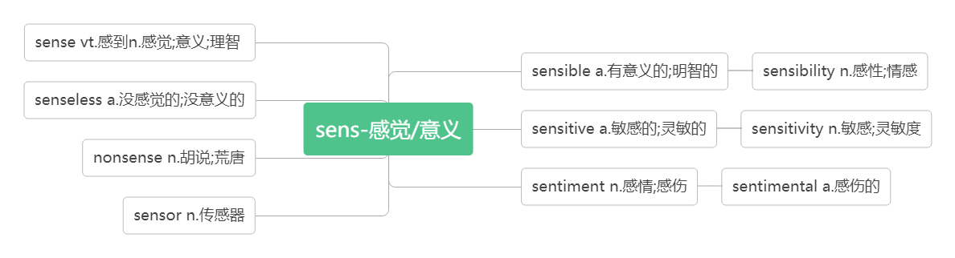
- pretend/prɪˈtend/vi.& vt.假装
词根词缀：pre-(向前)+tend-(伸展)：把肢体向前伸——假装在做某事
Do you sing karaoke and pretend you are a famous singer like Song Zuying or Liu Huan?
你是否唱卡拉OK，并假装自己是像宋祖英或刘欢一样著名的歌唱家？
He pretended to his family that everything was fine. 他对家人佯称一切都好。
pretend to do sth. 假装做某事
A soccer player should not pretend to fall down even if it helps his/her team.
足球运动员即使是帮助自己的球队也不能假摔。
If you pretend to know what you don't know, you'll only make a fool of yourself.
不懂装懂就会闹笑话。
pretend to be doing sth. 假装正在做某事（强调动作正在进行）
The boy pretended to be doing his homework when his mother came in．
当他妈妈进来的时候，这个男孩假装正在做作业。
pretend to have done sth. 假装做了某事（强调假装的动作已经完成）
He pretended to have forgotten his promise．他假装忘记了他的承诺。
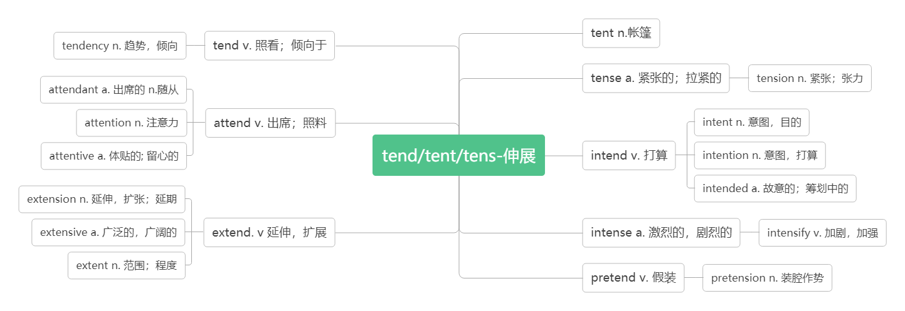

- even if/though 即使；尽管
WeChat Pay(微信支付) makes our life convenient. We can buy things even if/though we don’t take any money. 微信支付使我们的生活很便利。即使我们没带钱也可以买东西。
You will miss the flight even if/though you catch a Didi car.即使你打滴滴车，你也赶不上航班了。
Even even if/though it should rain tomorrow, they will go for an outing.即使明天下雨，他们也要去游览。
Even if/though the forest park is far away, a lot of people visit it every year.
尽管那个森林公园很遥远，但是每年都有很多游客到那里参观。

- million/ˈmɪljən/ num. 百万
They sold their house for about 1.4 million pounds. 他们把的房子卖了140 万英镑。
millions of 数百万的
It is wrong to pay people millions of yuan to play sport. 给人们几百万元来参加体育运动是不对的。
Millions of people all over the world watched the football game on TV. 全世界数百万的人通过电视观看这场足球赛。
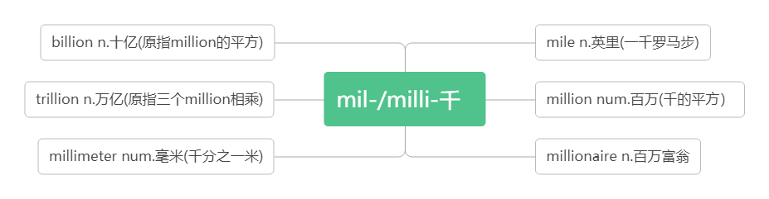
- cheat /tʃi:t/ vi.作弊；舞弊 vt. 欺骗；蒙骗 n. 欺骗；骗子
You should never cheat in an exam. 你永远不应该在考试中作弊。
John cheated in the exam, and the teacher kicked him out of the class. 约翰考试作弊，结果被老师赶出了教室。
Although people may cheat you, be honest anyway.虽然人们可能会欺骗你，但不管怎样，你都要诚实。
He looks honest, but actually he is a cheat. 他看上去挺厚道，可实际上他是个骗子。
cheat sb. of sth. 骗取某人的某物
He cheated the old lady of her money. 他骗取了老太太的钱。
- audience/ˈɔːdiəns/ n. 观众；听众
词根词缀：audi-(听)+-ence(名词后缀)：听的人——听众;观众
I see what you mean, but the audience wants fair play.我明白你的意思，但观众希望公平竞争。
The audience were greatly moved by his performance. 观众们被他的表演深深打动。
His speech made a strong impression on the audience. 他的演说给听众留下了深刻的印象。
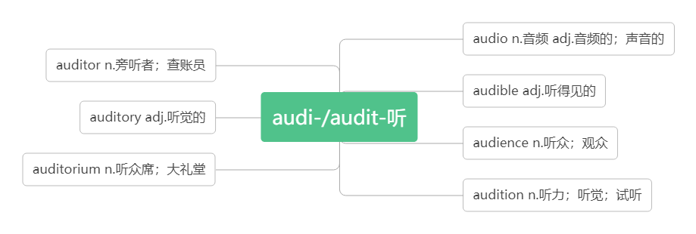
- positive / ˈpɒzətɪv / adj. 积极的；正面的；乐观的；肯定的
音义互通：跑着起舞 助记：积极乐观的人会随风奔跑着起舞。
By being positive about myself and my body, I became both happier and healthier.
通过对自己和身体保持积极的态度，我变得更快乐、更健康。
She tried to be more positive about her new job. 她力求对新工作更有信心。
Keep a positive attitude and good things will happen.保持乐观的心态，好事自然会发生。
I was positive that things were going to turn out fine. 我确信事情最终会好起来的。

- slim /slɪm/ adj. 苗条的；纤细的
I always wanted to look like the slim girls on TV even though I knew that it was impossible.
我一直想看起来像电视上的苗条女孩即使我知道这是不可能的。
She was tall and slim. 她是个瘦高个儿。
How do you manage to stay so slim?你是怎样把身材保持得这么苗条的？

- diet/ˈdaɪət /n.日常饮食；节食 vi.节食
音义互通：得饿他 助记：他要想节食就得饿他。
a balanced diet 均衡的饮食
go/be on a diet diet 节食
I worried about my weight and tried every new diet I read about online.
我担心我的体重，尝试了我在网上看到的每一种新的饮食。
Everybody has to eat, but do you eat a healthy diet? 人人都得吃饭，但是你有健康的饮食吗？
I decided to go on a diet before my holiday. 我决定在休假前节食。
She's always dieting but she never seems to lose any weight. 她总是在节食，但体重好像并未减少。

- make a difference 有影响，起作用
I had no idea a letter could make such a difference! 我不知道一封信会有这么大影响！
It shows that a knowledge of first aid can make a real difference.这表明懂得急救知识的确能发挥重要作用。
The dog makes a big difference to my life. 小狗对我的生活产生了很大的影响。
Whether he is here or not will make no difference to our work. 他在不在对我们的工作没有影响。
I have to make an effort if I want to make a difference. 如果我想有所改变，我一定会尽我所能。

- rather /ˈrɑ:ð ə(r) / adv.相当，很
She fell and hurt her leg rather badly. 她跌倒了，腿伤得相当重。
I didn't fail the exam; in fact I did rather well! 我没有考不及格，事实上，我考得不错！
It was a rather difficult question. 这是个相当难的问题。
rather than 而不是
Once I started thinking about fitness rather than weight, things began to change.
一旦我开始考虑健康而不是体重时，情况开始发生变化。
Rather than cutting out the foods I enjoyed, I added healthy foods to my meal.
没有停止吃我喜欢的食物，我在饮食上加了健康的食品。
I think I'll have a cold drink rather than coffee. 我想要冷饮，不要咖啡。
I'd stay at home rather than go out. 我宁可呆在家里也不出去.

- push-up /'pʊʃʌp / n. ( especially AmE) 俯卧撑
I want to be able to do 30 push-ups. 我想做30个俯卧撑。
How many push-ups can you do in a minute ? 你一分钟能做多少个俯卧撑？

- cut out 停止做；裁剪出；删去
Rather than cutting out the foods I enjoyed, I added healthy foods to my meal.
没有停止吃我喜欢的食物，我在饮食上加了健康的食物。
Cut out your stupid joke! Nobody wants to hear that. 停止你那愚蠢的笑话！没有人想听。
He cut out the picture from the newspaper.他从报上剪下这图片。

- now and then 有时；偶尔
I could still have a burger now and then, but I would add a salad or an apple. 我偶尔还会吃汉堡，但是我要加沙拉或苹果。
I like to go to the cinema now and then. 我喜欢偶尔去看电影。
We haven't seen each other for years, but we chat online now and then.
我们已有很多年没见过面了，但是我们有时会上网聊一聊。
I meet him every now and then on the campus. 我不时在校园里见到他。

- compare /kəmˈpeə(r)/ vt.比较;比作
词根词缀：com-(一起)+pare-(排列)：把东西排列在一起——作比较
Finally, I stopped comparing myself with actresses and models and looking for things that were wrong with my face or body.
最后，我不再拿自己跟女演员和模特比较, 也不再挑剔我的脸上或身体上的毛病了。
Please compare your answer with that on the blackboard. 请把你们的答案和黑板上的比较。
compare… with 把……与……比较
Don’t compare your life with others’. You have no idea what their journey is all about.
不要把你的生活跟别人比较。你不知道其他人走过什么样的路。
Enjoy your own life without comparing it with that of another. 享受自己的生活，不要和别人比较。
compare… to 把……比作……
We often compare a teacher to a candle．我们常把老师比喻成蜡烛。
Books can be compared to friends.书可以比喻为朋友。
compared with/to 与……相比（做方式状语）
Compared to/with our parents, we have greater opportunities to have a good time.
和我们的父母比起来，我们有更多机会享受生活。
