Unit 4 Book 1 导案
- disaster / d ɪˈzɑ:st ə(r) / n. 灾难；灾害
词根词缀：dis(远离,偏离)+aster(star星星)：星星偏离了原来的位置——灾难。
natural disasters 自然灾害
an air disaster 空难
It was the second air disaster in less than two months. 这是不到两个月内的第二次空难了。
Thousands of people died in the disaster. 数千人在这场灾难中丧生。
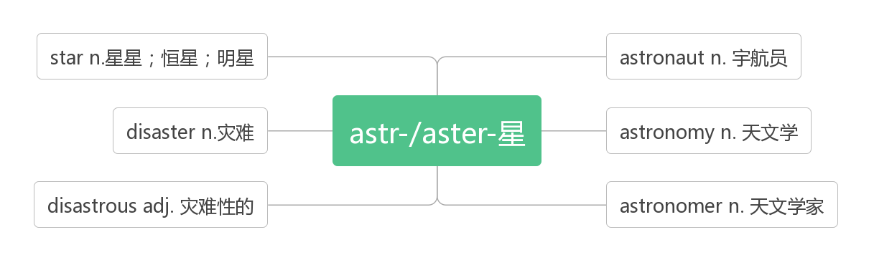
- tornado /t ɔ:ˈneɪdəʊ / n.龙卷风；旋风
破拆法：torn(tear撕扯)+a+do(door门) 助记：龙卷风撕扯着一扇门。
The tornado killed dozens of lives. 那场龙卷风夺去了几十条人命。

- drought / draʊt / n. 旱灾;干旱
类比：dry a.干燥的—— drought n.干旱
high a.高的—— height n.高度
see vt.看见—— sight n.视野
think vi.想—— thought n.想法
The ground is as hard as stone after the drought.长期干旱后土地硬得就像石头一样。
In fact many food crops failed because of the drought. 实际上，因为干旱，很多粮食作物歉收。

- slide / slaɪd / vi. & vt. (slid, slid ) (使）滑行；滑动
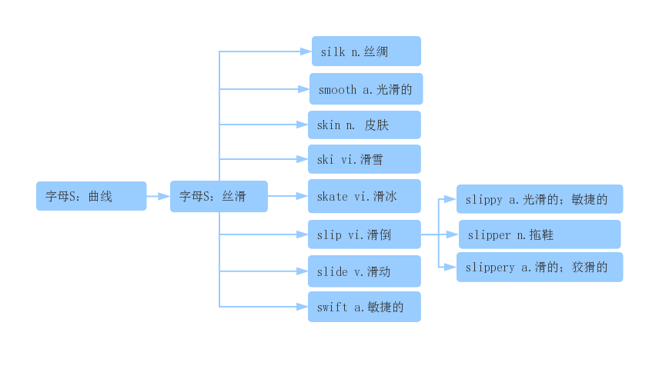
We slid on the ice. 我们在冰上滑行。
The door slid open. 门慢慢开了。
She slid the door open 她滑开了门。
slide into（使）滑入; 溜进
It seemed possible that the US and China could slide into some form of trade war.
有可能中国和美国会陷入某种形式的贸易战。
The thief slid into the room. 小偷悄悄溜进房间。
landslide /ˈlændslaɪd / n. ( landfall) 山体垮塌；滑坡
The village was destroyed by a landslide. 滑坡摧毀了村庄。
The heavy rain caused the landslide. 大雨引起山体滑坡。
- tsunami / tsu:ˈnɑ:mi / n.海啸
破拆法：t(turn转变)+sun(太阳)+a+mi(米粒) 助记：在海啸中，太阳变成米粒般大小。
Large earthquakes can cause powerful tsunamis. 大地震可以引起强烈的海啸。

- flood / flʌd /
n. 洪水
The heavy rain has caused floods in many parts of the country. 大雨使全国许多地方泛滥成灾。
More than 70 people were killed in the flood. 70 多人因洪灾丧生。
The river is in flood.河水泛滥。
a flood of 大量的
He received a flood of thank-you letters. 他收到大量感谢信件。
vt. 淹没；灌满
The heavy rain flood the village. 大雨淹没了这个村庄。
The afternoon light flooded the little rooms 午后的阳光洒满一间间小屋。
vi. 泛滥；大量涌入
Water flooded in through the back door. 水从后门涌进来。
Telephone calls flooded in from all over the country.全国各地的电话像潮水般打来。
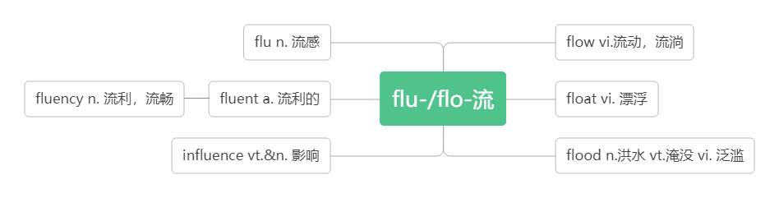
- erupt /ɪˈrʌpt / vi.& vt. 爆发; 喷出
The couple volunteered to help after the volcano erupted.火山爆发后这对夫妇自愿帮忙。
An active volcano may erupt at any time. 活火山会随时喷发。
A fight has erupted outside the restaurant. 饭馆外发生了斗殴。
eruption /ɪ'rʌpʃn/ n.爆发
The eruption of the volcano destroyed many villages. 火山爆发破坏了很多村庄。
Volcanic eruption is the most terrible natural disasters on earth.火山喷发是地球上最可怕的自然灾害之一。
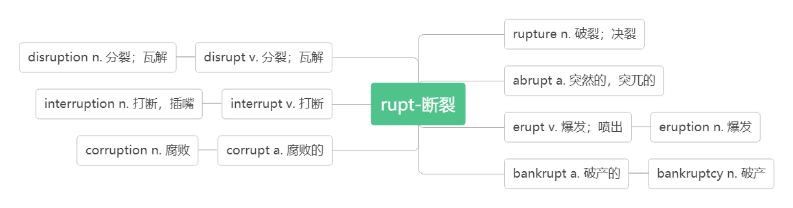
- magnitude /ˈmæ gnɪtju:d / n. 震级；量级
词根词缀：magni(大)+tude(名词后缀，表状态)：大的程度——震级，量级
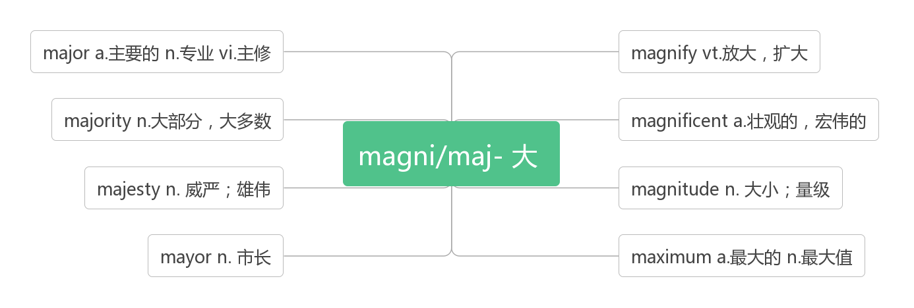
The Wenchuan earthquake had a magnitude of 8.0. 汶川地震的震级为8.0 级。
We did not realize the magnitude of the problem. 我们没有意识到这个问题的重要性。

- rescue /ˈreskju: / n.& vt.营救；救援
音意相通：来施救
rescue workers/boats 救援人员/船只
What are the rescue workers and soldiers doing in the flood-hit area? 在受灾地区，救援人员和士兵在做什么？
Internet rescue camps in South Korea and China try to save kids addicted to the screen.
韩国和中国的网络救援营试图拯救沉溺于手机的小孩。
Ten fishermen were saved in a sea rescue.在一次海上营救行动中，十名渔民获救。
They were rescued by helicopter.他们被直升机救走了。
rescue sb./ sth. from… 从……中营救某人/某物
Firefighters rescued a child from a burning building. 消防队员从着火的大楼里救出了一个孩子。
rescuer /'reskju:ə(r)/ n. 救援者；救助者
Many people burst into tears when a rescuer carried a girl out of the ruins.
当一名救援者从废墟里抱出一个女孩时,在场的许多人不禁潸然泪下。

- damage /ˈdæ mɪdʒ / vt. &.n.损害；损坏
破拆法：dam(大坝)+age(年纪) 助记：上了年纪的大坝一般都有所损坏。
Which buildings were damaged in Seoul？ 首尔哪些建筑物受损？
The fire badly damaged the town hall. 火灾使市政厅遭到严重破坏。
Smoking seriously damages your health. 吸烟严重损害健康。
The earthquake caused serious damage to the house.地震给这所房子造成了严重的损坏。
do damage to sb/sth. 对……造成损害
The storm didn't do much damage to crops. 暴风雨并未对庄稼造成严重损失。
词群：
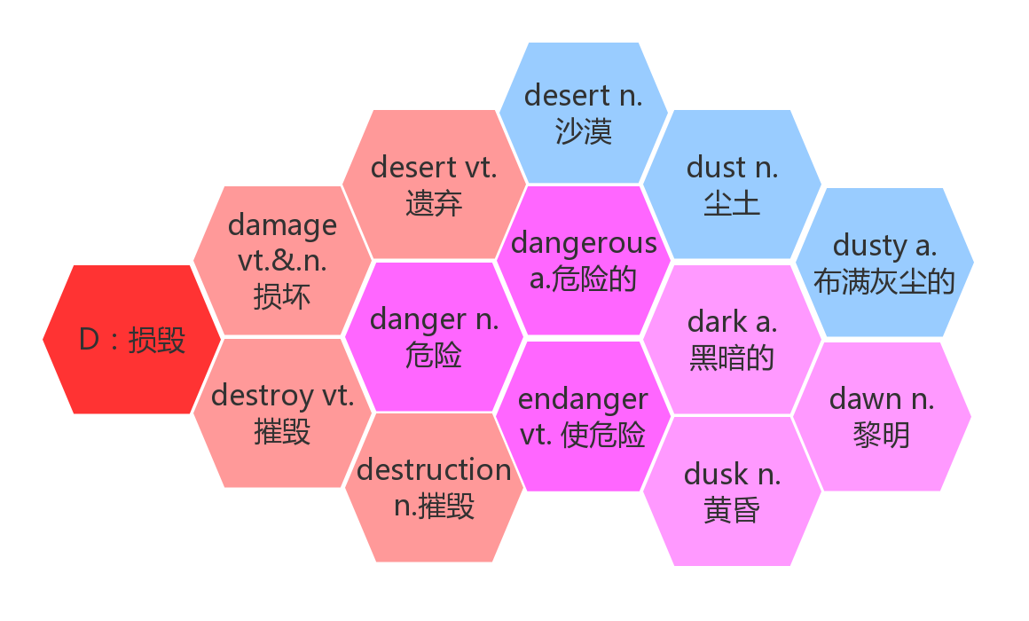
- destroy/ dɪ'str ɔɪ / vt. 摧毁 ；毁灭
破拆法：des-(毁掉)+troy(特洛伊，被希腊联军毁掉的名城)
Nearly everything in the city was destroyed. 城里几乎所有的东西都被毁了。
They've destroyed all the evidence. 他们销毁了一切证据。
Heat gradually destroys vitamin C. 加热会逐渐破坏维生素C。
You have destroyed my hopes of happiness.你毁掉了我得到幸福的希望。
A man can be destroyed but not defeated. 人可以被毁灭，但无法被打败。
destruction/dɪˈstrʌkʃ(ə)n/ n.摧毁；毁灭
Those already sold are to be recalled for repair, replacement or destruction.
已经销售的要召回修理、替换或销毁。

- evacuate / ɪˈvækjue ɪt / vt. 疏散；撤出vi. 撤离
词根词缀：e-(外)+vacu-(空)+-ate(动词后缀)：都到外面，使里面变空——撤出
Almost 88,000 people have been evacuated from the area.近88, 000人撤离了该地区。
The building is on fire. Evacuate all the people immediately.这座楼着火了，立即疏散人群。
When the forest fires broke out, we were told to evacuate.当森林大火爆发时，我们被通知撤离。
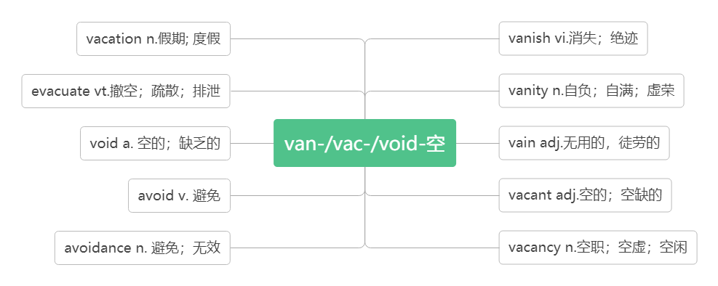
- helicopter /ˈhelɪkɒptə(r)/ n. 直升机
破拆法：he(他)+li(离)+cop(警察)+ter(特) 助记：他离警察特远，需要调动直升机去帮助。
Helicopters were used to fight the fire. 直升机被用来灭火。
The injured were sent to the hospital by helicopter. 伤员由直升机送到医院。

- death/ deθ/ n. 死；死亡
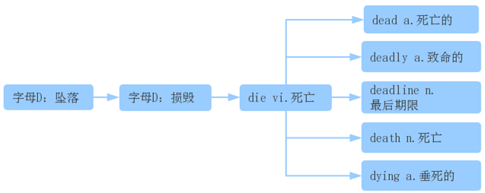
Before modern medicine changed the laws of nature, many children died of common childhood diseases. (2015广东)
在现代医学改变自然法则之前，许多儿童死于常见的儿童疾病。
You may drink, smoke,be overweight and still reduce your risk of dying early by running.(2018全国)
你可以喝酒，吸烟，肥胖，但通过跑步你仍然可以降低死亡率。
Mr. Holden returned home from his holiday upset and convinced his pet was dead.(2015 陕西)
当Holdern先生度假回到家时，他很伤心，因为他确信的自己的宠物已经死了。
He thought that Joe must be dead, but he didn’t want to leave immediately.(2014 全国I）
他认为Joe一定死了，但他不想立刻离开。
It should not cause deadly traffic accidents.(2017天津) 这不应该导致致命的交通事故。
The deadlines and what you need to apply depend on the program.(2019全国卷I)
最后期限以及你需要申请些什么取决于项目。
I knew it was the difference between life and death.(2017北京卷) 我知道这是生与死之间的差别。
Only five years after Steve Jobs' death, smart－phones defeated conventional PCs in sales.(2017江苏)
仅在 Steve Jobs去世五年后，智能手机就在销售量上击败了传统电脑。

- affect/ ə'fekt/ vt. 影响；感染；感动
A bad home environment can affect a child's healthy growth. 不良的家庭环境能影响儿童的健康成长。
The thoughts and behaviors of a teacher will affect those of his pupils.
教师的思想和言行将影响到其学生的品质。
The illness has affected both her mental and physical health. 这种疾病损害了她的身心健康。
They were deeply affected by the news of her death. 她死亡的消息使他们悲伤不已。
effect/ɪˈfekt/ n.效果，影响
have an effect on对……有影响
side effect 副作用
You might also begin to notice the effects not only on your health but in your pocket.(2018浙江卷)
你可能也会开始注意到，它不仅对你的健康，而且对你的经济都有影响
The weather effects, both good and bad, are felt in many places.(2016江苏卷)
天气的影响，无论好的还是坏的，在很多地方都能察觉到。
Your house may have an effect on your figure.(2015全国II) 你的住处可能对你的身材有影响。
Headaches are one of the side effects of the drug. 头痛是这种药物的副作用之一。
effective/ɪˈfektɪv/ a.有效的
They have reduced pollution through effective measures.(2014全国卷)
他们通过有效的措施减少了污染。
So far there is no effective way to get rid of it..(2018北京卷)
到目前为止还没有有效的方法摆脱它。
effectively/ɪˈfektɪvli/ ad.有效地
There are actually healthier ways that can work just as effectively.(2015重庆卷)
实际上有更加健康而且同样有效的方法。
Regardless of your choice of course, you'll develop your language ability both quickly and effectively.(2016 天津卷)
无论你选的那一门课，你都能迅速而有效地培养你的语言能力。
efficient/ɪˈfɪʃ(ə)nt/ a.高效的
When communication becomes more efficient, people are able to contact one another no matter where they are and at whatever time they wish to.(2014江西卷) 当交流变得更加高效时，人们就可以随时随地彼此联系。
efficiently /ɪˈfɪʃ(ə)ntli/ ad.高效地
Now that Chicago’s waste water was draining efficiently into the Chicago River, the city’s next step was to clean the polluted river. (2015湖南卷)
既然芝加哥市的废水更高效地排入了芝加哥河，该市的下一步举措就是治理这条被污染的河流。
affection /əˈfekʃ(ə)n/ n.喜爱，感情
Understanding your own needs and styles of communication is as important as learning to convey your affection and emotions.(2014湖南卷) 理解你自己的需求与交流风格就像学会表达你的喜爱与感情一样重要。
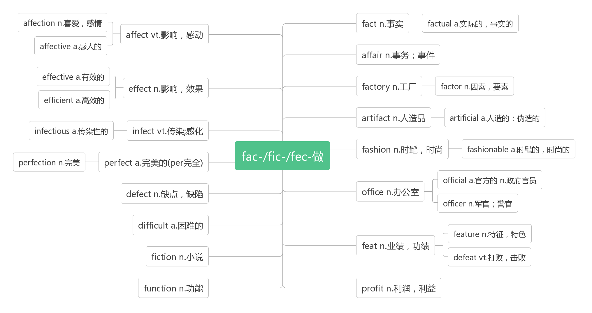
- shelter/'ʃeltə/
n.避难处；居所；庇护
a night shelter for the homeless 无家可归者夜间收容所
Shelters were set up by the government. 政府搭建了庇护所。
Workers built shelters for survivors whose homes had been destroyed.
救援人员为那些家园被毁的幸存者盖起了避难所。
People were running for the shelter from the storm. 人们跑着找地方躲避暴风雨。
Many are sleeping in the open because they have no shelters.
很多人因为没有栖身之所，只好露宿在外。
vt.保护；庇护
Perhaps I sheltered my daughter too much. 也许我对女儿保护过度了。
shelter sb/sth from sb/sth 保护……免受……
Some parents want to shelter their children from any harm.
一些父母想要保护他们的孩子不受一点伤害。
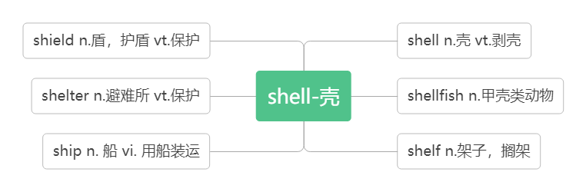
- crack /kræk/
音意相通：拟声词，咔嚓 助记：咔嚓一声墙壁裂开了。
n. 裂纹；裂缝
There were deep cracks that appeared in the well walls. 井壁上出现了深深的裂缝。
This cup has a crack in it. 这杯子有一道裂痕。
vi. & vt. (使) 裂开
The glass will crack if you pour hot water into it. 别往玻璃杯里倒热水，不然会烫裂杯子。
The ice cracked as I stepped onto it. 我一踩冰就裂了。
The little boy failed to crack the walnut. 小男孩没能砸开核桃。
She dropped a plate and cracked it this morning. 今天早上她把一个盘子掉在地上打破了。

- as if 似乎；好像；仿佛
It seemed as if the world were coming to an end. 世界似乎要到末日！！
It seems as if our team is going to win. 看来我们队要胜了。
She stood at the gate as if she was waiting for someone.她站在门口好像在等人。
as if的用法：
as if 后面即可以接陈述语气也可以接虚拟语气。如果后面接的并非真实情况，则要用虚拟语气，将时态向过去推移一个时态即可。
Some people like to talk about film stars’ personal life as if they were close friends.
一些人喜欢谈论影星的私生活，好像他们是亲密朋友。
She loves the boy as if she were his mother. 这男孩，就好像她是他的母亲一样。
It was John who broke the window. Why are you talking to me as if I had done it?
打破窗子的是约翰，为什么你和我说话，好像是我打破的。
He walked in as if he had bought the school.（2012 广东）

- ruin /'ru:ɪn/
vt. 毁掉；毁坏
The bad weather ruined our trip. 坏天气毁了我们的旅行.
My new shoes got ruined in the mud. 我的新鞋被泥浆毁了。
The crops were ruined by the heavy rain. 农作物被大雨全毁了。
n. 毁灭；废墟(pl)
Everywhere survivors looked, there was nothing but ruins. 幸存者无论朝哪里看，除了废墟什么也没有。
The house has fallen into ruins. 房子倒坍成了废墟。
Drinking was the ruin of him. 酗酒毁了他。
in ruins 严重受损；破败不堪
In less than one minute, a large city lay in ruins. 在不到一分钟内，一座大城市就沉沦在一片废墟之中。
The castle now lies in ruins. 这个城堡现在已成为一片废墟。
【辨析】
destroy | 只用作动词，指强调用某种摧毁性的力彻底破坏，以致不可能修复，常作"破坏"、"毁灭"解。
damage | 可以用作动词，也可以用作名词，用作名词时常与 to sb/sth 连用。指部分"损坏"、"损害"或指价值有所降低。一般被破坏的物品可以重新修复。
ruin | 可以用作动词，也可以用作名词，用作动词时, 作“毁掉；毁灭；弄糟"解；强调缓慢但无法逆转的毁灭。；用作名词时, 表示"毁灭；毁坏；废墟"等抽象概念。
The earthquake destroyed almost the whole town. 地震几乎毁灭了整个城镇。
His hope of being a writer was destroyed. 他想成为一个作家的希望破灭了。
Hundreds of houses in the area were damaged by the storm. 暴风雨毁坏了这个地区数以百计的房屋。
The accident did a lot of damage to his car. 这次车祸使他的车受到很大的损坏。
The floods ruined many precious paintings. 这次水灾毁坏了很多珍贵的画。
You’ll ruin your health if you go on like this. 这样下去你会毁了你的身体的。
- percent / pəˈsent / n. 百分之....
About 75 percent of the city’s factories and buildings, 90 percent of its homes, and all of its hospitals were gone.
大约75%的工厂和建筑物、90%的家园所有的医院都消失了。
We found that only fifteen percent of our students exercise every day. 我们发现仅有15%的学生每天锻炼。
The price of the house has risen by ten percent. 房价上升了10%。
percentage /pəˈsentɪdʒ/ n.百分比，百分率
A high percentage of the female staff are part-time workers. 女职员中，兼职工作的人占很高的比例。
The figure is expressed as a percentage. 数字是用百分率表示的。
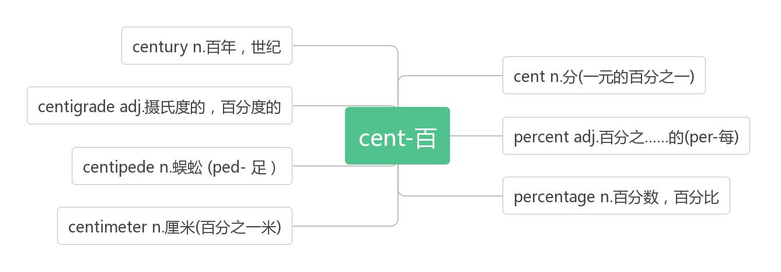
- brick /brɪk/ n. 砖；砖块
词源：break——>brick（原指碎石块）
联想记忆：b(Brazil)+r(Russia)+i(India)+c(China)：金砖四国——brick
Bricks covered the ground like red autumn leaves. 残砖就像秋天的红叶覆盖着大地。
The house is built of brick. 那座房子是用砖建造的。
This garden is surrounded by high brick walls. 花园四周有高高的砖墙环绕。

- metal /'metl/n. 金属
a piece of metal 一块金属
The railway tracks were now useless pieces of metal. 铁轨如今成了一块块废金属。
The box is made of metal. 盒子是用金属做的。
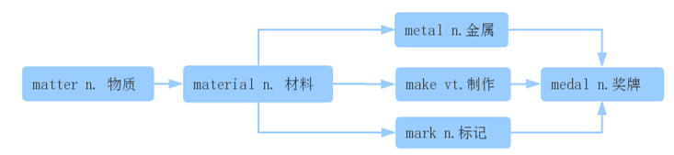
- shock /ʃɒk/ n.震惊；令人震惊的事；休克 vt.(使) 震惊；电击
The little boy was speechless with shock. 那小男孩震惊得说不出话来。
He has never recovered from the shock of his wife’s death. 他从未从妻子去世的打击中恢复过来。
Don't touch that wire or you'll get a shock . 别碰那根电线，不然你会触电的。
People were in shock—and then, later that afternoon, another big quake shook Tangshan again.
人们惊呆了。接着，在下午晚些时候，唐山又发生了一次大地震。
The news of his death shocked all of us.他死亡的消息我们所有的人都感到震惊。
Everyone in the street was shocked by the news. 街上所有的人都被那条消息震惊了。
in shock 处于震惊/休克中
She is still in shock after the accident. 事故发生后到现在，她仍然处于休克状态。
shocking /ˈʃɒkɪŋ/ adj.令人震惊的 （现在分词表示主动内涵，意为“令人……的”）
shocked / ʃɔkt/ adj.感到震惊的 （过去分词表示被动内涵，意为“感到……的”）
I was shocked to hear the shocking news. 听到这个令人震惊的消息，我感到很震惊。
- electricity / ɪˌlekˈtrɪsəti / n. 电；电能
拆破法：e(电子)+lect-(收集)+tri-(去)+city(城市) 助记：收集电子去给城市供电。
Water, food, and electricity were hard to get. 水、食物，和电都很难弄到。
The electricity had been cut off. 停电了。
We can use the power of the wind to make electricity．我们可以使用风力来发电。
electric [ɪˈlektrɪk] adj. 电动的
electrical [ɪˈlektrɪk(ə)l] adj. 与电相关的
electronic [ɪlekˈtrɔnɪk] a. 电子的
- trap /træp/ vt. 困住；使陷入圈套n. 困境；陷阱
The thick smoke and flames trapped people upstairs. 浓烟和火焰把人们困在了楼上。
The children trapped in the burning building were saved at last. 被困在燃烧着的楼房里的孩子们最后得救了。
A fox was caught in a trap. 一只狐狸掉进了陷阱里。
Some women see marriage as a trap. 有些妇女把婚姻视作围城。
Soon after the quakes, the army sent 150,000 soldiers to Tangshan to dig out those who were trapped and to bury the dead.
地震后不久，部队派了15 万名战士到唐山将受困的人们挖出来，并将死者掩埋。
be trapped in… 受困于
Some of the workers were trapped in the ruins. 有些工人被困在废墟中。
trap sb into（doing）sth. 诱使某人（做）某事
They trapped her into marrying their son. 他们诱使她嫁给他们的儿子。
词群：
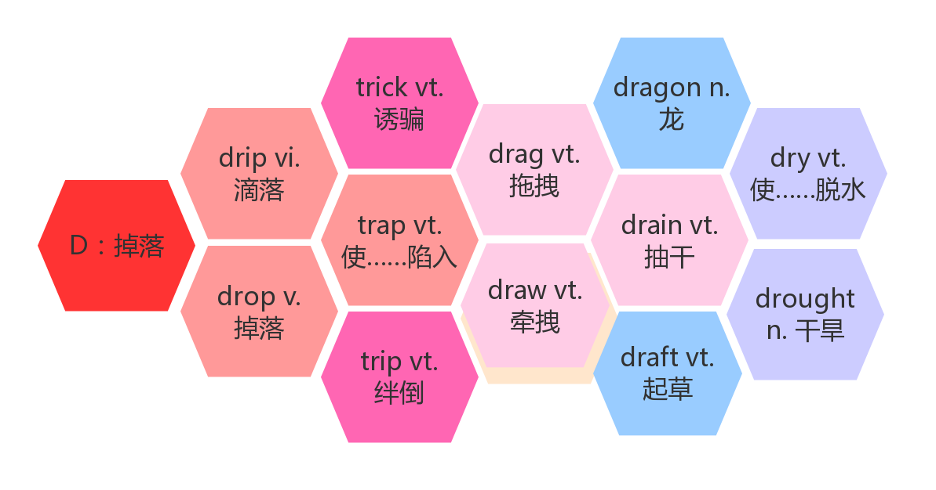
- bury / ˈberi / vt. 掩埋；埋葬
破拆法：bu(不)+r(让)+y(养) 助记：既然不让养，就把它埋了吧。
He died at the age of 80 and was buried in his homeland. 他80岁去世了，被安葬在他的家乡。
I was looking for my handbag, which was buried under a pile of old newspapers.
我正在找被埋在一堆旧报纸下面的手提包。
He buried his face in his hands and wept. 他双手掩面而泣。
She had learnt to bury her feelings. 她已经学会了感情不外露。
bury one’s head / oneself in…= be buried in… 埋头于，专心致志于
My father buried his head / himself in his newspaper.
= My father was buried in his newspaper. 我父亲专心致志地看他的报纸。
Buried in my book, I didn’t realize it was raining. 我专心致志地看书，没注意到下雨了。

- breathe /bri:ð / vi.& vt. 呼吸
breathe in/out 吸入/呼出
Slowly, the city began to breathe again. 慢慢地，这座城市又开始出现了生机。
It’s good for the health to breathe deeply. 做深呼吸对身体有益。
Most people don't realize that they are breathing polluted air. 大多数人没有意识到自己正呼吸着污染了的空气。
breath/breθ / n. 气息；呼吸；一口气
take a deep breath 深吸一口气
hold one’s breath 屏住呼吸
out of breath 上气不接下气
catch one’s breath 恢复呼吸
You can see peoples’ breath on a cold day. 冷天能看到人们呼出的空气。
She took a deep breath. 她做了一次深呼吸。
By mile 17, I became out of breath and the once injured ankle hurt badly. (2018北京)
跑到17英里的时候，我变得上气不接下气，受伤的脚踝疼的要命。
I paused to catch my breath and then positioned myself to take the best photo of this panorama(全景).(2017天津)
我停下来恢复呼吸，并找好位置去拍一幅最佳的全景照。
- revive /rɪˈvaɪv / vt.& vi. 复活；(使)复苏
Tangshan began to revive itself and get up on its feet again. 唐山开始恢复元气，重新站起来。
They managed to revive the injured driver at last. 他们最终使受伤的司机苏醒了过来。
The flowers soon revived in water. 这些花见了水很快就活过来了。
The economy is beginning to revive. 经济开始复苏。
revival /rɪˈvaɪvl / n. 复活；复兴
What do you think helped in the revival of Tangshan city? 你认为是什么帮助唐山市的复兴？
World trade is showing signs of revival. 世界贸易正显示出复苏的征兆。
Jazz is enjoying a revival.爵士音乐再度盛行。
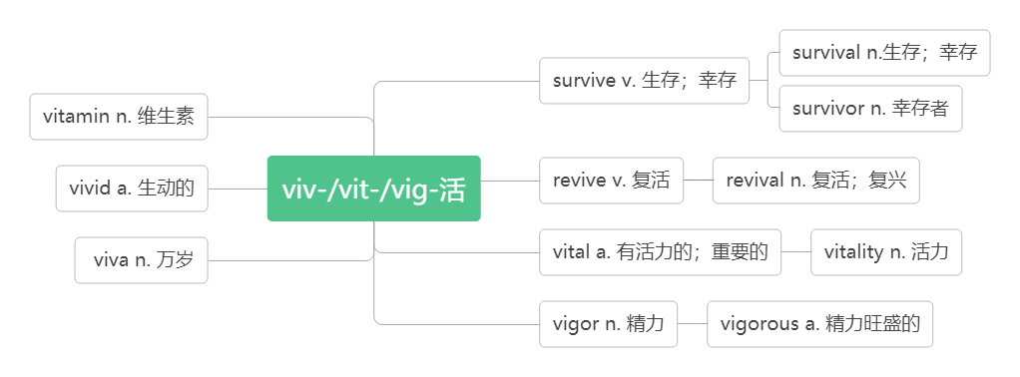

- effort /'efət/ n. 努力
词根词缀：ef(向外)+fort(力量)：向外用的力量——努力。
With strong support from the government and the tireless efforts of the city, a new Tangshan was built upon the earthquake ruins. 在政府的大力支持和全市人民的不懈努力下，一个新的唐山在地震废墟上建成了。
You should put more efforts into your work. 你应该更加努力地工作。
All my efforts ended in failure . 我的一切努力最后都无济于事。
A winner is one with a great effort of will. 成功者是有着强大努力意志的人。(2018北京)
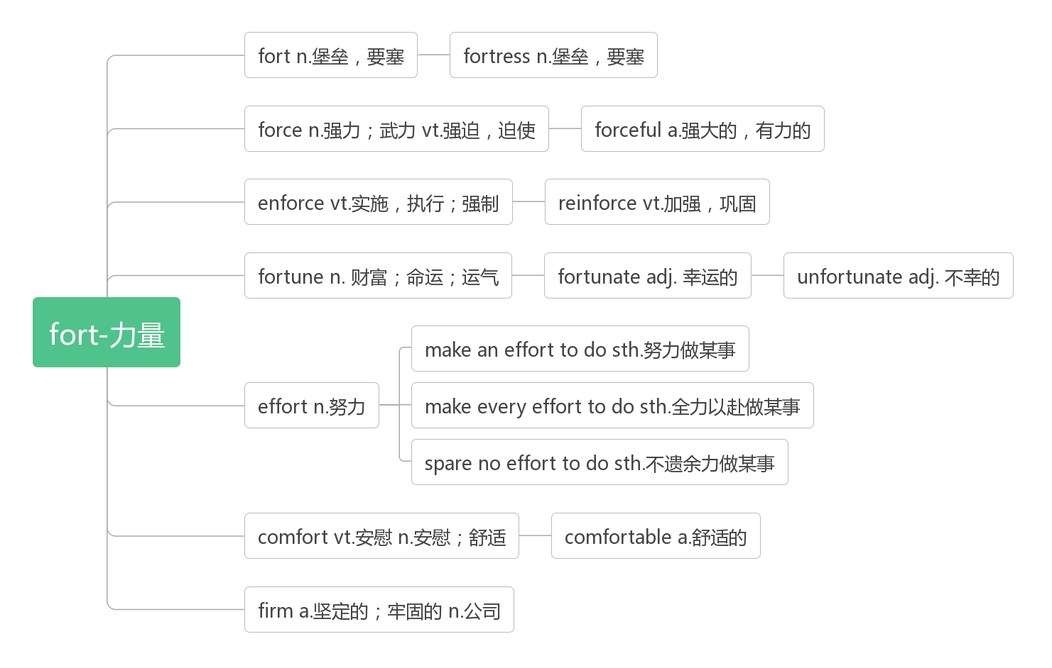
make an effort to do sth. 努力做某事
make every effort to do sth. 竭尽全力做某事
spare no effort to do sth.不遗余力做某事
So I make an effort to be on time when I meet my friends. 所以当我与朋友见面时，我努力做到守时。
He was making an effort to control himself. 他努力控制自己的情绪。
These flowers, with or without human care, whether or not some people appreciate, always make every effort to open their flowers.
这些花儿，不管有没有人在意，不管是不是有人欣赏，总是要竭尽全力开出自己的花朵。
Dear fellow students, let's start right now and spare no effort to do a little bit every day, every hour, and every minute!
亲爱的同学们，让我们从现在起，每一天，每一小时，每一分钟，都不遗余力地做一点贡献！

- unify /ˈju:nɪfaɪ/ vi.& vt. 统一;(使)成一体
Germany unified officially in 1990 ; Will the two Koreas unify?
德国在1990年正式统一了；两个朝鲜能统一吗？
The new leader hopes to unify the country. 新领袖希望把国家统一起来。
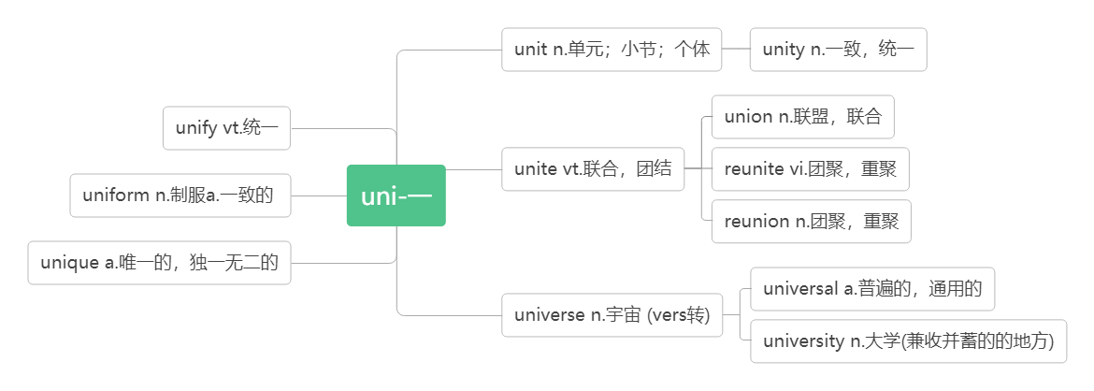
- wisdom /ˈwɪzdəm/ n. 智慧；才智
Tangshan city has proved to China and the rest of the world that in times of disaster, people must unify and show the wisdom to stay positive and rebuild for a brighter future. 唐山市已向中国和世界其他地区证明：在灾难时期，人们必须团结一致, 展现智慧，保持积极的心态，重建更光明的未来。
A man of great wisdom often appears slow . 大智若愚。
Experience is the mother of wisdom. 经验为智慧之母。
wise /waɪz/ adj. 明智的；有智慧的
She is a wise woman. 她是一个智慧的女性。
She made a very wise decision. 她作了一个非常明智的决定。
I'm wiser after ten years in the business. 在商界混了十年之后，我变得聪明了。
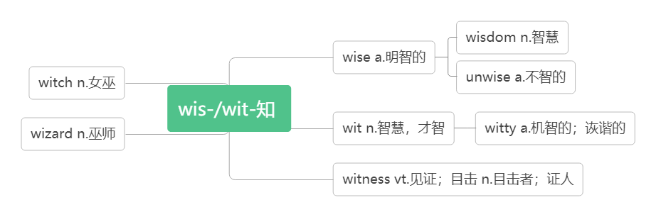
32. suffer /ˈsʌfə(r) /
vt. 遭受；蒙受
Within a few days she had become seriously ill and suffered great pain.
几天的时间，她就病得很严重了，疼痛难忍。
The company suffered heavy losses last year. 公司去年出现巨额亏损。
vi. ( 因疾病、痛苦、悲伤等）受苦
They suffered terribly when their son was killed. 儿子遇难之后，他们悲痛欲绝。
At least he died suddenly and didn’t suffer. 起码他死得很突然，没遭受痛苦。
suffer from 因……而痛苦；患有（疾病等）
He suffered from poor eyesight and could no longer read properly.
他视力不好，再也不能正常阅读了。
Some were found alive, though they were suffering from terrible injuries.
有些人被发现还活着，尽管他们受到了严重的伤。
He appears to be strong and healthy , but he suffers from heart disease.
他看上去强健, 其实他患有心脏病。
sufferer /ˈsʌfərə(r)/ n. 受苦者；受难者；患病者
This new cancer treatment offers hope to many sufferers. 这新的癌症治疗法给许多病人带来希望。
suffering /ˈsʌfərɪŋ/ n. 痛苦；苦难
We must bring suffering and hunger to an end in the world.
我们必须结束世界上的苦难和饥饿。
A man who fears suffering is already suffering from what he fears.
害怕承受痛苦的人，他已经在承受害怕本身所带来的痛苦了。
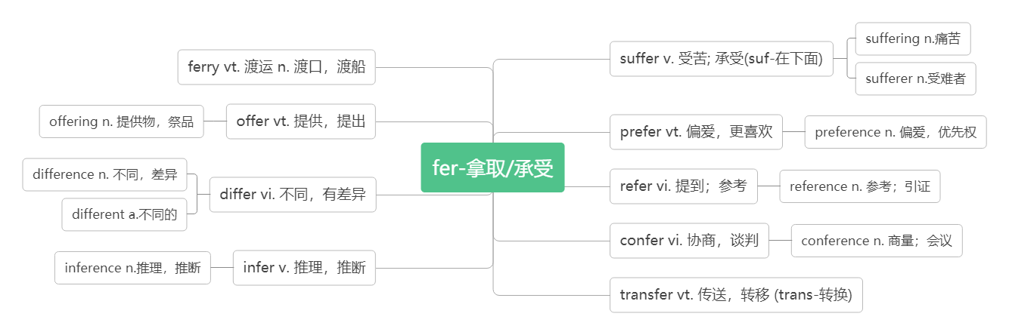
- volcano /vɒlˈkeɪnəʊ/n. 火山
破拆法：vol- (大声)+cano-(canon加农炮)：发出加农炮一般的声音——火山(喷发)
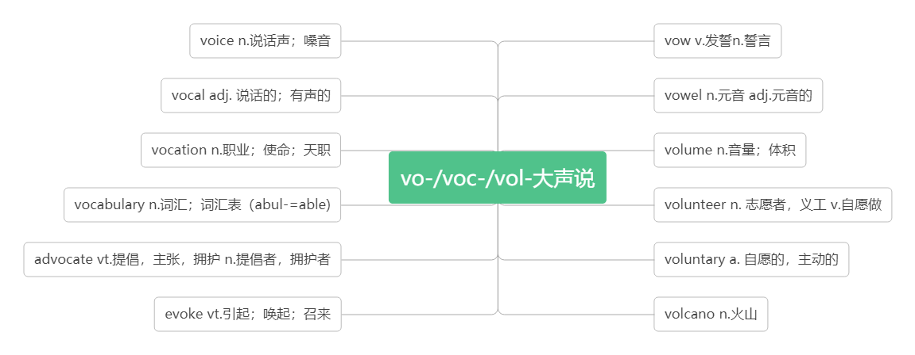
Etna is Europe's most active volcano. 埃特纳山是欧洲最活跃的火山。
There are more than 100 volcanoes in Japan. 日本有100 多处火山。

- supply / səˈplaɪ /vt. 供应, 供给n.供应；补给；[pl.] 补给品
supply sb. with sth. = supply sth. to sb. 向某人提供某物
Russia supplies the European countries with natural gas.
= Russia supplies natural gas to the European countries.
俄罗斯向欧盟国家输送天然气。
The supplies which were provided to the disaster area were collected from around the country.
向灾区提供的物资是从全国各地收集的。
Our water supply has been cut off. 我们断水了。
Books were in short supply.书籍供应短缺。
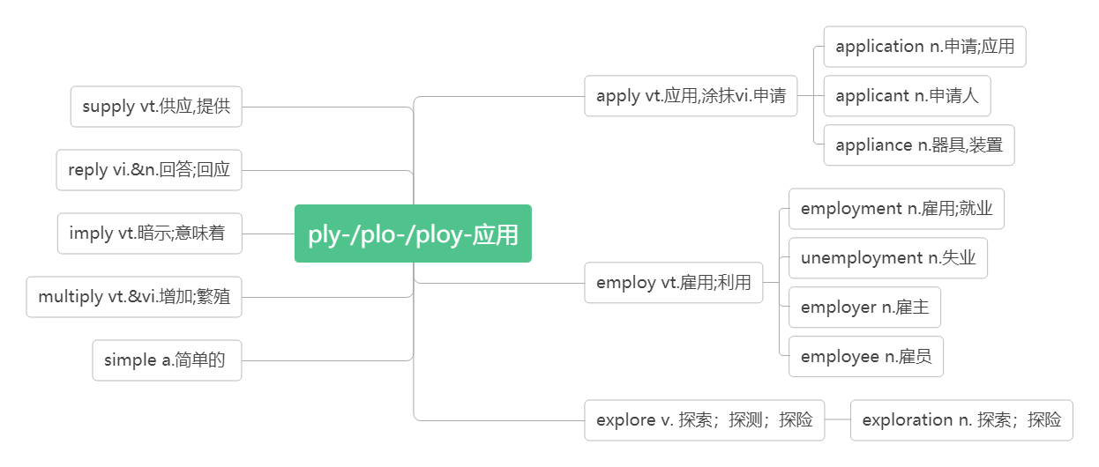
- typhoon / ta ɪˈfu:n / n.台风
音意相通：音译自汉语：台风
Many homes were destroyed by the typhoon.许多房屋被台风摧毁了。

- in the open air 露天；在户外
People put up shelters in the open air. 人们在户外搭建庇护所。
The film will be shown in the open air tonight. 今晚电影在露天演。
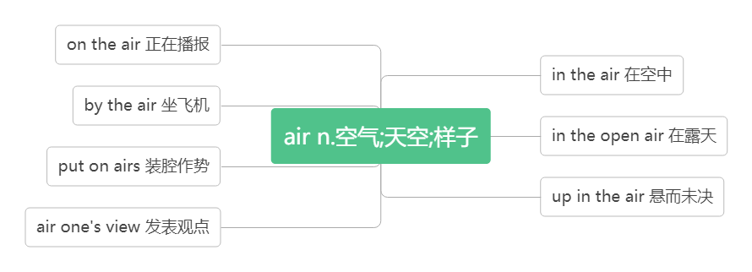
- hurricane /ˈhʌrɪkən / n .飓风
破拆法：hurri(迅速)+cane(棍杖) 助记：飓风来袭，像迅疾的棍杖肆虐着这个小镇。
After the hurricane, many people's homes were destroyed. 飓风过后许多人的房屋被毁。
- survive /səˈvaɪv/
词根词缀：sur(下)+vive(活)：活下去——生存，幸存
vt.幸存于
She's feeding the baby who survived the earthquake她正在喂养地震中幸存的婴儿。
Many birds didn't survive the cold winter. 很多鸟死于这次严冬。
She survived her husband by ten years. 丈夫死后她又活了十年。
vi.生存；存活
Of the six people injured in the crash, only two survived. 因这次撞车事故受伤的六人中，只有两人活了下来。
Companies must be able to survive in the marketplace. 公司必须有能力在市场竞争中生存下去。
Some strange customs have survived from earlier times.有些奇怪的风俗是从早年留存下来的。
survive on 依靠……生存
I can't survive on £40 a week. 一星期 40 英镑，我无法维持生活。
survivor /sə'vaɪvə/ n. 幸存者；生还者
Everywhere survivors looked, there was nothing but ruins. 幸存者们无论朝哪里看，除了废墟什么也没有。
Many firms will die, but the survivors will get stronger than before. 许多公司将会倒闭，但是幸存下来的会更强大。
survival /səˈvaɪvl/ n.存活；幸存
I think life is a struggle for survival. 我认为生活就是一场奋力求生的斗争。
If cancers are found early there's a high chance of survival. 如果癌症在早期发现的话，存活的几率会很高。
同源词：见28 revive

- power /ˈpaʊə(r) / n. 力量；电力；权力
音意相通：怕我 助记：我以前幼稚地以为，当我拥有权力后别人都会怕我。
power cut/failure 断电/停电
come to power 上台执政
out of power 丧失权力，在野
power lines 电线
nuclear/wind/solar power 核/风/太阳能
There was no power at school last night. It was so dark. 昨天晚上学校停电了，漆黑一片。
As is known to us, knowledge is power. 众所周知，知识就是力量。
I think it's important for China to raise its soft power. 我认为中国增加软实力是很重要的。
The Republican Party came to power in 2016. 美国共和党是在2016 年上台执政的。
powerful /ˈpaʊəfl/ adj.（指人）有权势的；有影响力的；（指物）强有力的
His grandfather once was a rich and powerful man. 他的爷爷曾经是一个有钱有势的人。
China is wealthier and more powerful than ever before. 中国比以往任何时候更加富有和强大。

- tap /tæp/
vi.&vt. 轻叩，轻敲，轻拍
音意相通：拟声词，模拟轻拍、轻敲的声音
Someone tapped at the door. 有人轻轻叩门。
He was busy tapping away at his computer. 他埋头敲着电脑键盘。
He tapped me on the shoulder. 他轻轻地拍了拍我的肩膀。
n. 水龙头；轻叩，轻敲
the hot/cold tap 热水/冷水龙头
He never drinks tap water. 他从不喝自来水。
Turn the tap on/off . 打开/关上龙头。
Don't leave the tap running. 别把水龙头开着白白流水。
He felt a tap on his shoulder and turned round. 他觉得有人轻轻拍他的肩膀便转过身来。

- pipe/ paɪp/ n. 管子；管道；烟斗
hot and cold water pipes 冷、热水管
The pipes are made of plastic . 这些管子是用塑料制作的。
piper/ˈpaɪpə/ n.管道工
Super Mario is a famous piper. 超级马里奥是一个著名的管道工。
In the city, the water pipes in some buildings cracked and burst. 在市内，有些建筑物里的水管爆裂开来。
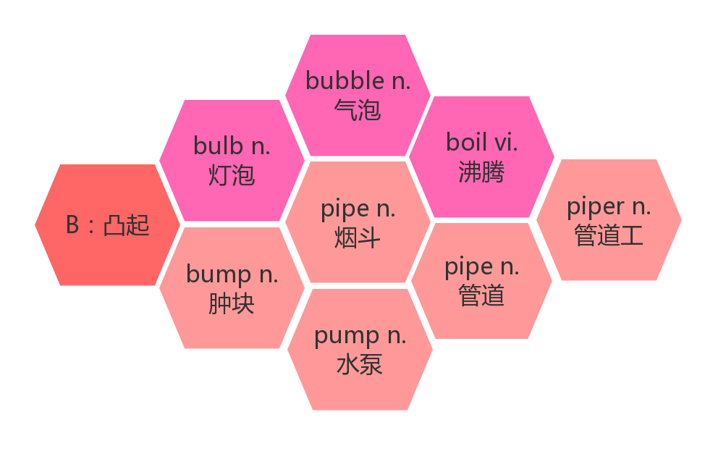
- whistle /ˈwɪsl/
音意相通：拟声词，模拟口哨声。
vi.吹口哨；发出笛声
The crowd whistled as the player came onto the field. 那队员上场时，人群吹起了口哨。
The kettle began to whistle. 烧水壶呜呜地响了起来。
n. 哨子(声)；呼啸声
He scored the winning goal just before the final whistle. 他就在终场哨声前打进了制胜的一球。
He listened to the whistle of a train. 他听着火车呼啸而过。

- emergency/iˈmɜ:dʒənsi / n. 突发事件；紧急情况
词根词缀：e(出)+merg(沉)+ency(名词后缀): 从沉没中突然浮出来——突发事件。
emergency room/exit 急诊室/紧急出口
Call an emergency number. 拨打紧急电话
We must keep as cool as a cucumber in an emergency.我们要在危急时刻保持镇定自若。
This door should only be used in an emergency. 这道门只能在紧急情况下使用。
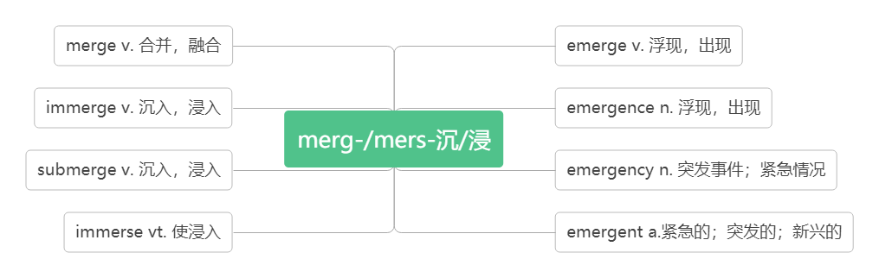
- calm /kɑ:m/
adj.镇定的，沉着的
stay calm 保持镇定
We should stay /keep/ remain calm in the face of danger.我们在危险面前要保持镇静.
vt.使平静，使镇定
calm sb./sth. down 使……平静或镇定下来
You will go somewhere quiet to calm your friend down.去个安静的地方让你的朋友平静下来。
He took a deep breath to calm himself down．他深吸了一口气使自己平静下来。
vi.平静，镇定
Gradually I calmed down and lost my anxiety.我渐渐平静了下来，忘掉了焦虑。
辨析：
calm | （人）情绪镇定冷静的；（天气，海洋等）平静的
quiet | 强调客观环境很安静或人性格文静
silent | 强调人主观上不愿意说话
still | 强调没有动作，静止不动
e.g.
It's a hot and calm day. I'd rather stay at home than go out. 天气炎热无风，我宁可待在家里也不想出门。
In an emergency, she is always calm. 在紧急关头，她通常很冷静。
The street is quiet at midnight. 深夜的街道非常安静。
The girl is quiet and popular. 这个女孩很文静，很受欢迎。
The man is very strange and silent. 这个男人非常奇怪，而且少言寡语。
When asked about the accident, he stayed silent. 当被问起这起事故时，他保持了沉默。
The still butterflies look like flowers. 那些静止的蝴蝶看起来像花朵。
I like to sit in front of the door and overlook the still/calm lake. 我喜欢坐在门前，远眺平静的湖面。

- aid /eɪd /
n.援助；帮助；救援物资
first aid 急救
with the aid of 在…的帮助下
economic/emergency aid 经济/紧急援助
He succeeded with the aid of a new method he discovered. 借助于自己发现的一种新的方法，他获得了成功。
vi.& vt. (formal) 帮助；援助
To aid the poor farmers, the government provided them with a lot of money.
为了帮助贫穷的农民，政府给他们提供了很多钱。
- sweep /swi:p/ vt. & vi.打扫；清扫 (swept, swept)
音意相通：四围扑 助记：用扫帚在四围扑打，清扫灰尘。
Could you please sweep the floor? 你扫扫地好吗？
Sweep the leaves into the corner where they won't be noticed. 把落叶扫到墙角去,那儿不会被人注意。
sweep away 消灭；彻底消除
Fishermen, tourists, hotels, homes, and cars were swept away by huge wave.渔民、游客、旅馆、住宅和汽车都被巨浪冲走了。
The boy helped Mother sweep the dirt away. 男孩帮助母亲清除尘土。
Let's sweep away the broken glass. 让我们把这些碎玻璃扫走。

- wave / weɪv / n.海浪；波浪
Cars were swept away by huge waves caused by the strong earthquake. 汽车被强烈地震引起的巨浪冲走了。
Children were playing in the waves. 孩子们在海浪中嬉戏。
vi.& vt. 挥手；招手
The people on the bus waved and we waved back. 公共汽车上的人挥手致意，我们也向他们挥手。
They came to the front door to wave goodbye. 他们来到前门挥手告别。
词群：
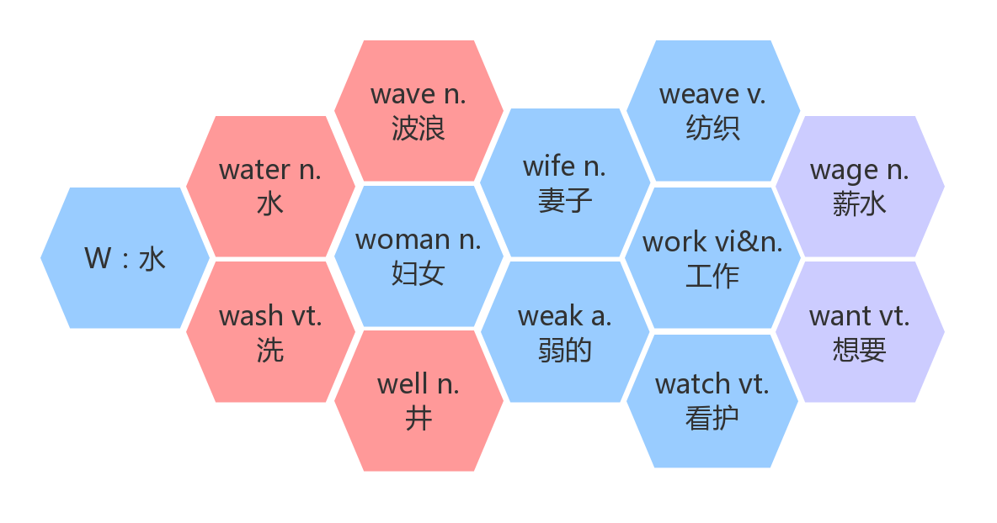
- strike /straɪk /
v.& n.击打；突击 (struck, struck/stricken)
an air strike 空袭
The undersea quake struck around 7:00. 海底地震发生在 7 点左右。
The ship struck a rock. 船触礁了。
The child ran into the road and was struck by a car. 孩子跑到公路上给车撞了。
Strike while the iron is hot. 趁热打铁。
n. 罢工
on strike 罢工
They went on strike for more money. 他们为了得到更多的钱而罢工。
The workers on strike were all fired. 罢工工人都被解雇了。
It strikes sb. that... 某人突然想到……
It suddenly struck me how we could improve the situation.
我一下子明白我们如何能改善局面了。
词群：
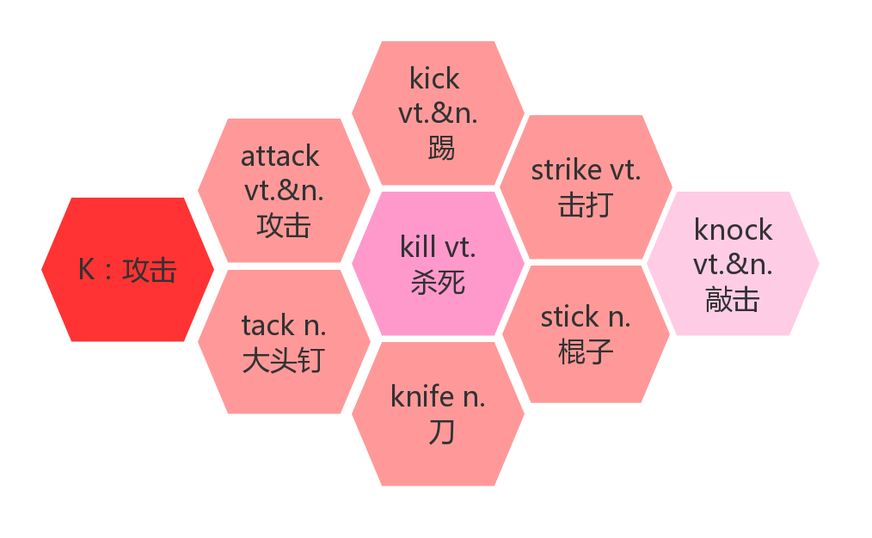
- deliver/dɪˈlɪvə(r)/ vt. & vi. 递送；传达；发表；接生
音意相通：递礼物 助记：为了感谢她为我接生，我在她发表演讲的时候给她递送了礼物。
However, dangerous conditions and damaged roads will make it difficult to deliver food and supplies.
然而，危险的状况和被毁坏的道路将使运送食物和供应品变得困难。
Do you have your milk delivered? 你的牛奶是让别人送吗？
We promise to deliver within 48 hours. 我们承诺在48 小时内送到。
The president will deliver a speech about the economic development. 总统将就经济发展发表讲话。
Lin Qiaozhi often went late at night to deliver a baby for a poor family.
林巧稚经常在深夜去为贫苦家庭的产妇接生。
be delivered of a baby 分娩；生孩子
She was delivered of a healthy boy.她生下一个健康的男孩儿。

- summary /ˈsʌməri/ n. 总结；概括；概要
词根词缀：summ-(总结，概括)+-ary(名词后缀)：概要，总结
A summary is a short statement of main point. 摘要是对要点的简短陈述。
Here's a summary of the day's news. 下面是今日新闻简报。
make a summary做总结；做摘要
Make a summary of the passage in not more than 80 words. Write two different paragraphs using the points and connections given below. 用不超过80个单词的篇幅写一篇本课课文的摘要，用以下要点和连词写出两段不同的文字。
in summary 总的来说
In summary, this was a disappointing performance. 总的来说，这场演出令人失望。
In summary the two universities have some things in common. 总之，那两所大学有一些共同之处。
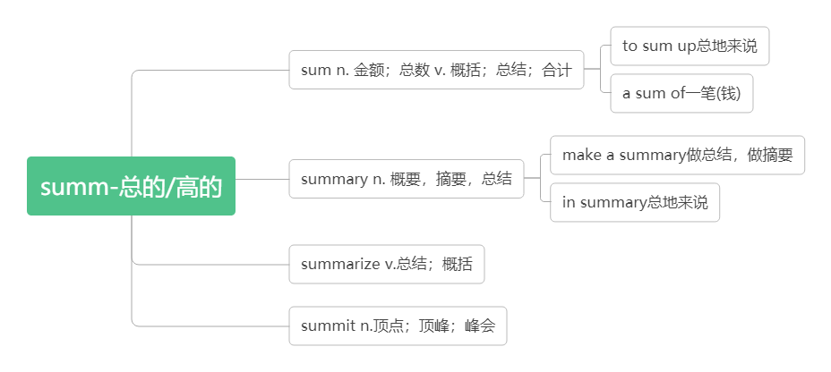
- length/ leŋθ/ n. 长；长度
类比：long a.长的——length n.长度
strong a.强壮的——strength n.力量；长处
dead a.死亡的——death n.死亡
wide a.宽的——width n.宽度
Is the summary the proper length? 摘要的长度合适吗？
This room is twice the length of the kitchen. 这个房间的长度是厨房的两倍。
The river is 300 miles in length .这条河长 300 英里。
The snake reaches a length of 100 cm. 蛇长达100厘米。
She had always kept his family at arm's length. 她一直与他的家人保持一定距离。

