Unit 4 Book 2 导案
- Confucius [kən'fju:ʃjəs]n. 孔子
音意相通：孔夫子
破拆法：confuc-(confuse使困惑)+-ius(形容词后缀)：令人困惑的 助记：孔子的一些理论令人很困惑

- mansion ['mænʃ(ə)n]n. 公馆，宅邸
破拆法：man(人)+-sion(名词后缀)：给人住的宅子——宅邸，公馆

- cemetery ['semɪtrɪ]n. 墓地，公墓
破拆法：ce-(co-共同)+met-(meet见面)+-ery(名词后缀)：最终大家见面的地方——墓地

- philosophy [fɪ'lɒsəfɪ]n. 哲学；哲理；人生观
词根词缀：philo-(爱) + -sophy(智慧)
音意相通：肥了社会 助记：合适的哲学能够促进社会的发展。

- descendant [dɪ'send(ə)nt] n. 后裔；子孙adj. 下降的；祖传的
破拆法：de-(向下)+scend-(send送)+-ant(名词/形容词后缀)：往下送的的人——后裔，子孙。
His design was a descendant of a 1956 device. 他的设计是从一个1956年的装置衍生而来的。
She is a direct descendant of Queen Victoria. 她是维多利亚女王的嫡系后代。

- individual [ɪndɪ'vɪdjʊ(ə)l；ɪndɪ'vɪdʒuəl] adj. 个人的；个别的n. 个人，个体
词根词缀：in-(否定前缀)+divid-(divide分开)+-ual(形容词后缀)：不可再分开的——个体
Their child is at the stage where she can say individual words but not full sentences.(2019天津)
他们的孩子正处于能说单个单词而不能说完整句子的阶段。
In baseball，the performance of individual players is less dependent on teammates.(2019北京)
在棒球运动中，个人球员的表现对队友的依赖性较小。

- heel [hiːl]n. 脚后跟；脚踵
Achilles' [ə'kili:z] heel（希腊神话） 阿基里斯之踵，致命的弱点
—Jack still can't help being anxious about his job interview. ——杰克还是禁不住为他的工作面试感到焦虑。
—Lack of self-confidence is his Achilles' heel, I am afraid. ——缺乏自信恐怕是他的致命弱点。(2016江苏)
词源：阿基里斯是古希腊神话中最伟大的英雄之一。相传，他的母亲是一位女神，在他降生之初，女神为了使他长生不死，将他浸入冥河洗礼。阿基里斯从此刀枪不入，百毒不侵，只有一点除外———他的脚踵当时被女神提在手中，未能浸入冥河，于是“阿基里斯之踵”就成了这位英雄的唯一弱点。在漫长的特洛亚战争中，阿基里斯一直是希腊人最勇敢的将领。在十年战争即将结束时，敌方将领在众神的示意下，抓住了阿基里斯的弱点，一箭射中他的脚踵，阿基里斯最终不治而亡。

- kingdom /'['kɪŋdəm]/ n.王国；领域
词根词缀：king(国王)+-dom(统治)：国王统治的地方——王国

- chief [tʃiːf]n. 首领；酋长；主要部分adj. 首席的；主要的【pl:chiefs】
词源:cap(头，帽子)—>chief：当头的——首领；首要的（c—>ch, a—>ie, p—>f）
音意相通：欺负 助记：当首领的不能欺负下属。
They said they would only let us through if we hired the chief and his brother as guides.
他们说，只有我们雇用部族酋长和他的兄弟作为向导，才允许我们通过此地。
She had to keep bringing forth new ideas in her dance to support her chief position in the troupe.
她得不断地创新她的舞蹈，才能继续保住她在剧团中的首席位置。
His chief joy centred in studying foreign language. 他的主要乐趣集中在学习外语上。

- puzzle ['pʌz(ə)l]vt. 使…困惑vi. 迷惑；冥思苦想n. 谜；难题；迷惑
词根词缀：puzz-(put摆放)+-le(反复)：反复摆在你的面前——谜，难题；使……困惑
be puzzled about/over/by sth.对某事感到困惑
Everyone was a bit puzzled by her sudden departure. 她突然离开，大家都感到有点莫名其妙。
Their reason for doing it is still a puzzle to me. 他们为什么要那样做此事我仍感到莫名其妙。
To explain the puzzling findings, he offers two theories.为了解释这些令人困惑的发现，他提出了两种理论。
I am puzzled that I haven’t heard from Liz for so long.我很奇怪这么长时间没有收到莉斯的信了。
She listened with a puzzled expression on her face.她脸上带着困惑的表情听着。
No one has yet succeeded in explaining the puzzle of how life began.
至今还没有人能成功地解释生命是如何开始的这个谜。

- nearby ['nɪəbaɪ]adj. 附近的，邻近的adv. 在附近prep. 在…附近
There were no camels nearby. Benjamin decided that cat hair would work instead.(2017浙江)
附近没有骆驼。本杰明决定用猫毛代替。
Some classmates suggest we should go to places of interest nearby.(2016全国II)
一些同学建议我们应该去附近的名胜古迹。
My dad and I spent the night in the guestroom of the farm house listening to the frogs and water rolling down the river nearby. (2018浙江)我和爸爸在农舍的客房里过夜，听着附近河里的青蛙和流水声。

- join ... to/with ... 把……和……连接起来
join | 指的是任何事物的直接连接，连接的程度可紧可松，含有“还能分开”之意。常用结构join ...to, join up。若非直接连接，则可与connect换用。
connect | 指的是通过某种媒介物把事物连接起来，事物的特征还保持着，常表示与技术有关的连接以及火车、飞机等实行联运。常用结构connect ...with/to。
combine | 着重指两个或两个以上的人或事物为了共同的目的而结合在一起，结合后原来的部分可能仍不改变，但也可能失去其本性，常用结构combine ...with。
unite | 强调紧密地结合成一个整体体，含难以分开之意，常用结构unite ...with。
Please join this pole to that one.请把这根竿子和那根竿子接起来。
The island is joined/connected to the mainland by a bridge.这座岛由一座桥与大陆相连。
The two parties have combined to form a new government. 两党联合组成了新政府。
Combine Chinese traditional medicine with western medicine. 将中西医结合。
This flight connects with a New York one.这班飞机可接上纽约的另一趟航班。
The fight against terrorism seemed to unite the nation.与恐怖主义的斗争似乎把全国人民团结了起来.

- break away (from sb/sth) 脱离；背叛；逃脱；摆脱
The thief broke away from the policeman.小偷从警察那里逃脱了。
He broke away from all his old friends.他同所有的老朋友断绝了往来。
You must break away from such habits.你必须摆脱那些习惯。
Among the painters who broke away from the traditional style of painting were the Impressionists,who lived and worked in Paris.在那些脱离传统绘画风格的画家中，有生活和工作在巴黎的印象派画家。
The southern part of Ireland was unwilling and broke away to form its own government.
爱尔兰南部不愿意，并脱离联邦，成立了自己的政府。
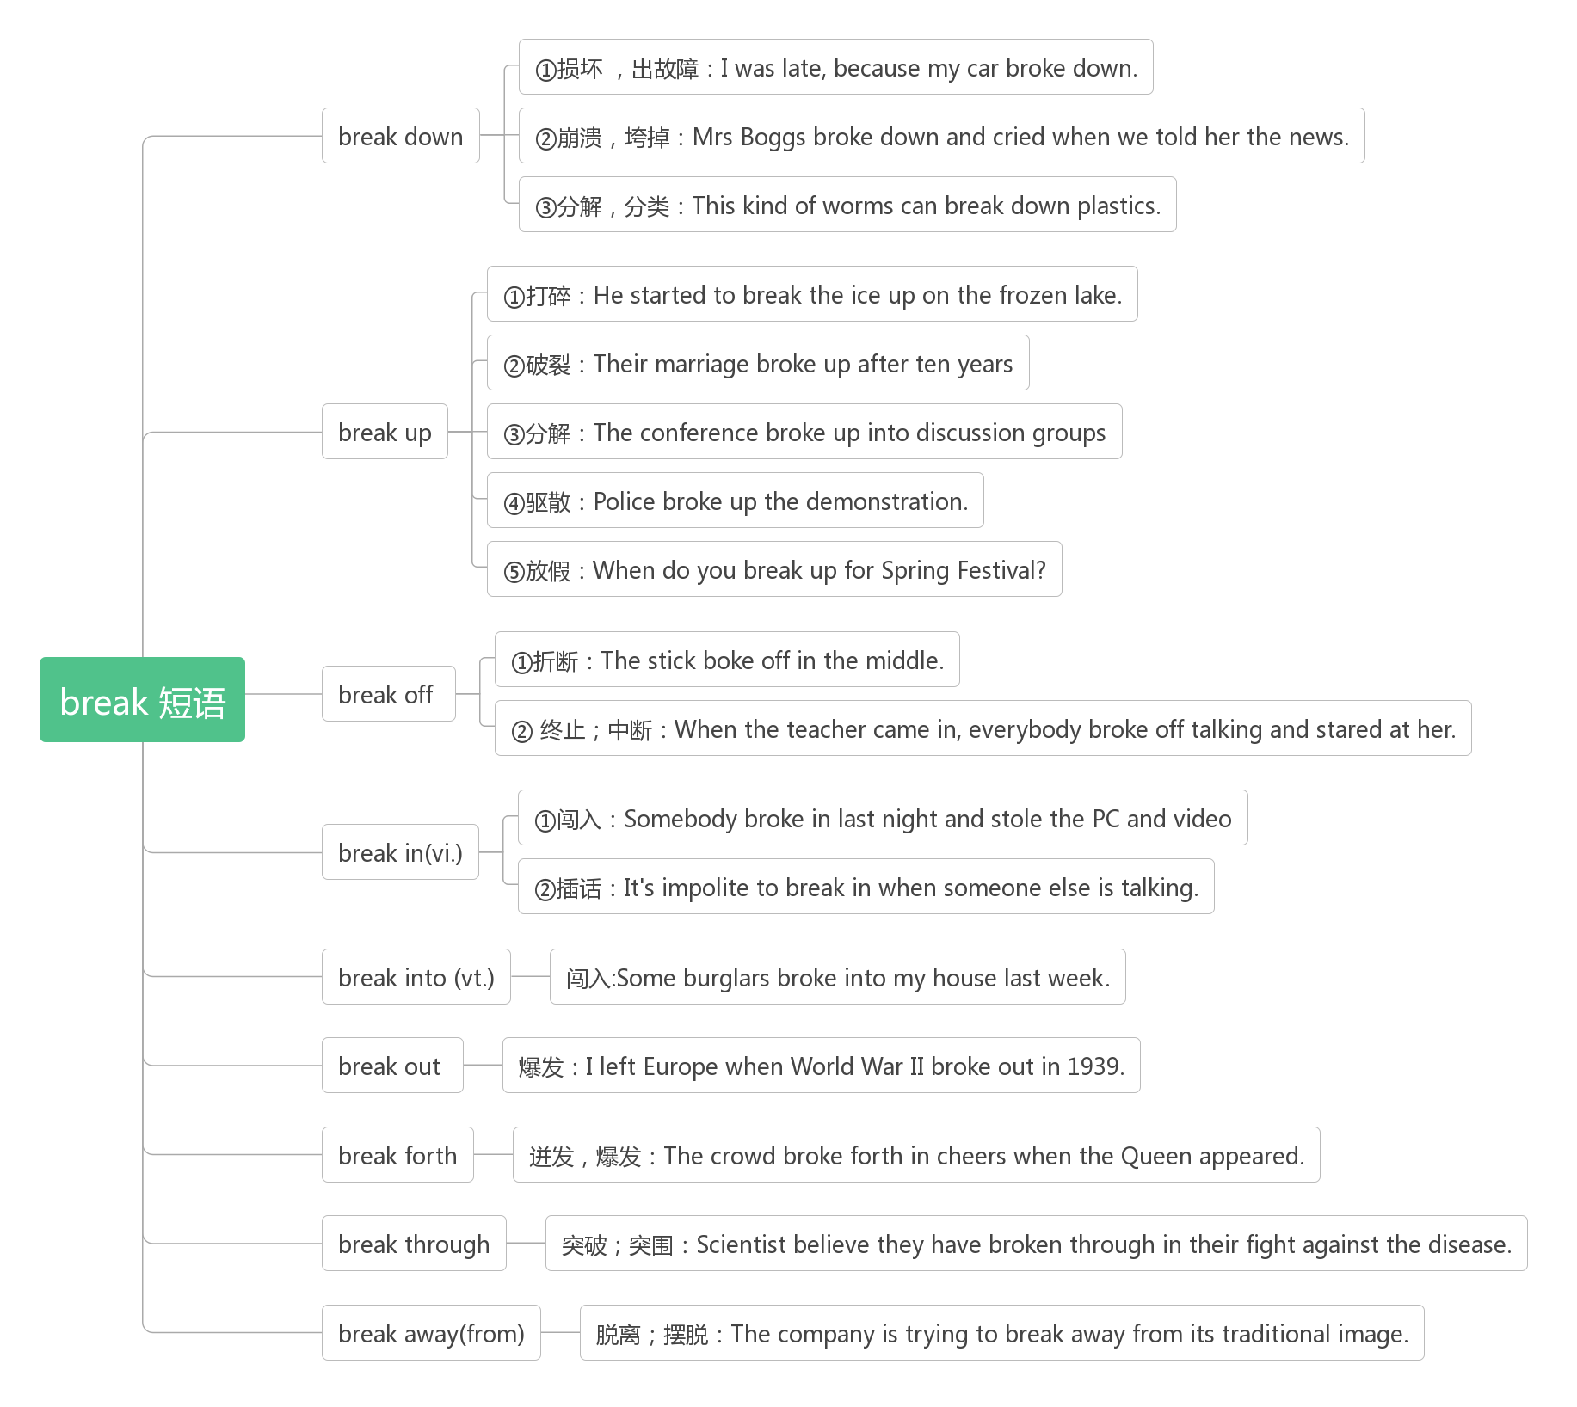
- belong [bɪ'lɒŋ]vi. 属于；应归入
belong to属于
The students feel that they belong to a particular group.(2019浙江)学生们觉得他们属于一个特定的群体。
Success will belong to those who never say "impossible". 成功将属于那些从不说“不可能”的人。
The future belongs to those who believe in the beauty of their dreams.未来属于那些相信梦想之美好的人。
belonging [bɪ'lɒŋɪŋ]n. 所有物；财产；归属
Dunn believes that people who reach out to strangers feel a significantly greater sense of belonging, a bond with others. (2018全国II) 邓恩认为，向陌生人伸出援手的人会感到一种强烈的归属感，一种与他人的联系。
Lockers are available to store any belongings during your visit.(2017全国I)
在您参观期间，可以用储物柜存放任何物品。

- as well 也
The classroom is a place for learning and that includes leaning from textbooks, and mistakes as well.(2018全国III)
教室是一个学习的地方，也包括从课本和错误中学习。
Now when people refer to England, they can find Wales included as well.
现在，当人们提到英格兰时，他们会发现威尔士也被包括在内。
as well as 和，以及；同……一样好（副词）
But Sarah, who has taken part in shows along with top models, wants to improve that she has brains as well as beauty.(2017全国III) 但曾和名模们一起参加过各种节目的莎拉，希望自己智慧与美貌并重。
Amy, as well as her brothers, was given a warm welcome when returning to the village last week.(2019天津)
艾米和她的兄弟们上周回到村子时受到了热烈的欢迎。
She cooks as well as her mother.她做饭做得和她妈妈一样好。
as good as 几乎和……一样；同……一样好（形容词）
I want to prove that I can teach myself a respectful profession, without going to college, and be just as good as, if not better than, my competitors.(2016北京)
我想证明，我可以不上大学，自学一门受人尊敬的专业，就算不比竞争对手强，至少也和他们一样优秀。
I washed those old curtains and now they look as good as new.
我洗过了这些旧窗帘，现在它们看上去几乎和新的一样。
A miss is as good as a mile. 失之毫厘，谬以千里。

- currency ['kʌr(ə)nsɪ]n. 货币；通货
词根词缀：curr-(跑/流通)+-ency(名词后缀)：流通的东西——货币
The ability to design, build and export green technologies for producing clean water, clean air and healthy and abundant food is going to be the currency of power in the new century.(2018浙江)
设计、建造和出口绿色技术以生产清洁的水、清洁的空气和健康丰富的食物的能力将成为新世纪的权力货币。
One of the problems she had was getting used to the foreign currency. 她的问题之一是如何适应外币。
current ['kʌr(ə)nt]adj. 现行的；流通的
These developments are likely to make our current problems with robocalls(自动电话) much worse.(2019北京)
这些发展可能会使我们目前的自动电话问题变得更糟。
Some analysts estimate that food production will need to be raised by 50 percent to maintain current levels.(2018天津)
一些分析人士估计，粮食产量需要提高50%才能维持目前的水平。
If current trends don't bend, Russia's population will be about the size of Yemen's by the year 2050.(2017江苏)
如果目前的趋势不改变，到2050年，俄罗斯的人口将和也门差不多。
currently ['kʌrəntlɪ]adv. 当前, 目前
The model projects that currently blue areas with little phytoplankton(浮游植物) could become even bluer.(2019北京)
该模型预测，目前浮游植物稀少的蓝色区域可能会变得更蓝。
Currently, most ingredients must be changed to a paste(糊状物) before a printer can use them.(2018天津)
目前，大多数成分必须变成糊状，然后打印机才能使用它们。
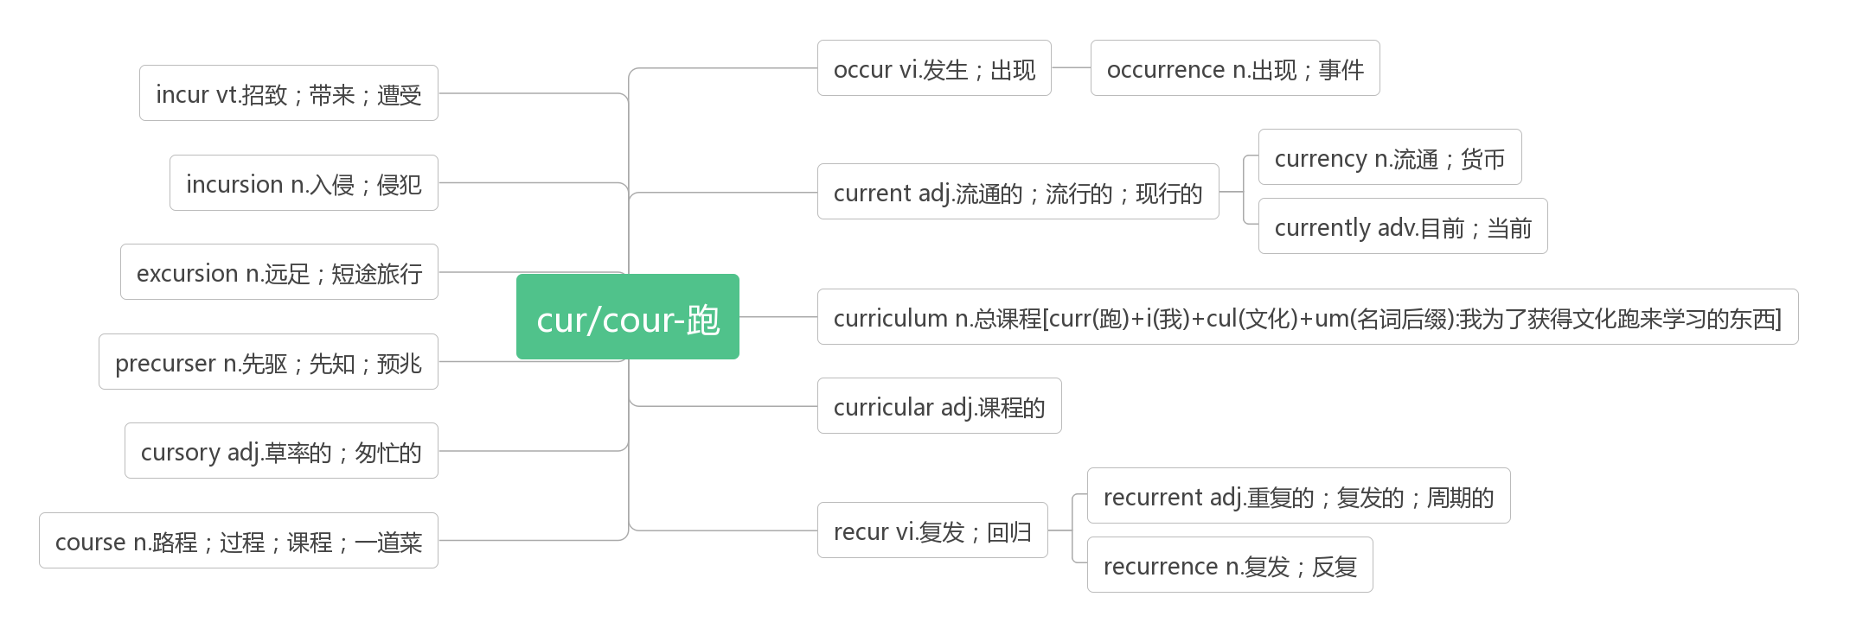
- military ['mɪlɪt(ə)rɪ]adj. 军事的；军用的
词根词缀：mil-(mile英里)+-it-(走)+-ary(形容词后缀)：走到远方去参军——军事的
military training军训
Like many military medals, the one Zac’s mother had found was a family treasure.(2019浙江)
和许多军功章一样，扎克的母亲发现的那枚也是家族的珍宝。
It was on the Chang’an Street that the military parade was held. 阅兵是在长安街举行的。
词源：military来自mile（一千罗马步），强调“行军”的内涵。一罗马步指的是古罗马士兵在行军时左右脚各移动一次的距离，相当于实际上的两步。所以一英里（mile）原本指的就是一千罗马步的距离（大约等于 1.48 公里）。1592 年，英国女王伊丽莎白一世颁布法令，规定一英里等于 1760 码（yard），大约 1.6 公里。

- defence [dɪ'fens]n. 防御；保卫；辩护
in defence of 为了保卫……；为……辩护
This fort was once the main defence of the island. 这座堡垒曾经是这个岛上主要的防御设施。
The forest will act as a defence against desert dust. 森林能起到防御沙漠尘土的作用。
The defence of the accused was rather weak. 被告人的辩护软弱无力。
They responded at once and rose as one man in defence of their motherland.
他们立即响应，团结得像一个人，起来保卫祖国。
defend [dɪ'fend]vt. 保卫；为……辩护vi. 防卫；防御
defend A from/against B 保卫A不受B的伤害
The wall was built to defend the road from being washed away by the sea.
建这个围墙是为了保护这条路不被海水冲垮。
Electricity is used for light, heating, power, and to defend the ship against attacks.
电被用来照明、取暖和作动力，也用来保卫船只免受攻击。
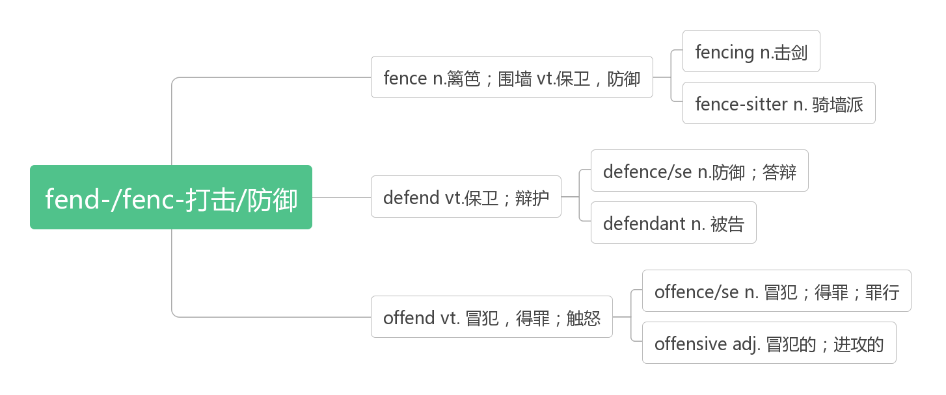
- legal ['liːg(ə)l]adj. 法律的；合法的；法定的
For legal reasons, most restaurants have a policy against giving away food waste. (2019浙江)
出于法律原因，大多数餐馆都有禁止转送厨余食物的政策。
It will put fully driverless cars on an equal legal footing to human drivers.(2017天津)
它将把无人驾驶汽车置于与人类司机同等的法律地位。
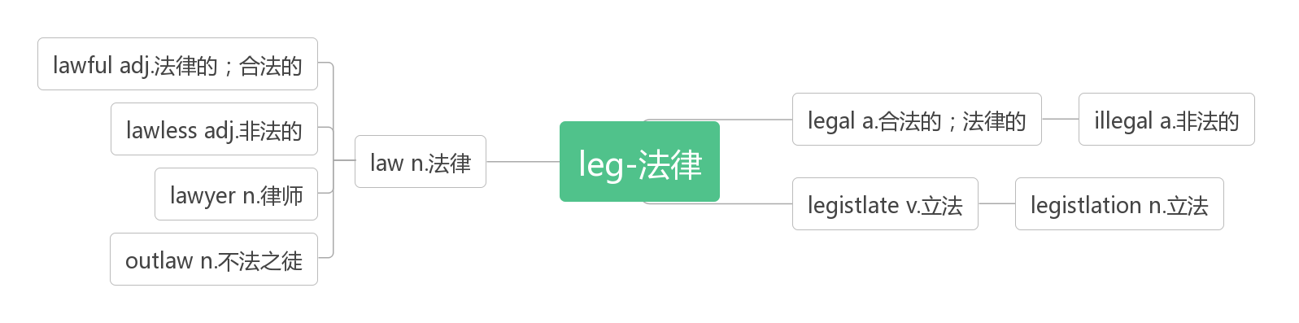
- surround [sə'raʊnd]vt. 围绕；包围
词根词缀:sur-(强调)+round(在周围)：在……周围——包围，围绕
Surround yourself with uplifting individuals who challenge you to be better while loving you for who you are.(2016浙江)
让你周围都是积极向上的人，他们会挑战你变得更好，同时也会爱你本来的样子。
be surrounded by被……所包围，被……所围绕
We are surrounded by a natural playground just perfect for walking, caving, climbing and cycling.(2019江苏)
我们周围有一个天然的操场，非常适合散步、洞穴探险、爬山和骑自行车。
Steve arrived and sat in the front row, surrounded by his family. (2019江苏)
史蒂夫来了，坐在第一排，周围都是他的家人。
Now we live in a world surrounded by the "can’t do" attitudes. (2018天津)
现在我们生活在一个被“做不到”的态度包围的世界。
surrounding [sə'raʊndɪŋ]adj. 周围的，周边的
That means a transparent object doesn't look very different from the surrounding air or water.(2015北京)
这意味着一个透明的物体看起来与周围的空气或水没有太大的不同。
Much of the real significance of railroads and highways is not in their direct physical effect on the scenery, but in the ways that they affect the surrounding community. (2011北京)
铁路和公路的真正意义不在于它们对风景的直接影响，而在于它们对周围社区的影响。
surroundings [sə'raʊndɪŋz]n. 环境；周围的事物【pl】
Why do the hikers take no notice of the surroundings during the journey?(2018天津)
为什么徒步旅行者在旅途中没有注意周围的环境?
Determining where we are in relation to our surroundings remains an essential skill for our survival.(2017江苏)
确定我们与周围环境的关系仍然是我们生存的基本技能。
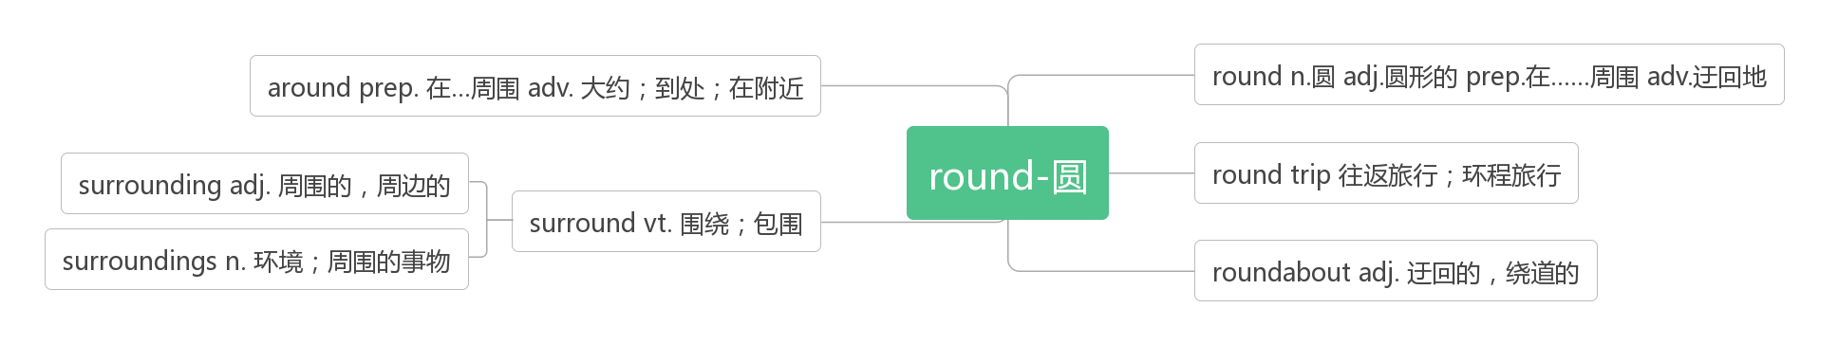
- evident ['evɪd(ə)nt]adj. 明显的；显然的
词根词缀：e-(外)+vid-+-ent(形容词后缀)：从外面就能看出来的——明显的
Mclntyre and his colleagues documented a widespread death of big trees that was evident even in wildlands protected from woodcutting or development.(2019浙江)
Mclntyre和他的同事们记录了一种大范围的大树死亡，这种现象甚至在禁止伐木或开发的野生丛林中也很明显。
This view is especially evident on Kilimanjaro as climbers go through five ecosystems(生态系统)in the space of a few kilometers.(2019全国I)这种景象在乞力马扎罗山上尤为明显，因为登山者在几公里的空间内穿过五个生态系统。
evidence ['evɪd(ə)ns]n. 证据，证明
There is evidence that they range all the way across the Arctic, and as far south as James Bay in Canada.(2019全国I)
有证据表明，它们的活动范围横跨北极，南至加拿大的詹姆斯湾。
That is only evidence that traditions once existed.(2018全国II) 这只是传统曾经存在过的证据。
Now we have the most direct evidence yet that he is right.(2017北京) 现在我们有最直接的证据证明他是对的。
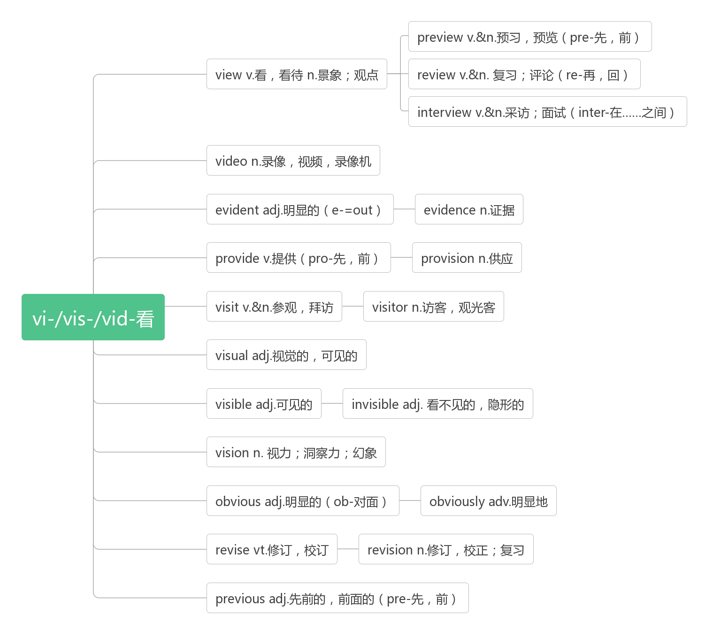
- achieve [ə'tʃiːv]vt. 达到；取得；实现
词根词缀：a-(去，到)+chiev-(chief头)+e：走到头——达到
We should especially recognize our children's efforts to push themselves and work hard to achieve a goal.(2019浙江)
我们尤其应该认可孩子们推动自己，努力工作以达到目标所付出的努力。
We can achieve meaning only if we have made a commitment to something larger than our own little egos(自我).(2019天津) 只有当我们献身于比我们自己更大的目标时，我们才能获得意义。
The only way to achieve the impossible is to believe that it is possible. (Alice in Wonderland)
实现“不可能”的唯一办法就是相信它是可能的。《爱丽丝漫游奇境》
achievement [ə'tʃiːvm(ə)nt]n. 成就；完成
Handle the most important tasks first so you'll feel a real sense of achievement. (2016全国II)
先处理最重要的任务，这样你才会有真正的成就感。
Picking up her “Lifetime Achievement” award, proud Irene declared she had no plans to retire from her 36-year-old business.(2019全国II)自豪的艾琳在领取“终身成就奖”时宣布，她没有退休的打算。
The father of success is work, and the mother of achievement is ambition.
勤奋乃成功之父，志向乃成功之母。
- locate [lə(ʊ)'keɪt]vt. 定位；确定……的位置
Whenever you move to a new area, you should locate the fire alarm pull stations and the two exits nearest your room.
(2018天津) 当你搬到一个新的地方，你应该找到消防警报拉站与最接近你房间的两个出口。
Located where the Belt meets the Road, Jiangsu will contribute more to the Belt and Road construction.(2017江苏)
江苏地处“一带一路”的交汇处，将为“一带一路”建设作出更大贡献。
be located at/in 位于，座落于
His office is located at the Xiangshan campus of the university in Hangzhou, Zhejiang Province.(2018全国III)
他的办公室位于浙江杭州大学象山校区。
The store is located upstairs in Building 3 right next to the Laser Dome.(2017全国I)
商店位于3号楼的楼上，就在激光穹顶的旁边。
location [lə(ʊ)'keɪʃ(ə)n]n. 位置；地点
When the Bishop Arts Theatre was donated to our town, the location was considered a poor area of town.(2018江苏)
当毕晓普艺术剧院被捐给我们镇时，这个地方被认为是镇上的贫困地区。
The scientist located the local location allocated to him.
教育家定位出了当地分配给他的位置。
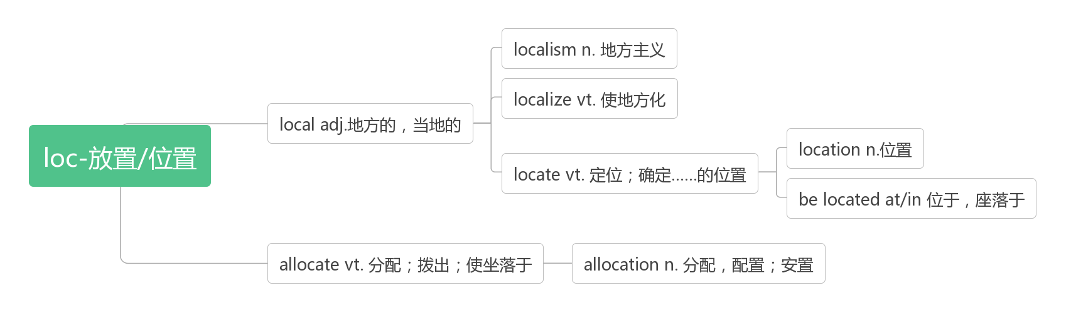
- conquer ['kɒŋkə]vt. 战胜，征服vi. 胜利，得胜
词根词缀：con-(全部)+-quer(寻求)：全部寻求到了——征服; 得胜
Energy and persistence conquer all things.(Benjamin Franklin) 精力加毅力可以征服一切。——本杰明·富兰克林
Dangers will arise in any career, but presence of mind will often conquer the worst of them.
凡事都有危险，但镇定沉着往往能克服最严重的危险。
conqueror [ˈkɒŋkərə(r)]n.征服者，胜利者
In 1066 William the Conqueror, the Duke of Normandy (part of modern France), invaded and conquered England.
1066年，诺曼底(现法国的一部分)公爵威廉率兵征服了英国。
conquest ['kɒŋkwest]n. 征服，战胜；战利品
The chase is always much more exciting than the conquest anyway. 不管怎么说，追求的过程总比得手更为刺激。
The French empire had expanded largely through military conquest. 法兰西帝国的扩张主要靠军事征服。
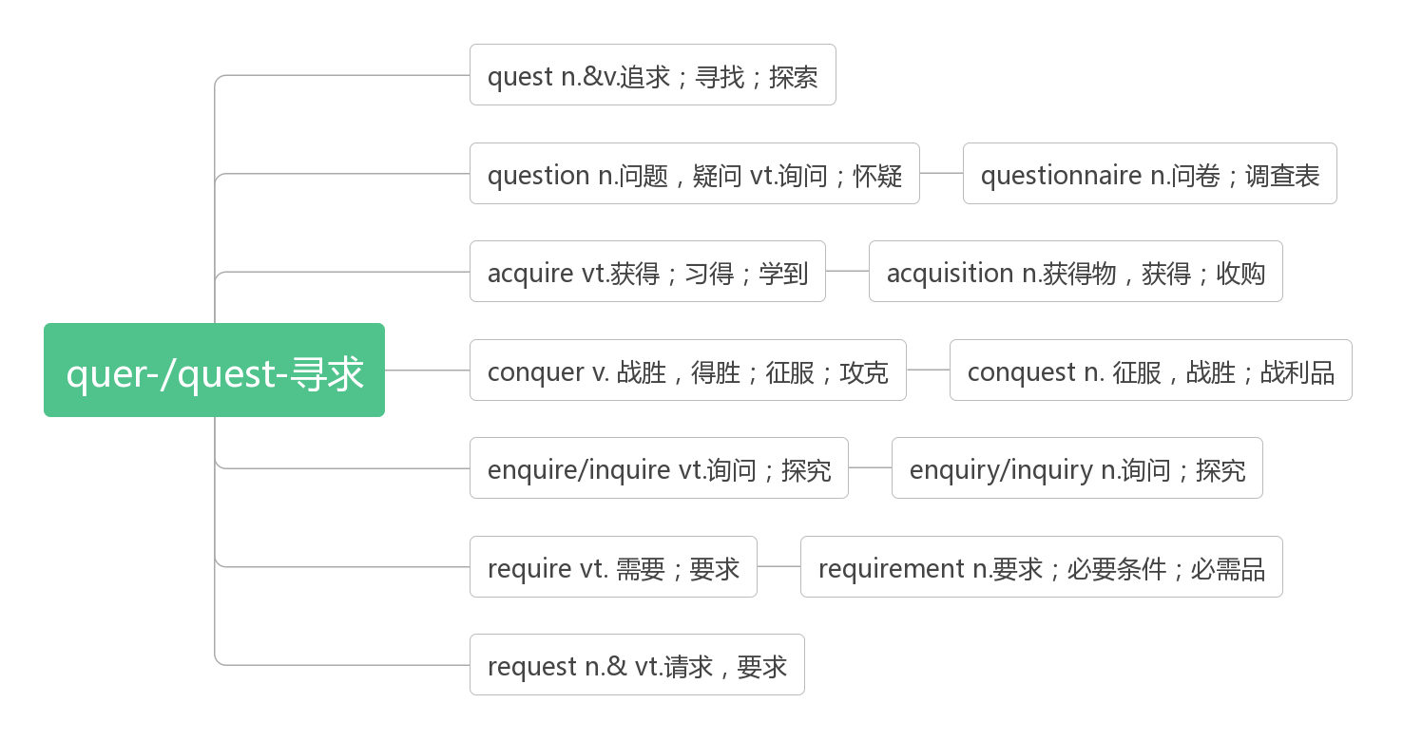
- battle ['bæt(ə)l]n.vi. & vt.战斗；搏斗；奋斗
词根词缀：bat-(打)+-tle(名词后缀，表反复)：反复打——战斗；搏斗
There's tension and anxiety from the beginning as Nick and Amy battle for your trust.(2019全国II)
从一开始尼克和艾米就在为你的信任而战，紧张和焦虑贯穿始终。
After a serious flu outbreak wipes out 99.4% of the world's population, a battle unfolds between good and evil.(2019全国II) 在一场严重的流感疫情席卷全球99.4%的人口之后，一场正义与邪恶之间的战争拉开了帷幕
When I started running in my 30s, I realized running was a battle against myself.(2018北京)
当我30多岁开始跑步时，我意识到跑步是一场与自己的战斗。
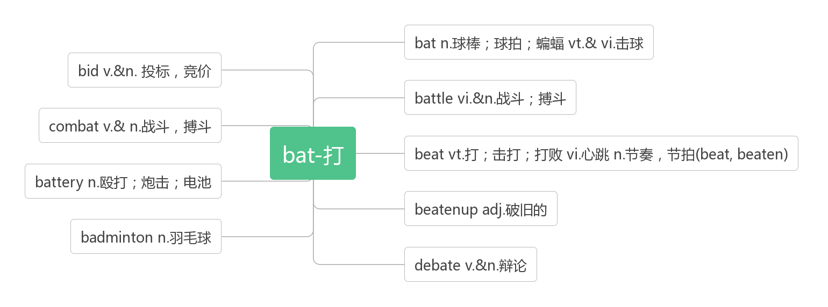
- port [pɔːt]n. 港口，口岸
Cities usually have a good reason for being where they are, like a nearby port or river. (2018全国III)
城市的存在的位置通常有很好的理由，比如附近有港口或河流。
When I reached the port, the workers were loading the rice onto the ship.
当我到达港口时，工人们正在把大米装船。
import [ɪm'pɔ:t; 'ɪm-]n. &vt. vi. 输入，进口
One solution is obviously to import foreign workers via immigration. (2017江苏)
一个解决办法显然是通过移民来引进外国工人。
The import of meat from aboard is held up for the epidemic situation.
由于疫情，从国外进口的肉类中断了。
export [ɪk'spɔːt; 'ek-]n. &vt.vi.输出，出口；出口商品
The ability to design, build and export green technologies for producing clean water, clean air and healthy and abundant food is going to be the currency of power in the new century.(2018浙江)
设计、建造和出口绿色技术以生产清洁的水、清洁的空气和健康丰富的食物的能力将成为新世纪的权力货币。
America will increase its food export.(2012江苏) 美国将增加食品出口。
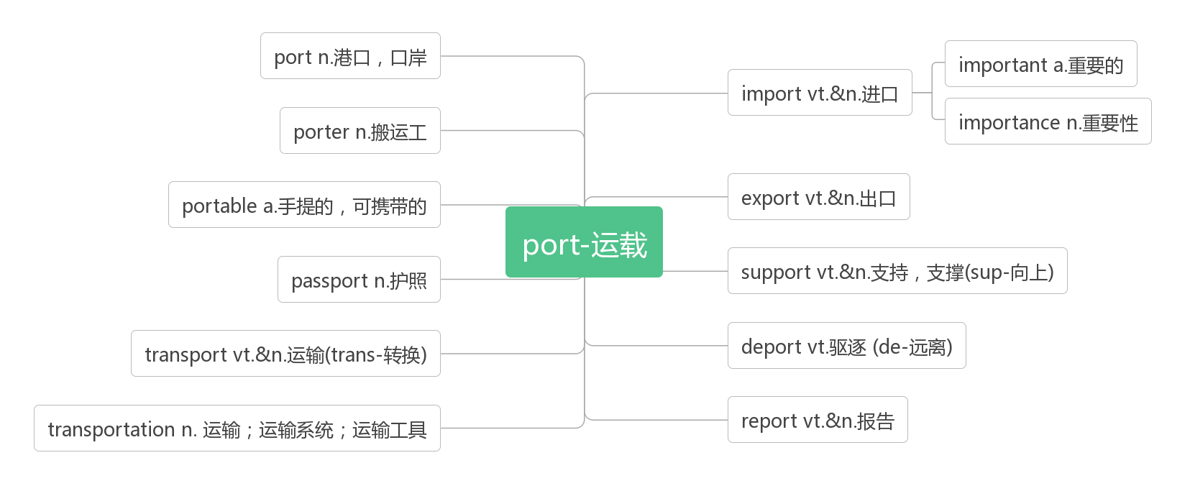
- fascinate ['fæsɪneɪt]vt. 迷住，使着迷，使神魂颠倒
词根词缀：fasc-(抓住)+-in(内)+-ate(动词后缀)：从内心抓住你——迷住，使着迷
The place continues to fascinate visitors, cloaked in its mystery.
这个地方笼罩在神秘气氛下,继续使游览者着迷.
The children are fascinated by the toys in the shop window.
孩子们让商店橱窗里的玩具给吸引住了
fascinating ['fæsɪneɪtɪŋ]adj. 迷人的；吸引人的；令人神魂颠倒的
I still find this story both fascinating and unbelievable. 我仍觉得这个故事既神奇又不太可信。
What it will be called in future, and what it will do, remain fascinating questions.
未来我们会把它叫做什么，会用它来干什么，依然是让人着迷的问题。
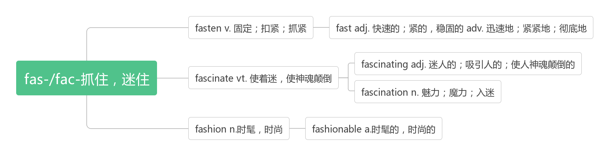
- keep your eyes open（for）留心；留意
You must keep your eyes open if you are going to make your trip to the UK enjoyable and worthwhile.
如果你要使你的英国之旅愉快而有意义，你必须时刻留意。
Keep your eyes open and be willing to change, but have faith in yourself, too.
时刻留心，愿意改变，但同时也要对自己有信心。
If that sounds like good news, keep your eyes open for your chance for change.
如果那听起来像好消息，那么要留心这个为你带来改变的机会。
keep an eye on照看；留意；密切关注
In general, keep an eye on their property while they are gone.(2018浙江)
一般来说，当他们离开的时候，要照看好他们的财产。
Could you please keep an eye on my luggage? 你能帮我照看下行李吗？
You must keep an eye on your young children when you are in a crowded street.
当你在拥挤的街道上时，你必须照看好你的小孩。

- charge [tʃɑːdʒ]n.收费；指控；主管vt.收费；控告；充电
巧句助记：
He was charged with being mean to the employees after he took charge of the company, which had been in the charge of his father, for he began to charge the staff for charging their electric bicycles.
他被指控在他掌管了他父亲管理的公司后对员工很刻薄，因为他开始向员工收取给电动车充电的费用。
We choose this hotel because the price for a night here is down to $20, half of what it used to charge.(2017江苏)
我们选择这家酒店是因为这里一晚的价格降到了20美元，是以前的一半。
The museum has no admission charge but visitors can make donations.博物馆不收门票，但游客可以捐款。
She rejected the charge that the story was untrue.她否认了说她编造事实的指控。
Before use, the battery must be charged. 使用前，电池必须充电。
charge sb. money for sth. 为某事向某人收取费用
How much did he charge for the repairs?他们收了多少修理费？
free of charge 免费
All goods are delivered free of charge. 一切物品免费送货。
Pushchairs are available free of charge near each checkroom.(2008江苏) 在每个寄存处附近都有免费的婴儿车。
be charged with 被指控犯……罪
He was charged with murder. 他被指控犯有谋杀罪。
in charge of 主管，负责
He was in charge of a flying task.(2013全国II) 他负责一项飞行任务。
in/under the charge of 由某人负责/主管
He told me that the factory was in the charge of his brother.他告诉我工厂由他兄弟管理。
take charge of接管，掌管
He took charge of the farm after his father’s death. 父亲去世后，他接管了农场。

- announce [ə'naʊns]vi. 宣布，宣告；声称
词根词缀：an-(强调)+nounc-(宣告)+e：宣布，宣告
Our retirement community announced that they were having an essay competition.(2011北京)
我们的老年社区宣布他们正在举办一场征文比赛。
He said the lucky woman will be announced on the website and the trip will be shared online.(2017全国III)
他说这个幸运的女士将会在网上公布，并且这次旅行将会全程直播。
announcement [ə'naʊnsm(ə)nt]n. 公告；通告；声明
announcer [ə'naʊnsə]n.播音员；告知者
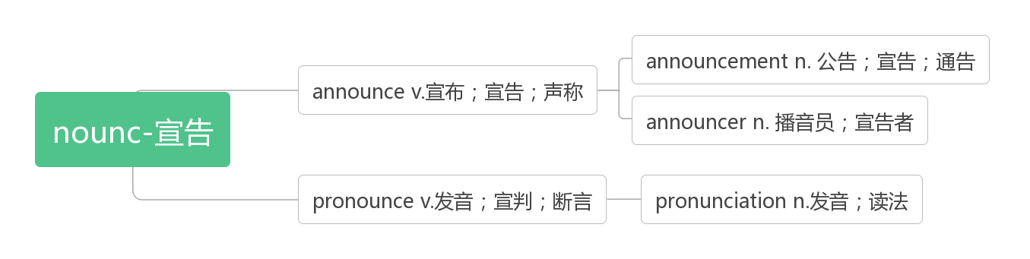
- amount [ə'maʊnt]vi. 总计，合计；相当于n. 数量；总额，总数
Today $8 or $10 seems a small amount of money, but at that time these amounts were forbidding to most citizens.(2019全国III)今天8美元或10美元似乎是一个小数目的钱，但在当时这些数额是大多数市民可望而不可及的。
But whatever it is, praise should be given on a case-by-case basis and be proportionate(成比例的)to the amount of effort your child has put into it.(2019浙江)但不管是什么，表扬都应该根据具体情况，并与孩子付出的努力成比例。
amount to 总计达到，等于
Planning without any real action amounts to nothing.只计划不行动等于什么都不做。
The total cost of repairs amounted to $100. 修理费用总计达100美元。
a large amount of/ large amounts of许多的，大量的(该短语只修饰不可数名词，且谓语的数由amount的数决定)
He met a large amount of difficulty but was never stopped. 他遇到了许多困难，但从未停止过。
Today, scholars have generated large amounts of instructive research about restaurants.(2018江苏)
今天，学者们已经开展了了大量关于餐馆的有益研究。
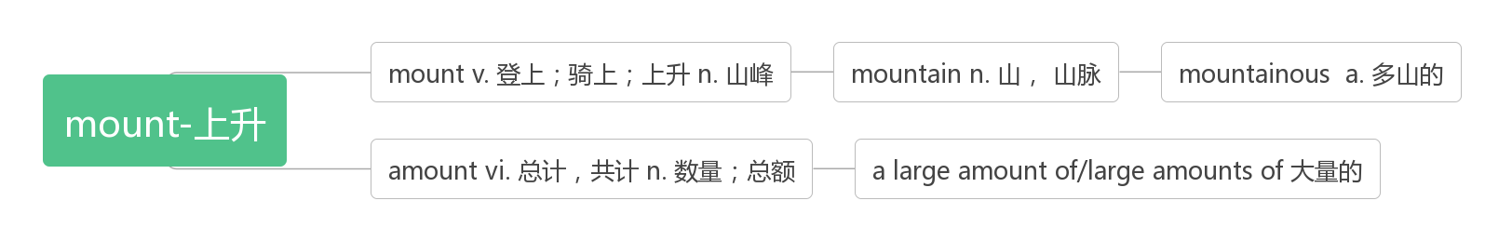
- gallery ['gæl(ə)rɪ]n.（艺术作品的)展览馆；画廊
破拆法：al-(all)+glery(glory)：都荣耀 助记：作品都能被画廊收藏是一种荣耀。
All special exhibitions, as well as films, lectures, guided tours, concerts, gallery talks, and family/children's programs are free with admission.(2018江苏)
所有特别展览、电影、讲座、导赏、音乐会、画廊讲座及家庭/儿童节目均可免费入场。
The older collections of the gallery are reached through the main entrance (2013全国I)美术馆的老藏品从正门参观。
- approach [ə'prəʊtʃ]n. 方法；途径；接近vt. 接近；处理vi. 靠近
词根词缀：ap-(去)+pro-(向前)+-ach(动词后缀)：去向前——接近，靠近
As a new approach starts to become apparent, two ideas stand out.(2017江苏)
随着一种新方法开始显现，两个想法脱颖而出。
His approach to the problem are wrong. All the approach to the palace were guarded by troops.
他处理这个问题的方法是错误的。通往宫殿的所有通道都有军队把守。
As you approach people, be polite.(2017浙江) 当你接近别人时，要有礼貌。
Many people don't dare to approach Nature any more; to them the world they were born to enjoy is all threat.(2014天津)许多人不敢再接近大自然；对他们来说，他们本来要享受的世界充满了威胁。
Over the years, there have been a number of different techniques to help designers approach this important point.(2018全国I)多年来，已经有许多不同的技术来帮助设计师处理这一重要问题。
It starts with looking inside yourself and understanding who you are with respect to the natural world and how you approach the gardening process.(2016全国II)
它开始于审视你自己，了解你是谁，尊重自然世界，以及你如何对待园艺的过程。
Most positive emotions are associated with approach behaviour: we move closer to people we like.(2014江苏)
大多数积极情绪都与亲近行为有关:我们更接近我们喜欢的人。
the approach to sth./doing sth.做某事的方法
China's approach to protecting its environment while feeding its citizens “offers useful lessons for agriculture and food policymakers worldwide.”(2018全国II)
中国在养活国民的同时保护环境的做法“为全世界的农业和粮食政策制定者提供了有益的教训”。
Facing up to your problem rather than running away from them is the best approach to working things out.(2014浙江)
解决问题的最佳方法是直面问题，而不是逃避问题。
Business is the organized approach to providing customers with the goods and services they want.(2013全国I)
商业是为顾客提供他们想要的商品和服务的有组织的方法。

- ensure [ɪn'ʃʊə]vt. 保证；确保；担保
词根词缀：en-(使)+sure(确定)：使确定——确保，保证
Wilson often goes beyond to ensure the welfare and safety of the students.(2019北京)
为了确保学生们的福利和安全，威尔逊经常做得更多。
Do the following to ensure the safe operation of your smoke detector.(2018天津)
采取以下措施以确保您的烟雾探测器的安全运行
We hope that our work will help with technological solutions to ensure that older drivers stay safer behind the wheel.(2017全国III)我们希望我们的工作将有助于技术解决方案，以确保老司机在驾驶时更安全。

- generous ['dʒen(ə)rəs] adj. 慷慨的，大方的；丰富的
词根词缀：gener-(产出)+-ous(形容词后缀)：不断产出的—— 慷慨的，大方的
Most streets are of vehicles, and there are generous green spaces and good public-transport lines, including fast buses and bicycle paths.(2010浙江)
大多数街道上都有车辆，而且有宽阔的绿地和良好的公共交通线路，包括快速巴士和自行车道
It's an amazing accomplishment and one we cannot achieve without generous support from individuals, corporations, and other social organizations. (2017全国I)
这是一项了不起的成就，没有个人、企业和其他社会组织的慷慨支持，我们是无法取得这一成就的。
be generous with sth. 慷慨于某物
He was generous with his time, for which I was grateful.他在时间上很慷慨，对此我很感激。
generosity [dʒenə'rɒsətɪ]n. 慷慨，大方；宽宏大量
While the clip(视频片段) might look like part of a new ad campaign, Bridges said the only goal was to show generosity and sympathy.(2019浙江)
虽然这段视频看起来像是一个新的广告宣传活动的一部分，但布里奇斯说，它唯一的目的是表达慷慨和同情。
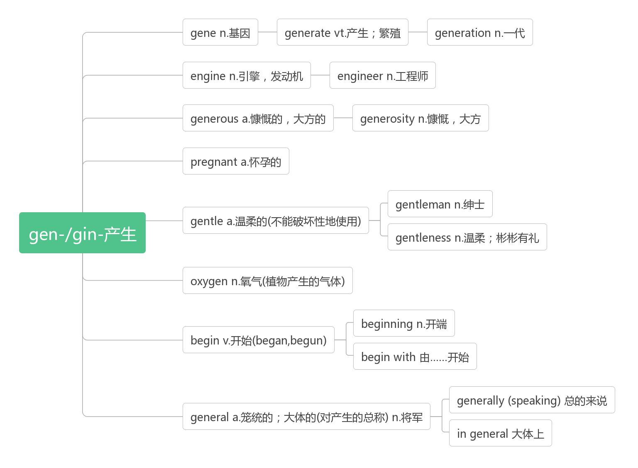
- butter['bʌtə]vt. 涂黄油于；讨好n. 黄油；奉承话

- honey ['hʌnɪ]n. 蜂蜜；宝贝；甜蜜

- ancestor ['ænsestə]n. 先祖，祖先
词根词缀：ance-(前)+st-(站)+-or(名词后缀)：站在前面的的人——祖先
The Johnsons are descendants of John; the Roberts family’s ancestor was Robert.(2010江苏)
约翰逊是约翰的后代;罗伯茨家族的祖先是罗伯特。
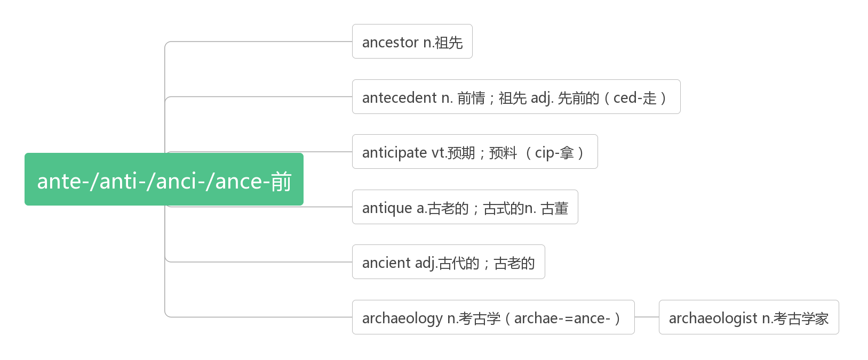
- position [pə'zɪʃ(ə)n]n. 位置，方位；职位vt. 安置；放置好
词根词缀：pos-(放置)+-ition(名词后缀)：放置的位置
I’m calling to ask about the position advertised in Friday’s DailyMail.(2019江苏)
我打电话来是想问一下星期五的《每日邮报》上广告招聘的职位。
I paused to catch my breath and then positioned myself to take the best photo of this panorama.(2017天津)
我停下来喘了口气，然后找好位置，拍下了这张全景照片中最好的一张。
The position of the classroom with its view made me felt like I was dreaming. (2015浙江)
教室的位置和视野让我感觉像是在做梦。
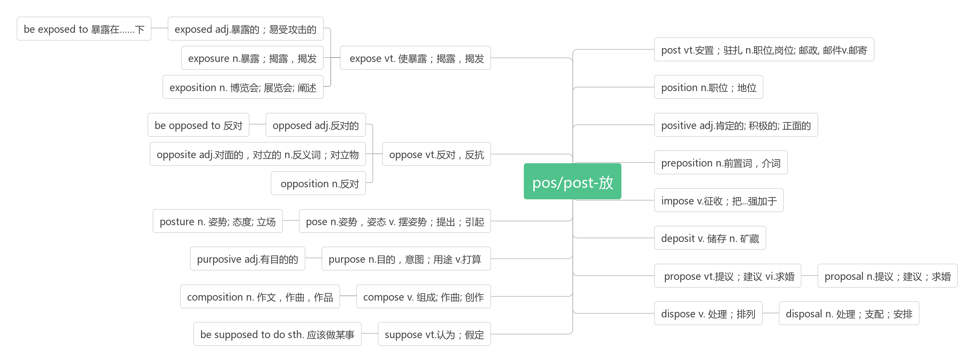
- courtyard ['kɔːtjɑːd]n. 庭院，院子
合成法：court(法庭，宫廷)+yard(院子)：庭院

- snack [snæk]n. 小吃，快餐
词源演变：snap(拟声词：打响指)——>snack(快速吃完：快餐)

- eager ['iːgə]adj. 渴望的；热切的；热心的
音意相通：一哥 助记：他渴望成为一哥。
be eager to do sth. 渴望做某事
be eager for sth. 渴望得到某物
Some of us were confident and eager to take part in the class activity, while others were nervous and anxious. (2018全国III)
我们中的一些人很自信并渴望参加课堂活动，而另一些人则有些紧张和焦虑。
Believe it or not, he or she is on your side and is eager to see you do well.(2015浙江)
信不信由你，他/她是站在你这一边得，并渴望看到你良好的表现。
It was of the man, no longer young, unbowed by defeat, unafraid of responsibility, and eager for greatness.
他已经不再年轻，不因为失败而屈服，不畏惧责任并且渴望成为伟大的人。
Some of them are eager for romance, while others enjoy being single.
在他们中，一些人渴望获得爱情，而另一些人则愿意享受单身的乐趣。

- poet ['pəʊɪt]n. 诗人
词根词缀：poe-(诗)+-t(人)：诗人
poem ['pəʊɪm]n. 诗
poetry ['pəʊɪtrɪ]n.诗歌（总称）；诗歌艺术

- county ['kaʊntɪ]n. 郡，县
词源演变：court(宫廷)——>count(伯爵)——>county(伯爵的领地：郡县)

- feast [fiːst]n. 盛宴，宴会；节日vt. 享受；款待，宴请vi. 享受；参加宴会
词源演变：feat(功绩)——>feast(庆祝功绩：宴会，盛宴）
People light lamps, play music on an important feast day, and offer good things to the dead.
人们在重要的节日点灯，演奏音乐，并向死者进贡。
I sincerely hope you can set aside some time for the art feast.(2017全国Ⅱ)
我真诚地希望你能抽出一些时间来参加艺术节。
A cheerful look makes a dish a feast.笑脸待客饭菜香。
feast sb. on sth.用……款待某人
The king feasted his friends on chicken and coconuts.国王以鸡肉和椰子款待他的朋友。
feast one’s eyes on尽情欣赏，饱览
He feasted his eyes on the beautiful scene.他尽情欣赏这美丽的景色。

- roll [rəʊl]vt. 卷；使滚动；辗vi. 滚动；转动；摇晃
As soon as I sat down, my weight made the wheelchair begin to roll.(2013全国I)
我一坐下，我的体重就使轮椅开始滚动。
When your neighbor forgets to take in his rubbish cans, roll them back into his yard.(2014浙江)
当你的邻居忘记收他的垃圾桶时，把它们推回他的院子里。
rock and roll摇滚乐
Their victory in America was still remembered as a major turning point in the history of rock and roll.(2019浙江)
他们在美国的胜利仍然被认为是摇滚乐历史上的一个重大转折点。
spring roll 春卷

- dot [dɒt]n. 点，圆点vt. 点缀；分布
The road to success is dotted with many tempting parking spaces.通往成功的道路上布满着诱惑人的停车场。
There is a small dot, brighter than its surroundings. 那里有个小点，要比周围亮一些。

- cattle ['kæt(ə)l]n. 牛群；家畜(集合名词，复数概念)
联想记忆：三个复数概念的集合名词：The police help people catch cattle.警察帮人民抓牛。
The cattle are in the shed. 牛在牛棚里。

- roar [rɔː]vi. &n. 咆哮；怒吼；轰鸣
音意相通：拟声词，模拟狮子的吼声。类似拟声词：owl[aʊl]n. 猫头鹰 wolf [wʊlf]n. 狼
The clapping turned into cheering, then into a deafening roar.(2012天津)
掌声变成了欢呼声，然后变成了震耳欲聋的吼声。
His amusing performance caused a roar of laughter in the audience.
他有趣的表演引起了观众的哄堂大笑。

- ocean ['əʊʃ(ə)n]n. 海洋
Oceania [ˌəʊʃiˈɑːniə]n. 大洋洲
词源：在希腊神话中，大洋神俄刻阿诺斯(Oceanus)是天神乌拉诺斯(Uranus)和地母该亚(Gaea)的儿子，12泰坦神之一。他娶了妹妹泰西斯（Téthys）为妻，后者为他生了三千个海洋女仙（Océanides）。在表现俄刻阿诺斯的形象时，人们往往将其刻画成一个从容不迫地立于惊涛骇浪中、被众多海怪所簇拥的白胡子老头。

- scent [sent]n. 气味；气息
同源词：sense(感觉)——>scent(感到的气息：气味)
Particular scents also have an effect: diners who got the scent of lavender(薰衣草) stayed longer and spent more than those who smelled lemon, or no scent.(2018江苏) 特定的香味也有影响:闻到薰衣草香味的食客比闻到柠檬味或没有香味的食客停留的时间更长，花费的时间也更多。
One sports goods company once reported that when it first introduced scent into its stores, customers' intention to purchase increased by 80 percent.(2014北京)
一家体育用品公司曾经报告说，当它第一次将香水引入商店时，顾客的购买意愿增加了80%。

- greet [griːt]vt. 欢迎，迎接；致敬，致意
联想：great——>greet 助记：You are great to greet us with such warm greetings.
greet the New Year 迎接新年
A sweet smell greets the nose.香气扑鼻
Li Jiang and Su Hua don't agree on what to wear when greeting the British students.(2019江苏)
李江和苏华在迎接英国学生时的着装上意见不一。
The moment I arrived in Paris, I was greeted by a nice French couple who would become my host parents.(2013浙江)
我一到巴黎就受到一对法国夫妇的欢迎，他们后来成了我的寄宿家长。
greeting [ˈɡriːtɪŋ] n. 问候，招呼
Most people around the world now greet each other by shaking hands, but some cultures use other greetings as well.
现在世界上大多数人都通过握手来问候对方，但有些文化也使用其他的问候方式。
Her greeting was less than enthusiastic. 她的问候一点都不热情。

- pub[pʌb]n. 酒馆；酒吧
词源：public house的缩写

- wine [waɪn]n. 葡萄酒；果酒
词源：W：起伏——>wind(蜿蜒)——>vine(藤蔓，葡萄藤)——>wine(葡萄酒)

- beer [bɪə]n. 啤酒vi. 喝啤酒
音意相通：音译词：beer(啤)酒

- stew [stjuː]n.炖菜(有肉和蔬菜) vt.炖；煨
联想：Steward：斯图亚特；管家 助记：名叫斯图亚特的管家爱吃炖菜。

- custom ['kʌstəm]n. 风俗；习惯；惯例
音意相通：卡死他们 助记：到国外生活很困难，光是适应当地的风俗习惯就可能卡死他们了。
On the first day of the new year, dressed up in new clothes, people visit their friends and relatives, which has become a custom.在新年的第一天，穿着新衣服，人们拜访他们的朋友和亲戚，这已成为一种习俗。
It was her custom to rise early.早起是她的习惯。
accustomed [əˈkʌstəmd] adj. 习惯的,惯常的
Instead of devoting themselves to their work, they find themselves working to support the lifestyle to which they have so quickly become accustomed.(2015浙江)
他们没有投入于工作中，反而发现自己工作是为了支持他们很快就习惯了的生活方式。
They are accustomed to not talking at meals.(2008江苏) 他们习惯于吃饭时不说话。
customer [ˈkʌstəmə(r)] n. 顾客，主顾
customs [ˈkʌstəm] n. 海关，关税
The customers are accustomed to the custom to offer small gifts at the local customs.
顾客们习惯了在当地海关提供小礼物的风俗。

- strike [straɪk]vt.vi.&n. 打，敲，打击；罢工；报时(struck, struck)
on strike 在罢工
strike a match 擦燃火柴
It is by no means clear what the president can do to end the strike.(2012全国II)
目前还不清楚总统能做些什么来结束罢工。
Just before September, Miller was struck by a car and lost his right arm.(2019全国III)
就在九月前，米勒被车撞了，失去了右臂
The children of Nome would be helpless if it struck the town.(2016北京)
如果传染病袭击城镇，诺姆的孩子们将束手无策。
Deals will be struck to reduce the immediate effects.(2011北京)各方将达成协议，以减少直接影响。
Strike the iron while it is hot.趁热打铁。
I was struck by the beauty of nature. 我被大自然的美丽所震撼。
The area was struck by a terrible earthquake.这个地区发生了可怕的地震。
The clock has just struck three.时钟刚敲过三点。
An idea has just struck me.我突然想到一个主意。
striking ['straɪkɪŋ]adj. 显著的，突出的，惊人的
That which is striking and beautiful is not always good. But that which is good is always beautiful.
引人注目和美丽的东西并非总是好的，但好的东西却总是美的。
For Japan, the numbers are more striking.(2020浙江一月) 对日本来说，这个数字更加惊人。
These effects of the Internet have become even more striking since I've begun using a smartphone.(2016江苏)
自从我开始使用智能手机以来，互联网的这些影响变得更加显著。

- transition [træn'zɪʃən] n. 过渡；转变
词根词缀：trans-(转变)+it-(走)+-ion(名词后缀)：转走的过程——转变，过渡
Adolescence is the transition period between childhood and manhood.
青春期是儿童和成人阶段的过渡时期。
No transition is ever smooth or easy.不曾有过平顺或轻松的过渡。
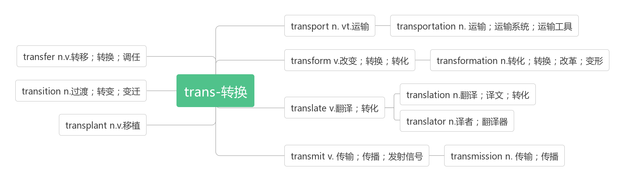
60. crowd [kraʊd] n.人群vt.挤满；使拥挤vi.拥挤；聚集
词源：group（群组）——>crowd（人群）(g-c, u-w, p-d)
crowd in涌入；涌上心头
It ran for just under seven kilometers and allowed people to avoid terrible crowds on the roads above as they travelled to and from work. (2017全国II)它的运行距离不到7公里，人们在上下班路上可以避开上面道路上可怕的人群。
Don't follow the crowd, let the crowd follow you.不要随波逐流，要引领潮流。
People crowded on the road and could not go forward because of the traffic accident some cars had made.
由于一些汽车造成的交通事故，人们拥挤在路上，不能前进。
The moment I saw the picture, it all came crowding in. 我一看到那张照片，所有回忆就都涌上心头。
crowded [ˈkraʊdɪd] a. 拥挤的
be crowded with 挤满了……
a crowded street 拥挤的街道
Does Kilimanjaro deserve its reputation as a crowded mountain with lines of tourists ruining the atmosphere of peace？(2019全国I)乞力马扎罗山是不是应该被称为一座拥挤的山峰，挤满了破坏宁静氛围的游客？
Aggressive wildfire control has left California forests crowded with small trees that compete with big trees for resources(2019浙江)积极的野火控制使得加利福尼亚的森林里到处都是小树，它们与大树争夺资源。
The city was crowded with disappointed people with no interest in settling down.(2018全国III)
城市里挤满了失望的人，他们对安定下来没有兴趣。

