阅读A篇
One Writer's Beginnings （P29-30）
作者：Eudora Welty
https://books.google.co.jp/books?id=lEM9l_Kka3wC&pg=PA29&lpg=PA29&dq=I+never+knew+anyone+who%27d+grown+up+in+Jackson+without+being+afraid+of+Mrs.+Calloway,+our+librarian.&source=bl&ots=pd7Dmyr2uY&sig=ACfU3U0xIav0cargn7LEY5CW7fdvr0ZmfA&hl=zh-CN&sa=X&ved=2ahUKEwjp5tKq4vPmAhWaxosBHeh5ABYQ6AEwAHoECAcQAQ#v=onepage&q&f=false
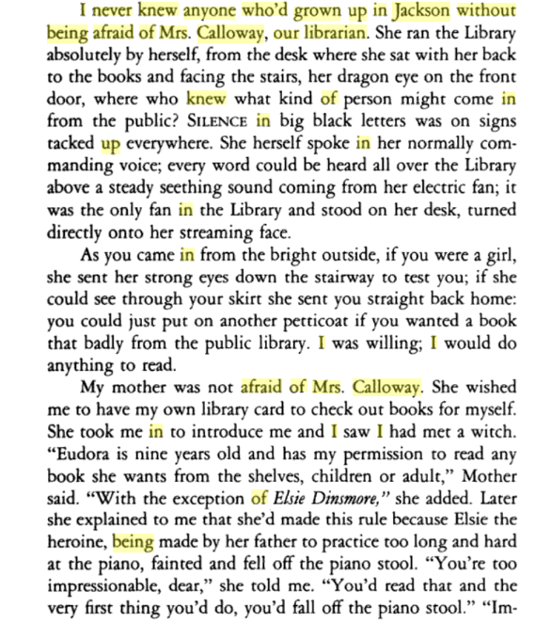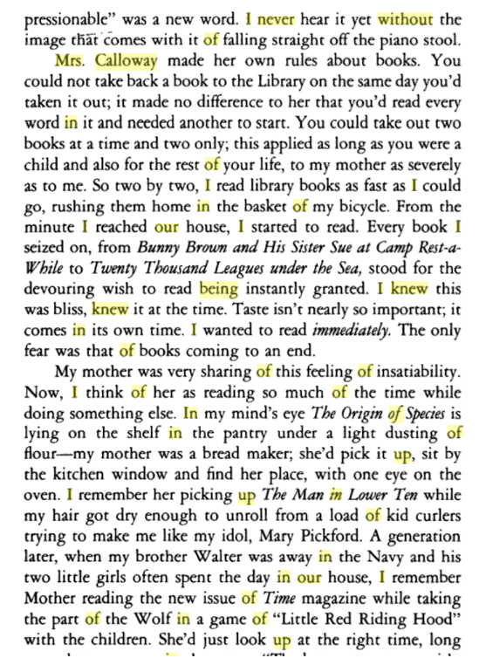

阅读B篇

阅读C篇
Children Tend to Learn Determination From Father
https://psychcentral.com/news/2012/06/18/children-tend-to-learn-determination-from-father/40301.html
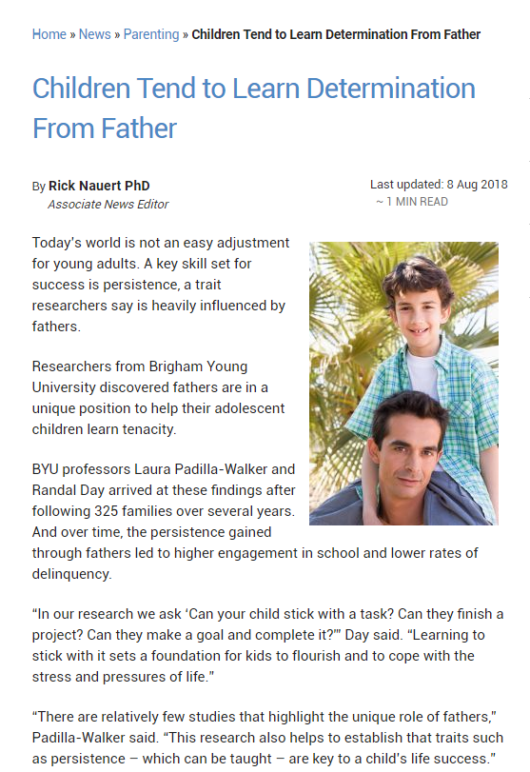

完型

填空

续写
https://www.readingvine.com/passages/a-puppy-for-poppy
