教学设计
Teaching Objectives：
By the end of the class, students will be able to
- know common trouble student’s have with English learning
- have a good understanding of how to write a blog about English learning problems and recommendations with various expressions
- know their trouble with English learning and form positive attitude to it
Teaching Important and Difficult Point：
- How to make students reflect on themselves and summarize their difficulties in English.
- How to make students write a blog about English learning with various expressions
Teaching Procedures:
hundred
thousand
million
_{____________关于}
Step 1: Lead-in
Student will be asked to look at a poster and answer the following questions:
- What’s the poster about?
- Where can we exchange ideas?
- How to organize your speech on an online forum.
（通过一张海报直接且简洁地导入话题）
Step 2: Read for main idea
Students will be asked to look through the passage and answer the questions:
1. Who puts forward the question “What are your biggest problem …”?
2. Who replies to the question?
3. What is the blog mainly about?
（快速阅读，帮助学生了解文本的大致内容，有一个心理准备）
Step 3: Read for details
Students will be asked to read the content carefully and fill in blanks
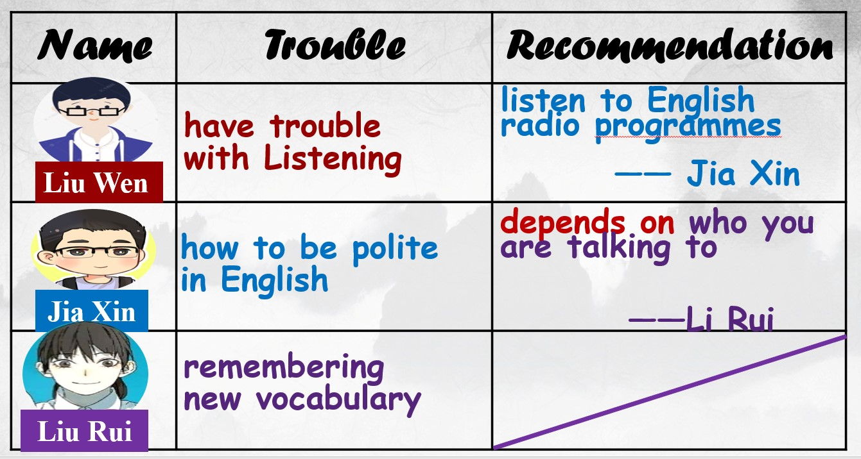
（快读、细读相结合，帮助学生了解文本的内容，对自己接下来的写作方向有一个心理准备）
Step 4: Read for organization
- Students will be asked to read the passage again and answer the questions:
How do they organize their trouble and recommendations？
- Teacher takes the Jia Xin’s post for example to work out the organization with students together
- Summary of the organization
Problem + example（they have met in study）
Trouble:

Advice + supporting details
Advice:

- How to put forward advice？
（通过读结构，帮助学生明白关于英语学习的blog是怎么构成的，有意识的在接下去的活动中朝着这个方向准备）
Step 5: Discussion and drafting
- Students will be asked to express their trouble and offer recommendations to their partners’ trouble.
A sample:
A: What are your biggest problems with learning English?
B: …is the biggest headache for me. I have no idea… Sometimes I believe… but in effect, I fail to…
A: If I were you, I would… It’s important to … That works for me.
- Then students will be asked to choose one problem from their partners and writer a blog about it.
While writing, you should
- Discribe the problem clearly
(problem+example, using various expressions)

b. Write one or two ideas on solving the problem
(advice+supporting details, using various expressions)

Step 6: Exchange drafts
Students will be asked to assess each other's work according to the checklist.

