Walk and Run
Teaching objectives:
By the end of the class, the students are able to
- Master the definition and function of particles;
- Have a collection of vivid verbs to describe “walk”;
- Have a collection of vivid verbs to describe “run”;
- Describe a scene or a picture by combining vivid verbs (run/walk) and accurate particles.
- Definition of particles
Observe the examples and make a definition.
He dashed out of the building to catch the bus.
We loaded suitcases, camping equipment and a tent into the car.
Then Mac heard quick and loud breathing behind him.
My dad and I got on our horses, heading slowly towards the mountains.
When I stepped off the plane, Luke was there, waiting for me.
A particle is__________________________________________________________.
- Function of particles
Compare the following two passages and think about the function of using particles.
A.
Mac was pedaling hard now. He waved and yelled at passing cars but was careful not to slow down. He saw a steep uphill climb before him. He knew that once he hit the hill, he'd be easily caught up and the wolf's teeth would be tearing into his flesh.
B.
Mac was pedaling hard now. He waved and yelled but was careful. He saw a steep uphill climb. He knew that once he hit the hill, he'd be easily bitten by the wolf.
- Types of particles
Brainstorm particles.

- Application of particles
Describe the following pictures by using particles.
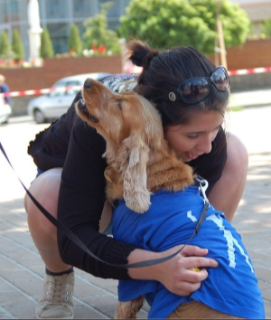
_____________________________________________________________________________________________________________________________________________________________________

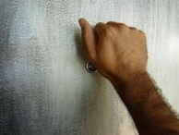
______________________________________________________________________________________________________________
_______________________________________________________


__________________________________________________________________________________________________________________________________________________________________ ______________________________________________________

- vivid verbs-- “walk”+particles
Brainstorm various verbs to describe “walk”
with mood
with sound
with a purpose
with a quick pace
with difficulty
with care

Walk with care Walk with difficulty Walk with a quick pace

Walk with a purpose Walk with sound Walk with mood

Practice:
Ex.1 Mini-writing(use vivid verbs of “walk” to translate the passage.)
语境：The darkness was gathering as she __________________________________
她穿着高跟鞋在公路边摇摇晃晃地走着。她的车意外地停了，像 每个正常的青少年都会做的，她唯一能想到的就是从车里出来然后步行。天很冷，夜已深，家很远。这可能是很漫长的夜晚。要是有人能停下来送她一程就好啦。她一边祈祷一边拖着腿继续往前走。
___________________________________________________________________________________________________________________________________________________________________________________________________________________________________________________________________________________________________________________________________________________________________________________________________________________________________________________________________________________________________

Ex.2 Mini-writing(use vivid verbs of walk to continue the story.)
Setting:
It was a rainy November morning. Overcome with anger I knew if I didn't leave the house soon I would lose my temper with my husband, Joe. As rain came down in sheets, Joe offered to take me to work. I struggled into my jacket, seized my bag and teaching plans and ignored him.__________________________________________
(What would I do next?)

- vivid verbs-- “run”+particles
Brainstorm various verbs to describe “run”.

How animals run?
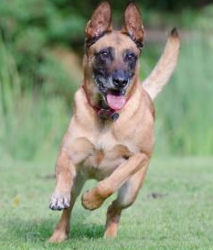
_____________________________________________________________________________________________________________________________________________________________________________________________

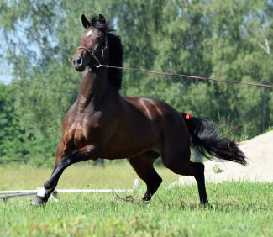
___________________________________________________________________________________________________________________________________________________________________________


__________________________________________________________________________________________________________________________________________________________________


________________________________________________________________________________________________________________________________________________________________________



_____________________________________________________________________________________________________________________________________________________________________

__________________________________________________________ __________________________________________________________
__________________________________________________________

Practice:
Ex. Describe the following pictures by using vivid verbs(run) and accurate particles (2 sentences).

__________________________________________________________ __________________________________________________________
__________________________________________________________

Vivid verbs+accurate particles exercise
Exercise1:Describe the following pictures by using one sentence including a vivid verb(run/walk) and accurate particle.
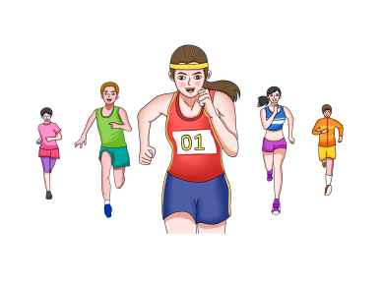
_____________________________________________________ _____________________________________________________
_____________________________________________________


_____________________________________________________ _____________________________________________________
_____________________________________________________

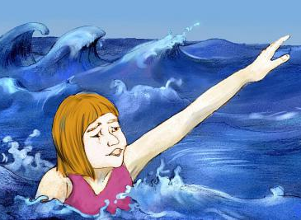
_____________________________________________________ _____________________________________________________
_____________________________________________________

Exercise2: Using vivid verbs of “walk” & “run” plus accurate particles to describe the actions and emotions of the characters above. (3-5sentences)
Characters: Mary, Colin, Dickon, Mr. Craven
A few days later Archibald Craven returned to Misselthwaite Manor and he went straight to the garden. _____________________________________________
___________________________________________________________________________________________________________________________________________________________________________________________________________________________________________________________________________________________________________________________________________________________________________________________________________________________________________________________________________________________________

Exercise 3：Continue the story by using vivid verbs accurate particles.
Lying in bed, the boy faintly heard the doctor talking to his mother that he would surely die, --for the terrible fire had destroyed so much flesh in the lower part of his body. But the brave boy didn't want to die. He made up his mind that he would survive. To the doctor's surprise, he made it. When the danger was past, he again heard the doctor whispering to his mother that he would be a lifetime cripple(跛子) because the severe injury made the lower part of his body stop functioning. Once more the brave boy made up his mind: he would not be a cripple. He would walk. Unwilling to be confined to a wheelchair, the little boy________________________
___________________________________________________________________________________________________________________________________________________________________________________________________________________________________________________________________________________________________________________________________________________________________________________________________________________________________________________________________________________________________ (write about 3-5 sentences)

Exercise 4：Weave the story based on the given plot by using vivid verbs accurate particles.(3-5 sentences)
Plot: 火灾发生，乔伊折回，勇救邻居小孩。
Looking at the smoke billowing from the burning houses, Joe took a deep breath and dived in for the boy._____________________________________________________
___________________________________________________________________________________________________________________________________________________________________________________________________________________________________________________________________________________________________________________________________________________________________________________________________________________________________________________________________________________________________

