Unit1 Model3 Reading for Writing
活动主题：该板块的活动主题是“写你的节日经历”（write about your festival experience）。该板块的教学目标是将交流的内容转化为文字，完成一篇有关节日经历的日记。通过阅读和学习这篇日记，学生不仅能够了解我国蒙古族“那达慕大会”这一传统节日，还能从文中感受到蒙古族人民的性格特色，娱乐精神及其浓厚的文化氛围，让学会学会欣赏和珍惜多姿多彩的民族文化。
文本分析：该文本是记叙文，日记。通过阅读该篇日记,了解写日记的几个注意要素：opening, body, closing。了解日记的人称、时态、写作顺序，作者的心理活动、情绪、感受描写等。以及本单元的目标语言结构－动词-ing形式，其中不仅包括做定语和表语的用法，还包括作主语、宾语补足语等的用法。

Teaching Aim:
- Help students learn some information about how to write a diary.
- Learn some ways to express emotions
- Learn some skills about describing activities in detail
- Learn how to arrange ideas
Teaching Importance:
- How to write a diary
- Make use of what you have learnt in the passage, such as text structures, micro-skills in writing etc.
Teaching Difficulties:
- Students have a Lack of writing skills
- Students don’t have a general idea of diversified interpretation

Teaching Procedure:
Step1 Lead in
Q: How did you feel about the hiking?
Q: Is there any related homework from your teachers about the hiking?
Step2: Pre-reading
Q: What is the text’s writing style ?
Q: What do you want to know according to the title?
Q: What activities did the writer experience?
Q: Why are these experiences amazing?
Step3: While-reading
- A general idea about a diary: person, tense, writing order
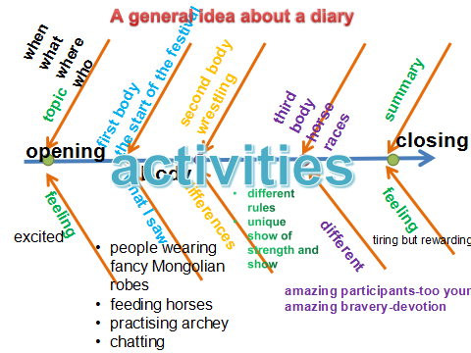
- What are amazing?
- How did the writer describe his/ her feelings/ emotions during the event? Please find out the sentences.

Step4: Further reading
Q: What does the sentence “Horses are at the heart of Mongolian culture...” imply?
Q: What is the most amazing thing to you about the festival?
Step 5: A quote
Keeping a diary supports a person’s development.
- Steven Sagmeister
Step6: Conclusion
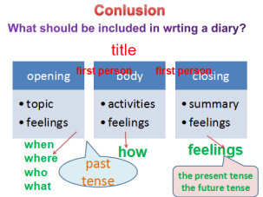
Step7: Assignment
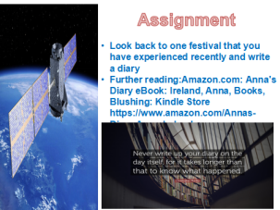
Step8 Samples from students

