M3U5 The Value Of Money
Period 1 Listening and Speaking
Teaching Objectives：
At the end of the class, students will be able to
1. master the new words in this period: on the basis of, take out a loan, plastic...
2. discuss the views of money in the lyrics and share their own views of money
3. improve their listening skills of identifying the characters and the relationship among them in listening
Teaching Important and Difficult Points：
How to make students work out the job, relationship of the characters in listening.
How to make students realize their views of money.
Teaching Procedures:
hundred
thousand
million
_{____________关于}
Step 1: Lead-in
Activity 1: Enjoy a short video
Students will be asked to enjoy a short video about money and fill in the lyrics:
ABBA ----money money money
I work all night, I work all day, to _____ ____ _______ I have to pay
Ain't it sad
And still there never seems to be a_______ _______ left for me
That's too bad
In my _________ I have a plan
If I got me a __________ man
I wouldn't have to work at all, I'd fool around and have a ball...
Money, money, money
Must be _________
In the rich man's world
Money, money, money
Always __________
In the rich man's world
Aha-ahaaa
All the_________ I could do
If I had a little money
It's a rich man's world
A man like that is______ to find but I can't get him off my ______
Ain't it _____
And if he happens to be free I _____ he wouldn't _______ me
That's too_____
So I must leave, I'll have to go
To Las Vegas or Monaco
And win a ________in a game, my life will never be the same...
Money, money, money
...

Activity 2: Have a look into the lyrics
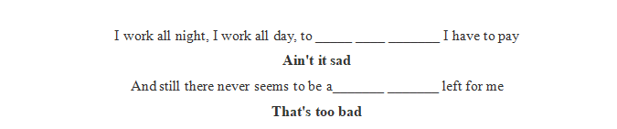
Q1: How do you figure out these lyrics? Why do people work so hard but still have no money?
(unreasonable consumption)
T: “ Money is a good servant and bad master”
Q2: What does this quotation mean? Do you want the money be your servant or master?
T: We should make good use of money.
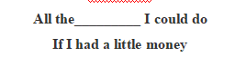
Q1: Do you agree with opinion? What can we do with money? What cannot we do with money?
Q2: How can we enrich our spiritual world?(reading)
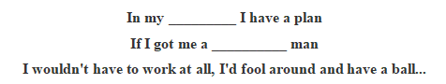
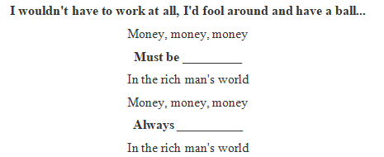

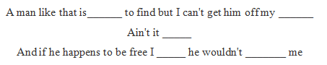

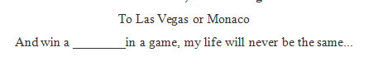

Q1: Do you agree with opinion? Is money the basis of a happy life?
Q2: There are two views of money in the lyrics, what are they? And what do you think of their views?
Q3: What should be our attitude to money? (Don’t let money direct you)
Step 2: Listening
Activity1:Listen for the general information
- Students will be asked to listen for the first time to get the main idea of listening material
Listening tip 1: For news, we should pay attention to 5W+H to get the main idea of the listening material
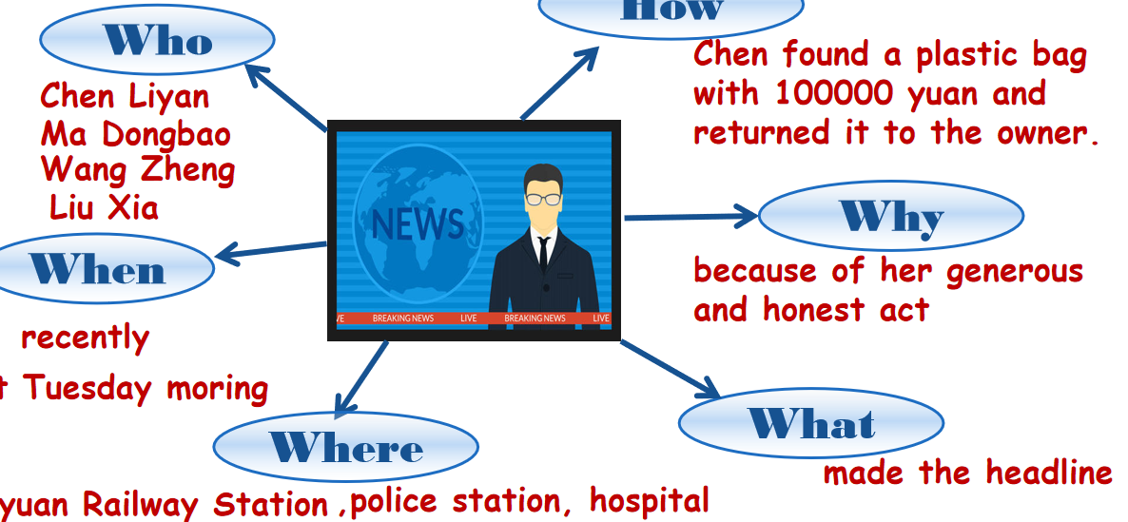
- Students will be asked to guess what happened in the news according to the answers.
Activity2:Listen for characters
Students will be asked to listen for the second time to make out the jobs and relationships of the characters.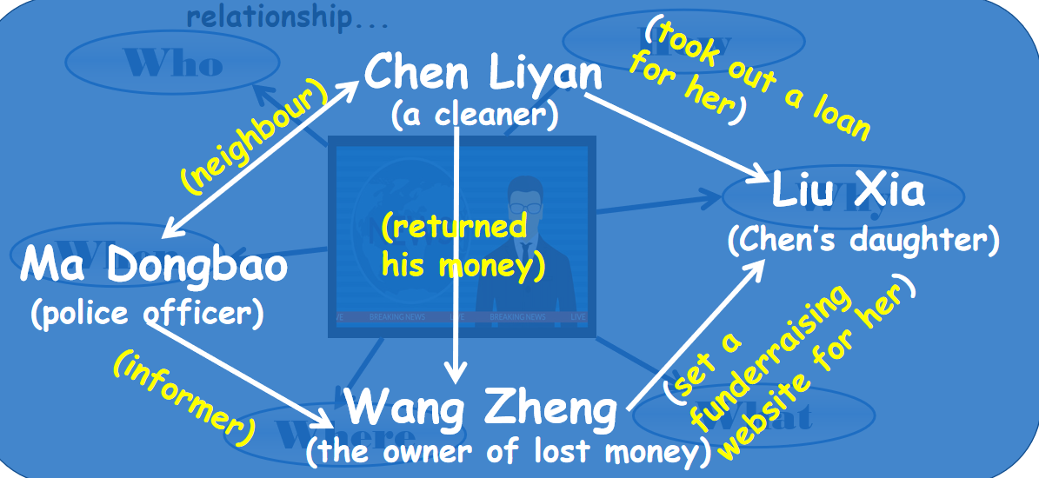
Activity3:Listen for the detailed story
Students will be asked to read the sentences and try to put the story into the right order, according to the hidden timeline in the sentences, and then listen again to check their prediction.(Listening tip 2)
____ Chen Liyan found Wang Zheng’s money and returned it to him.
____ Chen gave an interview to the local newspaper.
____ Wang built a website to help raise funds for Liu Xia.
____ Ma Dongbao shared Chen’s story with Wang.
____ Chen spent all her savings and took out a large loan.
____ Wang offered Chen 5,000 yuan.
Activity4:Listen and decide
1. It was the first time Chen Liyan’s story was reported.
2. Chen found 10,000 yuan in a small plastic bag in Taiyuan railway station.
3. Wang Zheng apologised to Chen because he couldn’t offer her more money.
4. Chen took out a large loan to cure her daughter.
5. Wang set up a fundraising website for Chen’s daughter after Chen told him about her situation.
Listening tip 3: Take down the key words, and correct the wrong places.
Q1: From the story, what can we know about Chen’s view of money?
Q2: Is there any similar example of this happened around you?

Step 3: Post-listening
Students will be asked to finish the gap filling of the listening material and analyse the structure of a piece of news.
Part1: Lead paragraph (5W+H)
Part2: Main body (detailed information, in time order)
Part3: Conclusion (Writer’s opinion on the issue)

Language feature:
content：wide
language：concise
timeliness：strong

