Unit 2 Looking into the future
The future continuous tense
教学设计
教学目标：
1.To identify and analyse the usages of the future progressive tense.
2.To master the usages of the future progressive tense through self-study and practice.
3.To use the future progressive tense to express your ideas.
教学过程：
一、Leading-in
Enjoy a short video about smart home in the future and guide the students to pay special attention to the italic and underlined sentences. ---future progressive tense ( future continuous tense )
- In the not-too-distant future, we will be living in smart homes that will lock the door for us when we are away and remember to switch off the TV when we forget.
2. In the future, we will be using advanced technology every day for automatic control of just about everything in our home.
注意：The future progressive tense is used to talk about prediction to the life in the future.
Enjoy another video and try to feel the future progressive tense in the situation.
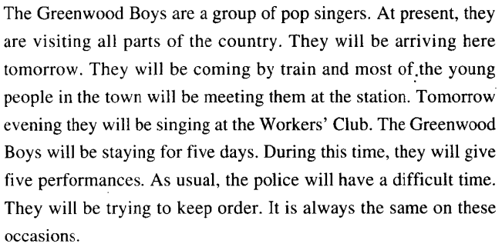
二、While-class
A.Observe and discover 1 and practice1.
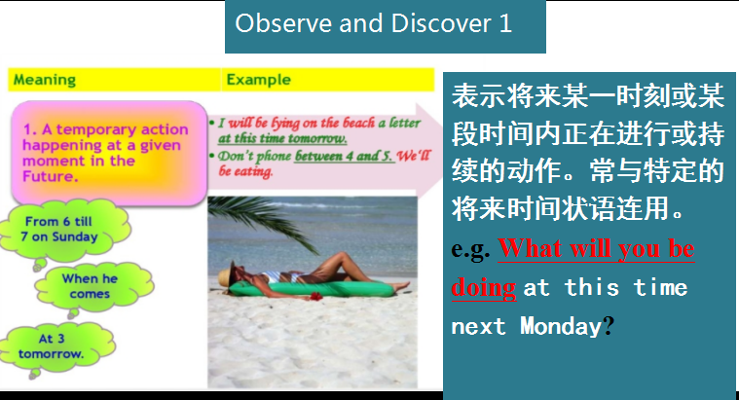
单句语法填空
1.I____________(do) my homework at ten tomorrow evening.
2.We____________(fly) to the United States this time next week.
3.You can call me at 8 in the evening.I____________(not sleep) then.
4.At 5:00 pm,the boys____________(practice) football on the playground.
5.The headmaster____________(meet) some parents at 3:00 this afternoon.

- Observe and discover 2 and practice2.
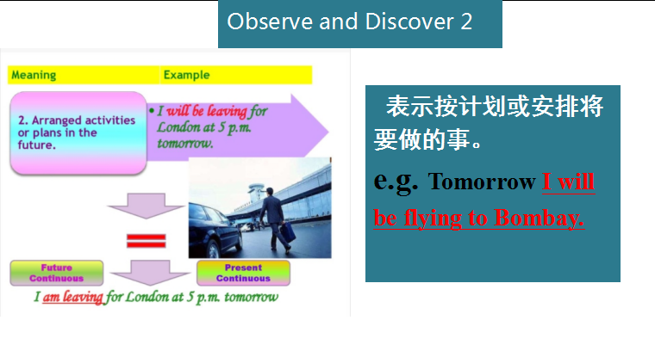
1．我们将在澳大利亚过冬。_____________________________________
2．下两个月玛丽将在这个厂里工作。_____________________________________
3．克雷格教授明晚作关于陶器的讲演。_____________________________________
4．后天这个时候我将飞往纽约。_____________________________________
C. Observe and discover 3 .
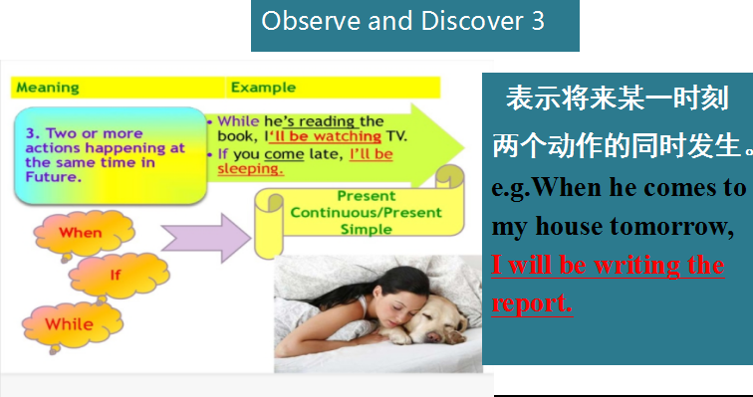
D.Summary:
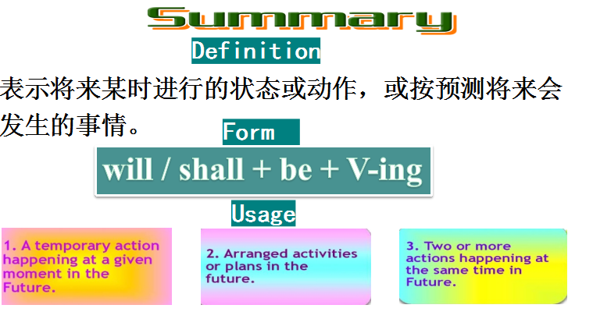
E.Compare and discover: 一般将来时 VS 将来进行时
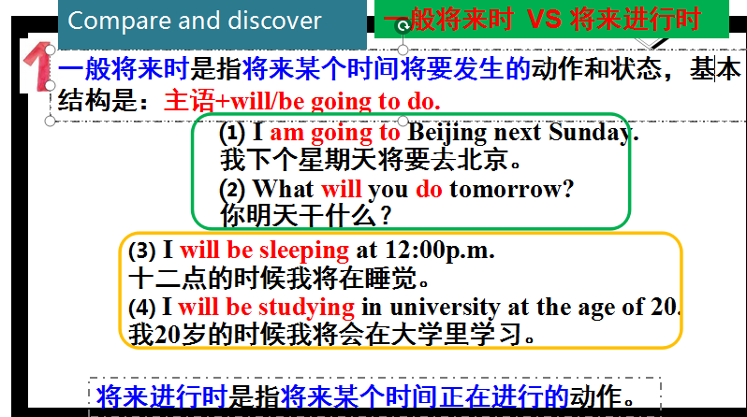
用动词的适当形式填空
Great changes 1.____________(take) place in the future.People 2.____________ (become) richer and richer, life 3.____________(be) more and more convenient.We 4.____________(have) lessons online at home instead of going to school.If we want to do something, the robots 5.____________(perform) all kinds of tasks for us according to our commands.
F. Pactice and Apply

